EXPERIMENT- 15
1.
category <- c("Electronics", "Clothing", "Furniture", "Books")
sales <- c(50000, 30000, 20000, 15000)

pie(sales,
labels = category,
col = rainbow(length(category)),
main = "Sales Distribution by Category")



2.
sales <- c(120, 180, 150, 200, 170)
profit <- c(25, 40, 30, 50, 35)
size <- c(8, 12, 10, 15, 11)

symbols(sales,
profit,
circles = size,
inches = 0.3,
bg = "skyblue",
fg = "black",
xlab = "Sales",
ylab = "Profit",
main = "Sales vs Profit Bubble Chart")

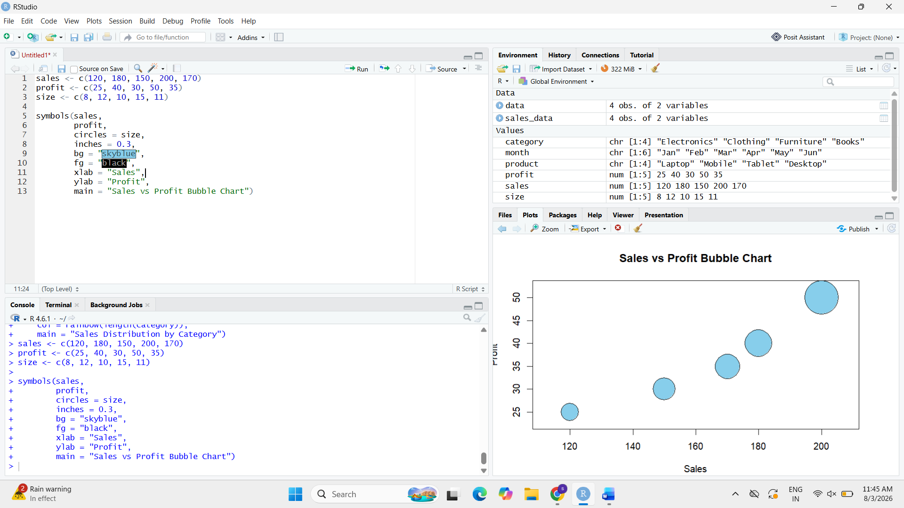

3.
sales_data <- data.frame(
Product = c("Product A", "Product B", "Product C", "Product D", "Product E"),
Sales = c(120, 180, 150, 200, 170),
Profit = c(25, 40, 30, 50, 35)
)

print(sales_data)

