EXPERIMENT- 19

9.department <- c("Sales", "HR", "Marketing", "Sales", "HR")

department_count <- table(department)

barplot(department_count,
col = "skyblue",
xlab = "Department",
ylab = "Number of Employees",
main = "Employees by Department")

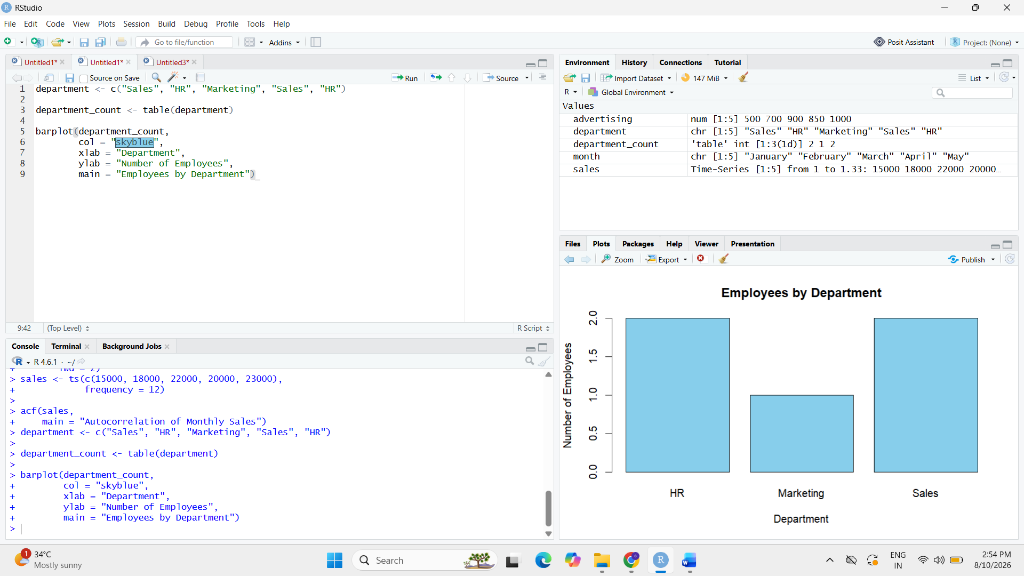

10. employee <- c("Emp1", "Emp2", "Emp3", "Emp4", "Emp5")
performance <- c(85, 92, 78, 90, 76)

plot(performance,
type = "o",
xaxt = "n",
col = "blue",
pch = 16,
xlab = "Employee",
ylab = "Performance Score",
main = "Employee Performance Trend")

axis(1,
at = 1:5,
labels = employee)

grid()

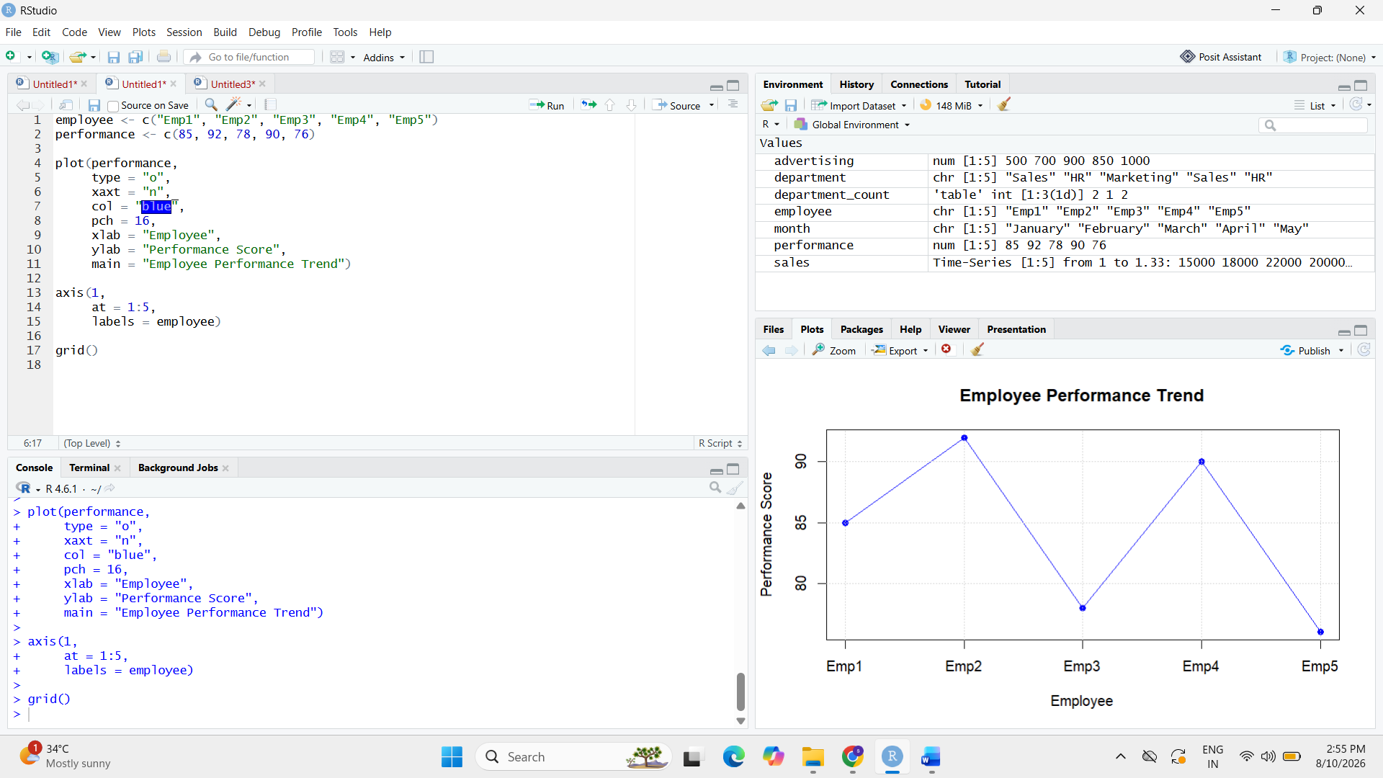

12.
employee_data <- data.frame(
Employee_ID = c(1, 2, 3, 4, 5),
Department = c("Sales", "HR", "Marketing", "Sales", "HR"),
Years_of_Service = c(5, 3, 7, 4, 2),
Performance_Score = c(85, 92, 78, 90, 76)
)

print(employee_data)

