作业一：米粒数量提取

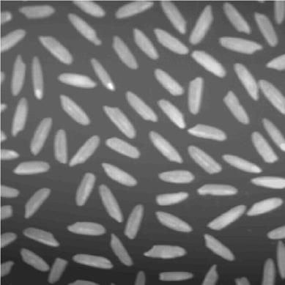

原图

代码如下：

import cv2

import numpy as np

img = cv2.imread("rice.jfif")

gray = cv2.cvtColor(img,cv2.COLOR_BGR2GRAY) #转换为灰度图

# 使用局部阈值的自适应阈值操作进行图像二值化

dst = cv2.adaptiveThreshold(gray,255, cv2.ADAPTIVE_THRESH_MEAN_C, cv2.THRESH_BINARY,101, 1)

# res ,dst = cv2.threshold(gray,0 ,255, cv2.THRESH_OTSU)

# 形态学去噪

element = cv2.getStructuringElement(cv2.MORPH_CROSS,(3, 3))

# 开运算去噪

dst=cv2.morphologyEx(dst,cv2.MORPH_OPEN,element)

# 轮廓检测函数

contours, hierarchy = cv2.findContours(dst,cv2.RETR_EXTERNAL,cv2.CHAIN_APPROX_SIMPLE)

# 绘制轮廓

cv2.drawContours(dst,contours,-1,(120,0,0),2)

count=0 # 米粒总数

# 遍历找到的所有米粒

for cont in contours:

    # 计算包围性状的面积

    ares = cv2.contourArea(cont)

    # 过滤面积小于50的形状

    if ares<5:

        continue

    if ares>1000:

        count+=1

    count+=1

    # 打印出每个米粒的面积

    print("{}-blob:{}".format(count,ares),end="  ")

    # 提取矩形坐标（x,y）

    rect = cv2.boundingRect(cont)

    # 打印坐标

    print("x:{} y:{}".format(rect[0],rect[1]))

    # 绘制矩形

    cv2.rectangle(img,rect,(0,0,255),1)

    # 防止编号到图片之外（上面）,因为绘制编号写在左上角，所以让最上面的米粒的y小于10的变为10个像素

    y=10 if rect[1]<10 else rect[1]

    # 在米粒左上角写上编号

    cv2.putText(img,str(count), (rect[0], y), cv2.FONT_HERSHEY_SIMPLEX, 0.3, (0, 255, 0), 1)

    if ares>1000:

        cv2.putText(img,"Two here", (rect[0], y+10), cv2.FONT_HERSHEY_SIMPLEX, 0.3, (0, 255, 0), 1)

    # print('编号坐标：',rect[0],' ', y)

print('个数',count)

cv2.namedWindow("imgshow", cv2.WINDOW_NORMAL)   #创建一个窗口

cv2.imshow('imgshow', img)    #显示原始图片（添加了外接矩形）

cv2.namedWindow("dst", cv2.WINDOW_NORMAL)   #创建一个窗口

cv2.imshow("dst", dst)  #显示灰度图

cv2.waitKey()

得到的结果：米粒数量为79

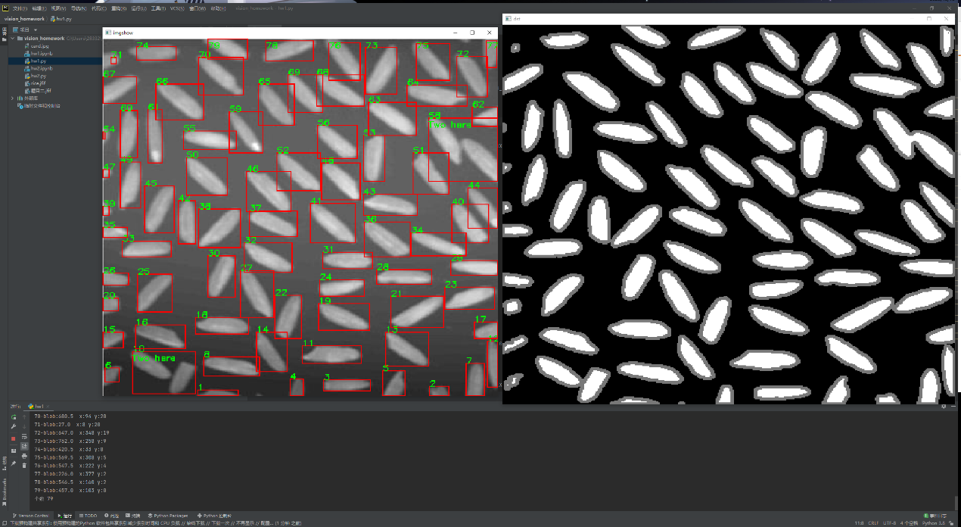

作业二：仿射变换校正畸变



原图

代码如下：

import cv2

import numpy as np

import matplotlib.pyplot as plt

def Cal_kb_linear_fitline(data_line1):

    output = cv2.fitLine(data_line1, cv2.DIST_L2, 0, 0.01, 0.01)

    k = output[1] / output[0]

    b = output[3] - k * output[2]

    return k,b

img = cv2.imread("card.jpg")

gray = cv2.cvtColor(img,cv2.COLOR_BGR2GRAY) #转换为灰度图

blur = cv2.GaussianBlur(gray, (5, 5), 0)

dst1 = cv2.Canny(blur, 75, 200)

contours, hierarchy = cv2.findContours(dst1,cv2.RETR_EXTERNAL,cv2.CHAIN_APPROX_SIMPLE)

# 绘制所有轮廓

cv2.drawContours(dst1,contours,-1,(120,0,0),2)

plt.subplot(221), plt.imshow(cv2.cvtColor(dst1, cv2.COLOR_BGR2RGB)), plt.title('dst1')

areas = []

for c in range(len(contours)):

    areas.append(contours[c].shape[0])

max_id = areas.index(max(areas))

maxContour = contours[max_id]

# 绘制最大的轮廓（即卡片的边框轮廓）

dst2 = cv2.drawContours(img,maxContour,-1,(0,255,0),2)

plt.subplot(222), plt.imshow(cv2.cvtColor(dst2, cv2.COLOR_BGR2RGB)), plt.title('dst2')

# 将图片划分为25x25个区域，分别对其中的点进行拟合，算出所有分区中的斜率和截距

yMag = img.shape[0]

xMag = img.shape[1]

print(img.shape)

lines = []

for i in range(25): # x

    for j in range(25): # y

        points = []

        for r in range(maxContour[:, 0, :].shape[0]):

            point_y = maxContour[r, 0, 1]

            point_x = maxContour[r, 0, 0]

            if (point_x >= i*xMag/25 and point_x < (i+1)*xMag/25) and (point_y >= j*yMag/25 and point_y < (j+1)*yMag/25):

                points.append([point_x, point_y])

        npPoints = np.array(points)

        if npPoints.size != 0:

            output = cv2.fitLine(npPoints, cv2.DIST_L2, 0, 0.01, 0.01)

            k = output[1] / output[0]

            b = output[3] - k * output[2]

            lines.append(np.array([k, b]))

# 将所得的斜率和截距进行比较，取得中间出现最多的四组解，即为卡片边框的四条边的解

lines = np.array(lines)

names = locals()

i = 0

while(lines.size != 0):

    absK = abs(lines[:, 0, 0] - lines[0, 0, 0])

    absB = abs(lines[:, 1, 0] - lines[0, 1, 0])

    idx = np.where(np.logical_and(absK < 0.5, absB < 150))

    names['KBs' + str(i)] = np.vstack((lines[:, 0, 0][idx], lines[:, 1, 0][idx]))

    lines = np.delete(lines, idx, 0)

    i += 1

t = []

for j in range(i):

    t.append(names['KBs' + str(j)].size)

max_number = []

max_index = []

for _ in range(4):

    number = max(t)

    index = t.index(number)

    t[index] = 0

    max_number.append(number)

    max_index.append(index)

Ks = []

Bs = []

for idx in max_index:

    Ks.append(np.average(names['KBs' + str(idx)][0, :]))

    Bs.append(np.average(names['KBs' + str(idx)][1, :]))

def cross_point(k1, b1, k2, b2):  # 计算交点函数

    #是否存在交点

    point_is_exist=False

    x = (b2 - b1) * 1.0 / (k1 - k2)

    y = k1 * x * 1.0 + b1 * 1.0

    if (x > 0 and x < xMag) and (y > 0 and y < yMag):

        point_is_exist=True

    return point_is_exist,[x, y]

# 由四条边算出原图中卡片的四个角点（这里也计算了落在屏幕外的点的位置，通过图片大小为阈值而舍弃）

pts1 = []

for i in range(4):

    for j in range(i, 4):

        point_is_exist,[x, y] = cross_point(Ks[i], Bs[i], Ks[j], Bs[j])

        if(point_is_exist == True):

            pts1.append([x, y])

pts1 = np.array(pts1).astype(int)

for i in range(4):

    ptStart = (0, int(Bs[i]))

    ptEnd = (4000, int(4000*Ks[i]+Bs[i]))

    dst3 = cv2.line(img, ptStart, ptEnd, (0, 0, 255), 2)

    cv2.circle(dst3, pts1[i], 10, (0, 0, 255), 5)

plt.subplot(223), plt.imshow(cv2.cvtColor(dst3, cv2.COLOR_BGR2RGB)), plt.title('dst3')

pts1 = np.float32(pts1)

pts2 = np.float32([[0, 0], [1000, 0], [0, 750], [1000, 750]])

# 生成透视变换矩阵

M = cv2.getPerspectiveTransform(pts1, pts2)

# 进行透视变换

dst4 = cv2.warpPerspective(img, M, (1000, 750))

plt.subplot(224), plt.imshow(cv2.cvtColor(dst4, cv2.COLOR_BGR2RGB)), plt.title('dst4')

plt.show()

结果如下：

