First we import a few English dictionaries along side os for file handling and string for punctuation characters
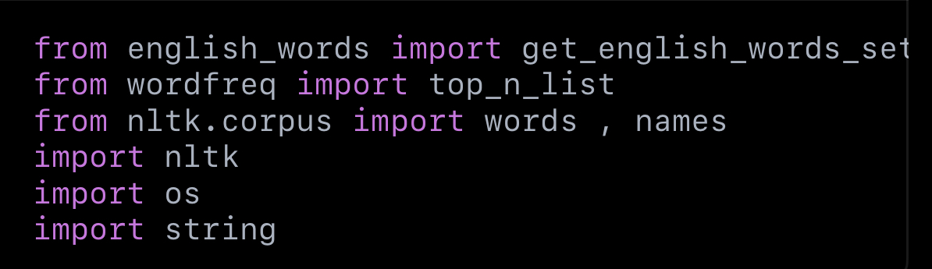
We set every dictionary into a specific word (english 1….. etc)
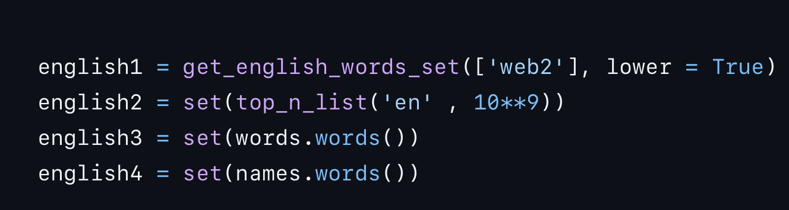
We then combine all dictionaries into one, and map the letters from the alphabet to numbers and numbers to alphabetical letters. (visca versa)

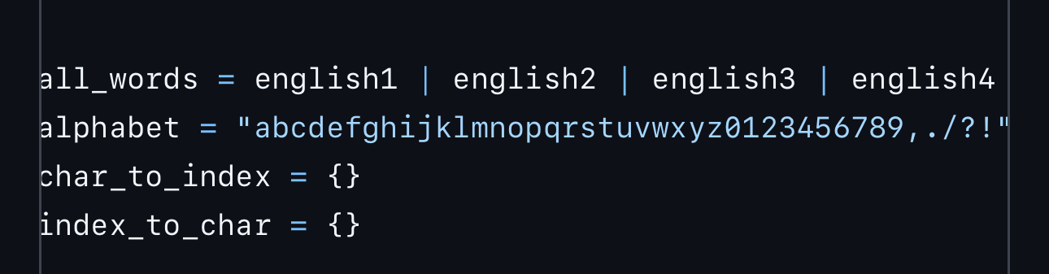
We then create a table that shows what each letter’s index is and each index’s letter. (storing them).
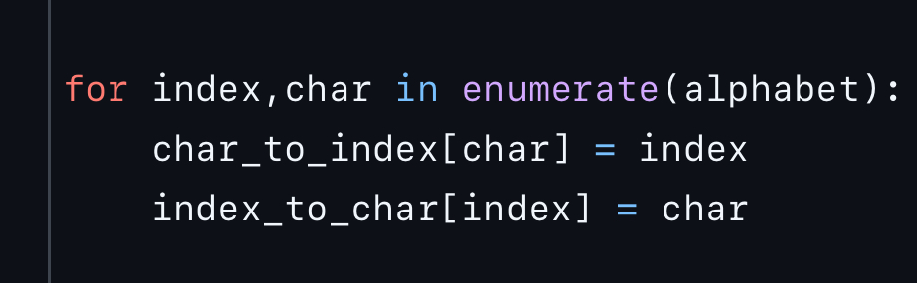
This is used to read the file line by line, skips empty lines and stops at the end of the file.
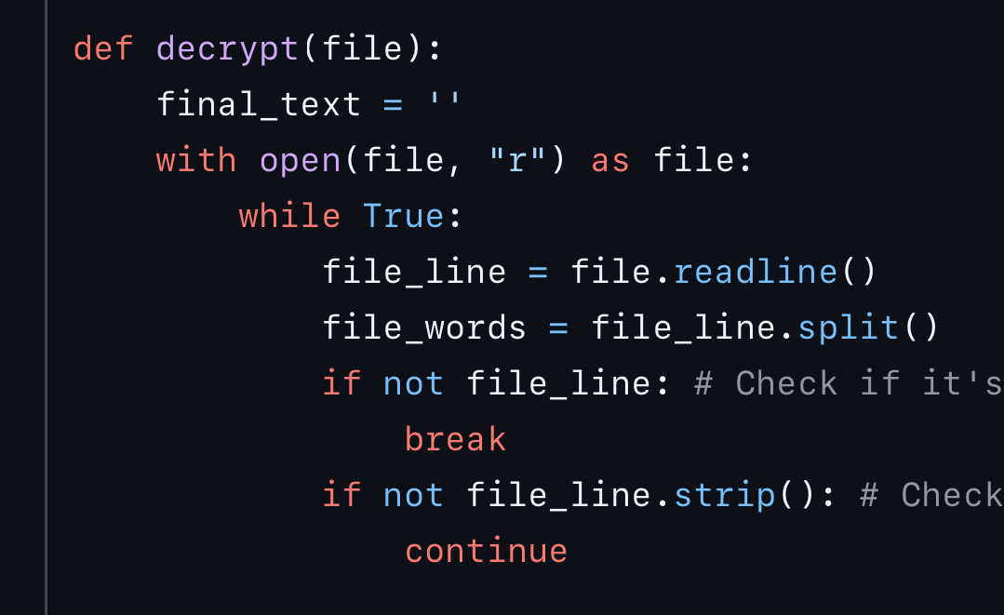
After that we try to find the key by shifting the Caeser cipher by 1 each time. We use the first few words to detect if it’s the right key or not, we then shift them backwards according to the key, if the words are real english and exists in the dictionary then the key is correct if now then the process is repeated
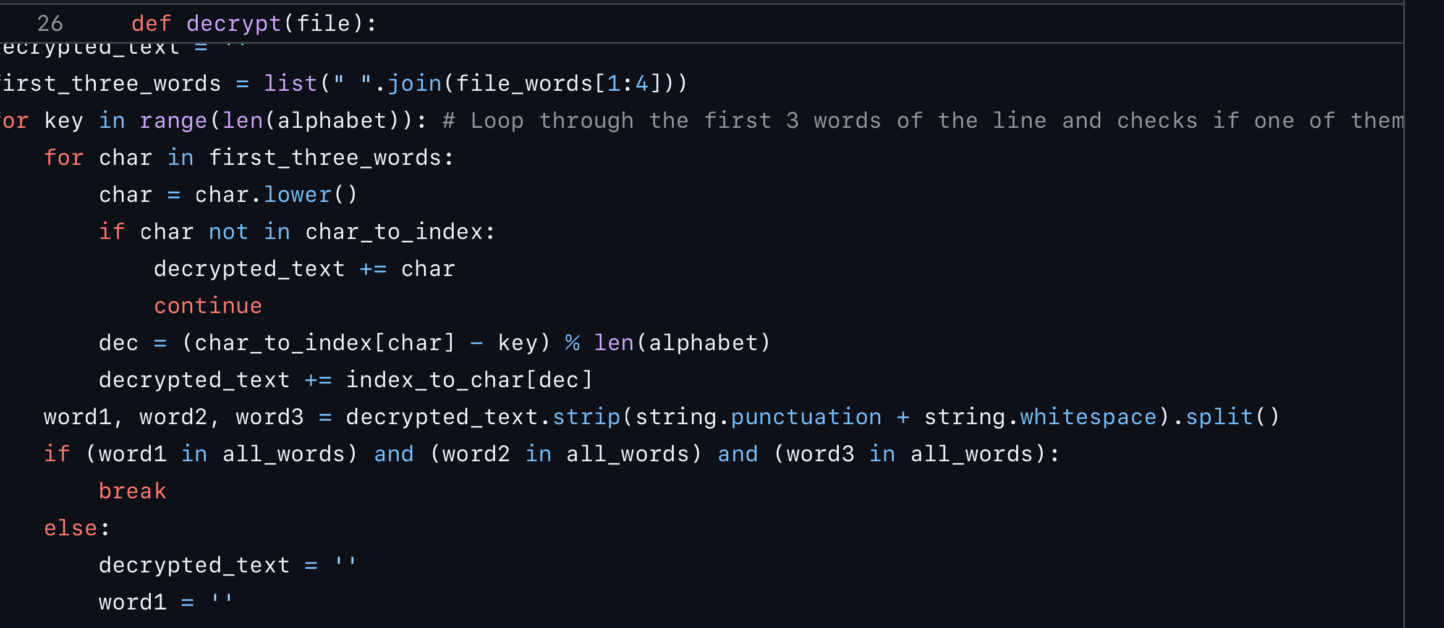
Once we found the key then we use it to decrypt the rest of the line.
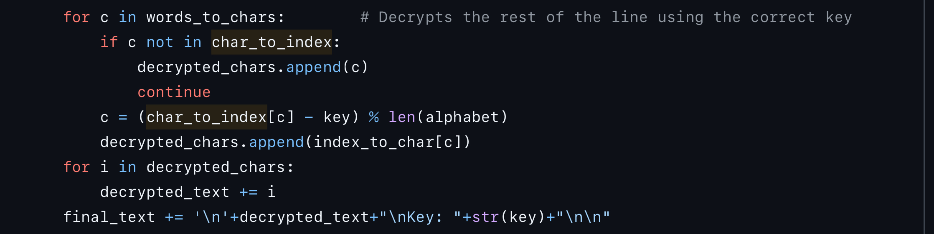
This finds the next available line so that we can decrypt it and save the decrypted text in a new file without overwriting any existing text.
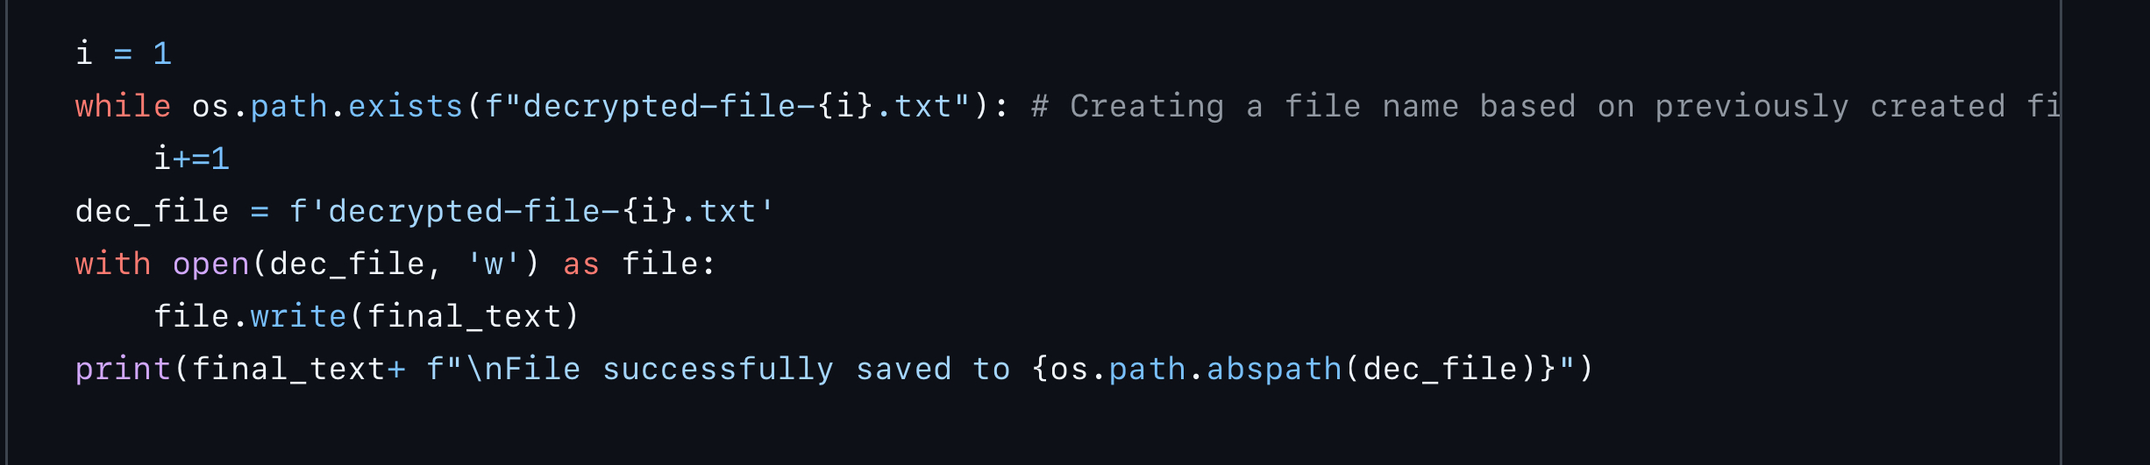
Prints the file contents

Finally, the main asks for the file name, whether you want to decrypt the text or just print it out while also handling errors.
