06/09/2022 Experiment 2

**RA2011028010057**

**S.M.DINESH**

**AIM:** To create a LAMP instance in the AWS CLI.

# PROCEDURE:

1. Firstly, type sudo su to become the root user.
2. To update all the packages in your instance type “yum update -y”.

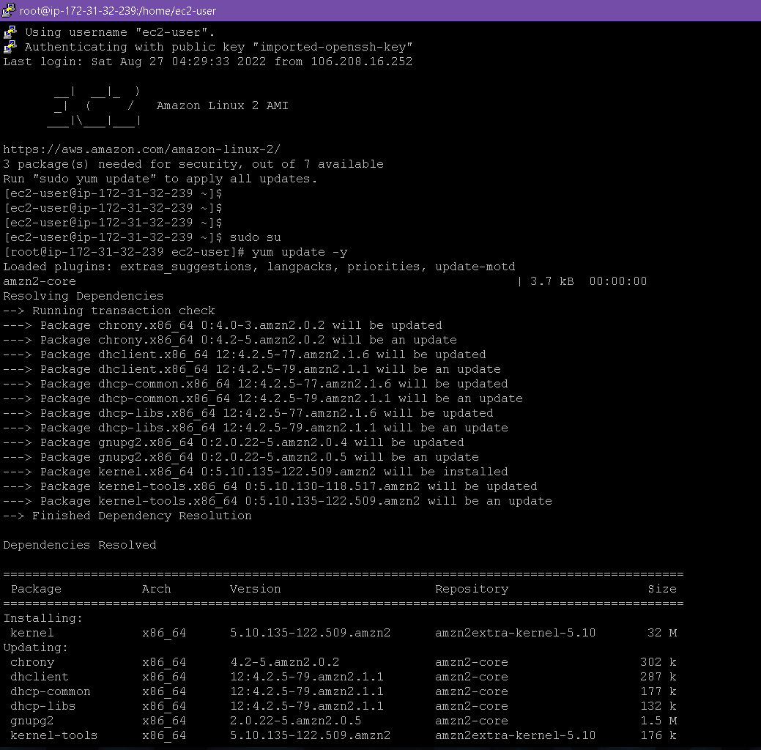

1. To install Apache server in linux, type “yum install httpd”.

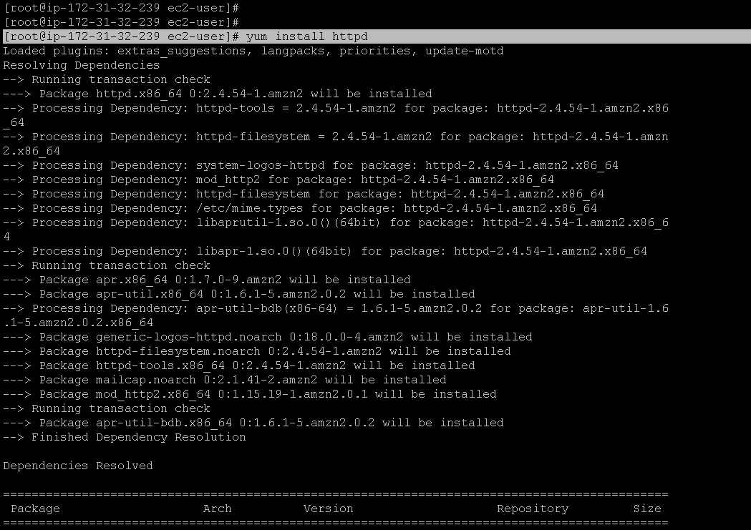

1. 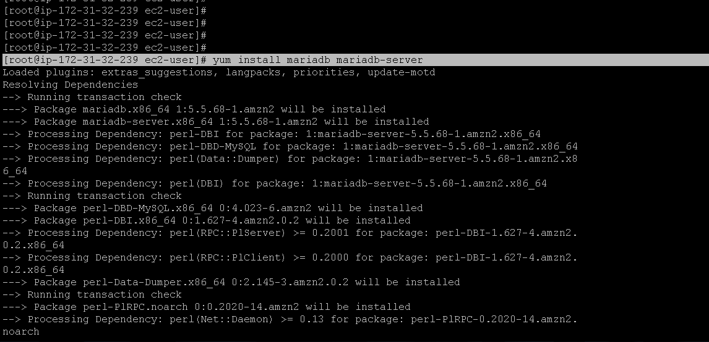To install mysql or mariadb type “yum install mariadb mariadb-server”.
2. To install php, type “yum install php php-mysql”.

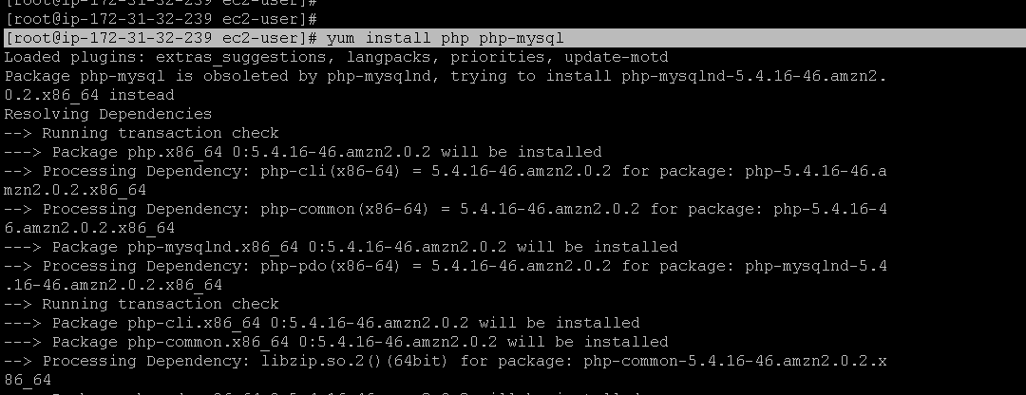

1. Type “yum search php” to see all the packages installed in the server.

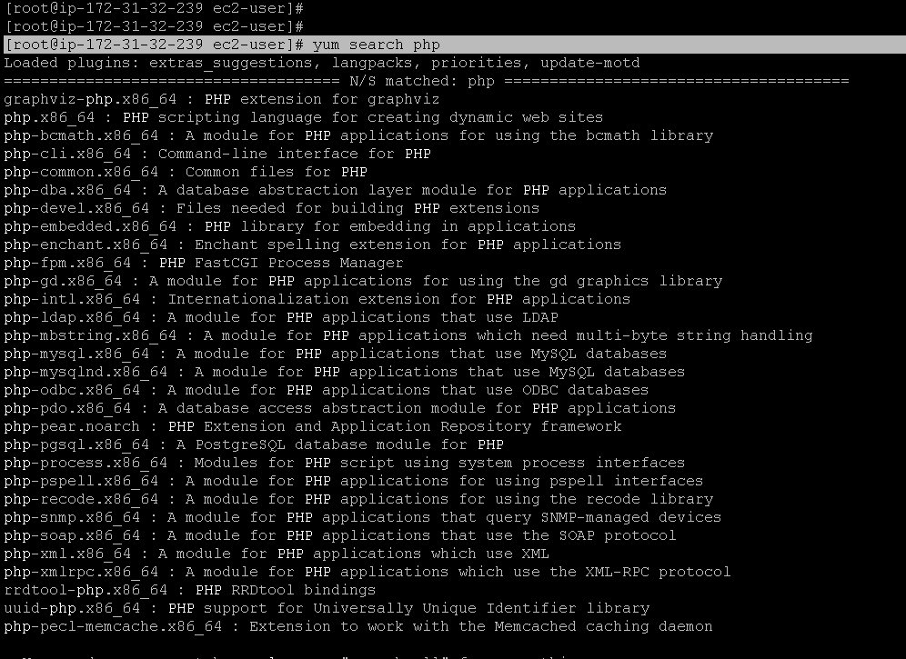

1. 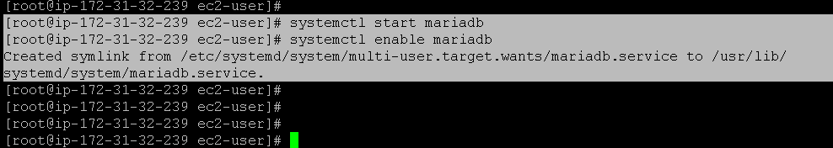Enabling the mariadb server.
2. After enabling httpd (apache server) , go to the directory where cd

/var/www/html/

1. 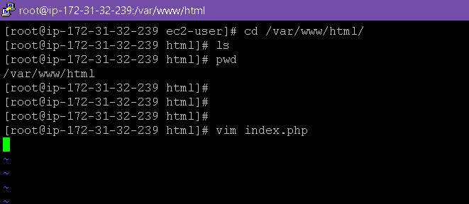Go to vim and type “<?php phpinfo(); ?>”.

Copy the public ip address or public domain name from the console and paste in the web browser.

We get the following output.

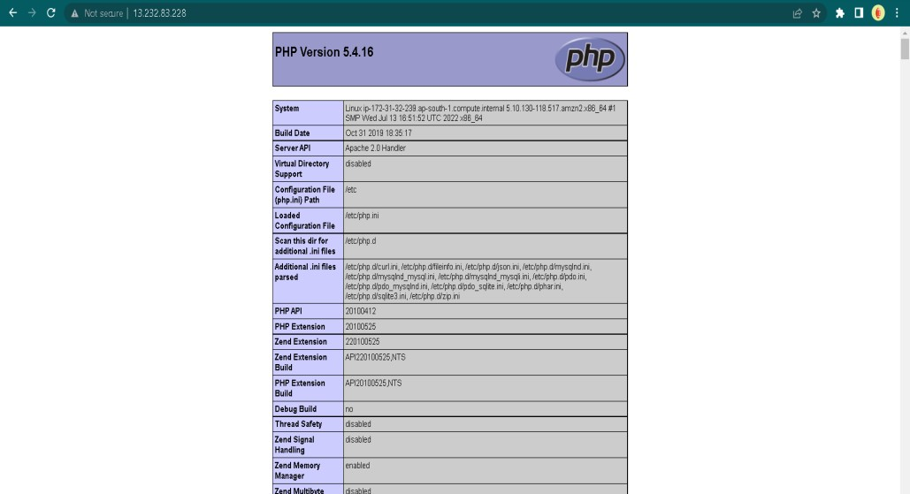

# RESULT:

LAMP instance was successfully created and executed in AWS CLI.

# DURGA CHANDANA SREE MANDAPATI RA2011028010099

**K2, CSE CLOUD COMPUTING**