### Library management system

1. RASHID MD MAMUNUR

(潘安) 1811562126

2. ZUBAYER S M

(苏贝尔) 1811562127

3. PARVEZ MOHAMMAD SHARIAR

(朴维) 1911562106

4. KAMRUZZAMAN MD (叶本领)

1811562117

We are go to create a software for library management system, According to data structure course Binary **Search Tree and Array List are implement** in this program. We divided this program into three section. **Student section (ArrList)**, **Book section** (BST), **Book issue&return section** (ArrList and BST).

**Problem definition and condition:**

* Book should contain at least the book ID, title, author, existing stock and total.
* The data can be stored in the prime memory without using files.
* Add a new book. If books with the same ID exist already, increase its total number by 1.
* Borrow: if the existing stock is greater than 1, then mark it has been borrowed. You should record the borrower’s license ID and the due time that he should return the book.
* Return: Remove the borrowing information and change the existing stock of the book.

**Demand analysis:**

This library management software must be a librarian or library management operator

There has three (3) section.

* Student section
* Book section
* Book issue and return section

Each section has few function to operate this software

1. Student section

* Student registration
* See all student record
* Delete a student record
* Search student (by student ID)
* Search student (by book ID) [if book are taken by which student]

1. Book section

* Book insert in library
* Book searching [to see existing details ]
* See all the book record
* Delete a book from library storage
* Delete all book from library storage

1. Book issue and return section

* Checking how many books copy are available for borrow
* Borrow book
* Return

In here, we are use incremental model:

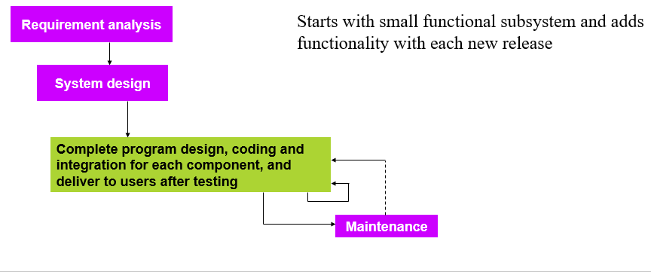

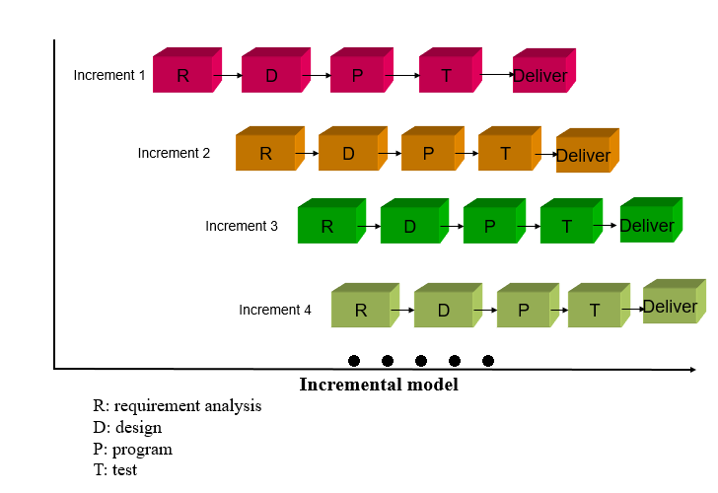

**UML design:**

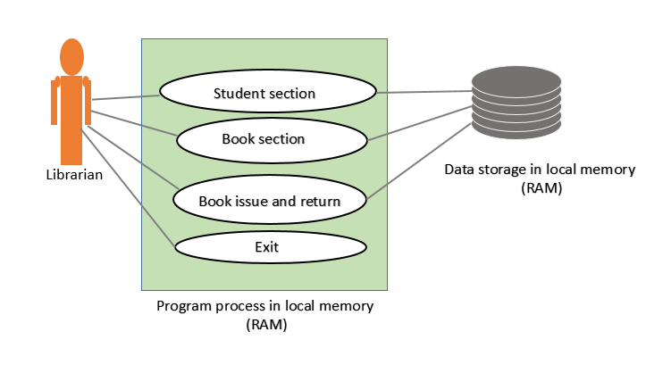

**Class-diagram:**

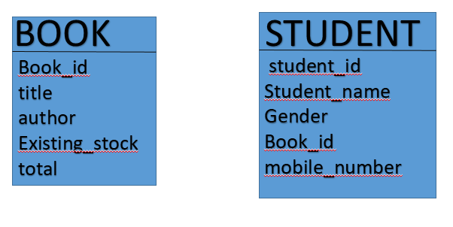

**Sequence-diagram:**

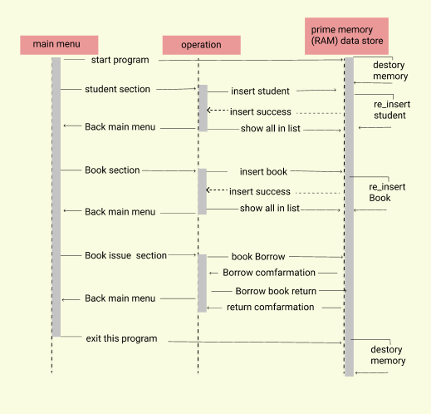

**Development diagram:**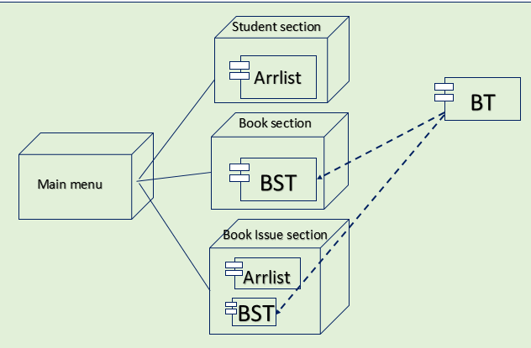

**Component Diagram:**

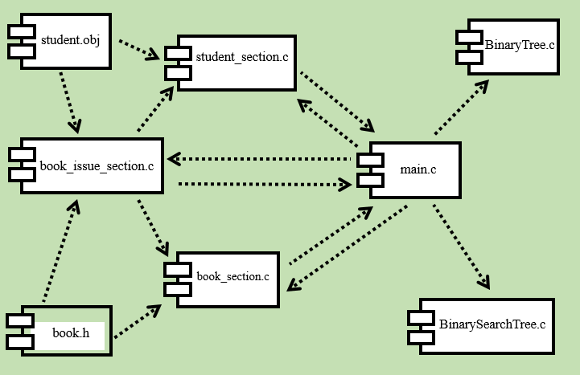

**Create book and student struct in c-language**

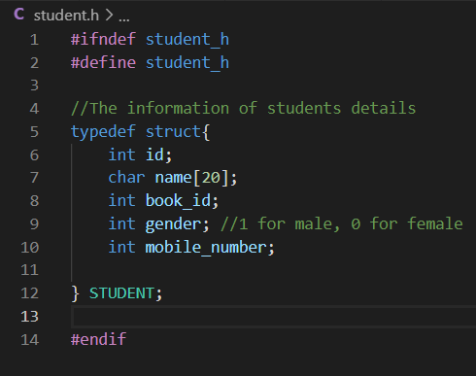 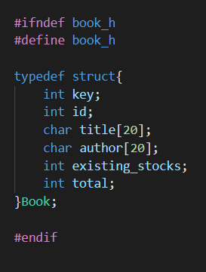

**Create arrayList.h , BinarySearchTree.h, BinaryTree.h**

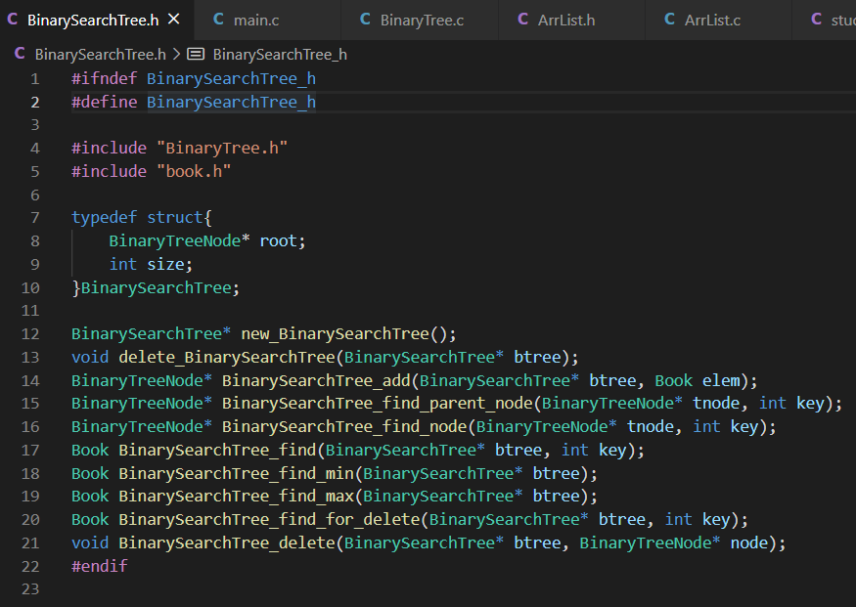

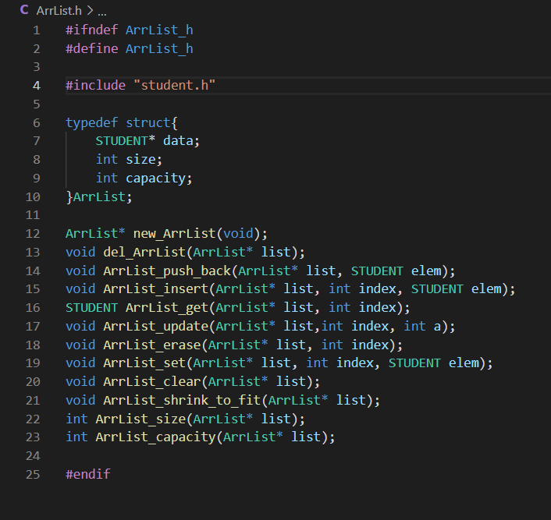

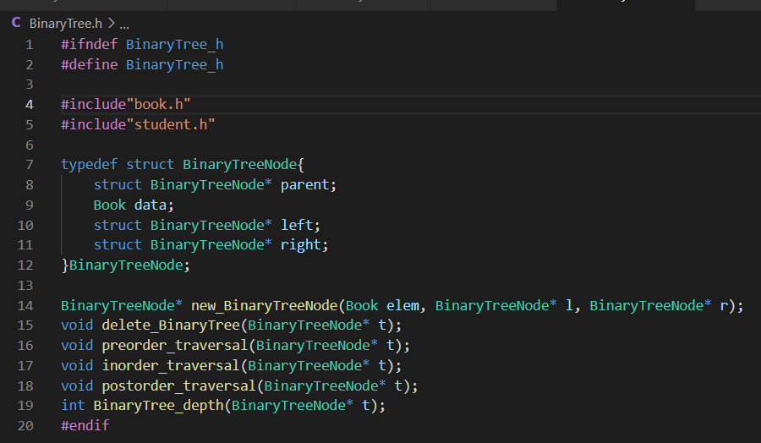

**Create main function:**

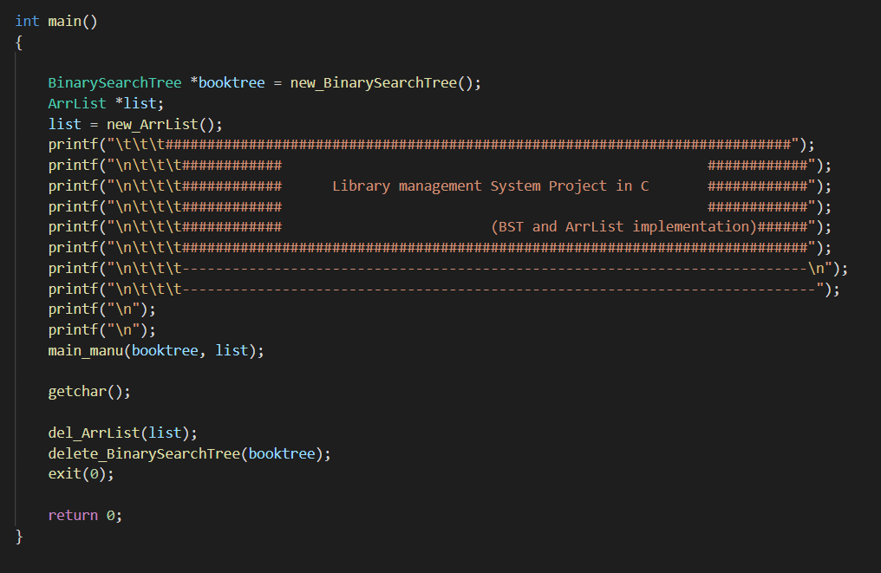

**Main Menu function is operator all function**

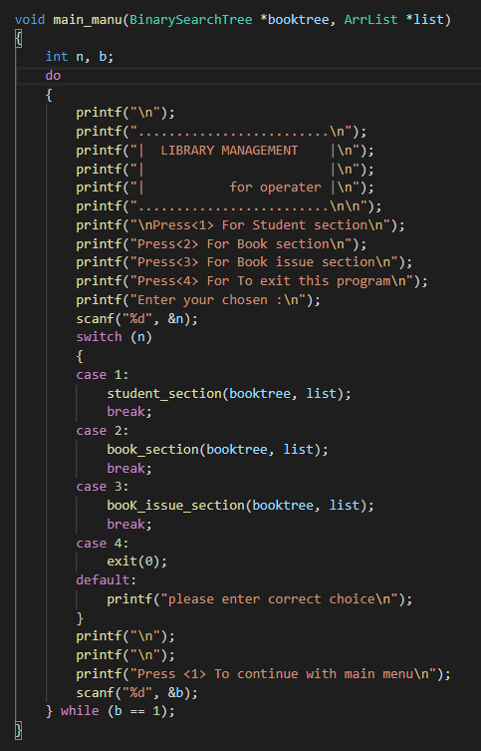

**Student section:**

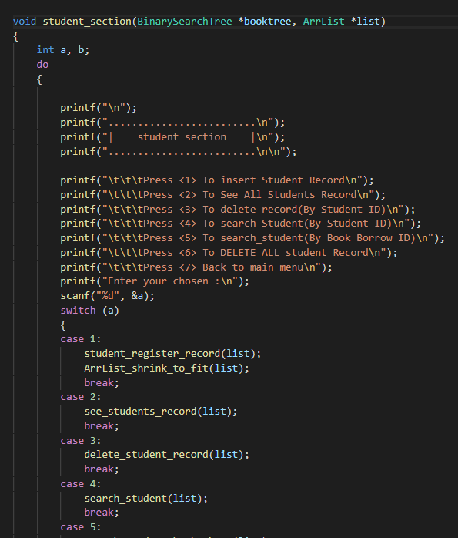 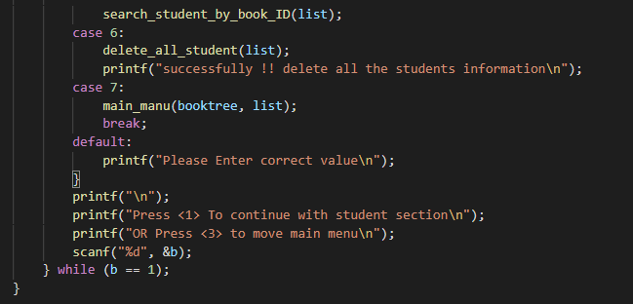

**Student Registration:**

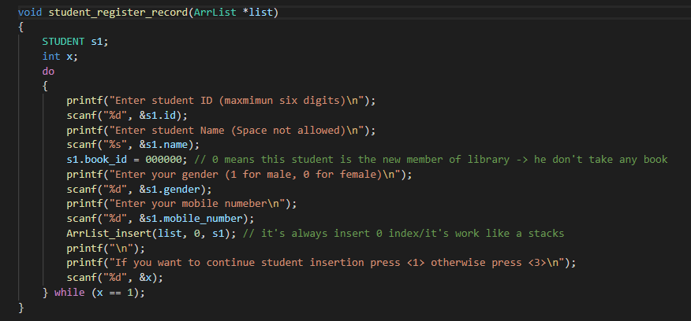

**Inhere, use array list to store data, after every insertion complete, run here shrink function.**

**So, memory Optimized**

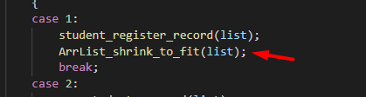

**Show student list:**

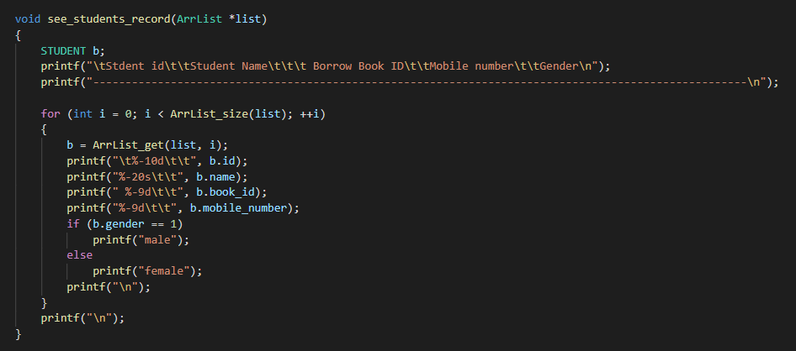

**In in here time complexity O(n).**

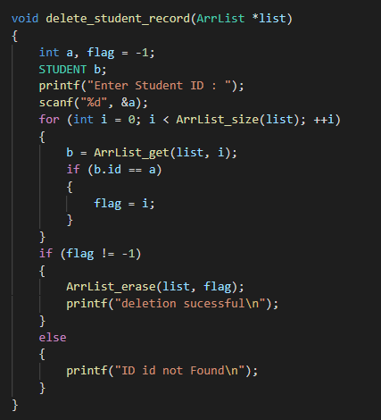 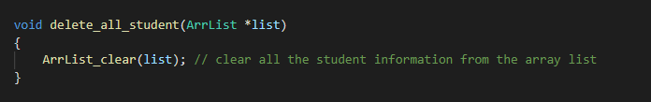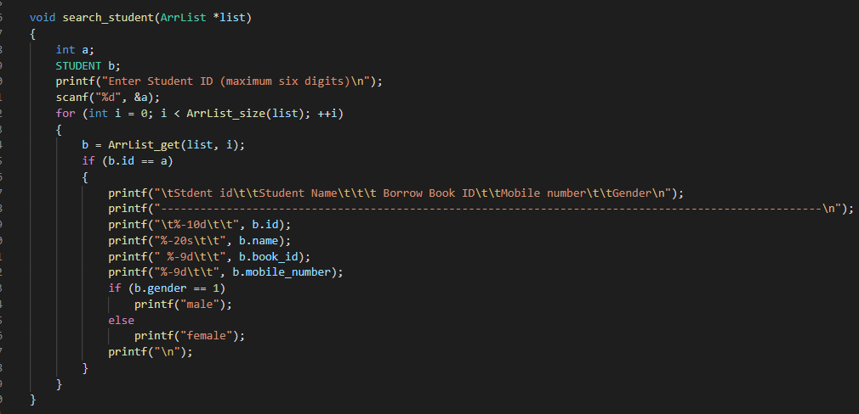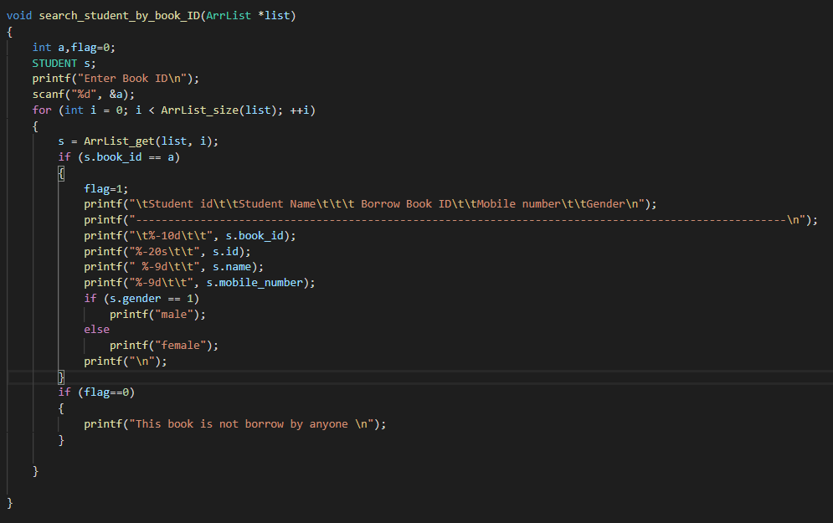

**In here time complexity is O(n)**

**Book section on program: using (BST)**

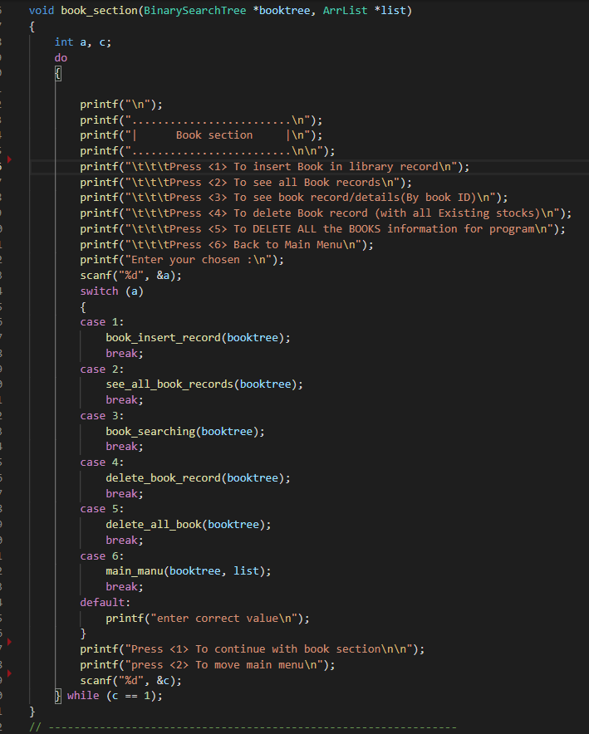

**Book insert:** 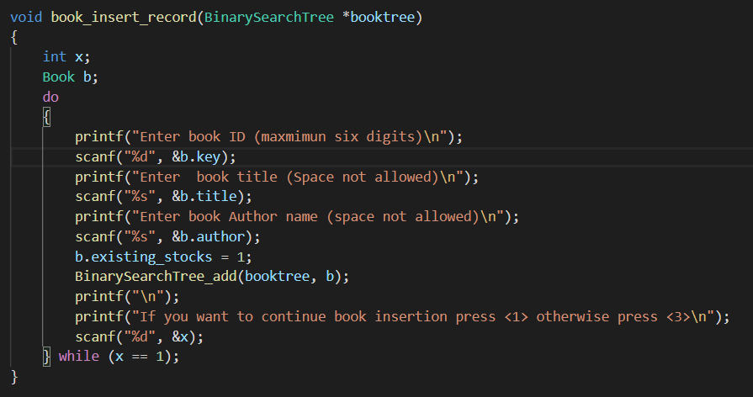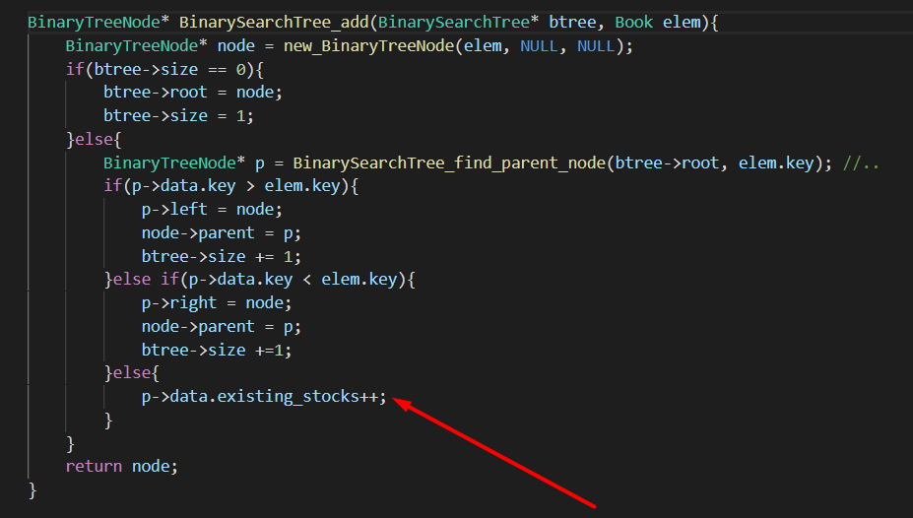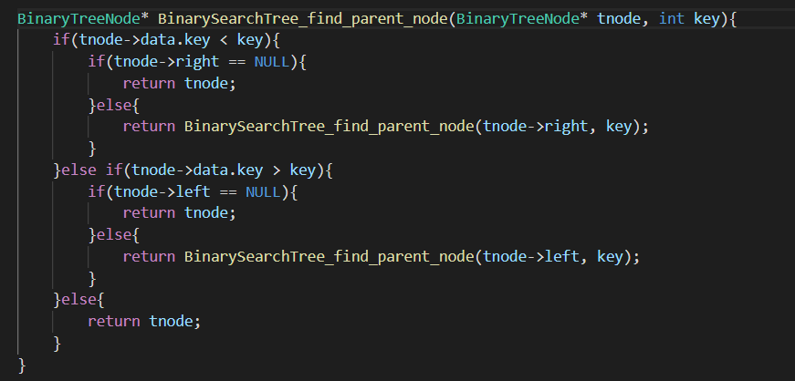

**If ID is same then automatically increase a book in store**

**Book searching:**

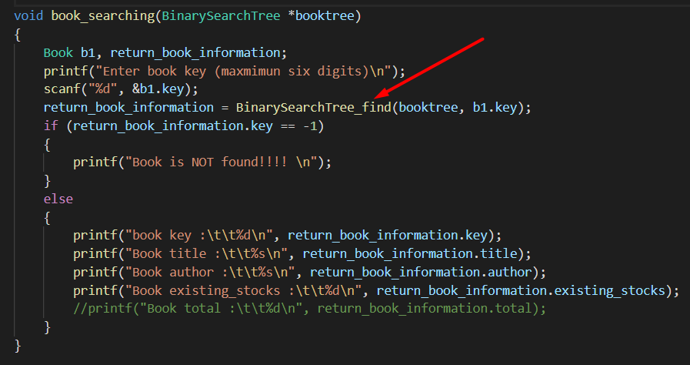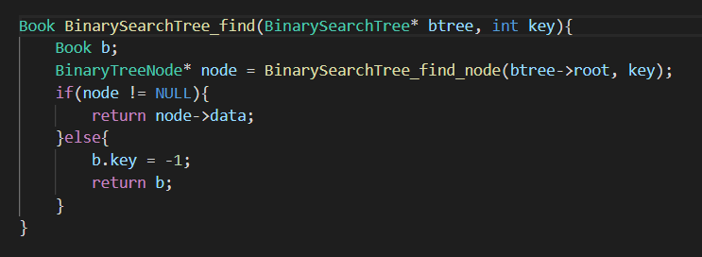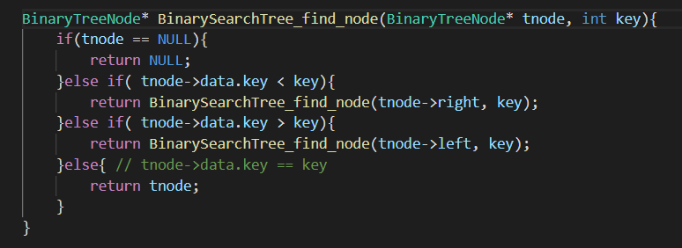

**A Book deletion:**

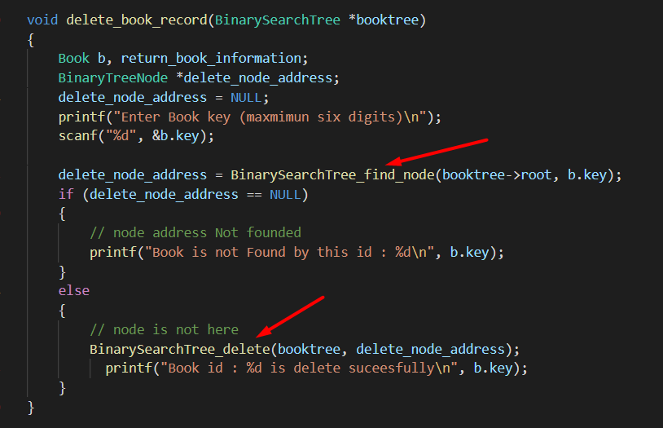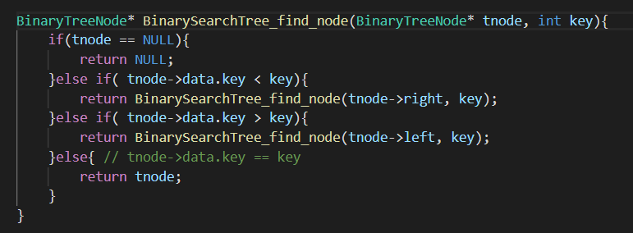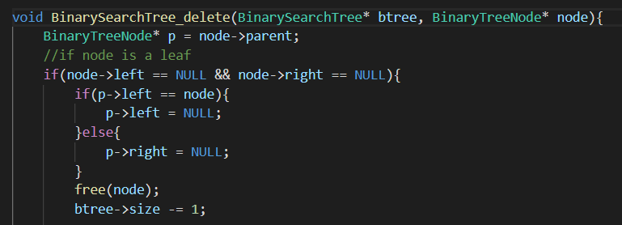

**See all the book record in list:**

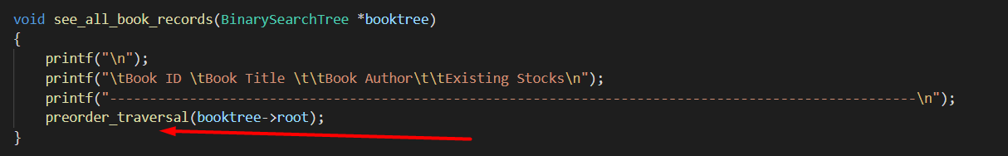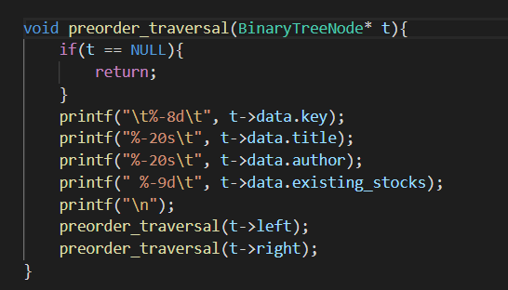

**Delete all book:**

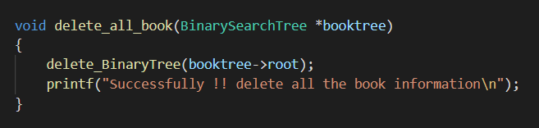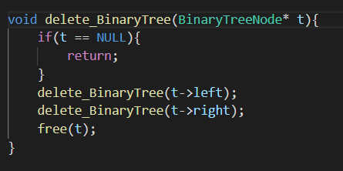

**Book issue for library: (BST and ArrList both use)**

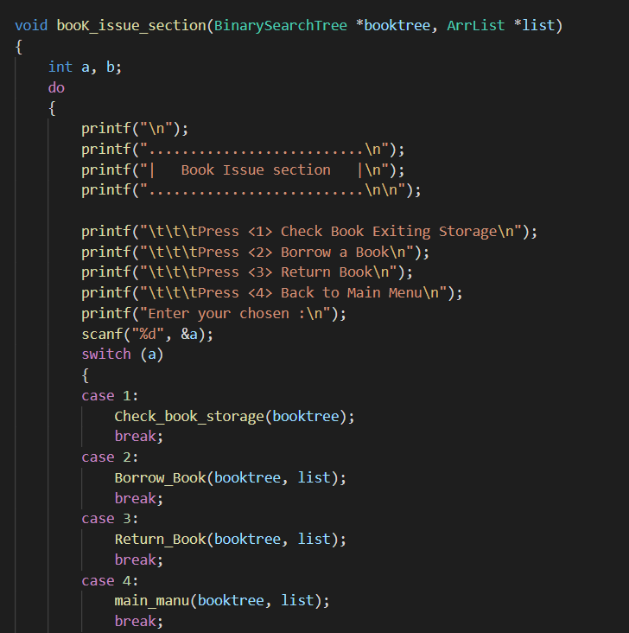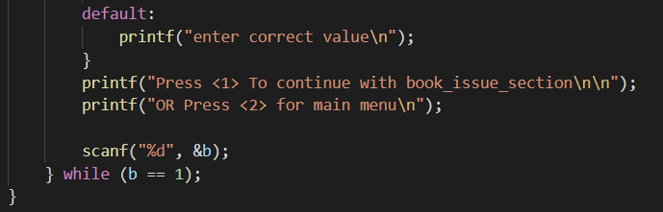

**Borrow book:**

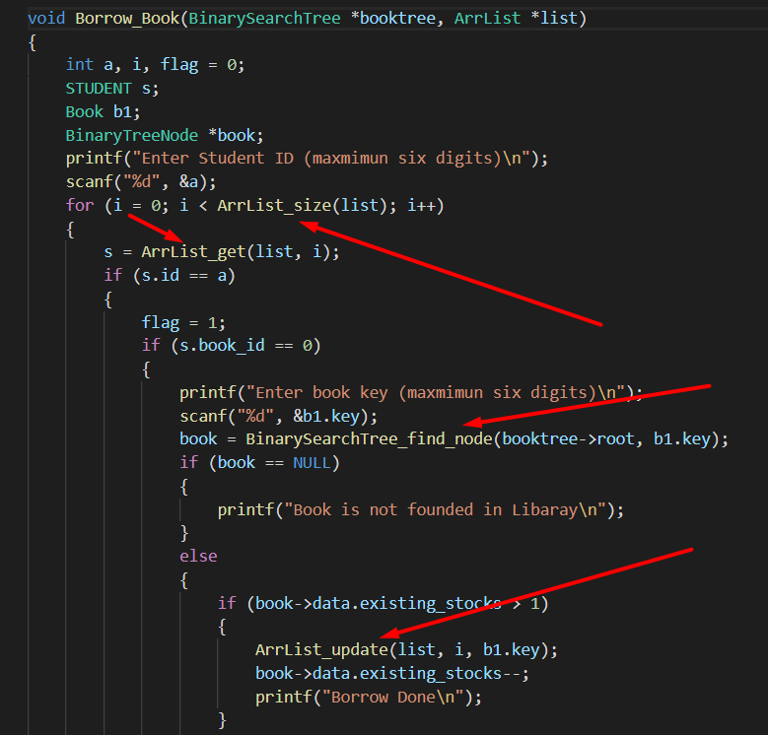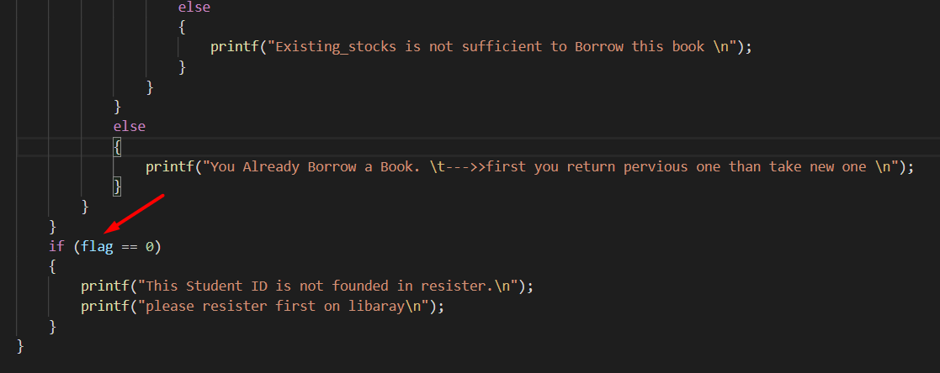

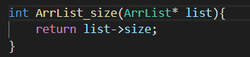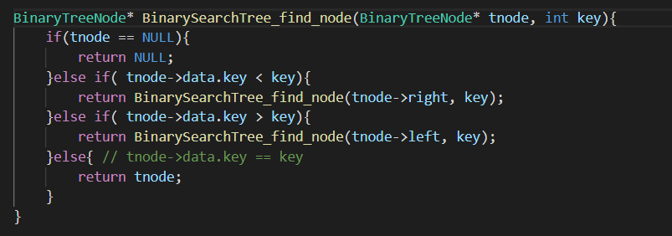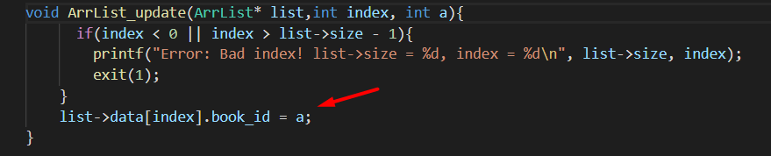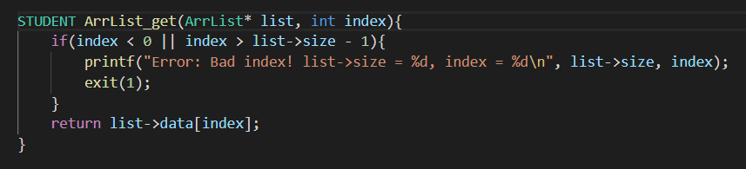

In BST time complexity is O(log(n)).

**Book Return:**

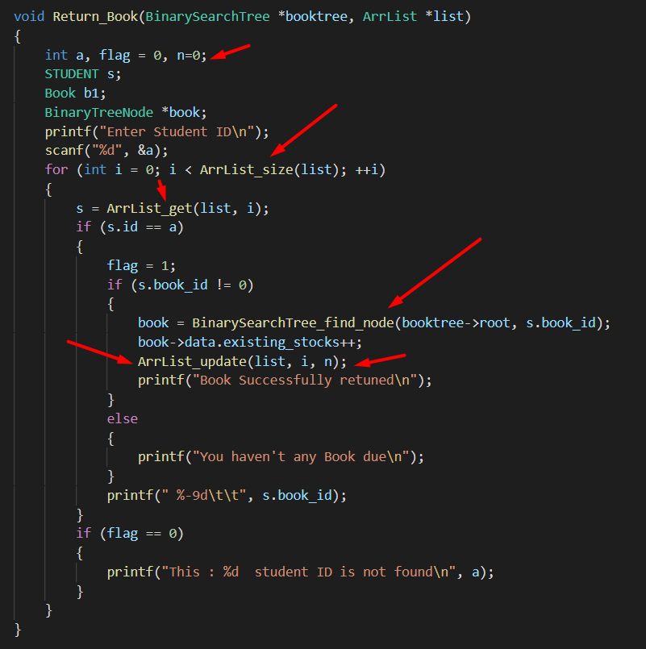



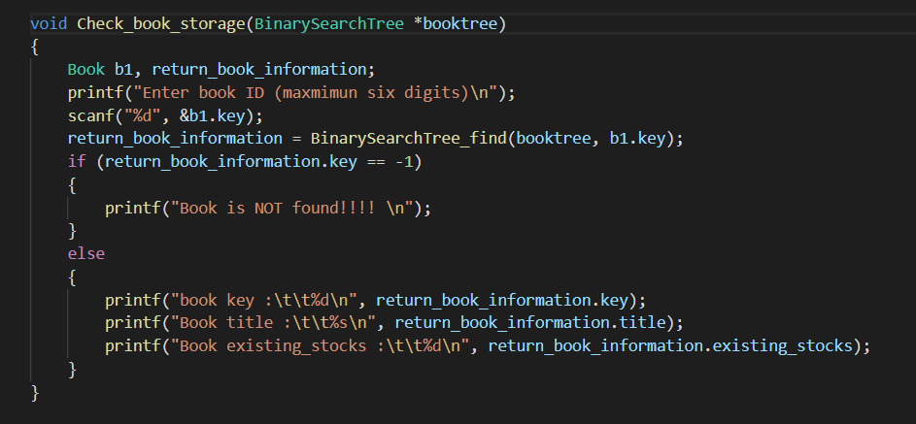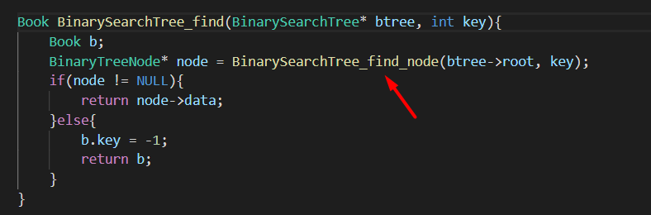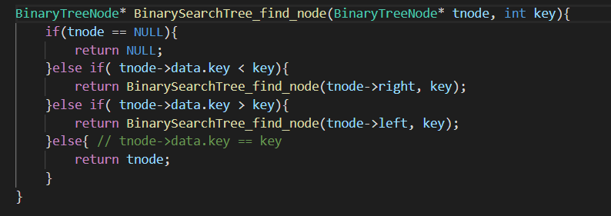

**Testing and analysis:**

* **White box testing**

Unit testing

Increment testing

* **Black book testing**

Functional testing

Mutation testing

Sanity testing

Regression testing

**Conclusion:**

A Library Management System is a software create c-language on run time memory (**RAM**) And this software abide by every condition from administer. Libraries rely on library management systems to manage asset collections as well as relationships with their members. It`s help a librarian who manage book and student connection and record.

This system will provide accuracy as well as efficiency to manage information of all the books and members.