**PROJECT TITLE : COVID-19 CASE ANALYSIS**

**COVID-19 CASE ANALYSIS :**

Building phase of the project :

COVID-19 paved the way towards subsequent nationwide lockdowns, resulting in a rise of loans or credit applications from financial institutions as the prime source of project financing. However, financing institutions are becoming cautious as current, short-term, and long-term economic growth is still uncertain. Therefore, financial institutions opt to reduce the approval rate for financing, including for construction projects, by implementing additional evaluation processes.

Correlation analysis and scatter plot were employed for the quantitative data. We used Spearman’s correlation analysis to determine relationship strength between cases and deaths and socio-economic and health systems. We organized qualitative information from the literature and conducted a thematic analysis to recognize patterns of cases and deaths and explain the findings from the quantitative data.

Datasets pre-processing :

This research focuses on development of a machine learning model for predicting

COVID-19 in patients. We also work to identify the features from the clinical in-

formation of patients that would influence the predictive result of COVID-19. This

study does not focus on outer factors such as weather or any environmental factors

that might influence results.

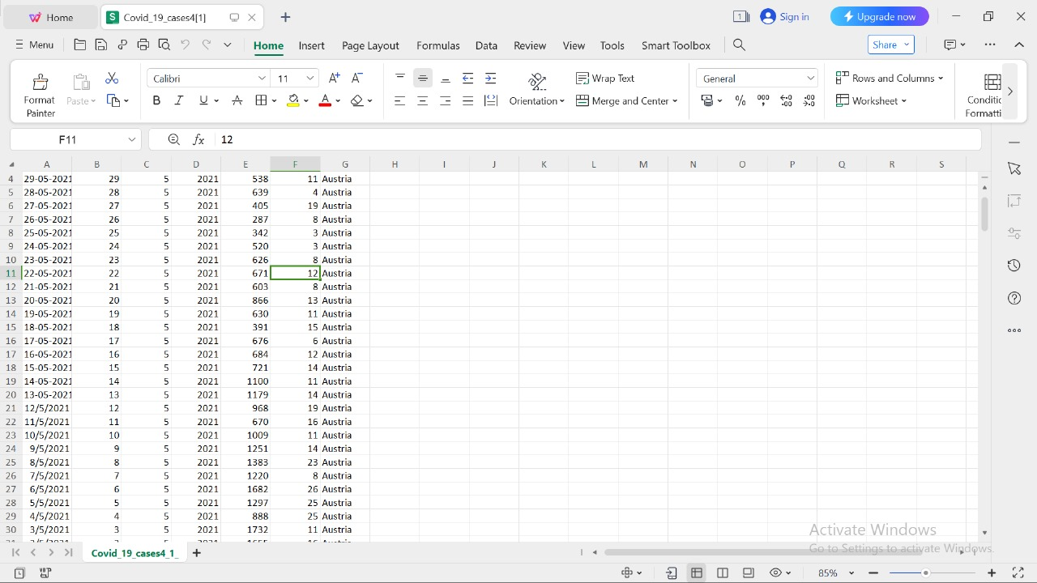Pre-processing and loading of dataset :

**COVID-19 case analysis using IBM cognos visualization :**

* Identifying the most suitable machine learning technique for prediction, toperform on clinical reports of patients.
* Preparing a machine learning model that could make accurate predictions of COVID-19 in patients.
* Identifying the features that affects the prediction of COVID-19 in patients.

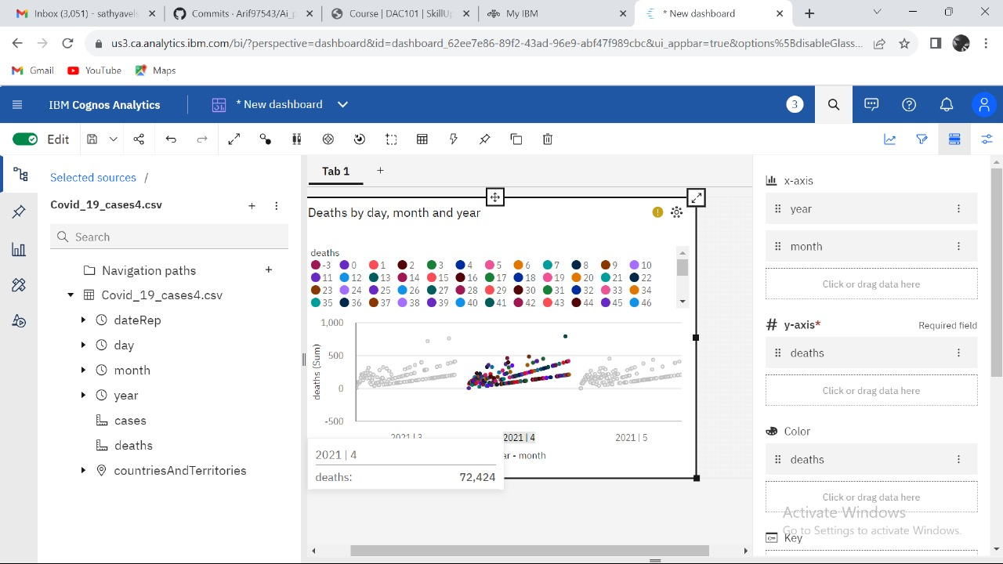**Visualization for deaths :**

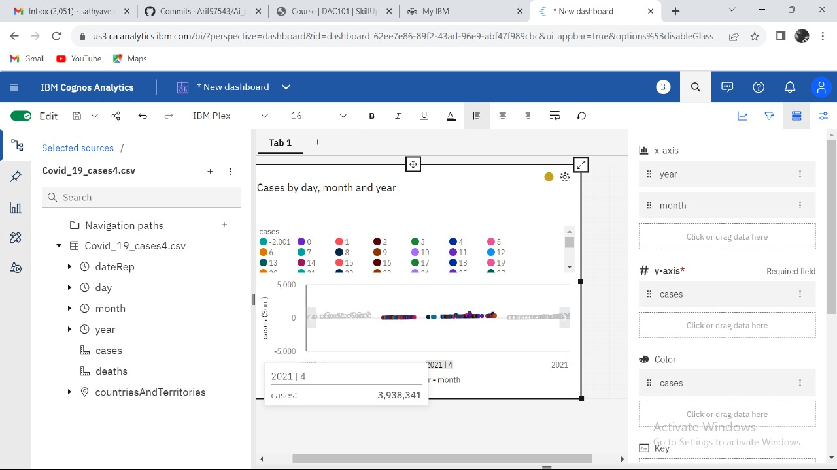**Visualization for cases :**

**Objectives of COVID-19 case analysis :**

We conducted a mixed-methods study to understand the heterogeneity of cases and deaths due to the COVID-19 pandemic. Correlation analysis and scatter plot were employed for the quantitative data. We used Spearman’s correlation analysis to determine relationship strength between cases and deaths and socio-economic and health systems. We organized qualitative information from the literature and conducted a thematic analysis to recognize patterns of cases and deaths and explain the findings from the quantitative data.

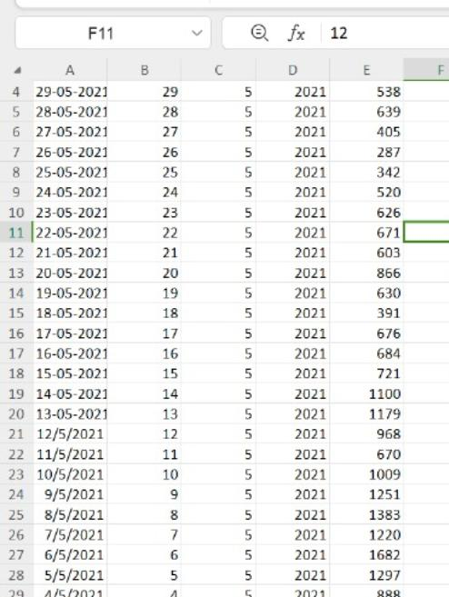COVID-19 case analysis :

Covid-19 death analysis :

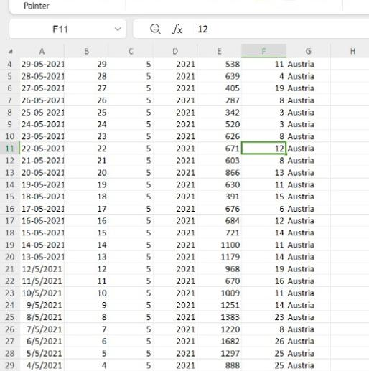

**Dataset :**

https://www.kaggle.com/datasets/chakradharmattapalli/covid-19-cases

**Conclusion :**

The coronavirus disease continues to spread across the world following a trajectory that is difficult to predict. The health, humanitarian and socio-economic policies adopted by countries will determine the speed and strength of the recovery.