**PROJECT TITLE : COVID – 19 CASE ANALYSIS**

**OBJECTIVES :**

We conducted a mixed-methods study to understand the heterogeneity of cases and deaths due to the COVID-19 pandemic. Correlation analysis and scatter plot were employed for the quantitative data. We used Spearman’s correlation analysis to determine relationship strength between cases and deaths and socio-economic and health systems. We organized qualitative information from the literature and conducted a thematic analysis to recognize patterns of cases and deaths and explain the findings from the quantitative data.

* To quantify hospital-based outcomes and deaths, including in relation to sociodemographic characteristics and comorbidities as ascertained from hospital AND general practice data.
* To estimate the strength of association between these outcomes and sociodemographic and health characteristics.

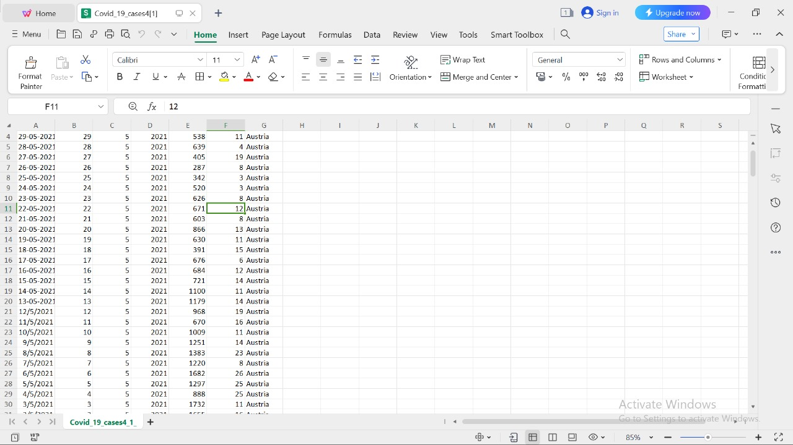

**DESIGNING THINKING PROCESS :**

* Design thinking is a methodology that provides a solutionbased approach to solving problems. It combines what’s desirable from a
* human point of view with what is technologically feasible and
* economically viable. It’s useful in tackling loosely defined, complex
* problems by understanding human needs.
* A global pandemic puts enormous stress on governments and
* healthcare services. Suddenly, there is a scramble to circulate the correct
* information and roll out products and services to deal with the crisis.
* These challenges bring together a blend of product design, experience
* design, and service design problems that are desperate for a solution, and
* design thinking can help.
* We are coming to grips with COVID-19, but it has caught us off guard.
* As most of the world’s population is under some form of lockdown, we
* find ourselves in the middle of an unprecedented social experiment with
* 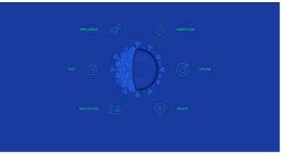many people working remotely and entire families staying home .

**Development phases :**

COVID-19 paved the way towards subsequent nationwide lockdowns, resulting in a rise of loans or credit applications from financial institutions as the prime source of project financing. However, financing institutions are becoming cautious as current, short-term, and long-term economic growth is still uncertain. Therefore, financial institutions opt to reduce the approval rate for financing, including for construction projects, by implementing additional evaluation processes.

Correlation analysis and scatter plot were employed for the quantitative data. We used Spearman’s correlation analysis to determine relationship strength between cases and deaths and socio-economic and health systems. We organized qualitative information from the literature and conducted a thematic analysis to recognize patterns of cases and deaths and explain the findings from the quantitative data.

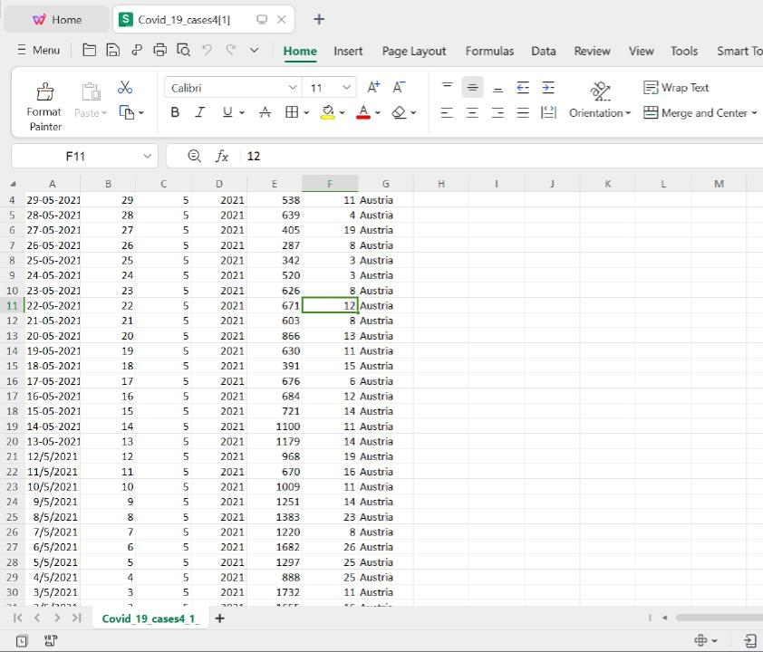

**ANALYSIS OF DATA COLLECTION, DATA VISUALIZATION PROCESS :**

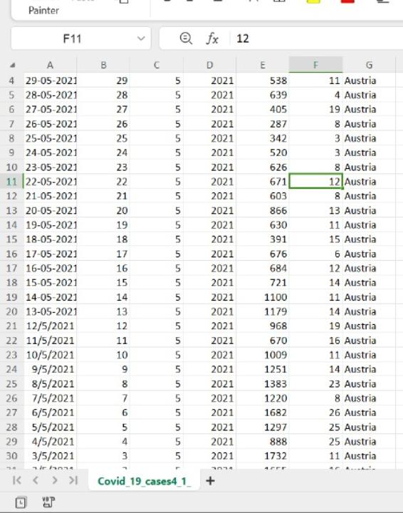**DATA COLLECTION PROCESS :**

**DATA VISUALIZATION USING IBM COGNOS :**

* Identifying the most suitable machine learning technique for prediction, to perform on clinical reports of patients.
* Preparing a machine learning model that could make accurate predictions of COVID-19 in patients.
* Identifying the features that affects the prediction of COVID-19 in patients.

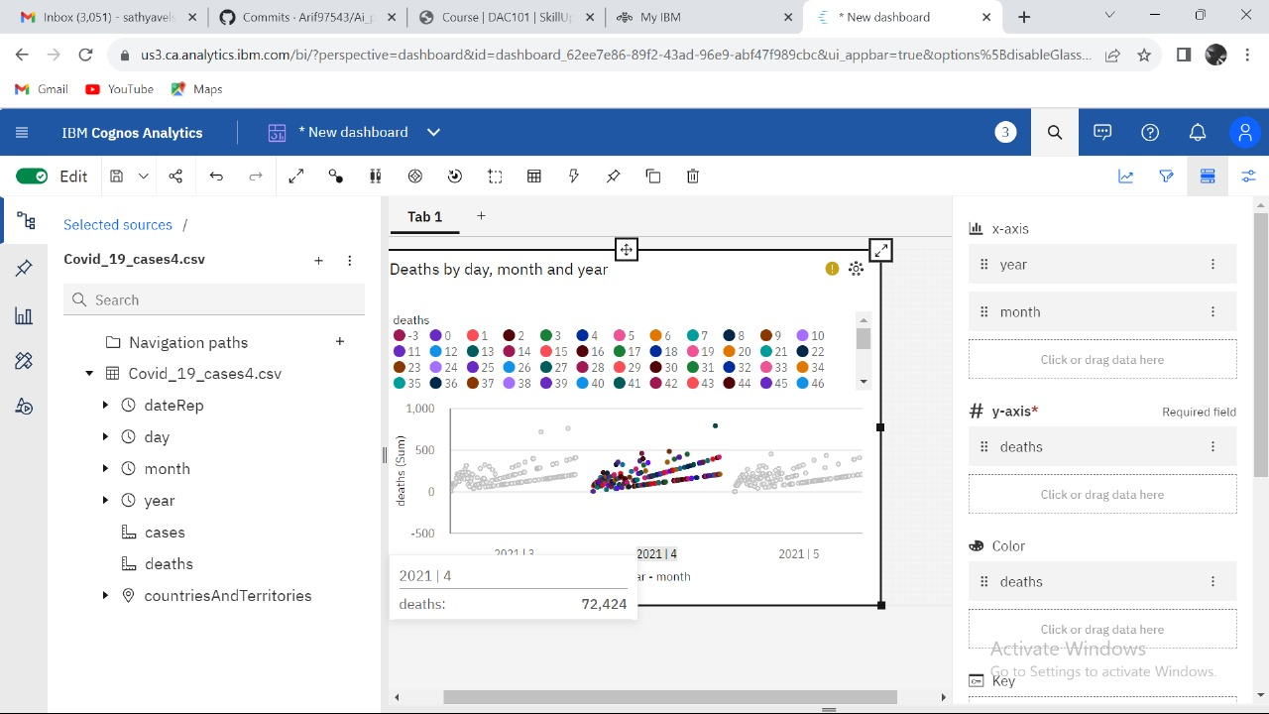**VISUALIZATION OF DEATHS :**

**VISUALIZATION OF CASES :**

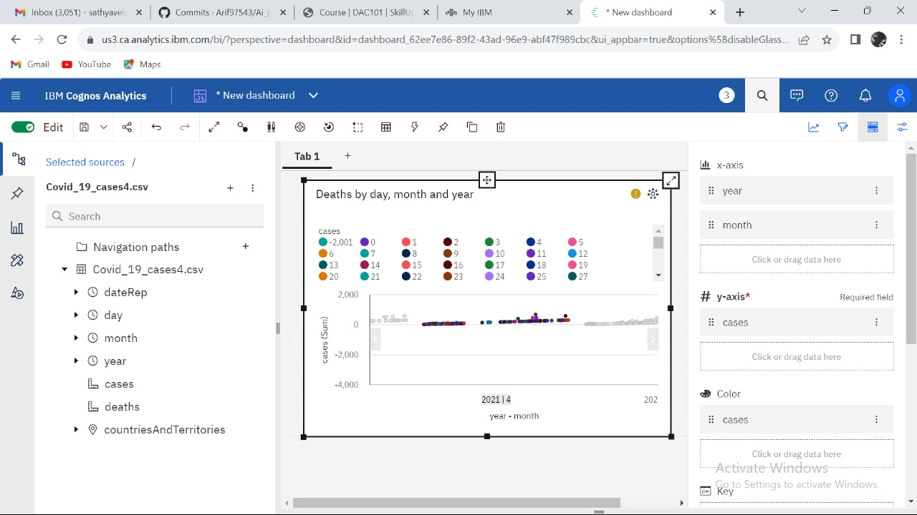

**PYTHON CODE INTEGRATION :**

### Initializing Dataset

Importing Dataset on Covid-19 India case time series

data = pd.read_csv('case_time_series.csv')

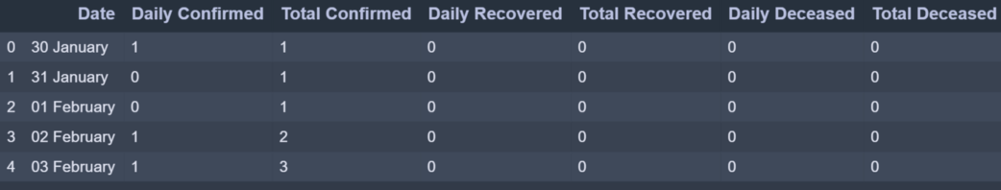

The plot function takes two arguments that are X-axis values and Y-axis values plot. In this case, we will pass the ‘X’ variable which has ‘Dates’ and ‘Y’ variable which has ‘Daily Confirmed’ to plot.

**import** numpy as np

**import** pandas as pd

**import** matplotlib.pyplot as plt

data **=** pd.read_csv('case_time_series.csv')

Y **=** data.iloc[61:,1].values

R **=** data.iloc[61:,3].values

D **=** data.iloc[61:,5].values

X **=** data.iloc[61:,0]

plt.plot(X,Y)

**OUTPUT :**

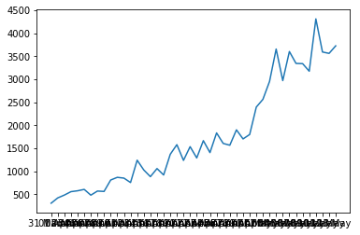

**COMPLETE CODE :**

**import** numpy as np

**import** pandas as pd

**import** matplotlib.pyplot as plt

data **=** pd.read_csv('case_time_series.csv')

 Y **=** data.iloc[61:,1].values

R **=** data.iloc[61:,3].values

D **=** data.iloc[61:,5].values

X **=** data.iloc[61:,0]

plt.figure(figsize**=**(25,8))

ax **=** plt.axes()

ax.grid(linewidth**=**0.4, color**=**'#8f8f8f')

 ax.set_facecolor("black")

ax.set_xlabel('\nDate',size**=**25,color**=**'#4bb4f2')

ax.set_ylabel('Number of Confirmed Cases\n’)

   size**=**25,color**=**'#4bb4f2')

  ax.plot(X,Y,

        color**=**'#1F77B4',

        marker**=**'o',

        linewidth**=**4,

        markersize**=**15,

        markeredgecolor**=**'#035E9B')

**OUTPUT** :

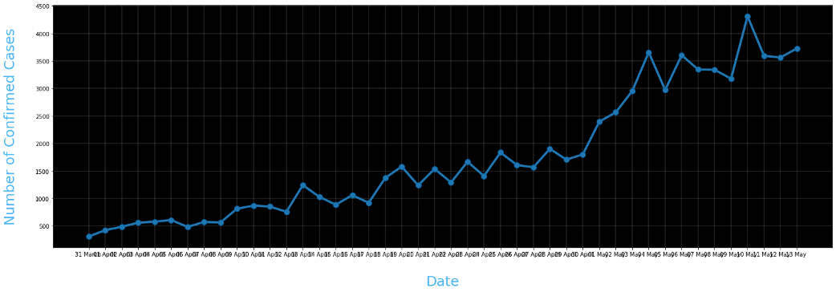

**INSIGHTS FROM THE ANALYSIS:**

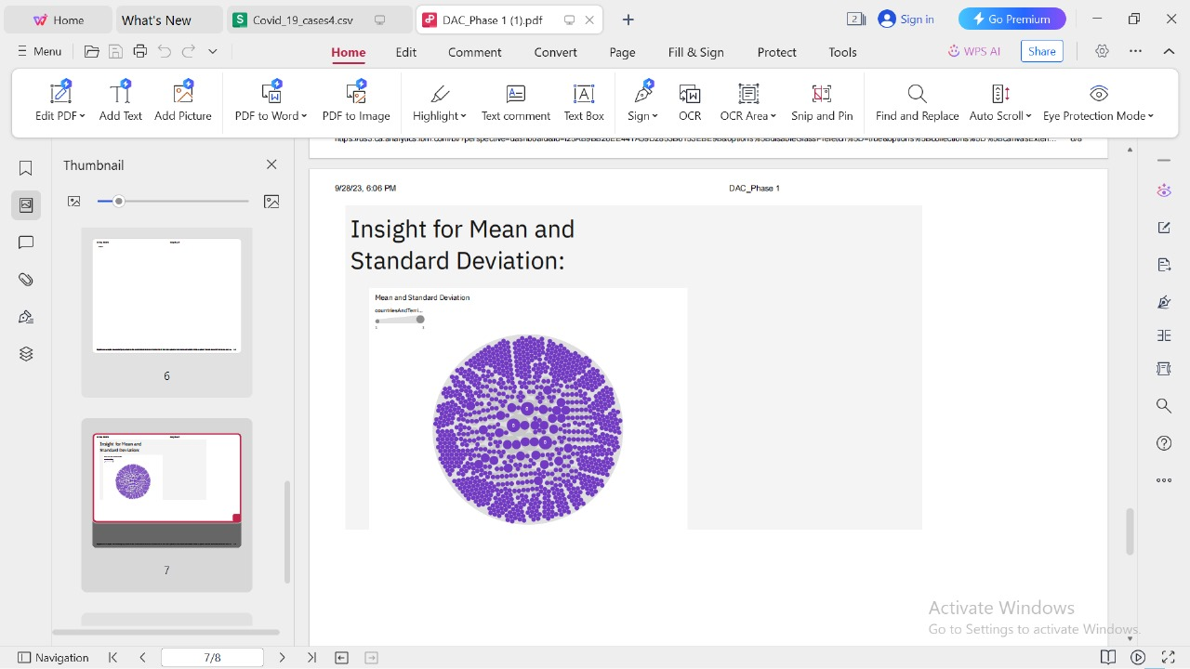

**DATASET LINK :**

[**https://www.kaggle.com/datasets/chakradharmattapalli/covid-19-cases**](https://www.kaggle.com/datasets/chakradharmattapalli/covid-19-cases)

**CONCLUSION :**

The coronavirus disease continues to spread across the world following a trajectory that is difficult to predict. The health, humanitarian and socio-economic policies adopted by countries will determine the speed and strength of the recovery.