**PHASE-2**

**Project Title:** Transfroming healthcare with AI-Powered disease  prediction based on patient data.

**Github link:**

<https://github.com/S-Mahalakshmi031/Transforming-healthcare-with-AI-powered-disease-prediction-based-on-patient-data.git>

**1.Problem Statement**

* Healthcare systems often struggle to predict diseases early due to lack of integrated data analysis. Manual diagnosis can be time-consuming and error-prone. By leveraging AI to predict diseases using patient data, healthcare providers can identify conditions early, improve treatment plans, and enhance patient outcomes.
* This project focuses on building a machine learning model to predict the presence or risk level of a specific disease using patient demographic, lifestyle, and clinical attributes.
* Significance: Enables preventive care, reduces healthcare costs, and improves quality of life.

**2.Project Objectives**

* Develop a predictive model that identifies potential diseases based on patient data.
* Improve diagnostic efficiency using machine learning algorithms.
* Deliver actionable insights to assist healthcare professionals in decision-making.
* Enhance early detection and prevention strategies.
* Build an accurate AI model for disease prediction.
* Identify the key features influencing disease risk.
* Interpret model outputs to guide clinical decisions.
* Deploy a user-friendly web interface for real-time predictions.
* Ensure ethical AI practices and patient data privacy

**3.Flowchart of the Project Workflow**

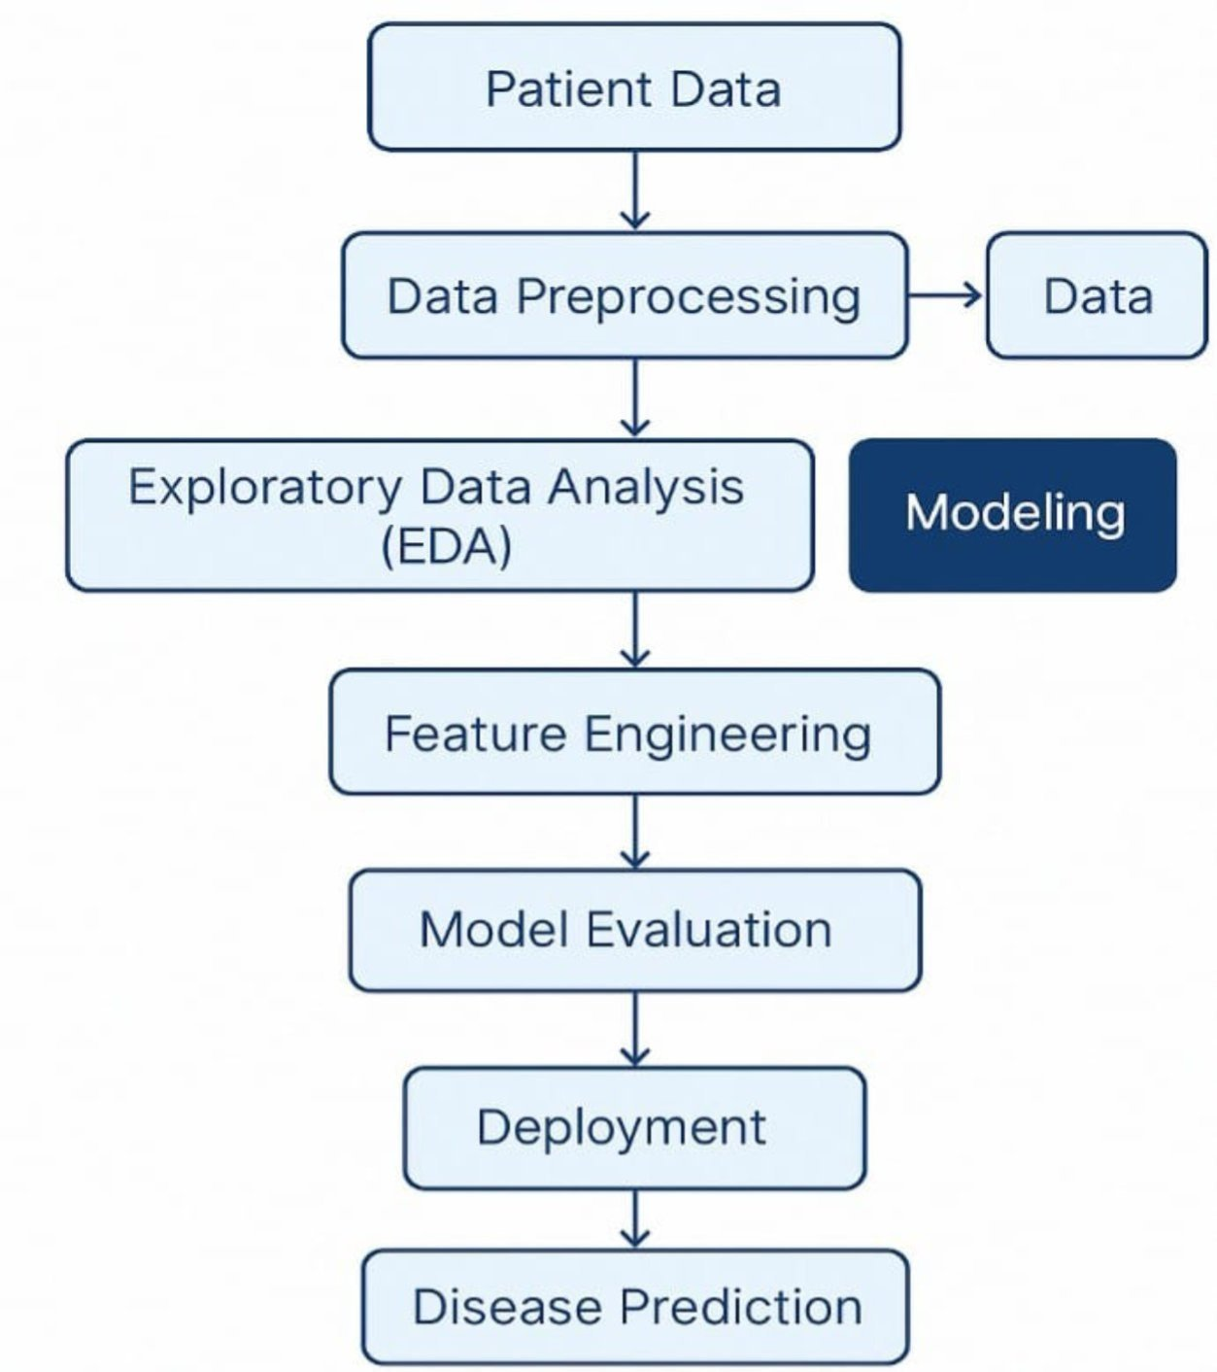

**4.Data Description**

* **Dataset Name:**

Could be sourced from open healthcare datasets.

* **Source:**

Public repositories like UCI, Kaggle, or hospital collaborations.

* **Data Type:**

Structured tabular (e.g., CSV).

* **Records and Features:**

1,00–100,0 records with 10–50 features.

* **Target Variable:**

Presence/absence or probability of diseases.(e.g.,stroke)

* **Features:**

id,Age, gender, hypertension,heart disease,work type,bmi,even married,smoking status ,stroke,etc..

* **Dataset link:**

<https://www.kaggle.com/code/manarmohamed11/stroke-prediction-eda?scriptVersionId=236663015&cellId=2>

**5.Data Preprocessing**

* Handle missing/null values.
* Convert categorical variables via one-hot encoding or label encoding.
* Scale numerical features using StandardScaler/MinMaxScaler.
* Remove or cap outliers (using z-scores or IQR).
* Address imbalanced data using SMOTE, oversampling, or class weights.

**6.Exploratory Data Analysis (EDA)**

* **Univariate:**

Distribution of disease status, age, BMI, etc.

* **Bivariate:**

Compare features (e.g., glucose vs. disease outcome).

* **Multivariate:**

Correlation heatmaps, risk factor clusters.

* **Key Insights:**
* High cholesterol, older age, and sedentary lifestyle may correlate with higher disease risk.
* Gender-specific trends may exist in disease occurrence.

**7.Feature Engineering**

* Create composite indicators (e.g., BMI from weight & height).
* Derive binary flags (e.g., smoker = yes/no).
* Remove redundant or highly correlated features.
* Encode interaction effects (e.g., age × cholesterol).

**8.Model Building**

* **Algorithms:**
* **Logistic Regression:** baseline model.
* **Random Forest / XGBoost**: for non-linear patterns

Neural Networks (optional for large data).

* **Train-Test Split**: 80/20 split using train_test_split.
* **Cross-Validation:** 5-fold or 10-fold to ensure robustness.
* **Evaluation Metrics:**
* Accuracy
* Precision, Recall, F1-score
* AUC-ROC Curve
* Confusion Matrix

**9.Visualization of Results & Model Insights**

* **Feature Importance:**
* Visualized via bar charts (Random Forest, SHAP values)
* Identify top 5–10 contributing factors
* **Model Performance:**
* Compare evaluation metrics across models
* ROC curves and confusion matrices for final model
* **Residual Analysis:**
* Check for prediction bias (e.g., gender, ethnicity)

**10.Deployment & Interface**

* **Tool:**

Gradio or Streamlit

* **Features:**
* Input patient data via sliders/forms
* Get real-time disease prediction and risk score
* Display risk explanation (via SHAP or LIME)

**11.Tools and Technologies Used**

* **Language:**

Python

* **Environment:**

Google Colab, Jupyter Notebook

* **Libraries:**
* **pandas, numpy** – Data handling
* **matplotlib, seaborn, plotly** – Visualization
* **scikit-learn, xgboost, shap** – Modeling
* **gradio, streamlit** – UI deployment

**12.Team Members and Contributions**

* Clearly mention who worked on:
* **V.SANGEETHA:**
* Data cleaning
* **C.NITHYAPRIYA:**
* EDA (Exploratory Data Analysis**)**
* **S.K.LAKSHMIPRIYA:**
* Feature engineering
* **S.MAHALAKSHMI**
* Model development
* Documentation and reporting