**Introduction**

Big Mountain Resort, a ski resort located in Montana, offers spectacular views of Glacier National Park and Flathead National Forest, with access to 105 trails. Every year about 350,000 people ski or snowboard at Big Mountain.This mountain can accommodate skiers and riders of all levels and abilities.

These ski runs are serviced by 11 lifts, 2 T-bars, and 1 magic carpet for novice skiers. The longest run is named Hellfire and is 3.3 miles in length. The base elevation is 4,464 ft, and the summit is 6,817 ft with a vertical drop of 2,353 ft.

Big Mountain Resort has recently installed an additional chair lift to help increase the distribution of visitors across the mountain. This additional chair increases their operating costs by $1,540,000 this season. The goal is to offer guidance on how to select a better value for Big Mountain Resort's ticket price, which is currently $81.

## Data Acquisition and Cleaning

The main data that was used is a CSV file that was provided by the database manager. The file contained information about 330 different resorts across the United States. The second data file, taken from Wikipedia, contains information about each state, particularly, state size and population.

The data started out with 330 rows and 27 columns. The cleaned data contained 277 rows and 25 columns. Rows containing no information for ticket pricing were removed. The two columns that were removed were fastEight and AdultWeekday. The fastEight column was removed since only one row had a value. The column for adult weekday pricing was also removed since other Montana resorts do not have separate pricing for weekend vs. weekday.

For all information about how the data was cleaned, please reference [this Jupyter Notebook](http://localhost:8888/notebooks/Documents/project_folders/Guided_Capstone/Guided_Capstone/Notebooks/02_data_wrangling.ipynb).

The plan became to 1) use state size and population data to see whether there is a relationship between these values and ticket prices, and 2) look into which amenities have the greatest impact on ticket price.

## Data Exploration

For all data exploration, please reference these two notebooks: [one](http://localhost:8888/notebooks/Documents/project_folders/Guided_Capstone/Guided_Capstone/Notebooks/03_exploratory_data_analysis.ipynb) and [two](http://localhost:8888/notebooks/Documents/project_folders/Guided_Capstone/Guided_Capstone/Notebooks/04_preprocessing_and_training.ipynb).

The first notebook takes a close look at the relationship between the state size, state population, number of resorts and ticket pricing. It also shows principle components analysis where it became clear that there is not a correlation between the state's population to the ticket prices. Moving forward, the state labels were able to be dropped.

Next, a heatmap was created to view resort features and how they correlate to each other. That heatmap can be viewed below.

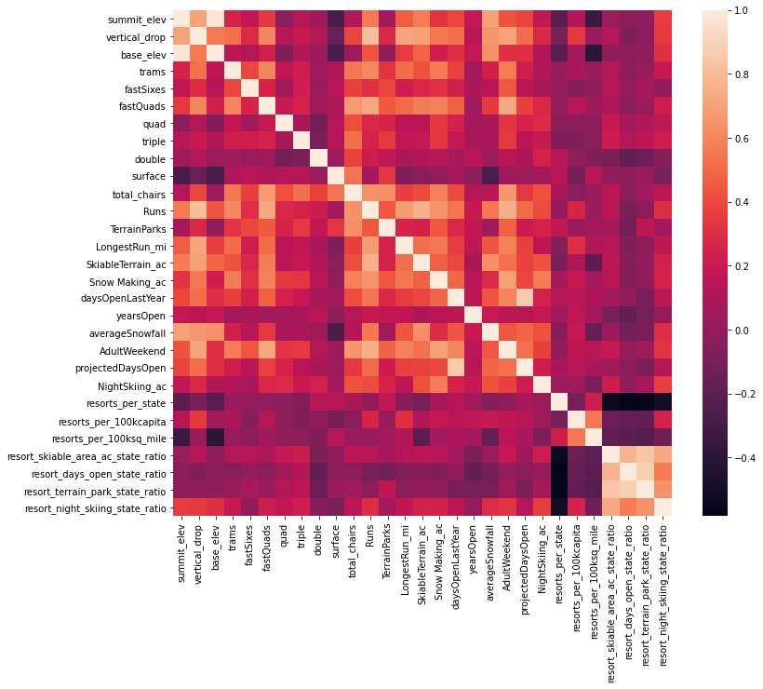

The heatmap shows a strong positive correlation between adult weekend ticket price and vertical_drop, fastQuads, runs, and total_chairs. These are some of the relationships that will be explored further in modeling.

The second notebook is where missing values in the data were imputed using the median, and a random forest model was set up using cross-validation to assess the performance. As the below graph shows, the dominate four features that effect ticket pricing are: fastQuads, Runs, Snow Making_ac, vertical_drop

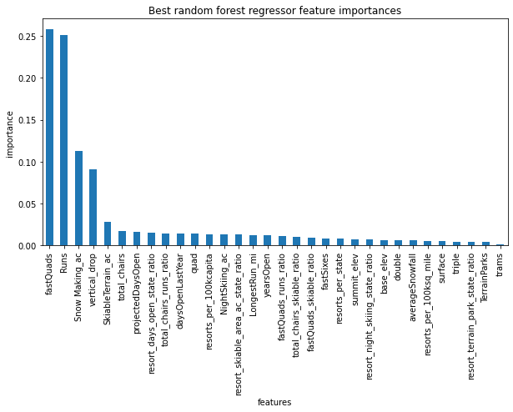

These features would then be looked at closer during modeling.

## Modeling

The model was first refit on all available data, not including Big Mountain Resort. Big Mountain Resort data was not used for the model in order to not bias the data toward an uninformed ticket price.

The first look was at where Big Mountain sits overall amongst all resorts for price.

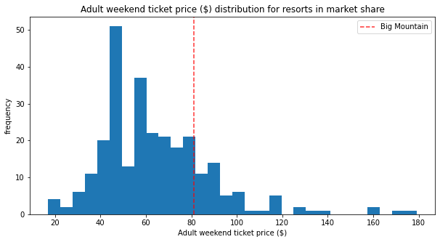

Next, the features most effecting ticket price were looked at to see where Big Mountain Resort is in comparison to all other resorts.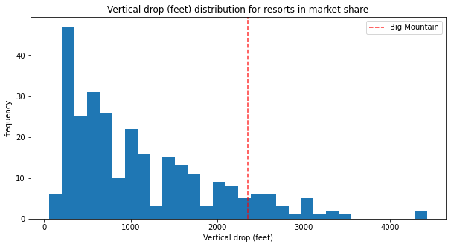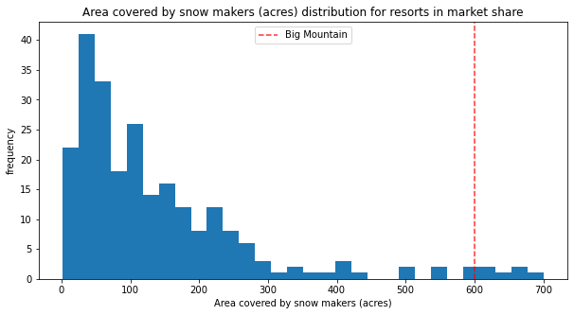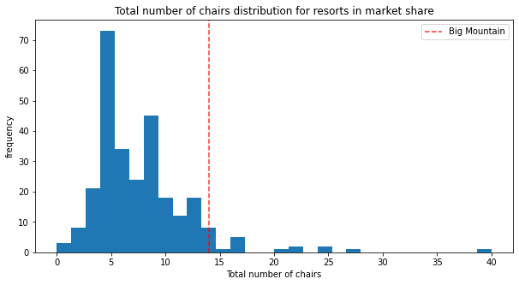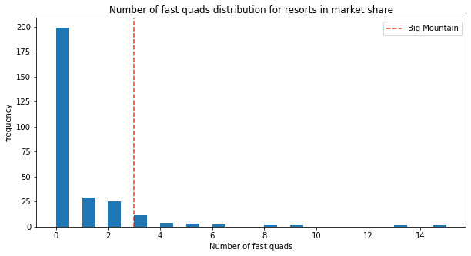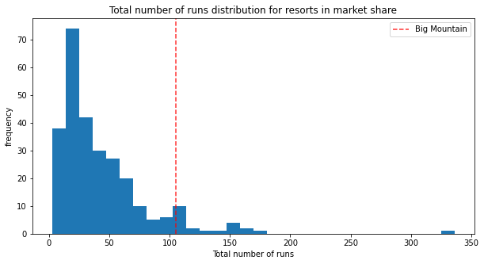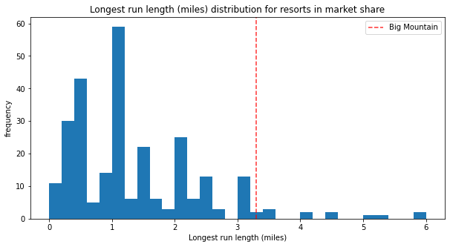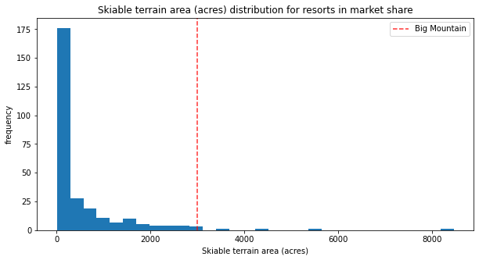

## Model Recommendations

Based on the model, Big Mountain Resort ticket prices should increase to between $85.48 and $95.87. Features that support an increase in ticket price for Big Mountain resort are:

* high up the league table of snow making area
* amongst the highest number of total chairs
* one of the longest runs
* high amount of skiable terrain

This result is optimistic. However, the validity of the model lies in the assumption that other resorts accurately set their prices according to what the market supports. If Big Mountain Resort is mispricing, are others?

Other options that Big Mountain Resort wanted to investigate:

1. Permanently closing down up to 10 of the least used runs. This doesn't impact any other resort statistics.  
   The resulting change in ticket price for each run closed can be seen below:

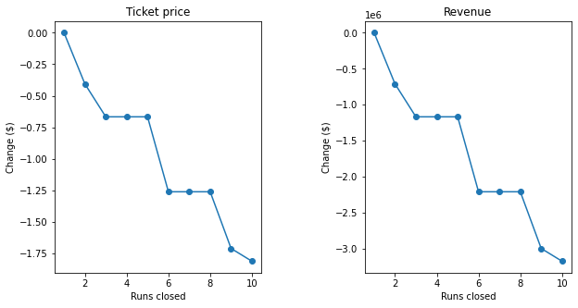

1. Increase the vertical drop by adding a run to a point 150 feet lower down but requiring the installation of an additional chair lift to bring skiers back up, without additional snow making coverage

This scenario increases support for ticket price by $1.99. Over the season, this could be expected to amount to $3,474,638.

1. Same as number 2, but adding 2 acres of snow making cover

This scenario provided the same result ticket increase as scenario 2.

1. Increase the longest run by 0.2 mile to boast 3.5 miles length, requiring an additional snow making coverage of 4 acres

This scenario made no difference to ticket pricing.

## Other Data and Future Work

Some additional data that would be useful is how many visitors each resort has per year. With this data, we could look at whether the popularity of a resort impacts ticket pricing.

It would also be useful to have data regarding operating costs. We can see that closing runs impacts ticket pricing but we cannot show the total financial impact, since run closer should reduce operating costs.

## Conclusions

The operating cost of the new lift is $1,540,000. An average season sells approximately 1,750,000 tickets *(350,000 visitors averaging 5 day tickets)*. By raising the price of ticket pricing to align with the model *($85.48)*, the resort should see a profit of approximately $6,300,000 *(1750000∗4.48−1540000)*.