Experiment: 2 Date: 17-06-2026

Use control structures in Shell Programming

AIM:
To evaluate the use of shell programming control structures.
DESCRIPTION:
- if . . . . fi structure :
The if . . fi structure allows shell to make decisions and execute statements conditionally.
SYNTAX: if [expression] then statements
fi

- if . . . . else statement
If else statements can be used to select an option from a given set of options. SYNTAX:
if [expression]
then statement(s) else statement
fi

- while loop:
The while loop enables us to execute a set of commands repeatedly until some condition occurs

SYNTAX:
while [condition] do
statement(s) done

- for loop
The for loop operates on list of items it repeats a set of commands for every item in a list.
SYNTAX:
for((i=0; i<n; i++))
do statement(s)
done
  - To check whether even or odd Input:
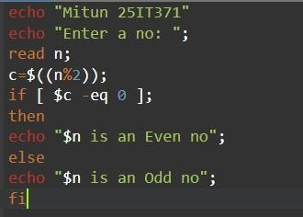

Output:
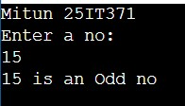

  - To check whether the person is eligible to vote Input:
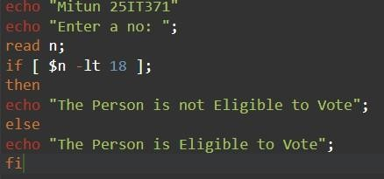
Output:
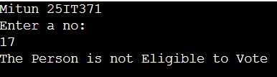

  - To find the sum of n numbers Input:
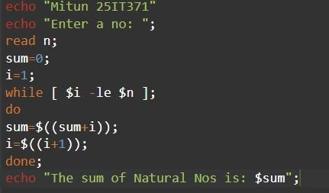
Output:
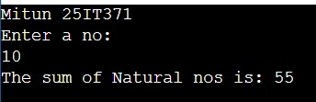

  - Find the Fibonacci series Input:
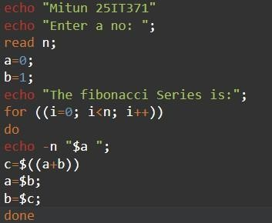
Output:
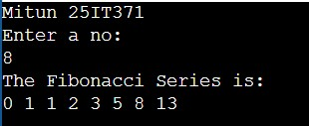

- Armstrong number
Input:

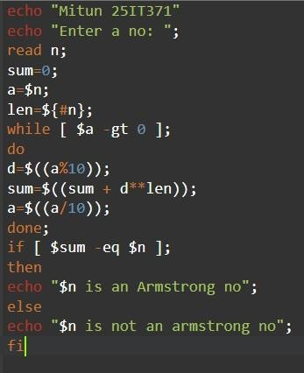
Output:

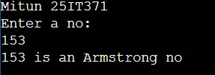

- Greatest of 3 nos Input:
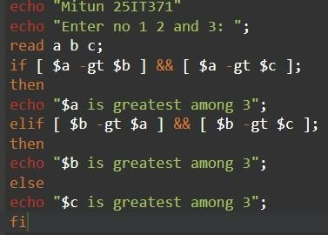
Output:

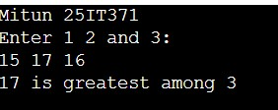

- Factorial Input:
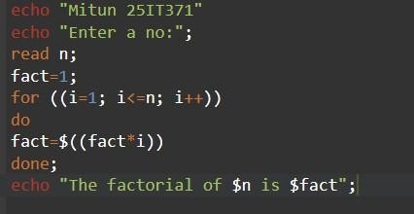

Output:

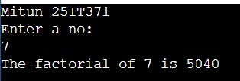

RESULT:
Thus the use of control structures by shell programming were constructed and demonstrated successfully.

