
DEPARTMENT OF ARTIFICIAL INTELLIGENCE AND DATA SCIENCE
SUBJECT CODE / TITLE : 25ADC01 / ARTIFICIAL INTELLIGENCE AND ITS
APPLICATIONS
LAB MANUAL
LIST OF EXPERIMENTS
- Implementation of BFS and DFS Algorithms
- Solve Water Jug / 8-Queens Problem using Python
- Implementation of Minimax / Alpha-Beta Pruning
- Develop an Expert System using Rule-Based Approach
- Classification using Decision Tree / KNN
- Clustering using K-Means Algorithm
- Regression Model Implementation and Evaluation
- Basic Neural Network using Python
- Sentiment Analysis / Chatbot using NLP
10.Mini Project on AI Application

EXPERIMENT 1
IMPLEMENTATION OF BFS AND DFS ALGORITHMS
AIM
To implement Breadth First Search (BFS) and Depth First Search (DFS) algorithms using Python.
OBJECTIVE
- To understand uninformed search techniques.
- To traverse graph structures using BFS and DFS.
SOFTWARE REQUIREMENTS
- Python 3.x
- Jupyter Notebook / Google Co-lab
THEORY
Breadth First Search explores nodes level by level using a queue. Depth First Search explores nodes deeply before backtracking using a stack or recursion.
ALGORITHM
BFS
- Start from root node.
- Visit neighbouring nodes.
- Add neighbours to queue.
- Continue until all nodes are visited.
DFS
- Start from root node.
- Visit node deeply.
- Backtrack when no unvisited node exists.

PROGRAM
graph = {
'A': ['B', 'C'],
'B': ['D', 'E'],
'C': ['F'],
'D': [],
'E': [],
'F': [] }
visited = [] queue = []
def bfs(visited, graph, node): visited.append(node) queue.append(node)
while queue:
s = queue.pop(0) print(s, end=" ")
for neighbour in graph[s]: if neighbour not in visited: visited.append(neighbour) queue.append(neighbour)
print("BFS Traversal:") bfs(visited, graph, 'A')

INPUT
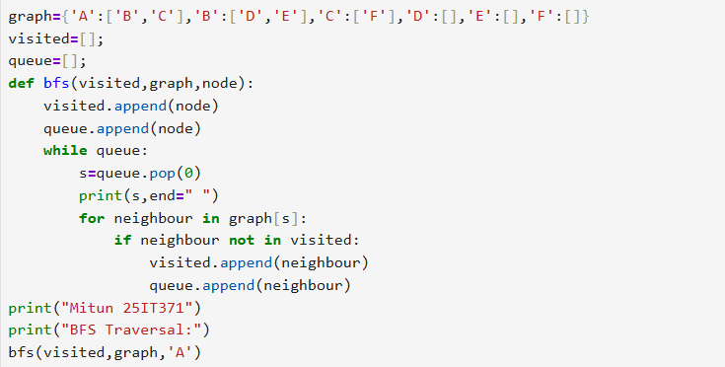

OUTPUT
BFS Traversal: A B C D E F
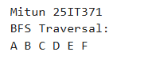

RESULT
Thus BFS and DFS algorithms were implemented successfully.

EXPERIMENT 2
SOLVE WATER JUG / 8-QUEENS PROBLEM USING PYTHON
AIM
To solve Water Jug and 8-Queens problems using AI problem-solving techniques.
THEORY
The Water Jug problem is solved using state-space representation. The 8-Queens problem is solved using backtracking.
WATER JUG PROGRAM
from collections import deque
visited = set() queue = deque([(0,0)])
while queue:
x, y = queue.popleft() if (x,y) in visited: continue visited.add((x,y)) print(x,y)
INPUT:
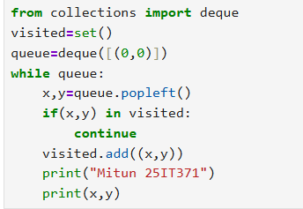

OUTPUT:
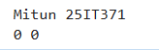

8-QUEENS PROGRAM

N = 8
board = [[0]*N for _ in range(N)]
def attack(i, j):
for k in range(0, N):
if board[i][k] == 1 or board[k][j] == 1:
return True
return False
print("Mitun 25IT371")
print(attack(0, 0))
print(attack(1, 1))
print(attack(2, 2))

INPUT: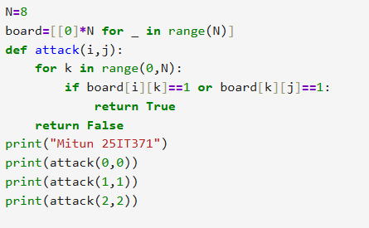
OUTPUT:
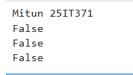
RESULT
Thus Water Jug and 8-Queens problems were solved successfully.

EXPERIMENT 3
IMPLEMENTATION OF MINIMAX / ALPHA-BETA PRUNING
AIM
To implement Minimax and Alpha-Beta pruning algorithms.
THEORY
Minimax is used in game playing AI. Alpha-Beta pruning reduces unnecessary node evaluation.
PROGRAM:
MAX, MIN = 1000, -1000
def minimax(depth, nodeIndex, maximizingPlayer, values, alpha, beta):
if depth == 3:
return values[nodeIndex]

if maximizingPlayer:
best = MIN

for i in range(2):
val = minimax(depth + 1, nodeIndex * 2 + i,
False, values, alpha, beta)

best = max(best, val)
alpha = max(alpha, best)

if beta <= alpha:
break

return best

else:
best = MAX

for i in range(2):
val = minimax(depth + 1, nodeIndex * 2 + i,
True, values, alpha, beta)

best = min(best, val)
beta = min(beta, best)

if beta <= alpha:
break

return best

values = [3, 5, 6, 9, 1, 2, 0, -1]

result = minimax(0, 0, True, values, MIN, MAX)
print("Mitun 25IT371")
print("The optimal value is", result)

INPUT:
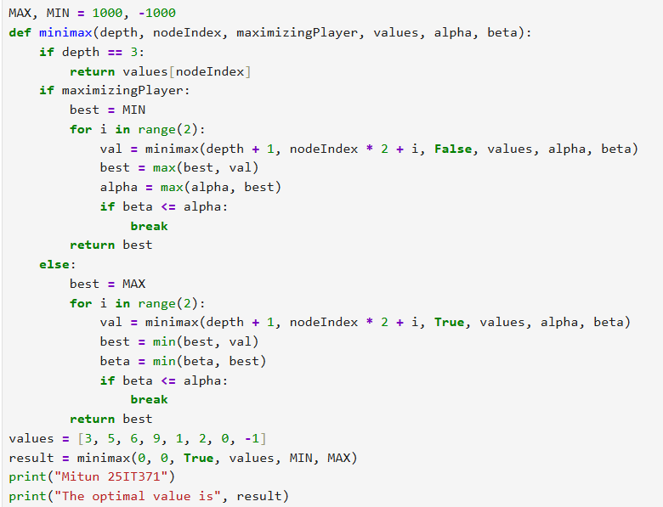

OUTPUT:
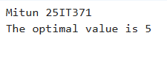

RESULT
Thus Minimax and Alpha-Beta pruning were implemented successfully.
EXPERIMENT 4
DEVELOP AN EXPERT SYSTEM USING RULE-BASED APPROACH
AIM
To develop a simple rule-based expert system.
THEORY
Expert systems mimic human experts using IF-THEN rules.

PROGRAM
symptom = input("Enter symptom: ")
print("Mitun 25IT371")

if symptom == "fever":
print("Possible Disease: Flu")
elif symptom == "cough":
print("Possible Disease: Cold")
else:
print("Consult Doctor")

INPUT:
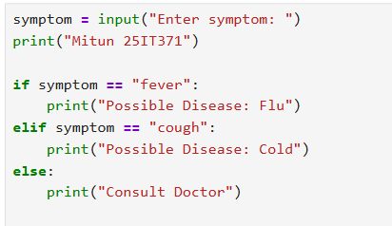

OUTPUT: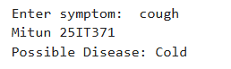

RESULT
Thus a rule-based expert system was developed successfully.

EXPERIMENT 5
CLASSIFICATION USING DECISION TREE / KNN
AIM
To implement classification algorithms using Decision Tree and KNN.

SOFTWARE REQUIREMENTS
- Python
- Scikit-learn

PROGRAM

from sklearn.neighbors import KNeighborsClassifier
from sklearn.datasets import load_iris
iris = load_iris()
X = iris.data
Y = iris.target
model = KNeighborsClassifier(n_neighbors=3)
model.fit(X,Y)
print(“Mitun 25IT371”)
print(model.predict([X[0]]))

INPUT:
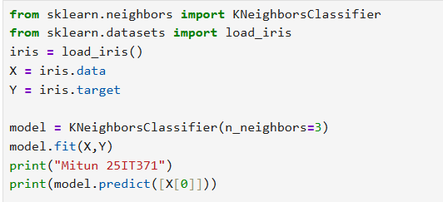

OUTPUT:
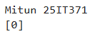

RESULT
Thus classification using KNN and Decision Tree was implemented successfully.

EXPERIMENT 6
CLUSTERING USING K-MEANS ALGORITHM
AIM
To implement K-Means clustering algorithm.

THEORY
K-Means groups similar data points into clusters.

PROGRAM

from sklearn.cluster import KMeans
import numpy as np
X = np.array([[1,2],[1,4],[1,0],[10,2],[10,4],[10,0]])
kmeans = KMeans(n_clusters=2)
kmeans.fit(X)
print(“Mitun 25IT371”)
print(kmeans.labels_)

INPUT:
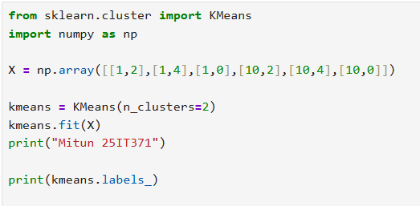

OUTPUT:
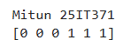

RESULT
Thus clustering using K-Means was implemented successfully.

EXPERIMENT 7
REGRESSION MODEL IMPLEMENTATION AND EVALUATION

AIM
To implement regression models and evaluate their performance.

PROGRAM

from sklearn.linear_model import LinearRegression
import numpy as np
X = np.array([[1],[2],[3],[4]])
Y = np.array([2,4,6,8])
model = LinearRegression()
model.fit(X,Y)
print(“Mitun 25IT371”)
print(model.predict([[5]]))

INPUT:
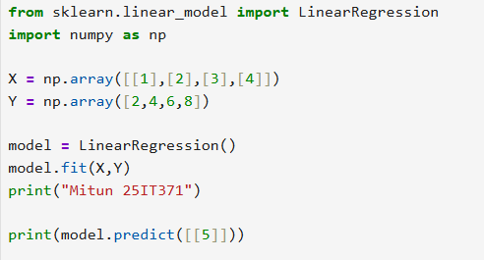

OUPUT:
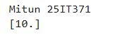

RESULT
Thus regression model was implemented and evaluated successfully.

EXPERIMENT 8
BASIC NEURAL NETWORK USING PYTHON
AIM
To implement a simple neural network using Python.

THEORY
Neural networks simulate the working of biological neurons.

PROGRAM

from tensorflow.keras.models import Sequential
from tensorflow.keras.layers import Dense
model = Sequential()
model.add(Dense(8, input_dim=4, activation='relu'))
model.add(Dense(1, activation='sigmoid'))
model.compile(loss='binary_crossentropy', optimizer='adam')
print("Mitun 25IT371")
print("Model Created Successfully!")

INPUT:

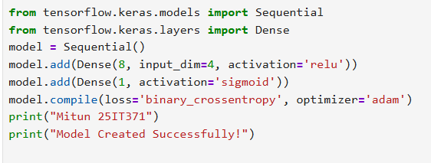
OUTPUT:
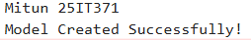

RESULT
Thus a basic neural network was implemented successfully.

EXPERIMENT 9
SENTIMENT ANALYSIS / CHATBOT USING NLP
AIM
To implement sentiment analysis and chatbot using NLP.
PROGRAM
from textblob import TextBlob

text = "AI is amazing"
blob = TextBlob(text)

print("Mitun 25IT371")
print(blob.sentiment)

# SIMPLE CHATBOT

while True:
msg = input("You: ")

if msg == "hello":
print("Bot: Hi")

elif msg == "bye":
print("Bot: Bye!")
break

else:
print("Bot: I don't understand.")

INPUT:

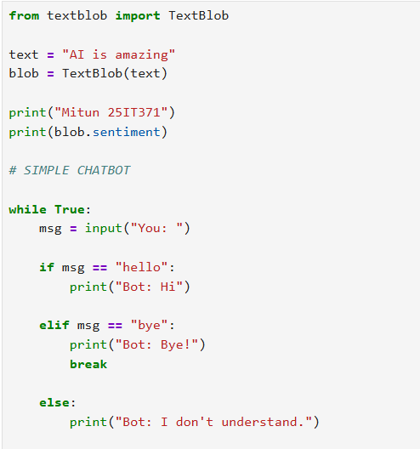
OUTPUT: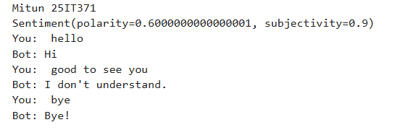
RESULT
Thus sentiment analysis and chatbot were implemented successfully.

EXPERIMENT 10
MINI PROJECT ON AI APPLICATION
AIM
To develop a mini project using AI concepts.
SAMPLE PROJECTS
- Face Recognition System
- AI Chatbot
- Heart Disease Prediction
- Smart Attendance System
- Object Detection using YOLO
MINI PROJECT FORMAT
- Problem Statement
- Objectives
- Methodology
- Dataset Description
- Implementation
- Results and Discussion
- Conclusion
RESULT
Thus the mini project was completed successfully.

VIVA VOCE QUESTIONS
- What is Artificial Intelligence?
- Differentiate BFS and DFS.
- What is heuristic search?
- Define Minimax algorithm.
- What is Alpha-Beta pruning?
- What is an Expert System?
- Define supervised learning.
- What is clustering?
- What is NLP?
10.Define neural network.

REFERENCES
- Stuart Russell and Peter Norvig – Artificial Intelligence: A Modern Approach.
- E. Rich and K. Knight – Artificial Intelligence.
- Python Documentation.
- TensorFlow Documentation.
- Scikit-learn Documentation.

