DESIGN DOCUMENT
Firmware Protocol Decoder
Definition-driven packet decoder and analyzer for UART, USB-CDC, RS485, CAN, Modbus and custom binary protocols
Document | Software design document (reference)
Product version | 1.0
Document version | 1.0
Date | 19 October 2026
Author | Vinaya Kumar
Status | Released for reference
Audience | Firmware / embedded engineers using or extending the tool
Code location | protocol_decoder/ (Python 3.11+, PySide6)

This document describes the architecture, data model, algorithms, user interface and extension points of the Firmware Protocol Decoder. It is intended as the reference for using the tool's protocol-definition format and for changing or extending the code.

Contents
1 Introduction
2 Goals, non-goals and design principles
3 System overview
4 Architecture
5 Protocol definition model
6 Decoding engine
7 CRC and checksum engine
8 Encoder (packet builder)
9 Analysis features
10 Optional AI analysis
11 User interface design
12 Files, persistence and configuration
13 Error handling and robustness
14 Extensibility and roadmap
15 Testing and verification
16 Known limitations
Appendix A Reference packet walkthrough
Appendix B Complete JSON example
Appendix C Glossary

Conventions: offsets are zero-based byte positions; byte ranges are inclusive ("4-11"); HEX is written as space-separated byte pairs (02 01 08); code marks file, function and JSON key names.

1 Introduction

1.1 Purpose
Firmware engineers spend a lot of time decoding raw bytes by hand: copying HEX out of a terminal, counting offsets, converting endianness and recomputing CRCs on a calculator. The Firmware Protocol Decoder replaces that with a desktop tool. A protocol is described once as data (JSON), and every packet pasted, loaded or captured afterwards is decoded field by field, with integrity checks and clear error messages.

1.2 Scope
Version 1.0 covers:
- Decoding of single packets against a user-defined protocol (fixed and variable-length frames).
- 16 data types, little/big endian, bit fields, value names, scaling, expected values.
- Parameterised CRC engine (16 presets plus custom) and six simple checksums.
- Protocol editor (GUI and raw JSON), example protocols, packet builder (encoder).
- TX/RX comparison, multi-packet difference analysis, session history with CSV export.
- Optional, provider-neutral AI analysis interface with an offline heuristic backend.
- An interface for future live transports (serial, USB-CDC, CAN, TCP) — no drivers in v1.0.

1.3 Intended users
Firmware and embedded engineers debugging UART, USB-CDC, RS485, CAN or Modbus traffic, reverse-engineering undocumented frames, or verifying that their own firmware produces correct packets.

1.4 References
Item | Location
Source code | protocol_decoder/
User guide | protocol_decoder/README.md
Example protocols | protocol_decoder/protocols/examples/*.json
Automated tests | protocol_decoder/tests/ (131 tests)
CRC parameter model | Rocksoft / Williams "Painless Guide to CRC Error Detection Algorithms" model

2 Goals, non-goals and design principles

2.1 Goals
Table 1 — Design goals
Goal | How it is met
No hard-coded packet formats | All layout comes from a JSON protocol definition; the decoder has no protocol-specific code.
Never crash on bad input | HEX parsing, layout and decoding report problems as messages; decode_packet() has a last-resort guard.
Deterministic, honest output | Undescribed bytes are shown as Unknown / Undefined; inferred meanings are always labelled.
Works offline | No network access in the core; the only dependency is PySide6.
Cross-platform | Pure Python + Qt; paths handled with pathlib; no OS-specific APIs.
Extensible | Clear seams for new field types, CRCs, AI backends and transports.

2.2 Non-goals (v1.0)
- Hardware communication (serial/CAN/TCP drivers) — the architecture is prepared, drivers are not included.
- Stream framing (splitting a continuous byte stream into packets).
- Conditional layouts (fields whose presence depends on another field's value, e.g. Modbus data per function code). Such data is shown raw.
- Bit-level field placement across byte boundaries; fields are byte-aligned, bits are defined inside a field.

2.3 Design principles
- The deterministic decoder is the source of truth. Every other feature (AI, diff analysis, GUI) consumes its result and never overrides it.
- Definitions are data. A protocol is a JSON document that can be versioned, diffed and shared.
- Report, don't raise. Malformed packets produce a complete result with errors and warnings, so the engineer still sees everything that could be decoded.
- Separate core from GUI. core/ has no Qt imports and can be scripted or tested headless.
- Label inference. Anything not directly decoded is marked "Possible interpretation" or "AI inference".

3 System overview
The application is a single-window PySide6 desktop program with four tabs and a set of dialogs. Figure 1 shows the Decoder tab with the reference packet decoded.
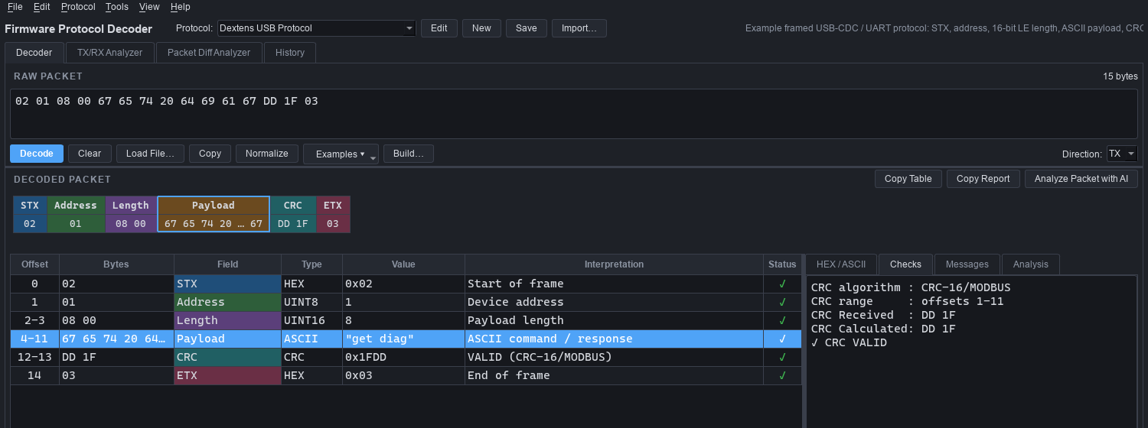
Figure 1 — Decoder tab — reference packet decoded, CRC verified
Table 2 — Feature summary
Feature | Where | Summary
Decode | Decoder tab | Paste/load HEX, decode with the selected protocol: layout boxes, field table, HEX/ASCII, checks, messages.
Protocol editor | Edit / New buttons | Field table editor, field dialog, raw JSON tab, validation, save.
Packet builder | Build… (Ctrl+B) | Enter user fields; frame, length and CRC are filled in.
CRC calculator | Tools (Ctrl+K) | All presets + custom CRC; CRC placement search.
TX/RX Analyzer | Tab 2 | Decode a request/response pair; field and byte differences.
Packet Diff Analyzer | Tab 3 | Patterns across many packets; verified CRC/checksum placement.
History | Tab 4 | Session log of decoded packets; CSV export; re-decode on double-click.
AI analysis | Analyze Packet with AI | Structured explanation; offline heuristic backend by default.

4 Architecture

4.1 Layered structure
The code is organised in layers with dependencies pointing only downwards (Figure 2). The core engine knows nothing about Qt, AI or hardware; the GUI composes core functions; optional packages sit beside the GUI and depend on the core's result types only.
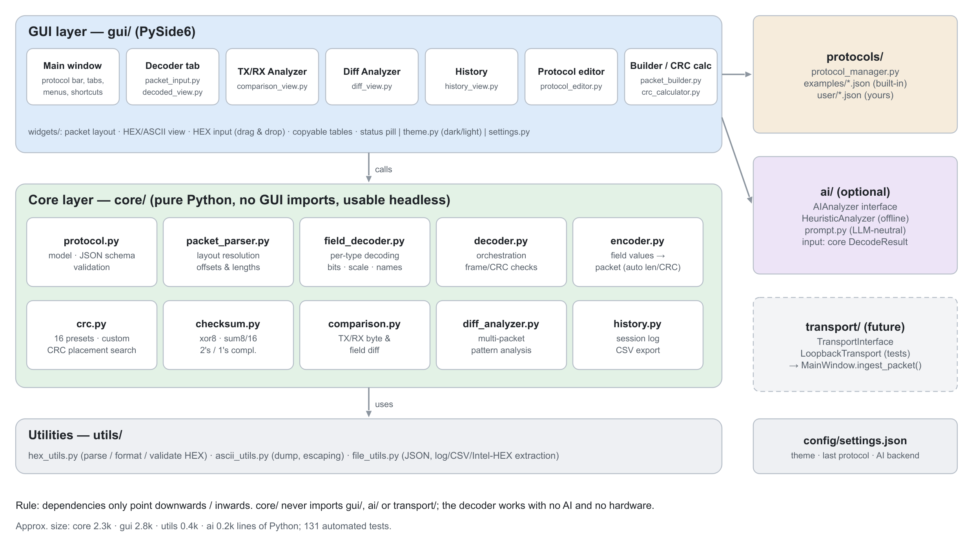
Figure 2 — Layered architecture and package responsibilities

4.2 Package responsibilities
Table 3 — Module responsibilities
Package / module | Responsibility
main.py | Entry point: sets sys.path, creates the QApplication, applies the theme, loads protocols, opens the main window.
core/protocol.py | Protocol model (dataclasses), JSON load/save with alias normalisation, static validation (validate() → issues).
core/packet_parser.py | Layout resolution: offset and length of each field in a concrete packet (resolve_layout).
core/field_decoder.py | Decoding of one field's bytes by type, bits, value names, scale/bias/unit.
core/decoder.py | Orchestration (decode_packet): validation, frame checks, layout, field decoding, CRC/checksum verification, undefined regions, status.
core/encoder.py | Builds packets from values; auto-fills frame bytes, length fields and checks.
core/crc.py | Parameterised CRC engine, presets, find_matching_crc.
core/checksum.py | XOR / SUM / two's- and one's-complement / Fletcher checksums and placement search.
core/comparison.py | Positional byte diff and field-by-field comparison of two results.
core/diff_analyzer.py | Pattern classification across packets, multi-byte counters, CRC verification.
core/history.py | Bounded session history, CSV export.
protocols/protocol_manager.py | Discovers, loads, imports and saves protocol JSON files.
gui/ | Main window, tabs, dialogs, theme, settings and reusable widgets.
ai/ | AIAnalyzer interface, offline HeuristicAnalyzer, provider-neutral prompt builder.
transport/ | TransportInterface and LoopbackTransport for future live capture.
utils/ | HEX parsing/formatting, ASCII rendering, JSON persistence, packet extraction from files.

4.3 Main runtime flow
- main.py loads config/settings.json (defaults if missing or corrupt) and applies the theme.
- ProtocolManager.reload() loads protocols/examples/*.json then protocols/user/*.json; a user protocol with the same name overrides an example. Unloadable files are listed, not fatal.
- The main window restores the last protocol and preloads the last (or default) packet.
- On Decode, the input text is parsed by parse_hex(); on success decode_packet() returns a DecodeResult that is rendered by DecodedView and appended to the history.
- On close, window geometry and the last input are written back to the settings file.

5 Protocol definition model
A protocol is an ordered list of fields plus optional framing information. Figure 3 shows the in-memory model on the left and the decode result model on the right.
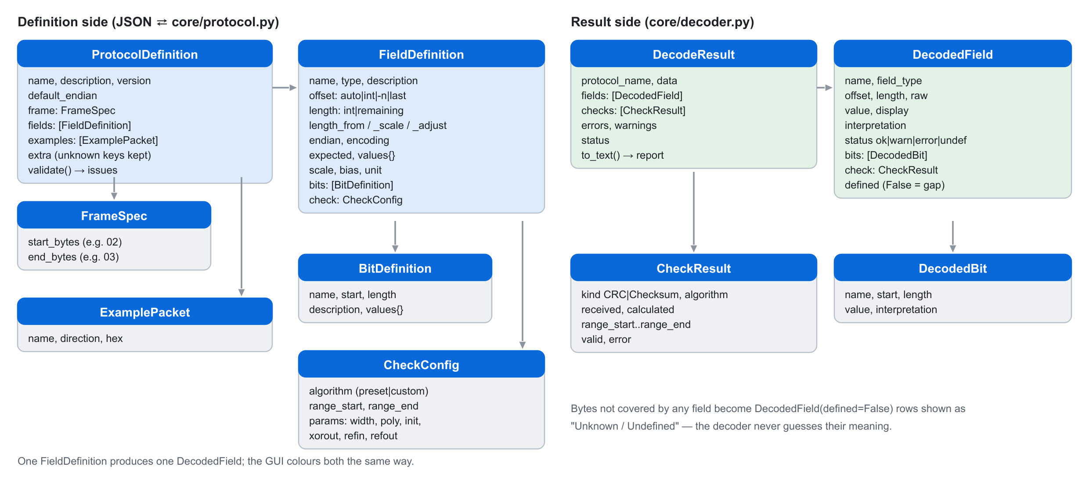
Figure 3 — Definition model and result model

5.1 Protocol-level keys
Table 4 — Protocol keys
Key | Type | Description
schema_version | int | Format version (currently 1); written on save.
name | string | Unique protocol name (required); shown in the selector.
description, version | string | Free text.
default_endian | "big" | "little" | Byte order for fields without their own endian.
frame.start_byte / frame.end_byte | HEX string | Optional; mismatch → *Missing STX* / *Missing ETX*. May be multi-byte (e.g. "AA55").
fields | list | Ordered field definitions (required).
examples | list | Named example packets: name, direction (TX/RX), hex.
any other key | any | Preserved unchanged in extra (forward compatibility).

5.2 Field keys
Table 5 — Field keys
Key | Description
name | Unique field name (required). Used by length_from and check ranges.
type | One of the data types in Table 6 (aliases such as UINT16, UTF-8, CRC16 accepted).
offset | auto (default), absolute int, negative int (from end), or last — see Table 7.
length | Fixed bytes, or remaining. Defaults to the type size for numeric types.
length_from, length_scale, length_adjust | Length taken from an earlier integer field: value × scale + adjust.
endian | little or big; overrides the protocol default.
encoding, null_terminated | Text fields: codec override (e.g. latin-1); stop at first 0x00.
expected | HEX bytes the field must contain; mismatch is an error (e.g. sync header).
values | Map of number → name (keys decimal or 0x..). Missing value → *Undefined value N*.
scale, bias, unit | Engineering value = raw × scale + bias, shown with unit.
bits | List of bit definitions: name, start (bit 0 = LSB), length, description, values.
crc / checksum | Check configuration for crc / checksum fields (§7).
description | Shown as the interpretation when no more specific meaning exists.

5.3 Data types
Table 6 — Supported data types
Type | Size | Decoded as
hex | variable | Raw bytes (0x02 / DD 1F). May carry bits if ≤ 8 bytes.
uint8 … uint64 | 1/2/4/8 | Unsigned integer; endian-aware; optional value names, scale, bits.
int8 … int64 | 1/2/4/8 | Two's-complement signed integer.
float32, float64 | 4/8 | IEEE-754; NaN/Inf reported as warnings.
ascii, utf8 | variable | Text; control characters shown as \r, \n, \xNN; invalid bytes warned.
binary | variable | Bit string per byte (10100101).
bitfield | 1–8 | Unsigned value split into named bit ranges.
bool | 1–8 | Zero = False, non-zero = True (warning if not 0/1).
crc | width/8 | Received CRC, verified against the computed value.
checksum | 1–2 | Received checksum, verified against the computed value.

5.4 Offsets and lengths
Placement is declarative so that variable-length frames need no code. Each field's position is resolved at decode time from the concrete packet.
Table 7 — Offset and length rules
Setting | Meaning | Typical use
offset omitted / auto | Directly after the previous field | Most fields; CRC after a variable payload
offset: n (n ≥ 0) | Absolute byte position | STX at 0; overlapping sub-views
offset: -n | n bytes before the end (-1 = last byte) | Trailers in variable frames
offset: last | Field ends at the last byte | ETX
length: n | Fixed size | Headers, numbers
length_from: X | value(X) × length_scale + length_adjust | Payload after a length byte
length: remaining | Up to the fixed-size fields that follow | Modbus data before CRC

5.5 Validation rules
ProtocolDefinition.validate() runs before every decode and in the editor. Errors block decoding (the packet is shown as undefined); warnings do not.
- Name present; at least one field; field names unique; types supported.
- Numeric type length must equal the type size; bitfield/bool 1–8 bytes; variable types need a length.
- length_from must reference an earlier integer field; length_scale ≥ 1.
- Only one remaining field; fields after it must be fixed-size with auto/last offsets.
- last requires a known length; fields after a last field produce a warning.
- Bits must fit within the field width; CRC/checksum length must match the algorithm width.
- Check ranges must reference existing fields; text encodings must exist.

6 Decoding engine

6.1 Pipeline
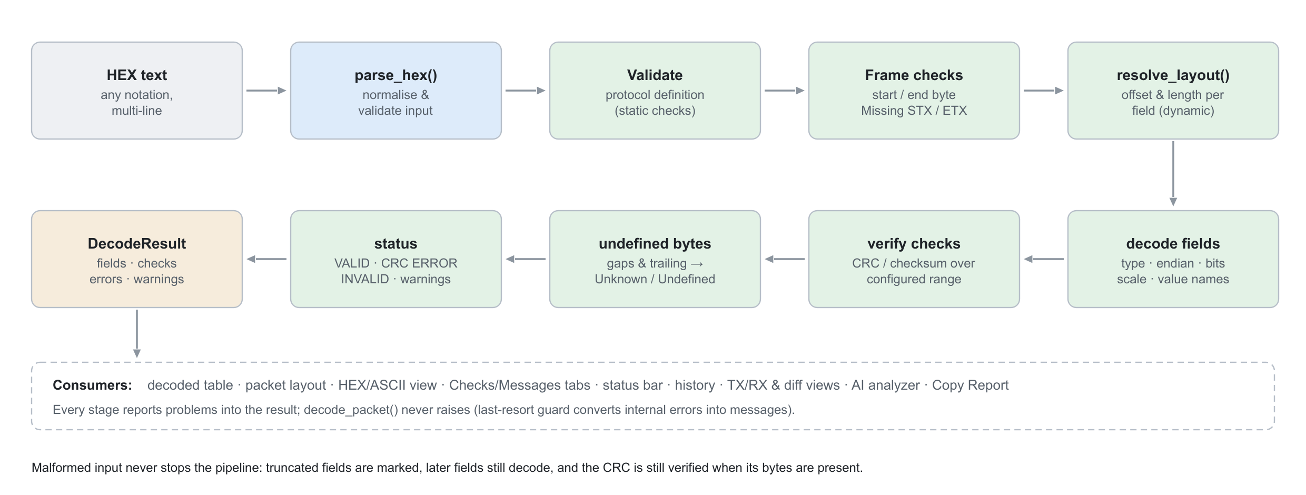
Figure 4 — Decode pipeline

6.2 HEX input normalisation (`utils/hex_utils.parse_hex`)
Input is tokenised on whitespace, commas, semicolons, colons, dashes and pipes; # and // start comments. Accepted notations can be mixed and span lines:
02 01 08 00 0x02 0x01 0x08 02,01,08,00
020108 02:01:08 \x02\x01\x08

Table 8 — HEX input validation
Condition | Message (example)
Empty input | Empty packet: no HEX data entered
Non-HEX character | Invalid HEX data: invalid character 'G' in '0G' (line 1, column 4)
Odd digit count | Odd number of HEX characters in '1' (line 1, column 4) …
Prefixed value > 1 byte digits odd | Invalid byte value '0x123' … odd number of HEX digits

6.3 Layout resolution (`core/packet_parser.resolve_layout`)
Fields are processed in order with a running cursor. For each field:
- Compute the size: from length_from (using the already-decoded integer value), from the fixed size, or — for remaining — packet length minus cursor minus the total size of the fixed fields that follow.
- Compute the start: cursor (auto), absolute, from end, or packet length − size (last).
- Clamp to the packet: a start beyond the end or a size larger than the remaining bytes yields *Packet shorter than expected* or *Length field exceeds packet size* and a truncated slice.
- Warn if a relatively placed field overlaps the previous one (packet shorter than the length fields imply).
- If the field is a complete integer ≤ 8 bytes, store its value for later length_from lookups.

6.4 Field decoding and checks
Each complete slice is decoded by decode_field_value() according to type and endianness. Interpretation priority is: value name → engineering value note → description. Expected-value mismatches are errors. Then, for each CRC/checksum field, the configured range is resolved (field names or offsets), the value computed and compared with the received bytes in the field's byte order.

6.5 Undefined regions
After decoding, a coverage map marks bytes not covered by any field. Each gap becomes a row with defined = False displayed as Unknown / Undefined: a trailing gap gives *Packet longer than expected*, an inner gap gives *N undefined byte(s) … (packet longer than the length fields imply?)*.

6.6 Result status
Table 9 — Decode status values
Status | Condition
VALID | No errors, no warnings.
VALID (WARNINGS) | No errors; warnings such as trailing bytes or non-printable text.
CRC ERROR / CHECKSUM ERROR | The only errors are CRC/checksum mismatches (structure decoded fine).
INVALID | Any structural error: missing STX/ETX, truncation, bad length, invalid definition.

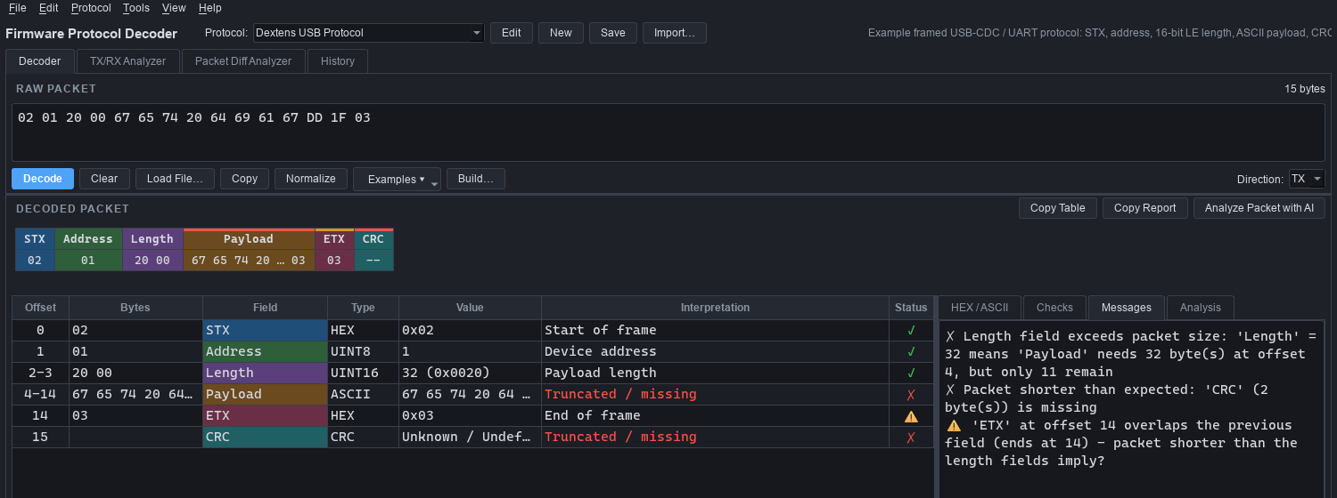
Figure 5 — Malformed packet: length field (0x20) larger than the packet — every problem is reported and the remaining fields still decode

7 CRC and checksum engine

7.1 CRC model
core/crc.py implements the Rocksoft/Williams parameter model: width, poly, init, refin, refout, xorout. Widths 8–64 are supported with a cached 256-entry table per (width, poly, reflection). Reflected algorithms run the right-shifting table with a reflected polynomial; non-reflected ones run the left-shifting form. Every preset carries its standard *check* value (CRC of ASCII "123456789"), which the unit tests verify.
Table 10 — CRC presets (all verified by tests)
Preset | Width | Poly | Init | RefIn/Out | XorOut | Check
CRC-8 (SMBUS) | 8 | 0x07 | 0x00 | F/F | 0x00 | 0xF4
CRC-8/MAXIM | 8 | 0x31 | 0x00 | T/T | 0x00 | 0xA1
CRC-8/AUTOSAR | 8 | 0x2F | 0xFF | F/F | 0xFF | 0xDF
CRC-16 (ARC) | 16 | 0x8005 | 0x0000 | T/T | 0x0000 | 0xBB3D
CRC-16/CCITT (FALSE) | 16 | 0x1021 | 0xFFFF | F/F | 0x0000 | 0x29B1
CRC-16/MODBUS | 16 | 0x8005 | 0xFFFF | T/T | 0x0000 | 0x4B37
CRC-16/XMODEM | 16 | 0x1021 | 0x0000 | F/F | 0x0000 | 0x31C3
CRC-16/KERMIT | 16 | 0x1021 | 0x0000 | T/T | 0x0000 | 0x2189
CRC-16/X-25 | 16 | 0x1021 | 0xFFFF | T/T | 0xFFFF | 0x906E
CRC-16/AUG-CCITT | 16 | 0x1021 | 0x1D0F | F/F | 0x0000 | 0xE5CC
CRC-16/USB | 16 | 0x8005 | 0xFFFF | T/T | 0xFFFF | 0xB4C8
CRC-16/MAXIM | 16 | 0x8005 | 0x0000 | T/T | 0xFFFF | 0x44C2
CRC-16/DNP | 16 | 0x3D65 | 0x0000 | T/T | 0xFFFF | 0xEA82
CRC-32 | 32 | 0x04C11DB7 | 0xFFFFFFFF | T/T | 0xFFFFFFFF | 0xCBF43926
CRC-32C | 32 | 0x1EDC6F41 | 0xFFFFFFFF | T/T | 0xFFFFFFFF | 0xE3069283
CRC-32/MPEG-2 | 32 | 0x04C11DB7 | 0xFFFFFFFF | F/F | 0x00000000 | 0x0376E6E7

7.2 Configuration in a definition
{ "name": "CRC", "type": "crc", "length": 2, "endian": "little",
"crc": { "algorithm": "CRC-16/MODBUS", "range_start": "Address", "range_end": "Payload" } }

"crc": { "algorithm": "custom", "width": 16, "poly": "0x1021", "init": "0xFFFF",
"xorout": "0x0000", "refin": false, "refout": false }

- Range: range_start/range_end accept a field name (its first/last byte) or an offset (negative = from end); inclusive. Defaults: offset 0 up to the byte before the CRC.
- Byte order on the wire comes from the field's endian (protocol default otherwise).
- Overrides: any parameter given alongside a preset changes it and renames it "<preset> (modified)".
- Aliases: CRC16, CRC-16/CCITT-FALSE, MODBUS, CRC32, … are normalised.

7.3 Checksums
Table 11 — Checksum algorithms
Name | Width | Definition
xor8 | 8 | XOR of all bytes (LRC)
sum8 | 8 | Sum of bytes mod 256
sum16 | 16 | Sum of bytes mod 65536
twos_complement8 | 8 | −sum mod 256, so data + checksum ≡ 0 (Intel HEX, Modbus ASCII LRC)
ones_complement16 | 16 | One's-complement sum of big-endian 16-bit words (RFC 1071)
fletcher16 | 16 | Fletcher-16

7.4 CRC placement search
find_matching_crc(packets) tries every preset, start offsets 0–4, both byte orders and 0–2 trailer bytes (e.g. ETX after the CRC), returning only placements that match every packet. find_matching_checksum does the same for checksums (≥ 2 packets required, since a single 8-bit checksum matches by chance too often). Results are computed facts, but the GUI warns that very few samples can match coincidentally. This search is how the reference packet's CRC (CRC-16/MODBUS over offsets 1–11, little-endian) was identified.
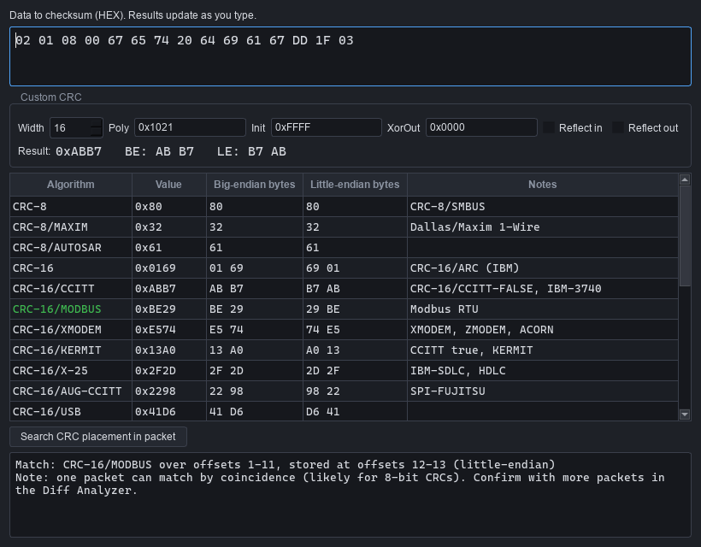
Figure 6 — CRC / Checksum Calculator with placement search

8 Encoder (packet builder)
core/encoder.py is the inverse of the decoder and backs the Build… dialog. It is also the foundation for packet replay and automated test-sequence generation.
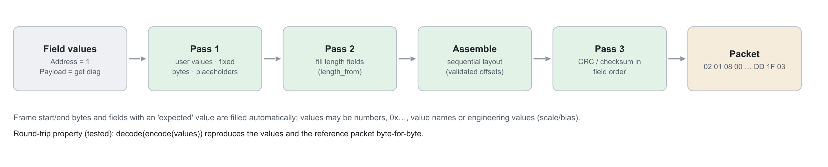
Figure 7 — Encoder passes
- user_fields(protocol) returns only fields the user must supply — frame bytes, fields with expected, length sources and checks are automatic.
- Values may be numbers, 0x…/0b… literals, value names ("Read Holding Registers"), engineering values for scaled fields, text, or HEX for raw fields.
- Checks are computed in field order by decoding the assembled packet, so a later check can cover an earlier one.
- Errors (missing value, overflow, non-ASCII text, non-sequential layout) raise EncodeError with the field name; the dialog shows them live.
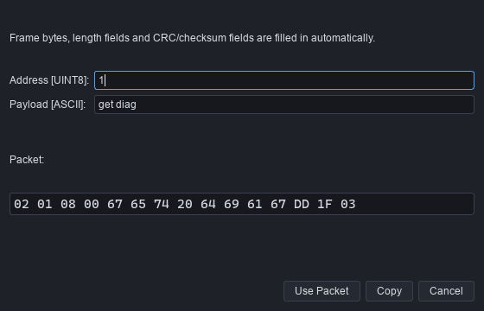
Figure 8 — Packet builder — length and CRC filled in automatically

9 Analysis features

9.1 TX/RX Analyzer
Both packets are decoded with the selected protocol. The summary lists text fields as *Command* (TX) and *Response* (RX), check results and problems; the field table compares values by field name; the HEX views highlight positional byte differences (core/comparison.py).
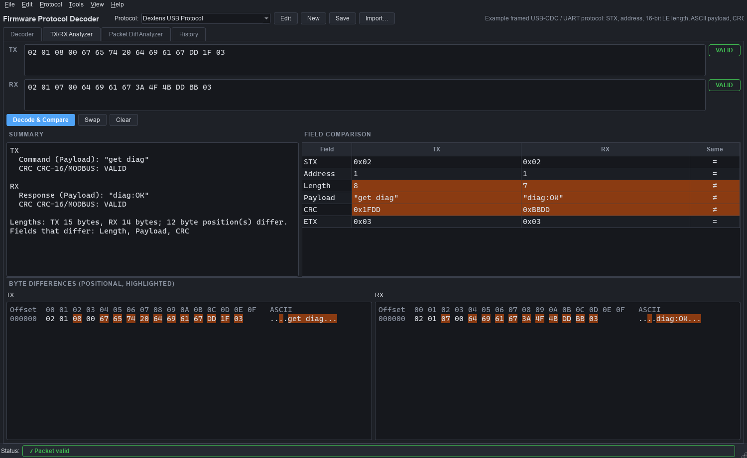
Figure 9 — TX/RX Analyzer — request and response compared

9.2 Packet Difference Analyzer
core/diff_analyzer.analyze_packets() compares packets offset by offset:
Table 12 — Diff analyzer patterns
Pattern | Rule | Possible interpretation
Constant | Same value in all packets | — (counted, not interpreted)
Incrementing / Decrementing | Constant step, modulo 256 (wrap-around allowed) | counter / sequence number / measurement value
Alternating | Two values alternating (≥ 3 samples) | toggle flag / alternating state / bit field
Increasing / Decreasing | Monotonic, irregular steps (no wrap) | measurement value / timestamp
Varying | Anything else | data / measurement / payload — or checksum/CRC if in the last 2 bytes (or the 2 before a constant end byte)
Absent in some packets | Packets of different length | —

- Adjacent changing bytes are tested as 16/32-bit little- and big-endian integers to find multi-byte counters.
- CRC and checksum placements consistent with all packets are reported as verified facts.
- Field names are added from the selected protocol only if packet 1 decodes cleanly with it.
- All meanings carry the prefix "Possible interpretation:" — never presented as certain.
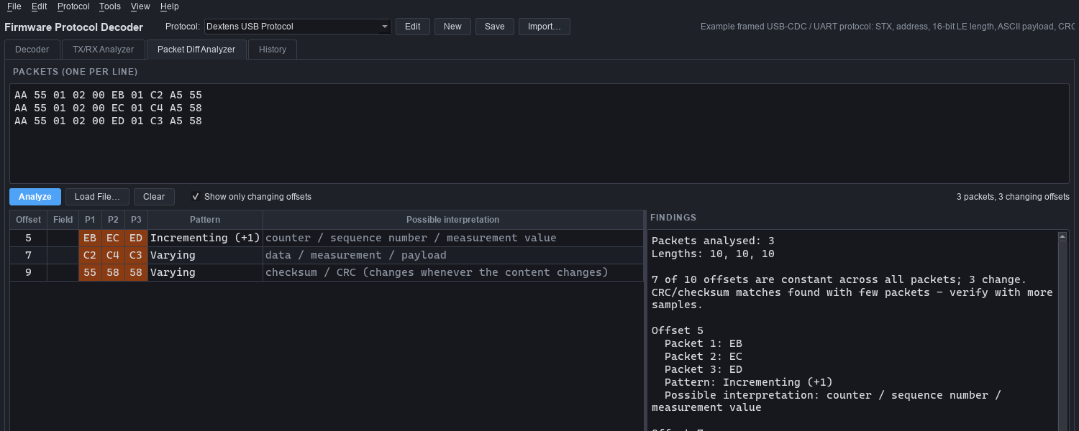
Figure 10 — Packet Diff Analyzer — counter detected, SUM-8 checksum verified

9.3 History
Every decode (Decoder, TX/RX, live ingest) appends an entry: time, direction, length, status, protocol, text summary and data. The history is bounded (10 000 entries), can be cleared, exported to CSV and re-decoded by double-click.

10 Optional AI analysis
The Analyze Packet with AI button runs the configured AIAnalyzer on the finished DecodeResult. The decoder never depends on this package.
class AIAnalyzer(ABC):
name: str
is_ai: bool = True
def is_available(self) -> bool: ...
def analyze(self, result: DecodeResult, direction: str = "") -> AnalysisReport: ...

- AnalysisReport contains sections flagged inferred=True/False; rendering labels inferred sections "AI inference — not verified" (or "Heuristic inference" for the offline backend).
- HeuristicAnalyzer (default) restates decoded facts and adds a few conservative inferences (command vs response frame by direction, exception codes, undefined regions, overall verdict).
- ai/prompt.py builds a provider-neutral prompt that pins a language model to the deterministic decode and requires every non-decoded statement to be prefixed "AI inference:".
- Backends are registered in ai.ANALYZERS and selected by ai_backend in settings; an unavailable backend falls back to the heuristic one.
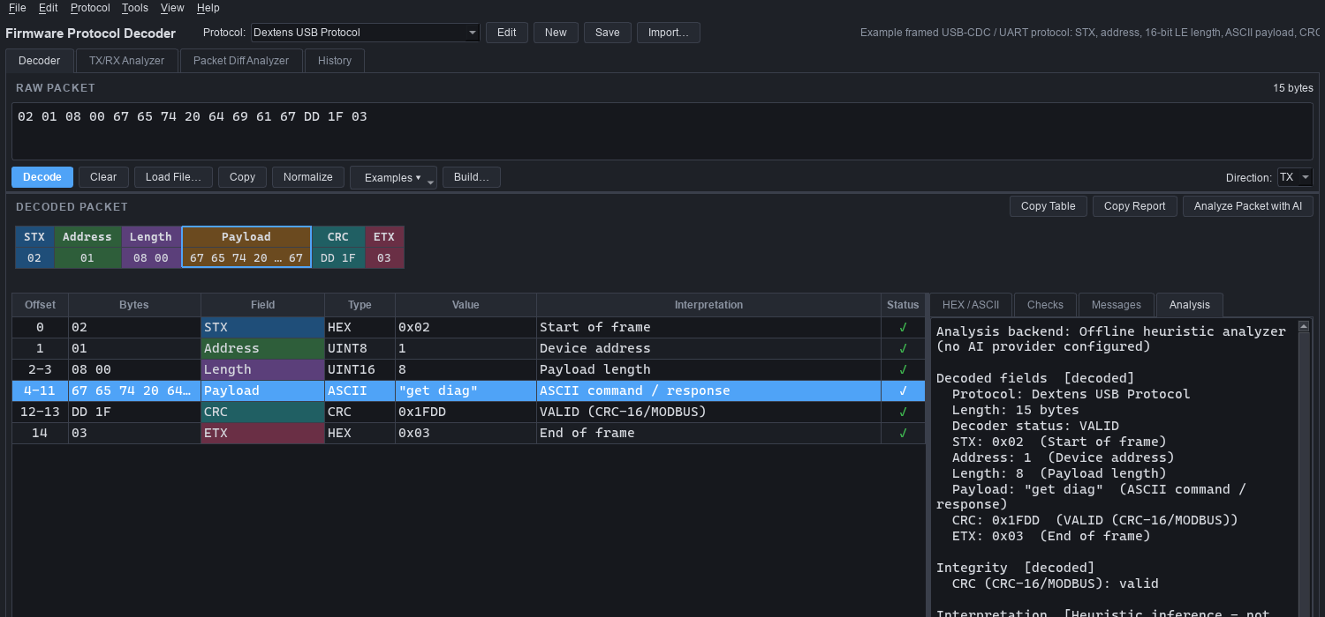
Figure 11 — Analysis tab — decoded facts and labelled inferences

11 User interface design

11.1 Main window layout
Table 13 — Main window regions
Region | Widget / module | Behaviour
Protocol bar | main_window.py | Protocol selector, Edit/New/Save/Import, description.
Raw packet | packet_input.py, widgets/hex_input.py | Monospaced input, drag-and-drop files, live byte count, Examples menu, direction.
Packet layout | widgets/packet_layout.py | Custom-painted boxes per field; click selects the row; red/amber strip marks errors/warnings.
Decoded table | decoded_view.py | Offset, bytes, field, type, value, interpretation, status; bit rows indented; Ctrl+C copies rows.
Side tabs | widgets/hex_view.py | HEX/ASCII (selected field highlighted), Checks, Messages, Analysis.
Status bar | widgets/common.StatusIndicator | Coloured pill: ✓ valid, ⚠ warnings, ✗ error.

Field colours are assigned by field index and shared by the layout boxes, the table and the HEX view, so the three views correspond visually. Panels are in resizable splitters.
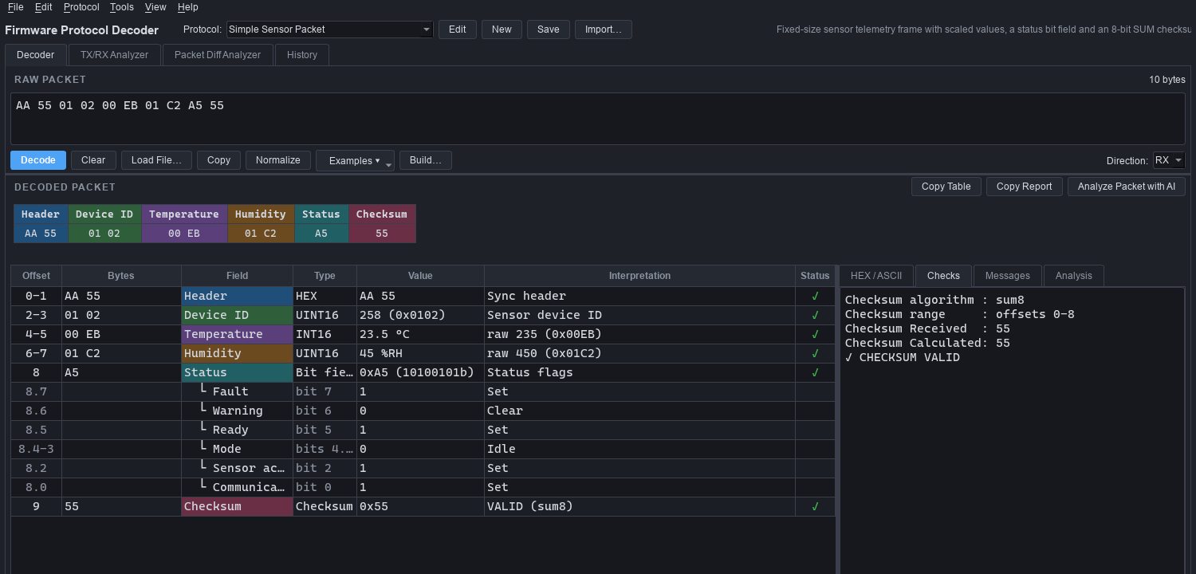
Figure 12 — Sensor packet — scaled values, bit-field rows and checksum

11.2 Protocol editor
The editor works on a copy of the protocol. The Definition tab edits header data and the field table (Add/Edit/Delete/Move); the field dialog has General, Values & Bits and CRC/Checksum tabs; the JSON tab shows the full definition and can apply hand edits. Validation results appear live. Renaming a field updates length_from and check-range references.
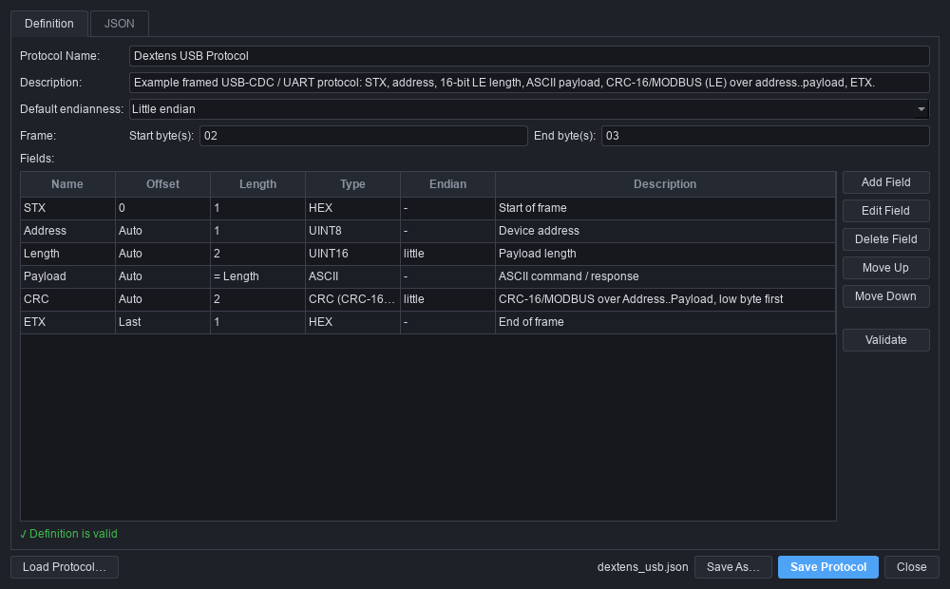
Figure 13 — Protocol editor — Definition tab

11.3 Themes, fonts and shortcuts
Fusion style with a palette and stylesheet per theme (dark default, light optional), monospaced fonts for all HEX (first available of JetBrains Mono, Cascadia Mono, Consolas, DejaVu Sans Mono, Menlo).
Table 14 — Keyboard shortcuts
Keys | Action
Ctrl+Enter | Decode (Analyze in TX/RX and Diff tabs)
Ctrl+O | Open packet file
Ctrl+S | Save protocol
Ctrl+C / Ctrl+Shift+C | Copy selection / whole decoded table
Ctrl+L | Clear input
Ctrl+E / Ctrl+N | Edit / new protocol
Ctrl+B | Build packet
Ctrl+K | CRC / checksum calculator
Alt+1…4 | Switch tabs
F5 / F1 | Reload protocols / shortcuts

12 Files, persistence and configuration
Table 15 — Persistent files
Path | Content | Written by
protocols/examples/*.json | Built-in protocols (Dextens USB, Modbus RTU, Simple Sensor Packet) | Shipped; editor saves back to source
protocols/user/*.json | User protocols (file name = slug of protocol name) | Protocol editor
config/settings.json | Application settings (Table 16) | On exit
History CSV | Exported history | Export History…

Table 16 — Settings keys
Setting | Default | Meaning
theme | dark | dark | light
last_protocol | Dextens USB Protocol | Selected at start-up
default_packet | 02 01 08 00 … | Preloaded on first launch
last_input | — | Last decoded input text
hex_font_size, bytes_per_row | 11, 16 | HEX view appearance
ai_backend | heuristic | Key in ai.ANALYZERS
auto_add_history | true | Record decodes in history
window_geometry, last_dir | — | UI state

JSON files are written atomically (temporary file + rename). Loading tolerates missing or corrupt settings (defaults are used and the problem is shown in the status bar).

12.1 Packet file import
- Formats: .txt, .hex, .log, .csv (text, one packet per line) and .bin (one raw packet).
- Timestamps (12:32:10.123, ISO dates, [123.45]) are removed before parsing.
- CSV: the cell with the most HEX bytes wins, so timestamp/length columns are not glued to the data.
- Other lines: the longest run of byte tokens; TX/RX/SEND/RECV words set the direction.
- Intel HEX data records (:LLAAAA00…CC) contribute their data bytes.

13 Error handling and robustness
Table 17 — Error catalogue
Message | Raised by | Meaning
Invalid HEX data | parse_hex | Bad character, odd digit count, bad byte value
Empty packet | parse_hex / decoder | No bytes
Packet shorter than expected | layout | Field extends past the end of the packet
Length field exceeds packet size | layout | length_from value larger than available bytes
CRC mismatch / Checksum mismatch | decoder | Received ≠ calculated
Missing STX / Missing ETX | decoder | Frame start/end byte mismatch
Unsupported field type | validation / field decoder | Unknown type
Invalid protocol definition | validation / loader | Definition fails validation or JSON is malformed
Packet longer than expected | decoder | Trailing bytes not described
'X' expected AA 55, found … | decoder | expected mismatch
Internal decoder error | decoder guard | Unexpected exception converted to a message

Robustness measures: every decode path returns a result; a fuzz-style test decodes 120 random packets (0–39 bytes) against all three example protocols; GUI actions catch file and JSON errors and show dialogs; the protocol manager skips unreadable files and lists them.

14 Extensibility and roadmap

14.1 Extension points
Table 18 — Extension points
To add… | Change
A data type | Add to FIELD_TYPES (and TYPE_SIZES if fixed) in core/protocol.py; add a branch in decode_field_value(); add encoding in encode_field_value(); add tests.
A CRC preset | Append a CRCParams (with its check value) to _PRESET_LIST in core/crc.py.
A checksum | Add a function and a ChecksumAlgorithm entry in core/checksum.py.
An AI backend | Subclass AIAnalyzer, use build_prompt(), register in ai.ANALYZERS, set ai_backend.
A live transport | Implement TransportInterface (open/close/write/is_open, RX callback); frame the byte stream; call MainWindow.ingest_packet(data, direction).
A new protocol | No code: create it in the editor or drop a JSON file in protocols/user/.

14.2 Roadmap
- Encoder tab: live encoding, deliberate overrides for negative tests, sequence generation, C/Python export.
- Live UART / USB-CDC / CAN / TCP capture with stream framers (delimiter and length-based).
- Protocol auto-detection: decode against every definition and rank by validity.
- AI-assisted protocol inference seeded from the diff analyzer.
- Conditional layouts (e.g. Modbus data structure per function code).
- Firmware log analysis, packet replay, HEX editor, automated test-sequence generation.

15 Testing and verification
131 automated tests (standard-library unittest, also runnable with pytest). GUI smoke tests run headless with the Qt offscreen platform.
Table 19 — Test suite
Test file | Tests | Coverage
test_hex_utils.py | 17 | All accepted notations, comments, empty/invalid/odd input, formatting, ASCII
test_field_decoder.py | 22 | Endianness (0x1234/0x3412 example), integers, floats, text, binary, bit fields, bool, unsupported types
test_crc_checksum.py | 16 | All 16 presets vs check values, Modbus vector, custom/override/invalid parameters, checksums (Intel HEX, RFC 1071), placement search
test_decoder.py | 27 | Reference packet field by field, CRC mismatch, missing STX/ETX, length errors, truncation, trailing/undefined bytes, random garbage, dynamic lengths, examples
test_protocol_model.py | 17 | Spec-style JSON, round trip, unknown keys, aliases, validation rules, manager save/reload, broken files
test_analysis.py | 24 | Encoder round trip, TX/RX comparison, diff patterns, history CSV, file extraction, AI labelling, transport
test_gui_smoke.py | 8 | First-launch state, Decode button, Ctrl+Enter, invalid input, bit rows, tabs, dialogs, ingest hook

cd protocol_decoder
python -m unittest discover -s tests -t .
# Ran 131 tests ... OK

16 Known limitations
Table 20 — Known limitations
Limitation | Impact / workaround
No live hardware capture in v1.0 | Paste or load captured data; TransportInterface is ready for drivers.
One packet per decode; no stream framing | Split captures into one packet per line before loading.
No conditional layouts | Function-specific data (e.g. Modbus) is shown raw as HEX.
Fields are byte-aligned | Sub-byte values are modelled as bits inside a field.
CRC widths 8–64 only | CRC-5/CRC-15 (e.g. CAN bit-level CRC) are not modelled; CAN payload CRCs are.
Encoder supports sequential layouts | Absolute offsets must follow the previous field; gaps are rejected.
Diff analysis is positional | Packets with variable-length sections may not line up after that section.
Saving an edited example overwrites the shipped file | Use *Save As…* to keep the original.
Settings stored next to the application | The install folder must be writable.
Verified on Windows; GUI tested headless | Linux support is by design (Qt, pathlib) but not yet exercised interactively.

Appendix A Reference packet walkthrough
Packet 02 01 08 00 67 65 74 20 64 69 61 67 DD 1F 03 (15 bytes):
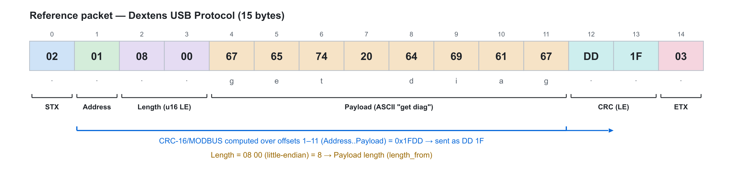
Figure 14 — Reference packet byte map
Table 21 — Reference packet decode
Offset | Bytes | Field | Value | Interpretation
0 | 02 | STX | 0x02 | Start of frame
1 | 01 | Address | 1 | Device address
2-3 | 08 00 | Length | 8 | Payload length (UINT16 LE)
4-11 | 67 65 74 20 64 69 61 67 | Payload | "get diag" | ASCII command
12-13 | DD 1F | CRC | 0x1FDD | VALID (CRC-16/MODBUS)
14 | 03 | ETX | 0x03 | End of frame

Derivation: The packet length (15) and payload ("get diag", 8 bytes) only fit a 2-byte length field (08 00, little-endian). The CRC was identified with the placement search: only CRC-16/MODBUS over offsets 1–11, stored low byte first, matches.

Appendix B Complete JSON example
protocols/examples/dextens_usb.json as shipped:
{
"schema_version": 1,
"name": "Dextens USB Protocol",
"description": "Example framed USB-CDC / UART protocol: STX, address, 16-bit LE length, ASCII payload, CRC-16/MODBUS (LE) over address..payload, ETX.",
"version": "1.0",
"default_endian": "little",
"frame": {
"start_byte": "02",
"end_byte": "03"
},
"fields": [
{
"name": "STX",
"type": "hex",
"offset": 0,
"length": 1,
"description": "Start of frame"
},
{
"name": "Address",
"type": "uint8",
"description": "Device address"
},
{
"name": "Length",
"type": "uint16",
"endian": "little",
"description": "Payload length"
},
{
"name": "Payload",
"type": "ascii",
"length_from": "Length",
"description": "ASCII command / response"
},
{
"name": "CRC",
"type": "crc",
"length": 2,
"endian": "little",
"crc": {
"algorithm": "CRC-16/MODBUS",
"range_start": "Address",
"range_end": "Payload"
},
"description": "CRC-16/MODBUS over Address..Payload, low byte first"
},
{
"name": "ETX",
"type": "hex",
"offset": "last",
"length": 1,
"description": "End of frame"
}
],
"examples": [
{
"name": "TX: get diag",
"direction": "TX",
"hex": "02 01 08 00 67 65 74 20 64 69 61 67 DD 1F 03"
},
{
"name": "RX: diag:OK",
"direction": "RX",
"hex": "02 01 07 00 64 69 61 67 3A 4F 4B DD BB 03"
},
{
"name": "TX: corrupted CRC",
"direction": "TX",
"hex": "02 01 08 00 67 65 74 20 64 69 61 67 A3 27 03"
},
{
"name": "TX: length field too large",
"direction": "TX",
"hex": "02 01 20 00 67 65 74 20 64 69 61 67 DD 1F 03"
}
]
}

Appendix C Glossary
Table 22 — Glossary
Term | Meaning
STX / ETX | Start / end of text (frame) bytes, commonly 0x02 / 0x03.
CRC | Cyclic redundancy check; polynomial checksum detecting transmission errors.
refin / refout | Bit reflection of input bytes / final CRC value in the Rocksoft model.
Check value | CRC of ASCII "123456789"; standard test vector for a CRC definition.
LRC | Longitudinal redundancy check (XOR or two's-complement sum).
LE / BE | Little-endian (least significant byte first) / big-endian.
Undefined region | Bytes not covered by any field definition.
Possible interpretation | Label for inferred, unverified meanings.

