Firmware Binary Comparison Tool
Design Document · Feature Specification

Item | Value
Document version | 1.0
Software version | 1.0.0 — frozen baseline
Date | 16 October 2026
Status | Frozen — feature complete for v1.0.0
Prepared by | Vinaya Kumar
Verification | 84 automated tests passing; validated on STM32F411 and PIC32MX575 production firmware

Revision history
Version | Date | Description
1.0 | 16 Oct 2026 | First release of the design document for the frozen v1.0.0 baseline.

Contents
1. Introduction
1.1 Purpose · 1.2 Scope · 1.3 Intended audience · 1.4 Terms
2. Feature overview and requirements traceability
3. Architecture
3.1 Package structure · 3.2 Processing pipeline
4. Data model
4.1 Firmware image · 4.2 Address sets · 4.3 Configuration file
5. Comparison engine
5.1 Algorithm · 5.2 Gap-fill mode · 5.3 Results · 5.4 Performance
6. Region, block and expected-difference analysis
7. File format support
8. Function- and module-level change analysis
8.1 Symbol sources · 8.2 Matching and statuses · 8.3 Relocation-aware comparison · 8.4 Validation
9. Controller identification
10. Metadata, checksums and ELF comparison
11. Outputs: GUI, CLI and reports
11.1 GUI · 11.2 Command-line interface · 11.3 Reports
12. Engineering requirements compliance
13. Verification
14. Build, deployment and baseline
15. Known limitations and future work

1. Introduction

1.1 Purpose
This document describes the design and the complete feature set of the Firmware Binary Comparison Tool, a desktop and command-line utility for embedded firmware engineers. It compares two firmware images and shows exactly what changed, where it changed, which functions and modules were affected, and whether each change was expected. It is the reference for the frozen v1.0.0 baseline.

1.2 Scope
- Comparison of raw binary (.bin), Intel HEX (.hex/.ihex/.ihx) and ELF (.elf/.axf/.out) firmware images, in any combination, by MCU memory address.
- Region-based and expected-difference analysis, changed-block analysis and memory-map visualisation.
- Function- and module-level change analysis from ELF or GNU ld / XC32 linker map files, with relocation-aware comparison that separates real edits from address shifts.
- Heuristic controller identification, firmware metadata detection and checksums.
- Engineering reports (HTML, CSV, JSON), a command-line interface for CI and a Tkinter GUI.

1.3 Intended audience
Embedded firmware engineers, test and release engineers, and maintainers of the tool.

1.4 Terms
Term | Meaning
Address | MCU memory address a byte is programmed to (e.g. 0x08012A40). All analysis uses addresses.
File offset | Byte position inside the file on disk, always shown with a '+' prefix (+0x12A40). Intel HEX has no byte-level file offset (shown as n/a).
Base address | For raw .bin files: the MCU address of file offset 0.
LMA / VMA | Load (flash) address and virtual (run-time) address of ELF content. Images are compared at the LMA by default.
Region | Named, user-defined address range (Bootloader, Application, Calibration …).
Expected area | User-defined range that is allowed to change between builds (version, timestamp, CRC). Nothing is assumed to be expected unless configured.
Changed block | Contiguous run of differing bytes (optionally merged across small gaps).
RELOCATED | A function whose bytes differ only because call targets or pointers moved — a side effect, not an edit.

2. Feature overview and requirements traceability
Table 1 maps every original requirement to its implementation. Features added during development are listed at the end.
Table 1: Requirements traceability
# | Requirement | Implementation | Status
1 | File selection, drag-and-drop, file information | Files tab: A/B cards with drop zones, SHA-256, format, address range, controller | Done
2 | Byte-by-byte comparison statistics | core.binary_comparator + Summary tab / CLI | Done
3 | Hex comparison viewer with navigation and search | gui.hex_viewer (virtualised) | Done
4 | Memory region configuration, reusable files | core.region_manager + Configuration tab, JSON | Done
5 | Region-based comparison | core.analysis + Regions tab / report | Done
6 | Changed block analysis, sorting | core.block_detector + Changed Blocks tab | Done
7 | Binary / memory-map visualisation | gui.memory_map + report SVG | Done
8 | Difference filters | Hex viewer and block-table filters | Done
9 | Expected / ignored areas, EXPECTED vs UNEXPECTED | core.analysis, verdict logic | Done
10 | Firmware metadata detection (heuristic) | core.metadata_detector + Metadata tab | Done
11 | CRC-32 / CRC-16 / SHA-256 | core.checksum + Checksums tab / --checksum | Done
12 | ELF support: sections, symbols, build info | formats.elf_parser + core.elf_compare + ELF tab | Done
13 | HTML report (10 sections) and CSV export | reports.html_report / reports.csv_report | Done
14 | Command-line interface | cli.cli (firmware-diff), exit codes | Done
15 | Python 3.11+, Tkinter, minimal dependencies, modular | Standard library only | Done
16 | Engineering requirements (read-only, large files …) | See section 13 | Done
17 | Engineering-tool UX | Tabbed GUI, header, tiles, tooltips | Done
+ | Function / module level changes | core.symbols + core.feature_diff | Added
+ | Relocation-aware comparison (ARM Thumb-2, MIPS32) | core.feature_diff | Added
+ | Controller identification | core.mcu_detector | Added
+ | PIC32 KSEG ↔ physical address mapping | formats.elf_parser, core.symbols | Added
+ | Gap-fill mode (sparse HEX vs full BIN) | compare_images(fill=…) | Added
+ | Recent comparisons, remembered folders, tooltips | gui.settings, gui.widgets | Added

3. Architecture
The tool is a pure-Python 3.11 application with no mandatory third-party dependencies. It is split into layers so that the comparison engine can be used without the GUI — the CLI and the automated tests call the same API.
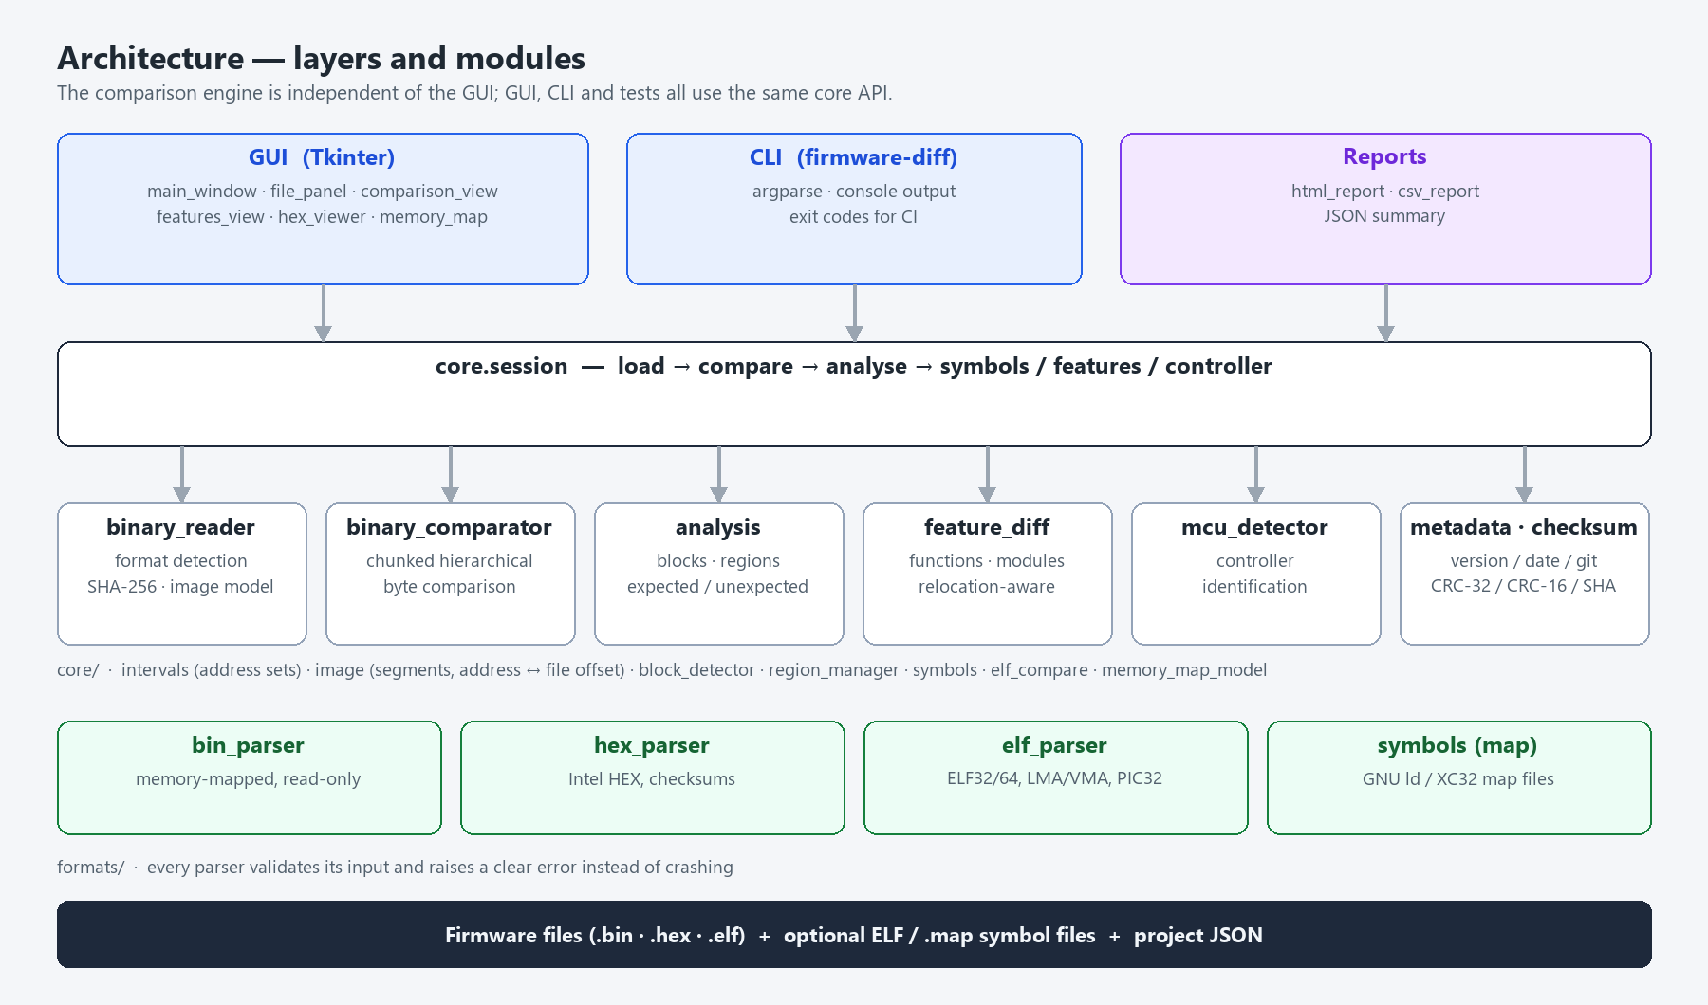
Figure 1: Layers and modules

3.1 Package structure
Table 2: Modules
Package / module | Responsibility
core/binary_reader.py | Format detection (magic bytes, extension, content), SHA-256, loader dispatch, controller identification on load
core/image.py | FirmwareImage and Segment model; address ↔ file-offset mapping; reads, search, iteration
core/intervals.py | IntervalSet: sorted disjoint address ranges with O(log n) overlap queries
core/binary_comparator.py | Chunked hierarchical byte comparison over the union of address ranges
core/block_detector.py | Changed-block grouping (merge gap), per-block statistics, sorting
core/region_manager.py | Regions, expected areas, project configuration, validation, JSON I/O
core/analysis.py | Region results, expected/unexpected split, verdict
core/symbols.py | Symbol tables from ELF or GNU ld / XC32 map files, labels, aliases, LMA/VMA
core/feature_diff.py | Function / variable / module comparison, relocation-aware decoding
core/mcu_detector.py | Heuristic controller identification with evidence
core/metadata_detector.py | Heuristic version / date / time / git / product / board detection
core/checksum.py | CRC-32, CRC-16 variants, SHA-256 over files, images and ranges
core/elf_compare.py | ELF section and symbol comparison
core/memory_map_model.py | Data model for the map visualisation (GUI and report)
core/session.py | Orchestration: load → compare → analyse → metadata → ELF → features
formats/ | bin_parser (mmap), hex_parser (+writer), elf_parser, elf_builder (tests/examples)
reports/ | html_report, csv_report
cli/cli.py | firmware-diff command-line interface
gui/ | main_window, file_panel, comparison_view, features_view, hex_viewer, hex_model, memory_map, config_editor, details_view, widgets, theme, settings

3.2 Processing pipeline
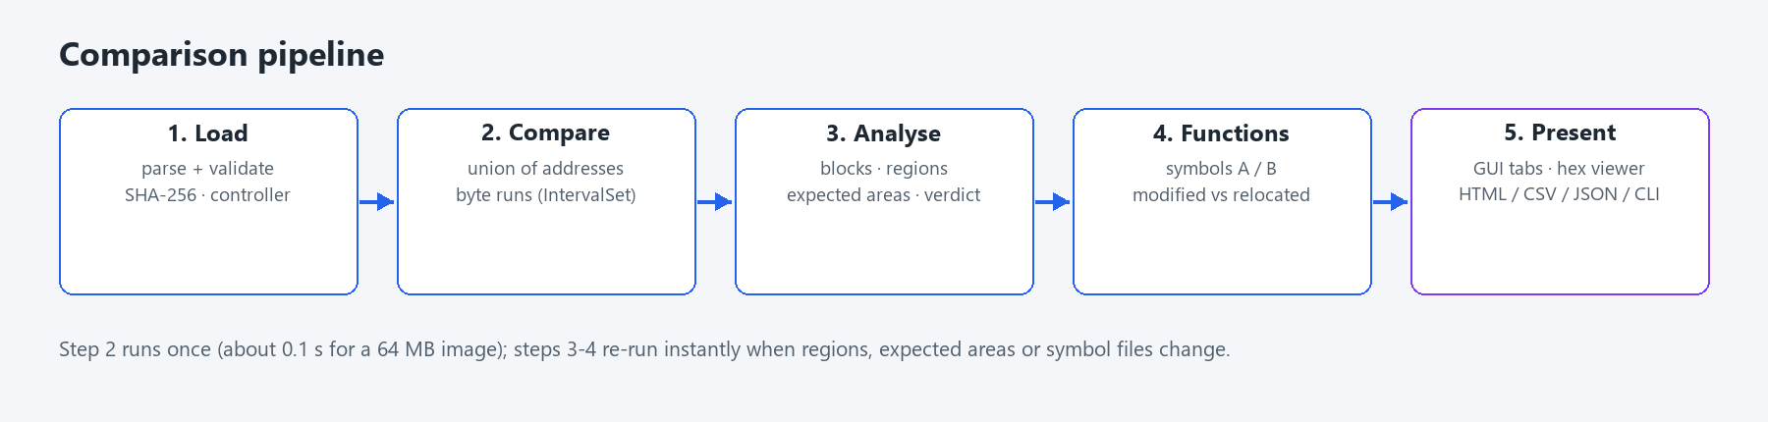
Figure 2: Comparison pipeline
The byte comparison runs once per file pair on a worker thread. Region, expected-area and symbol analysis are re-computed instantly when the configuration or symbol files change, without re-comparing bytes.

4. Data model

4.1 Firmware image
A FirmwareImage is a list of non-overlapping Segments. Each segment maps a range of MCU addresses to bytes and remembers its file offset when one exists:
- Raw BIN: one segment at the configured base address; the file is memory-mapped read-only (mmap ACCESS_READ), so large images are not copied into memory.
- Intel HEX: one segment per contiguous run of records; gaps are preserved, never filled.
- ELF: one segment per PT_LOAD program header at its load address (LMA). VMA mode is optional. For PIC32 (MIPS32) KSEG0/KSEG1 addresses are converted to physical addresses so ELF, HEX and programmer addresses agree.

4.2 Address sets
Every set of addresses — file coverage, differences, expected areas, regions — is an IntervalSet of sorted half-open ranges with a prefix-sum index. This keeps memory proportional to the number of changed runs, not changed bytes, and answers 'how many changed bytes lie in [s, e)' in O(log n). Intersection, subtraction and union are linear merges.

4.3 Configuration file
Regions and expected areas are stored in one JSON project file (schema: firmware_binary_tool/config/schema.json). End addresses are inclusive; 'size' may replace 'end'; 'ignore' is an alias of 'expected'.
{
"name": "STM32F4 XC-200 motor controller",
"base_address": "0x08000000",
"merge_gap": 0,
"gap_fill": null,
"regions": [
{ "name": "Bootloader", "start": "0x08000000", "end": "0x08007FFF" },
{ "name": "Application", "start": "0x08008000", "end": "0x0803FFFF" }
],
"expected": [
{ "name": "Version", "start": "0x08001000", "end": "0x0800101F" },
{ "name": "CRC", "start": "0x0807FFFC", "end": "0x0807FFFF" }
]
}
Validation reports errors (start after end, invalid numbers, duplicate names, out-of-range values) and warnings (overlapping regions).

5. Comparison engine

5.1 Algorithm
- The comparison runs over the union of both images' address ranges. Addresses present in both are compared byte by byte; addresses present in only one image are reported as ONLY A / ONLY B differences, so a size change is never silently ignored.
- Data is processed in 64 KiB chunks. Identical chunks are skipped at memcmp speed; differing chunks are narrowed down hierarchically (4096 → 256 → 16 → 1 bytes) so only differing bytes are inspected individually.
- Differences are accumulated as runs and stored in an IntervalSet; adjacent runs across chunk and segment boundaries are merged.
- Progress reporting and cancellation are supported (worker thread in the GUI).

5.2 Gap-fill mode (optional)
A sparse Intel HEX file omits erased flash pages, so it differs from a full BIN dump of the same build. With gap fill (e.g. 0xFF) bytes present in only one image are compared against the fill value instead. The mode is off by default and its state is shown in every summary and report.

5.3 Results
Table 3: Summary statistics
Statistic | Definition
Total compared | Bytes present in both images (plus one-sided bytes in gap-fill mode)
Different bytes / Changed % | All differing addresses / union of both images
First / last difference | Lowest / highest differing address, with file offsets of A and B
Changed blocks / largest block | Contiguous runs (merge gap optional)
Only in A / only in B | Bytes with data in one image only
Expected / unexpected changes | Differences inside / outside configured expected areas
Verdict | IDENTICAL, EXPECTED CHANGES ONLY or UNEXPECTED CHANGES

5.4 Performance (measured)
Table 4: Performance
Case | Time
Byte comparison, 64 MB image with 2,000 changed areas | ≈ 0.1 s
Full session for the same images (hashing, metadata scan) | ≈ 2 s
Every other byte differs in 4 MB (2 million blocks, pathological) | ≈ 9 s
Real STM32F411 / PIC32MX575 production images | < 0.1 s

6. Region, block and expected-difference analysis
- Regions: for every region the tool reports size, changed bytes, changed %, expected and unexpected bytes, coverage of A and B, and a status: SAME, CHANGED, EXPECTED CHANGE or NOT PRESENT. Changes outside all regions are reported in their own row.
- Changed blocks: start, end, size, changed bytes, expected/unexpected bytes, classification (EXPECTED / UNEXPECTED / MIXED), regions, kind (modified / only in A / only in B), file offsets and the containing function. Sorting by address, size, changed bytes or region; filters by class, region and minimum size.
- Expected areas: a difference is EXPECTED only inside an area the user configured. Each area reports CHANGED (EXPECTED), UNCHANGED or NOT PRESENT.
- Memory map: region tree, linear region bar, change strip and a clickable block grid over a compressed address axis (gaps without data are omitted and marked).
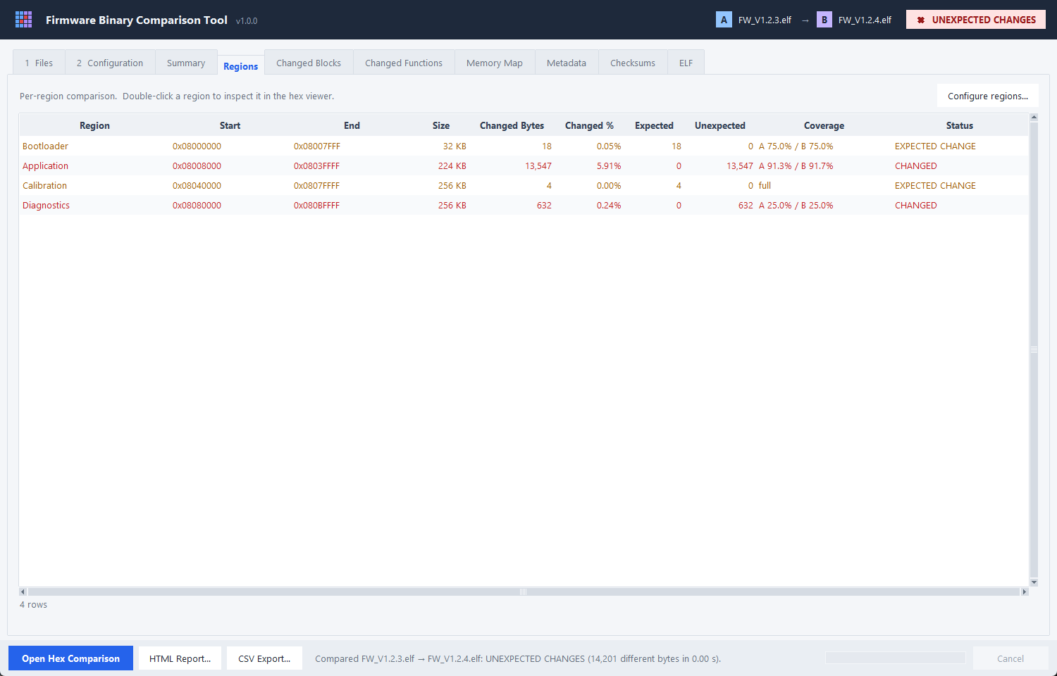
Figure 3: Regions tab — per-region statistics with expected/unexpected split
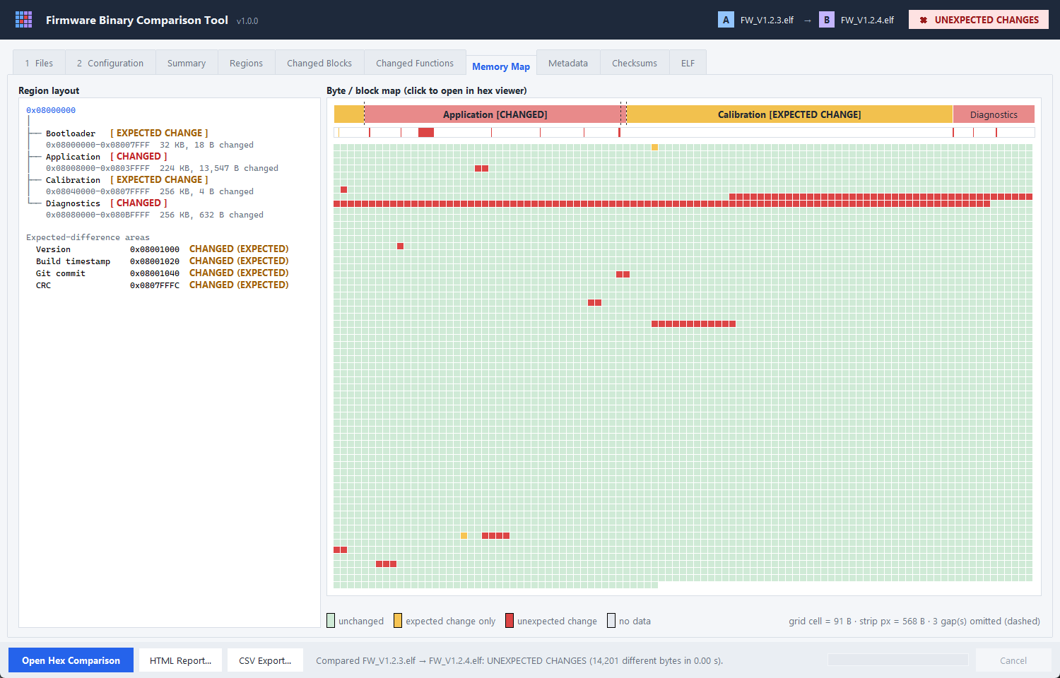
Figure 4: Memory map — region layout, change strip and block grid

7. File format support
Table 5: Supported formats
Format | Support | Validation / errors
Raw BIN | Memory-mapped read-only; base address per file or from configuration | Empty file → warning; never modified
Intel HEX | Records 00–05, extended segment / linear addressing, start addresses; HEX writer for examples | Line-level errors for bad syntax, length, checksum, type; overlapping records rejected; missing EOF warned
ELF | ELF32/64, little/big endian; PT_LOAD segments at LMA (or VMA); sections, symbols, .comment, GNU build-id; PIC32 KSEG→physical | Bounds-checked tables; truncated or invalid files give a clear error
GNU ld / XC32 map | Input sections, symbols (incl. COMMON), modules, load addresses, linker labels; PIC32 detection | Rejects files without a memory-map section

Format detection: ELF by magic, Intel HEX by extension or text records, otherwise raw binary. The format can be forced per file.

8. Function- and module-level change analysis
A binary does not know about 'features'. The closest reliable proxy is the symbol information of each build: functions, variables and the source module they come from.

8.1 Symbol sources
- ELF: symbol table, Thumb bit cleared, LMA computed from program headers, source file of local symbols from STT_FILE entries, size-0 linker labels collected separately.
- Linker map: GNU ld and XC32 map files; gives the object file (module) of every symbol and the load address of initialised data.

8.2 Matching and statuses
- Aliases (several names at one address) are grouped into one symbol.
- Symbols are matched by name and module; compiler-generated names that change between builds (C.55.31329, counter.1234) are paired by identical content or unique candidates.
- Each side's bytes are read at that side's own address and compared.
Table 6: Function statuses
Status | Meaning | Counted as edit
MODIFIED | Content changed | Yes
ADDED / REMOVED | Only in the new / old build | Yes
LIKELY RELOCATED | Only address references differ, some to unnamed data — listed for review | Review
RELOCATED | Only call targets / pointers changed because referenced code or data moved | No
MOVED | Identical content at a new address | No
UNCHANGED / NOT IN IMAGE | Identical / RAM-only (.bss) | No

8.3 Relocation-aware comparison
Removing or adding code shifts everything linked after it, which changes the bytes of many unedited functions. Every differing branch or pointer is therefore decoded in both builds and resolved to a build-independent key (symbol + offset, linker label, identical pointed-to content, or position relative to neighbouring symbols):
- ARM / Cortex-M: Thumb-2 BL / BLX / B.W, ARM B / BL, literal-pool pointers.
- MIPS32 / PIC32: J / JAL, LUI + ADDIU / load / store address pairs with register tracking (including branch delay slots), $gp-relative small-data accesses.

8.4 Validation on production firmware
Table 7: Real-firmware validation
Firmware | Change | Result
STM32F411 analysis board | Watchdog commented out | 2 modified (peripheralInit, main), 6 removed (iwdgInit, HAL_IWDG_Init, iwdgRefresh, HAL_IWDG_Refresh, iwdgInstance, iwdgHandle); 762 side effects separated. Before relocation analysis: 350 'modified'.
PIC32MX575F512L system controller | Release IR44 → IR45 | Modbus stack added, Chinese language data removed, 91 size-changed functions; unexplained bytes reduced from 420,619 to ~21–36 k after KSEG mapping.

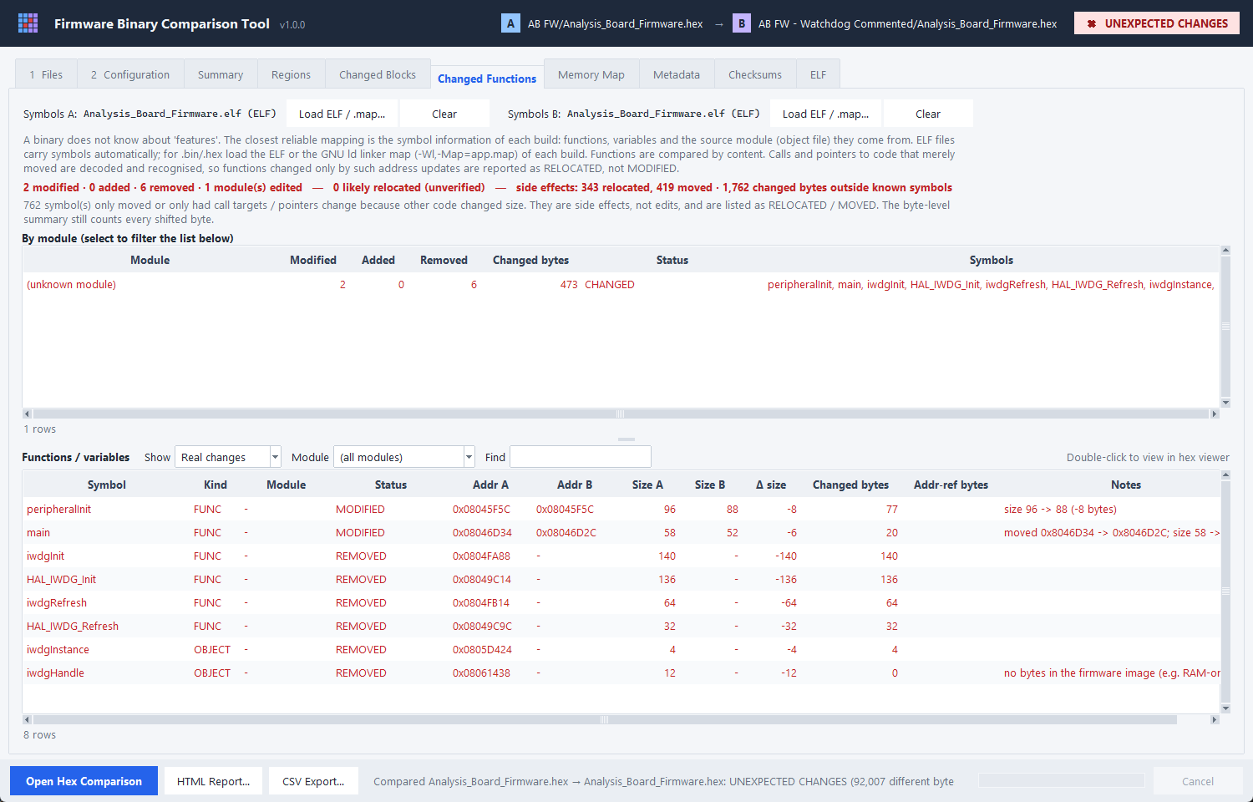
Figure 5: Changed Functions — exactly the watchdog change in a 900-symbol firmware

9. Controller identification
The target controller is identified heuristically and every result lists its evidence with a confidence.
Table 8: Controller evidence
Evidence | Example | Gives | Confidence
ELF debug info / strings | stm32f411xe.h, startup_stm32f411retx.s, p32mx575f512l.h | Exact part | High
Linker map | 32MX575F512L (XC32) | Exact part | High
Compiler options | -mcpu=cortex-m4 -mfpu=fpv4-sp-d16 | Core, FPU | High
Memory layout | 0x08000000 flash; 0x1D000000 + 0x1FC00000 | Family | Medium / low
PIC32 configuration words | 0x1FC02FF0 / 0x1FC00BF0 / 0x1FC0FFxx | MX3-7 / MX1-2 / MZ | Medium
Cortex-M vector table | SP 0x20020000, 102 vectors | RAM ≥ 128 KB, 86 IRQs | Medium
Image headers | ESP 0xE9 + chip id, AVR JMP table | ESP32 variant / AVR | Medium

Part numbers are decoded (STM32F411RET → 512 KB flash, 64 pins, LQFP; PIC32MX575F512L → 512 KB, 100 pins). An application starting inside flash is flagged as likely behind a bootloader. A warning is shown when A and B target conflicting controllers; an exact part within a family-level result is treated as compatible.
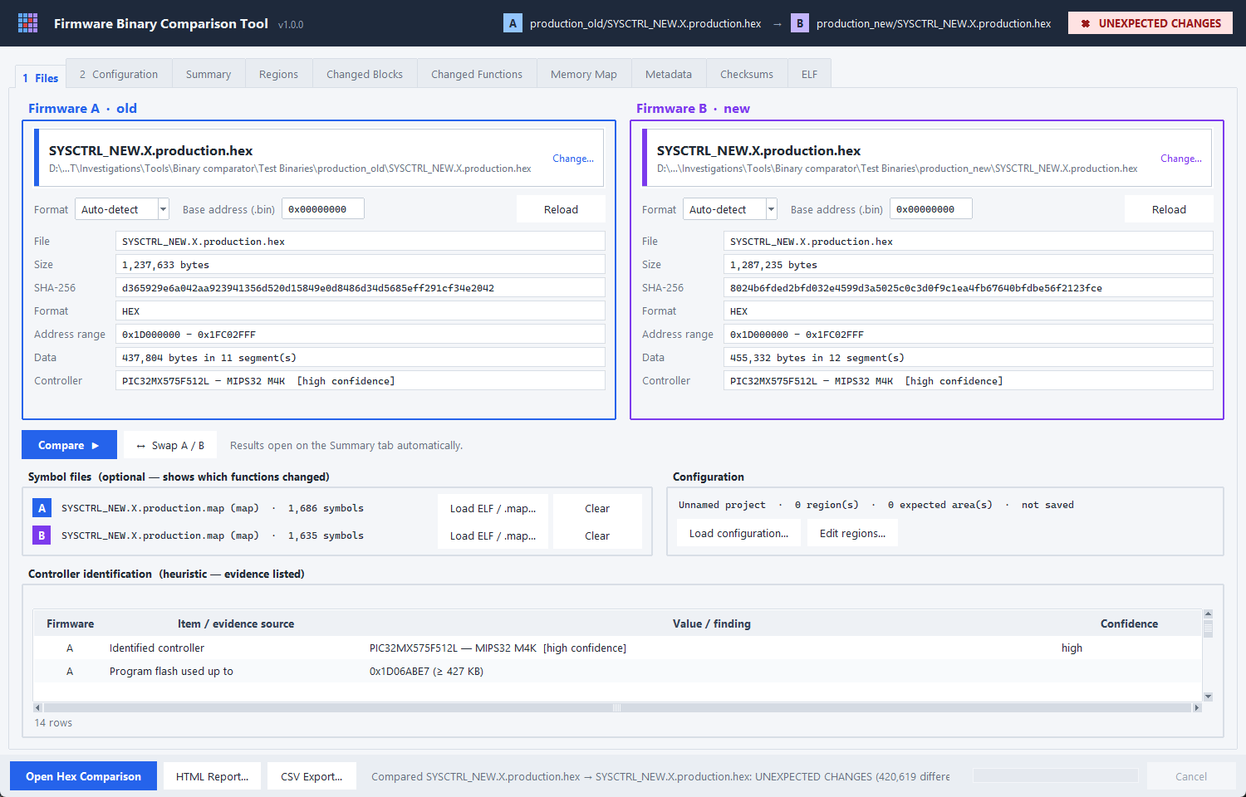
Figure 6: Files tab — PIC32 identification refined by the linker map

10. Metadata, checksums and ELF comparison
- Metadata (heuristic): printable strings are matched against patterns for firmware version, build date / time (__DATE__ / ISO), git commit, product and board name, each with a confidence and address. The UI and reports state that detection is not guaranteed.
- Checksums: CRC-32 (ISO-HDLC), CRC-16/CCITT-FALSE, XMODEM, MODBUS, ARC and SHA-256 over the file, the image data, a region or a custom range with gap fill. The tool never assumes the firmware's own CRC algorithm.
- ELF comparison: sections (address, size, differing bytes, status, notes), build information (compiler, build-id) and symbol changes (added / removed / moved / resized).
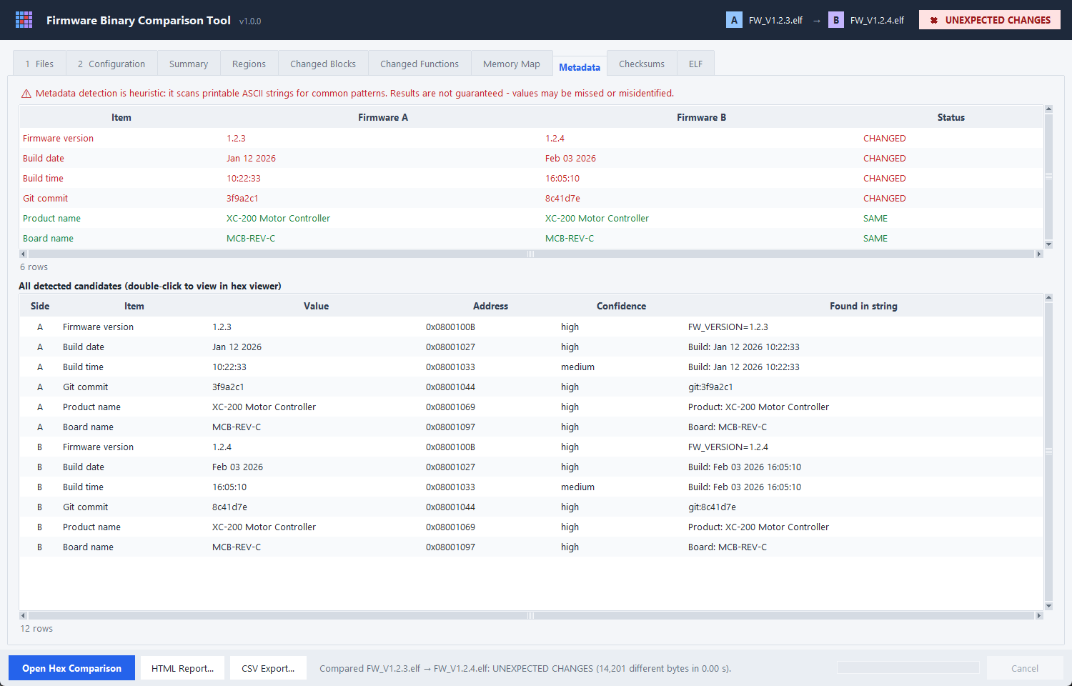
Figure 7: Metadata tab with heuristic disclaimer

11. Outputs: GUI, CLI and reports

11.1 Graphical user interface
Table 9: GUI tabs
Tab | Content
1 Files | A/B cards (drop zone, format, base address, file details, controller), Compare / Swap, symbol files, configuration, controller evidence
2 Configuration | Regions, expected areas, base address, merge gap, gap fill; load/save/import
Summary | Verdict banner, number tiles, details, 'What changed' function list
Regions / Changed Blocks | Per-region and per-block tables with filters, CSV export
Changed Functions | Modules, functions, real / likely relocated / side-effect filters
Memory Map | Region tree, region bar, change strip, clickable block grid
Metadata / Checksums / ELF | Heuristic metadata, checksum calculator, ELF sections and symbols
Hex Comparison (window) | Virtualised side-by-side or 1-byte table view; first/prev/next/last difference; go to address or file offset; hex search; filters; status bar with offsets, region, block and function

Usability: header with file names and verdict badge, colour coding (A blue, B purple), tooltips, helpful empty states, remembered folders and window size, File → Recent comparisons, Quick start and keyboard shortcuts, high-DPI awareness on Windows.
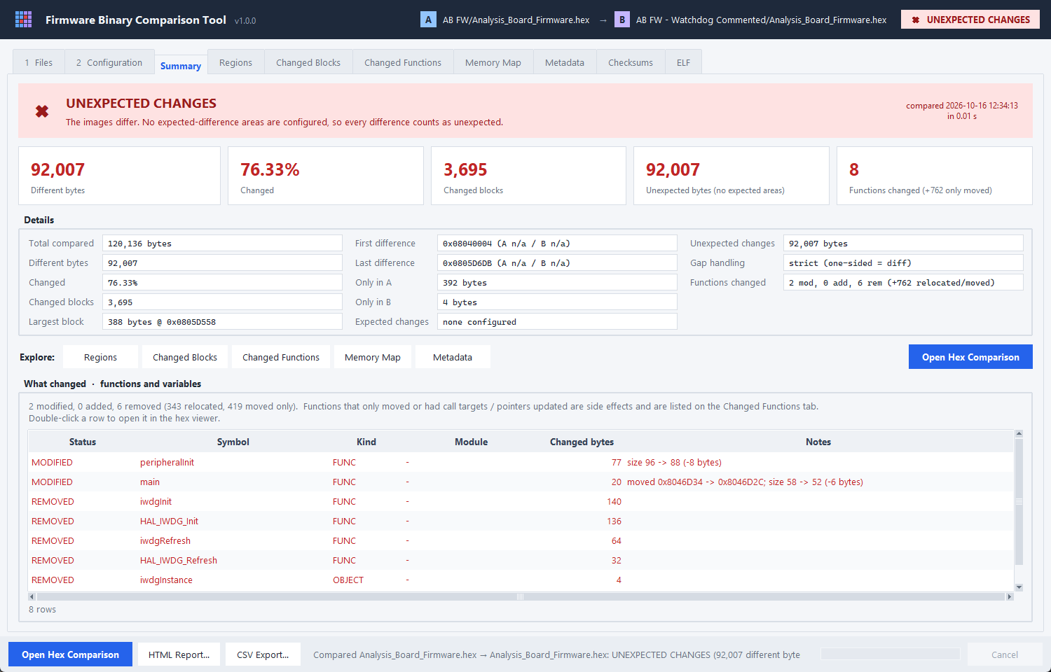
Figure 8: Summary tab
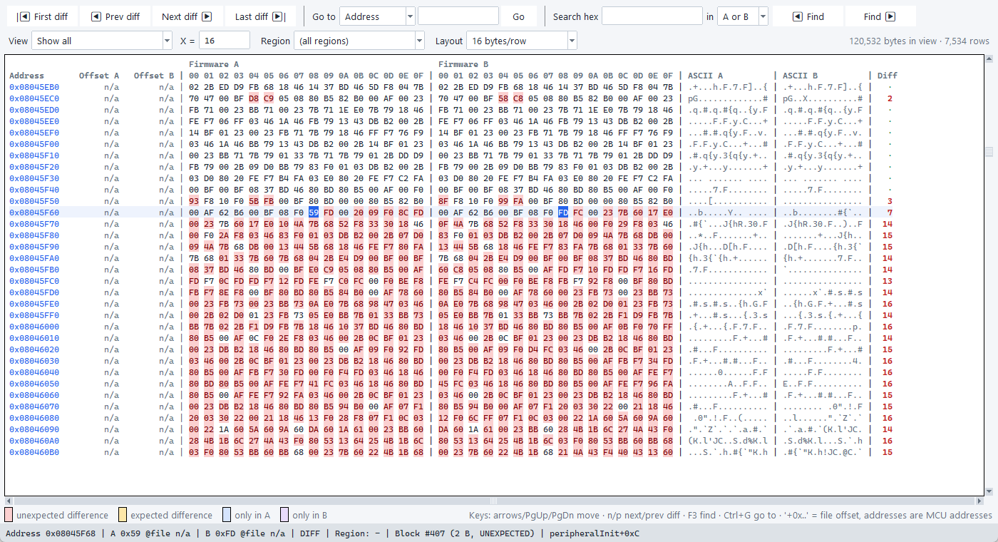
Figure 9: Hex comparison viewer

11.2 Command-line interface
Table 10: Main CLI options
Option | Purpose
--regions / --ignore | Project / region file; extra expected areas
--report / --csv / --json | HTML report, changed-block CSV, JSON summary ('-' = stdout)
--base / --base-a / --base-b | Base address for raw .bin files
--format-a / --format-b / --elf-vaddr | Force format; use ELF VMA
--fill / --merge-gap | Gap-fill value; block merge gap
--symbols-a / --symbols-b | ELF or map file per build (function-level analysis)
--functions / --show-relocated / --functions-csv | Function listing, side effects, CSV
--checksum ALG | CRC-32, CRC-16 variants, SHA-256
--controller-details / --no-metadata / -q | Evidence output, skip metadata, verdict only

Exit codes: 0 = identical or only expected changes, 1 = unexpected changes, 2 = error — suitable as a CI gate.
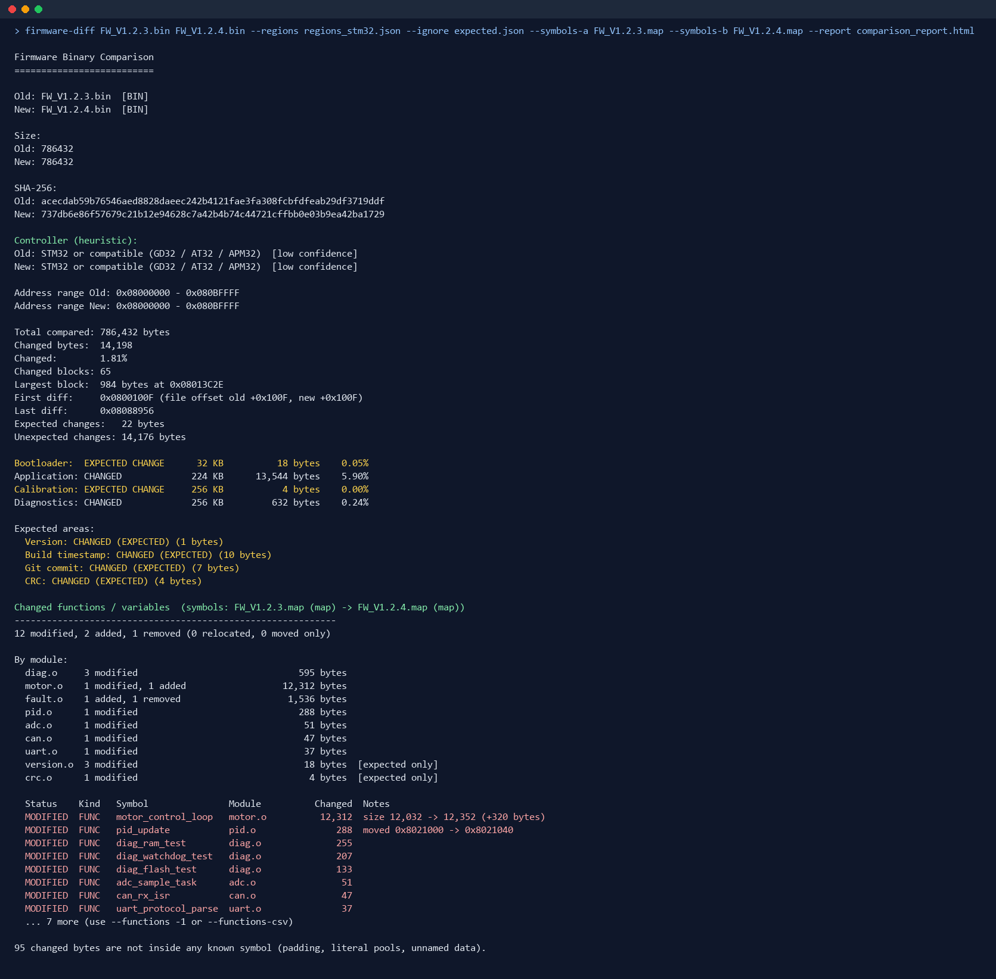
Figure 10: CLI output

11.3 Reports
The HTML report is self-contained (no external resources) and contains: firmware A and B information (including controller), SHA-256 hashes, overall summary with memory map, region comparison, changed blocks with function names, expected changes, unexpected changes, function and module changes (with side effects and likely-relocated sections), metadata differences, ELF comparison and the comparison timestamp. CSV exports cover changed blocks and function changes; JSON provides a machine-readable summary.

12. Engineering requirements compliance
Table 11: Engineering requirements
Requirement | How it is met
Never modify original files | Files opened read-only; BIN mmap with ACCESS_READ; test verifies hash and modification time are unchanged
Large images | mmap, 64 KiB chunked hierarchical comparison, run-based storage, virtualised hex viewer, capped tables with CSV for full lists
File offset vs MCU address | Separate columns everywhere; offsets prefixed '+', n/a for Intel HEX
Never silently ignore differences | One-sided bytes counted, outside-region changes listed, unattributed bytes reported, gap fill opt-in and always displayed
Clear errors | Typed exceptions with line numbers / offsets; GUI dialogs and status bar; CLI exit code 2
Validate memory regions | Range, number, duplicate-name checks; overlap warnings
Different sizes, empty and malformed files | ONLY A / ONLY B, empty-file warnings, parser validation
Unit tests for the engine | 84 tests (section 13)

13. Verification
Table 12: Automated tests (84, all passing)
Test module | Tests | Coverage
test_intervals | 5 | Interval algebra checked against Python sets on random data
test_comparator | 12 | Naive byte-by-byte reference on random data, chunk boundaries, sizes, empty, sparse, gap fill, progress / cancel
test_blocks_regions | 15 | Merge gap, blocks across regions, expected vs unexpected, config validation
test_formats | 17 | BIN, HEX (malformed, overlapping, extended addressing), ELF (truncated, VMA/LMA), files never modified
test_checksum_metadata | 7 | CRC catalogue check values, chunking, metadata heuristics
test_features | 11 | Map parsing, function statuses, real Thumb-2 and MIPS code, aliases, labels, renamed symbols, PIC32 KSEG
test_mcu_detector | 8 | Part decoding, vector tables, PIC32 layout, mismatch rules
test_reports_cli | 8 | HTML / CSV / JSON content, exit codes, hex row model
test_gui_smoke | 1 | Drives the real GUI: load, compare, tabs, hex navigation, filters, search

In addition the tool was validated manually on two production firmware pairs (section 8.4) and on the deterministic example builds in examples/.

14. Build, deployment and baseline
- Runtime: Python 3.11+ standard library; optional tkinterdnd2 for drag-and-drop.
- Run: python firmware_compare_gui.py (GUI), python firmware_diff.py (CLI), or pip install . for the firmware-diff / firmware-diff-gui commands.
- Standalone executables: build_windows.bat / build_linux.sh (PyInstaller).
- Frozen baseline: docs/FREEZE_v1.0.0.md lists the SHA-256 of every source, test and build file.
- Per-user settings: %APPDATA%\FirmwareBinaryTool\settings.json (Windows) or ~/.config/firmware_binary_tool (Linux).

15. Known limitations and future work
- Instruction decoding covers ARM/Thumb-2 and MIPS32; MOVW/MOVT pairs, microMIPS/MIPS16e and other architectures (e.g. RISC-V) are not decoded — address-only changes there may appear as MODIFIED.
- Map parsing supports GNU ld and XC32; IAR and Keil map files are not supported (use their ELF output).
- Metadata and controller identification are heuristic and labelled as such.
- Intel HEX and ELF files are parsed into memory (raw BIN files are memory-mapped).
- Motorola S-record is not supported.
- Same-size MODIFIED functions can be side effects of header changes (e.g. struct layout) or compiler scheduling; the binary shows that code changed, not which source line.
- Candidate future work: S-record, IAR/Keil maps, RISC-V decoding, git integration, batch comparison.

