# CS 255 DriverPass System Design Document

### UML Use Case Diagram

### UML Activity Diagram 1

### Activity Diagram 2

### UML Sequence Diagram

### UML Class Diagram

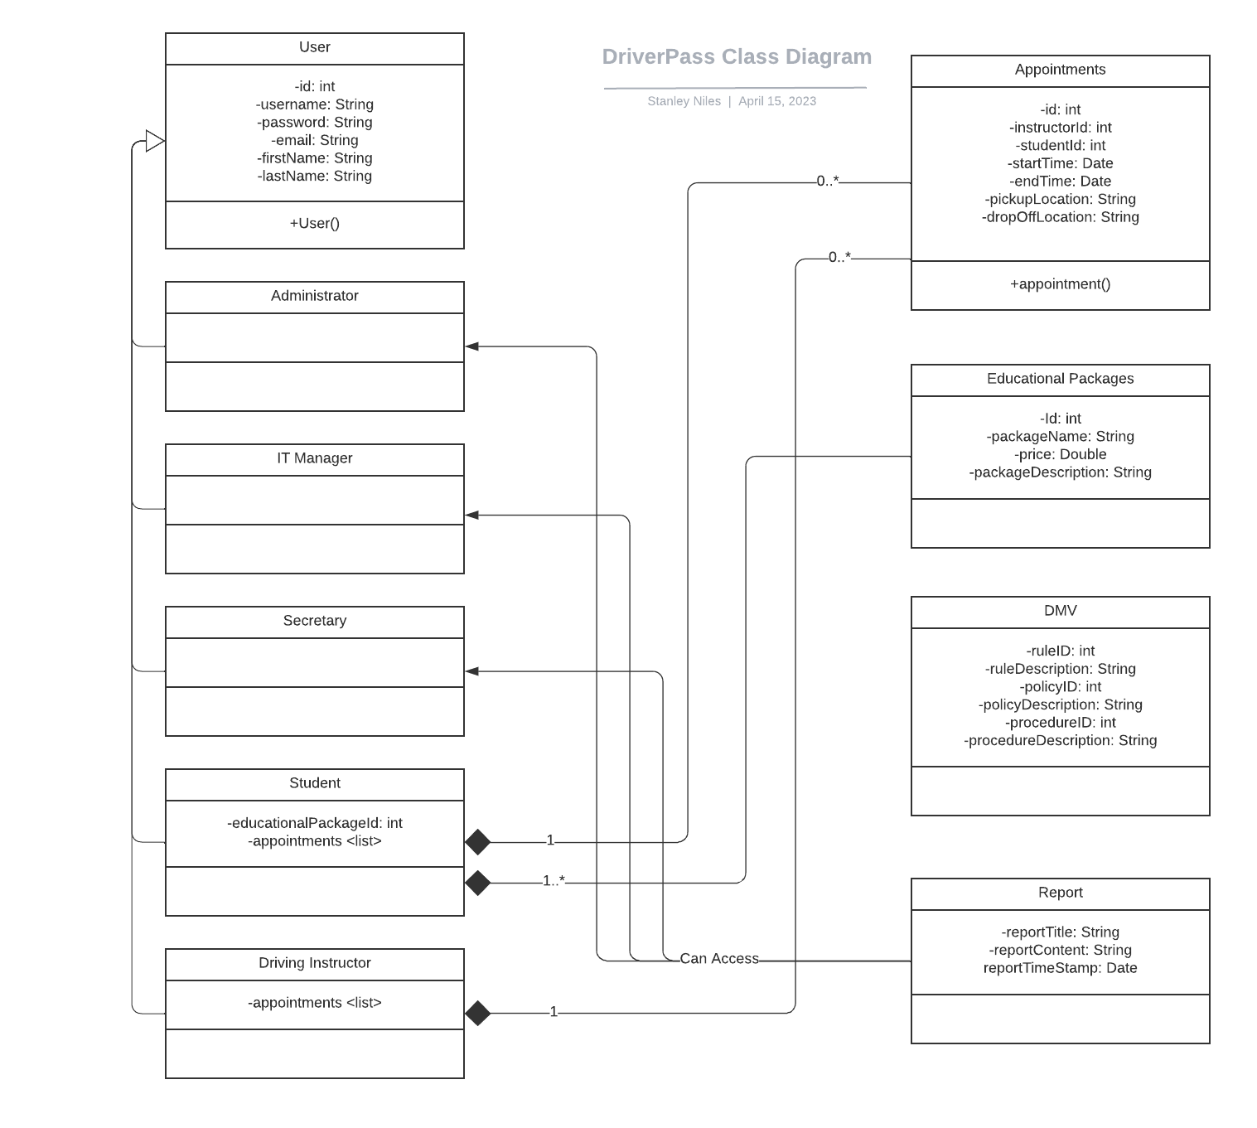

## Technical Requirements

***Hardware Requirements:***

It is recommended that DriverPass utilize a cloud-based server to host their web application and database. This will keep the system scalable and capable of handling an ever-growing number of users and increase the amount of data storage if needed.

DriverPass should guarantee access to high-speed internet connections locally with proper networking equipment along with appropriate access to their cloud server. This will ensure smooth daily operations and connectivity between the users and the server.

***Software Requirements:***

It is recommended that DriverPass utilize a common operating system along with implementing the use of Rest APIs so that their system will be accessible to users accessing their system with different types of IoT devices.

The overall design of the UI should be user friendly and easy for all users to navigate and efficiently interact with.

***Tools and Infrastructure:***

Implementation of a version control system, such as Git, so that tracking of source code and changes are recorded throughout further development and maintenance of the system.

Project Management Tools to organize, track and plan in collaboration with the Driver Pass team on future development and system changes.

Acquiring some form of automated testing tools to periodically check the application for functionality and consistency.

DriverPass will need to select a cloud service provider to operate their cloud-based application from such as Microsoft Azure, Amazon Web Services or Google Cloud.

Appropriate domain and SSL/HTTPS protocols to ensure secure communications between users and the system to prevent malicious actors.

A secure connection to the local DMV office for periodic updates of the rules, policies and procedures that DriverPass needs to stay aware of.