***Grazioso Salvara Animal Shelter Dashboard***

**Introduction**

The Animal Shelter Dashboard is designed to help Grazioso Salvare navigate and analyze the data of animals available for different types of rescue services. With interactive filters, a detailed table, and visual maps and charts, users can effortlessly find the information they need.

**Project Features and Usage:**

1. Interactive Filter Buttons

The dashboard offers four buttons to filter animals based on rescue type:

* Water Rescue
* Mountain or Wilderness Rescue
* Disaster or Individual Tracking
* Reset (to display all records)

These buttons allow users to view animals suited for specific rescue services.

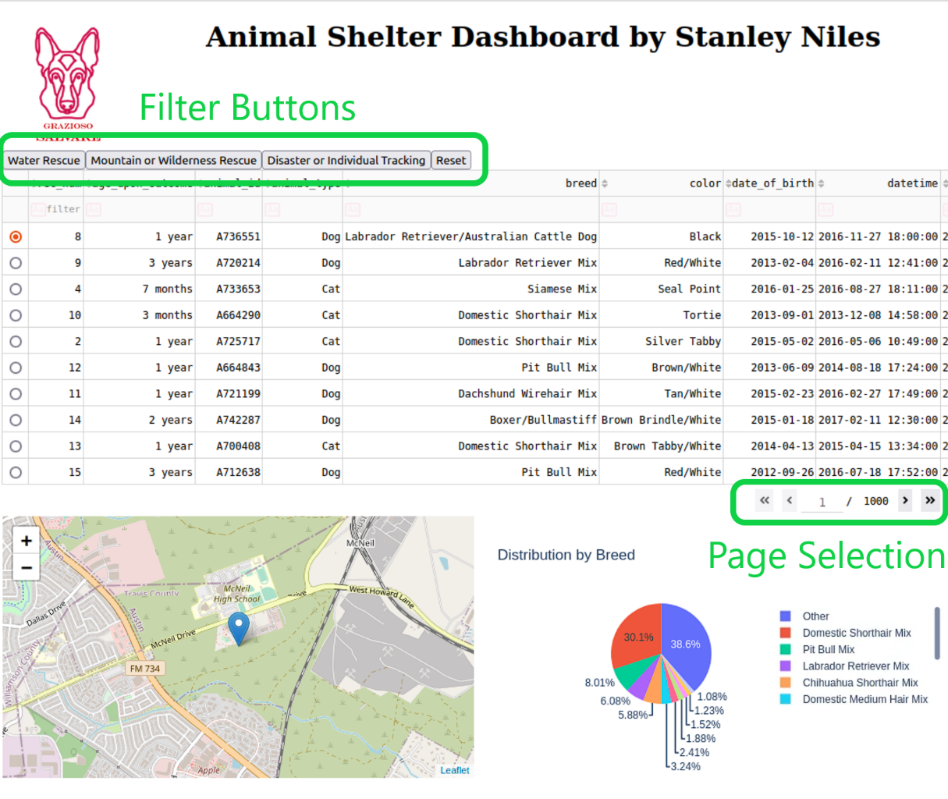

**2. Data Table:** The data table displays filtered records, providing details like breed, age, sex, and more. It supports sorting and native filtering to ease navigation.

**3. Map Visualization:** A map component that updates based on the selected animal in the data table, showing its location with additional information in tooltips and popups.

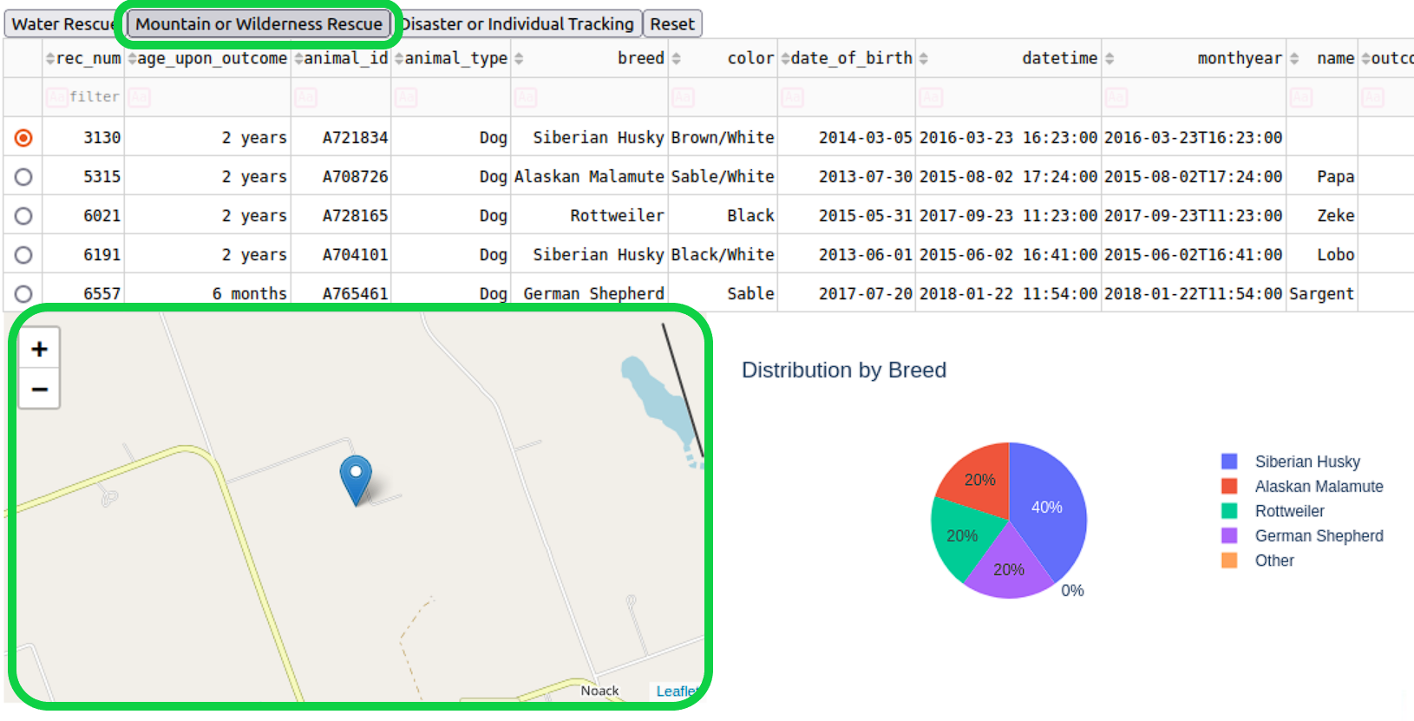

**4. Pie Chart:** A dynamic pie chart displays the distribution of breeds within the filtered records, grouping smaller percentages under "Other".

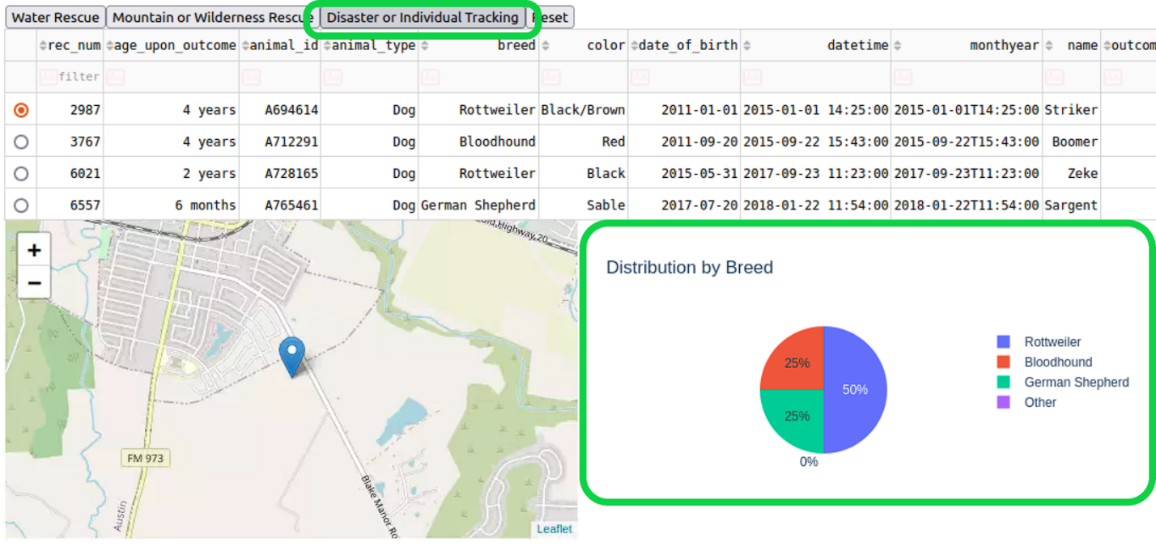

**5. Reset:** A quick reset button is provided to quickly return to the starting state of the dashboard.

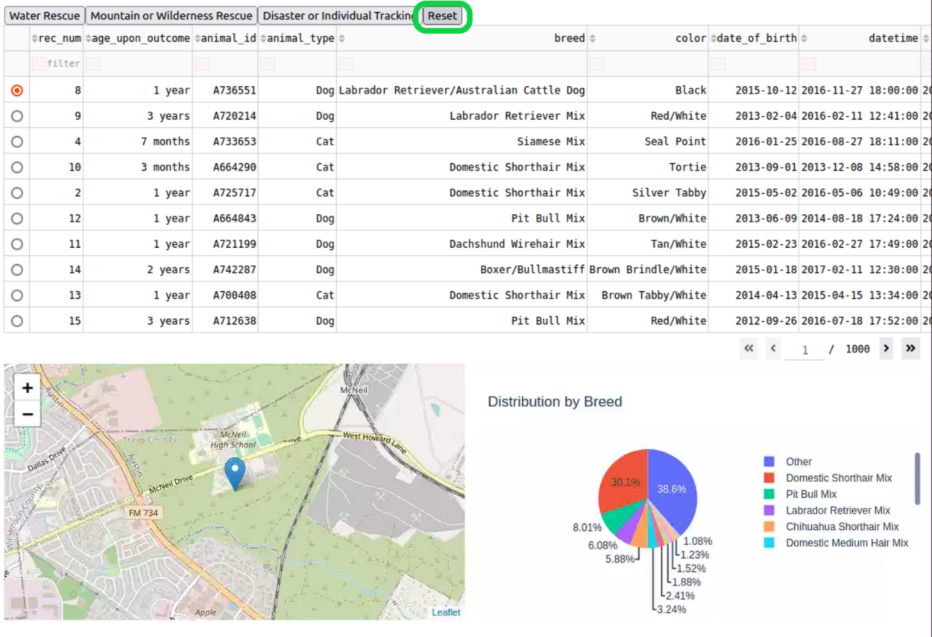

**Tools and Technologies**

Dash Framework

Dash was employed to structure the web application, chosen for:

* Rapid development with Python.
* Integration with Plotly, enabling various visualizations.
* Simple yet powerful callback system to bind interactive components.

MongoDB

MongoDB was selected as the database solution for reasons such as:

* Flexible schema to accommodate diverse data attributes.
* Efficient scalability.
* Support for JSON-like documents, favoring smooth interfacing with Python.

Other Tools

* Pandas: Data handling and manipulation.
* Plotly Express: Visualizations.
* Dash Leaflet: Rendering maps.

***Installation***

Requirements

* Python 3.x: The project is developed in Python and requires version 3.x to run.
* MongoDB: A database system used to store animal data.
* Required Libraries: Libraries including Dash, Pandas, Plotly Express, and Dash Leaflet must be installed.

Steps

1. Clone the Repository

2. Install Python if you do not have Python 3.x installed, download, and install it from Python's official website.

3. Install MongoDB by following the official MongoDB installation guide for your operating system.

5. Install Required Libraries, all necessary libraries are provided in the below libs.txt file.

6. Initialize MongoDB. Follow the instructions to load the animal data into MongoDB and configure the necessary settings.

7. Run the application.

***Conclusion***

The Animal Shelter Dashboard provides Grazioso Salvare with an intuitive and interactive platform for accessing animal data tailored to their rescue services. By leveraging modern tools like Dash and MongoDB, the dashboard offers real-time insights and customization, streamlining the decision-making process.