Ex.no:01  
OUTPUT:

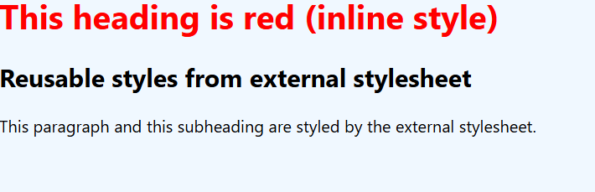

Ex.no:02  
OUTPUT:

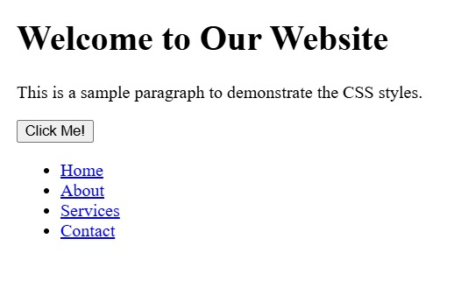

Ex.no:03  
OUTPUT:

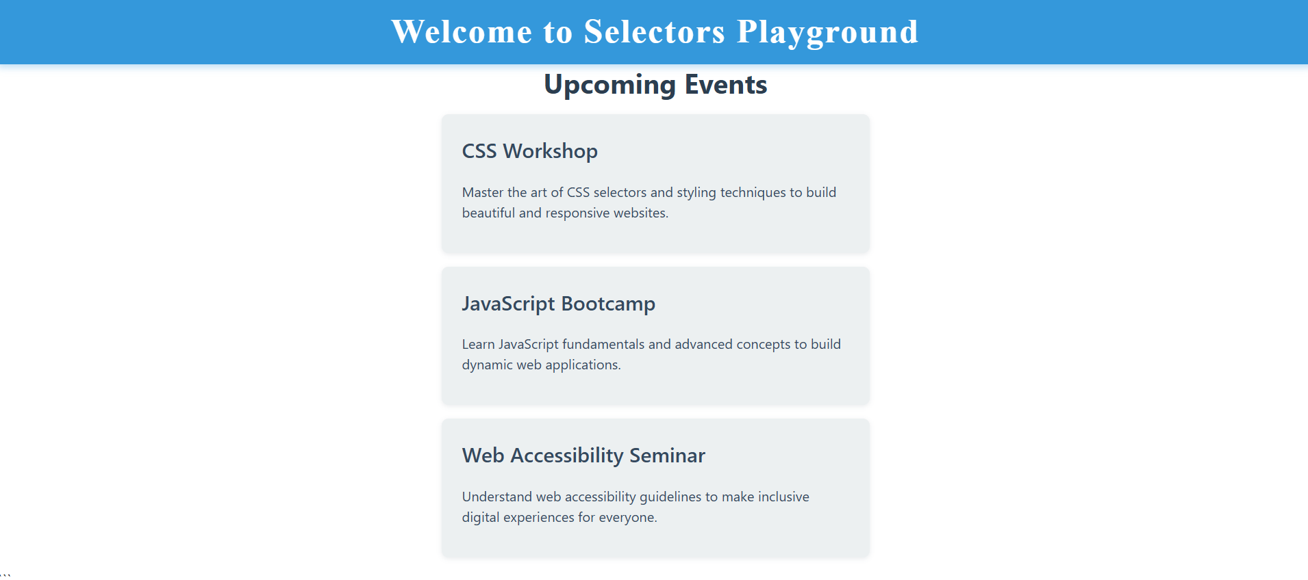

Ex.no:04  
OUTPUT:

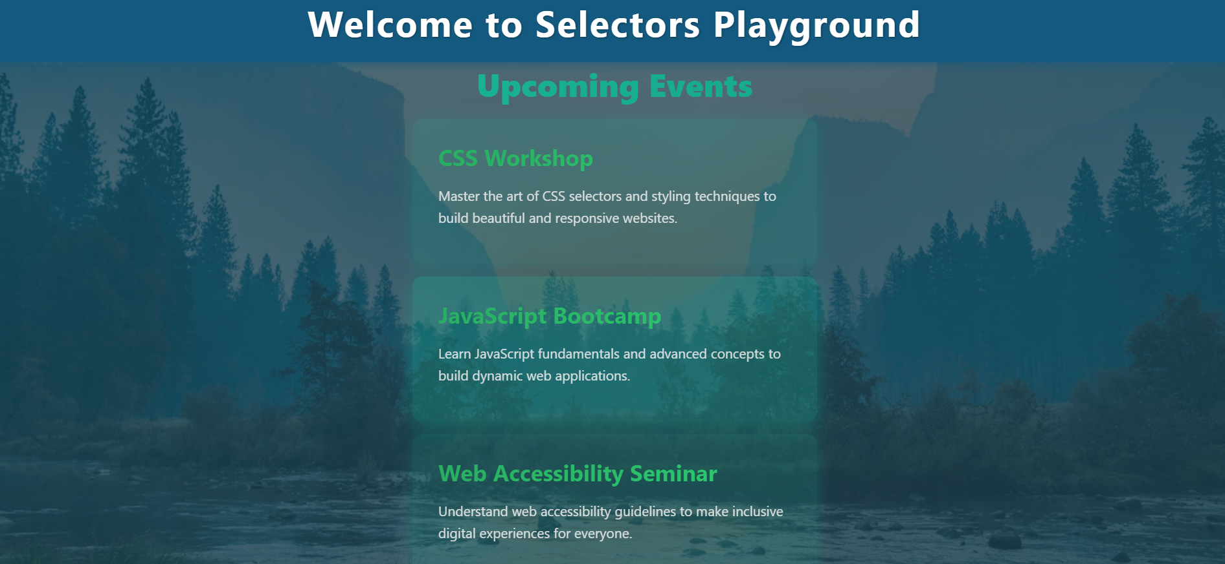

Ex.no:05  
OUTPUT:



Ex.no:06  
OUTPUT:



Ex.no:07  
OUTPUT:



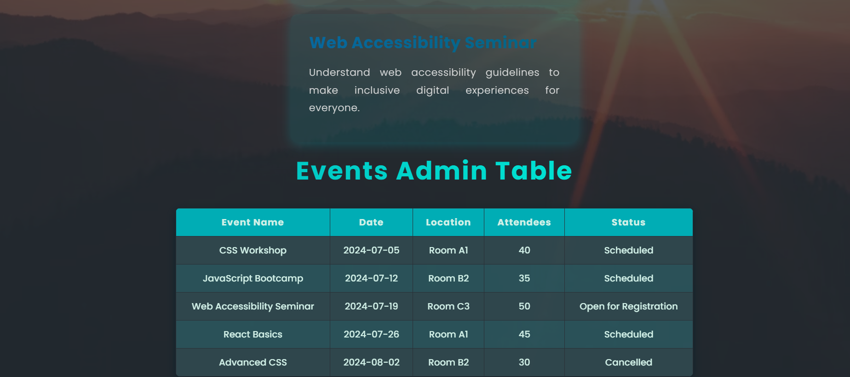

Ex.no:08  
OUTPUT:

Ex.no:09  
OUTPUT:

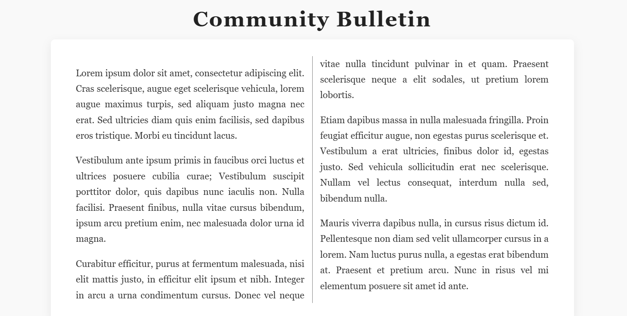

Ex.no:10  
OUTPUT:

Ex.no:11  
OUTPUT:

