1.

OUTPUT:





2.

OUTPUT:



3.

OUTPUT:

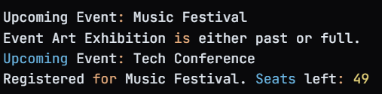

4.

OUTPUT:

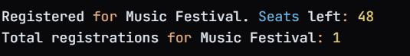

5.

OUTPUT:



6.

OUTPUT:



7.

OUTPUT:

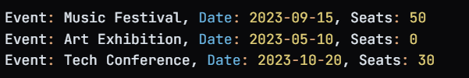

8.

OUTPUT:







9.

OUTPUT:

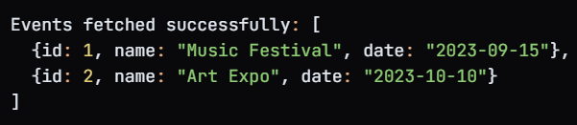

10.

OUTPUT:



11.

OUTPUT:



12.

OUTPUT:



13.

OUTPUT:

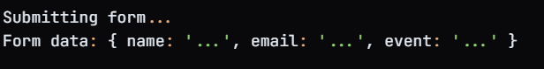

14.

OUTPUT:

