Samir Rathore
Documentation Document
I. Before you run code.
a. The first step is to install python version 3.11.6. The newest version of python, 3.12.1, gave me issues when running with YOLOv8.
b. The next step is to pip install Ultralytics in the terminal, this will take a bit depending on your internet speed. Then import the YOLO module from
Ultralytics which allows you to use YOLOv8n. Then install OpenCV
Matplotlib, and NumPy if you don’t have them already. Be sure to make
sure that you have the same versions as me, so that there are no errors.
c. The next step is to choose a file path for the test video. Depending on how fast you want the code to run, use either the short video or test video. The short video is only a second long and will do just as good as the test video. The test video will take a lot longer and requires a lot more memory to
use. If you don’t have a graphics card in your computer, consider running the short video first by commenting out the test video and uncommenting the short video. Note that you will need to also change the file path at the end of the code when we display both videos side by side. Scroll to line
121 and uncomment it and subsequently comment out line 120. This will ensure that only the short video is being used throughout the entirety of
the code. Also note that if you are running the code more than once and want to use the short video first and then the test video, you must delete the runs folder that is produced from the YOLOv8n prediction. This is because each time you run the code, a new video file will be produced in a different folder, changing the file path. To prevent this, we delete the folder so that a new one can be made again, so the file path never changes.
d. The model command passes the input as the source and limits the minimum confidence of a prediction to 0.5. The arguments save and show are both true so that we can simultaneously show the results on a window popup and save them to the file as I discussed earlier.
II. What to expect once you run code.
a. The first thing that will happen is a window will pop up on your screen. Depending on what file path you choose, the actually video will be
different, but it should look something like this:
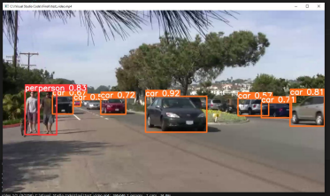
b. You will also notice that a folder called runs will be created. This file stores the video file you just saw. Make sure that every time you change the file path, you delete this folder.
c. Once that video finishes, how long depends on your computer specifications, a new popup will show. This is the realtime predictation that OpenCV is making, this will take considerably longer than the previous popup. It should look like this:
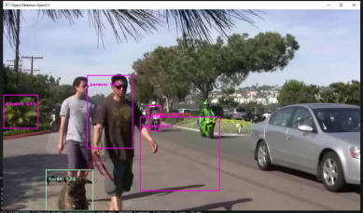
d. Note that you can quit this by pressing the spacebar. However, this will reduce the number of frames recorded to the output_file.avi. This step will have a large effect on how long the next video is, so let it run for a bit and then you can close it when you are ready, or let it play out fully, but that might take a while.
e. After you either close the popup or wait for it to finish, a new popup with the two videos you just saw is displayed. It should look like this:
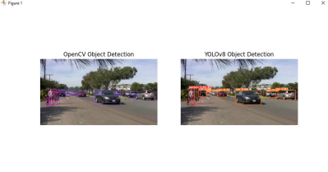f. Once the video on the left runs out of frames, there will be an error, and the code will quit, but that’s fine because that is the last step. This only happens because the video on the right still has more frames and therefore when the update function wants to switch the color channels of the frame in the video to the left, there are no frames to do so.
g. Notice how YOLOv8 has better Object Detection and Tracking. It is more accurate and doesn’t lose sight of objects like OpenCV does at close distances. The confidence scores are also higher on average for YOLOv8.

