Program 12(i)

import java.util.\*;

public class pgm13{

public static void main(String a[]){

Scanner obj= new Scanner(System.in);

int n=obj.nextInt();

for(int i=1;i<=n;i++){

for(int j=1;j<=i;j++){

if((i+j)%2==0)

System.out.print("1");

else

System.out.print("0");

}

System.out.println();

}

}

}

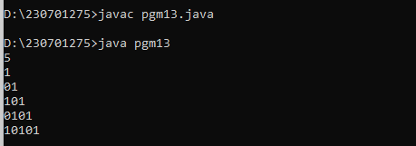

Program 12(ii)

import java.util.\*;

public class pgm14{

public static void main(String a[]){

Scanner obj= new Scanner(System.in);

int n=obj.nextInt();

for(int i=n;i>=1;i--){

for(int j=1;j<=i;j++){

System.out.print(j);

}

System.out.println();

}

}

}

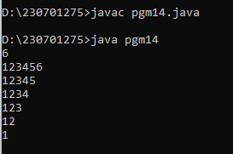

Program 13

import java.util.\*;

public class pgm15{

public static void main(String a[]){

Scanner obj= new Scanner(System.in);

String n=obj.next();

switch(n){

case "Monday":

System.out.println("It Weeksday");

break;

case "Tuesday":

System.out.println("It Weeksday");

break;

case "Wednesday":

System.out.println("It Weeksday");

break;

case "Thursday":

System.out.println("It Weeksday");

break;

case "Friday":

System.out.println("It Weeksday");

break;

case "Saturday":

System.out.println("It Weekend");

break;

case "Sunday":

System.out.println("It Weekend");

break;

}

}

}

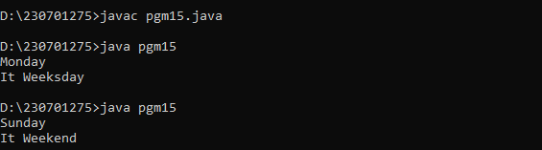

Program 14:

import java.util.\*;

public class pgm16{

public static void main(String a[]){

Scanner obj= new Scanner(System.in);

int n=obj.nextInt();

int b=n;

int sum=0;

while(n!=0){

int rem=n%10;

n=n/10;

int f=1;

for(int i=2;i<=rem;i++)

f\*=i;

sum+=f;

}

if(b==sum)

System.out.println("strong number");

else

System.out.println("not verified");

}

}

