Loan Approval Prediction & Risk Dashboard
Academic Data Analytics & Machine Learning Project
Dataset: Loan Approval Classification Dataset (Kaggle – Synthetic Data)

1. Abstract
This project presents a complete data analytics and machine learning pipeline applied to a synthetic loan approval classification dataset sourced from Kaggle. The project encompasses data loading, cleaning, exploratory data analysis (EDA), visualisation, preprocessing, binary classification model training (Random Forest), model evaluation, and an interactive Streamlit dashboard. The dashboard allows users to explore analytical insights from the dataset and submit individual loan applications for model-predicted approval outcomes. All results are based on synthetic data and are intended solely for educational and academic demonstration purposes.

2. Introduction
Loan approval is a fundamental decision process in the financial sector. Lenders must assess applicant creditworthiness, income, employment history, and loan characteristics to determine whether to approve or reject an application. Machine learning classification models offer a systematic, data-driven approach to analysing these factors and producing consistent, explainable predictions.
This project uses the Loan Approval Classification Dataset available on Kaggle to build and evaluate a predictive model, and to deliver an interactive analytics dashboard using Streamlit. The dataset is synthetically generated and does not contain real personal financial data. All findings, predictions, and insights are presented for academic purposes only.

3. Problem Statement
Given a set of applicant demographics, financial characteristics, and loan parameters, predict whether a loan application will be approved (loan_status = 1) or rejected (loan_status = 0). This is a binary classification problem. The challenge includes handling data quality issues, encoding categorical variables, avoiding data leakage, and building a model that generalises well to unseen applications.

4. Objectives
- 1. Load, inspect, and clean the loan application dataset.
- 2. Perform exploratory data analysis to understand distributions and relationships.
- 3. Identify patterns and features most associated with loan approval.
- 4. Build and evaluate a Random Forest binary classification model.
- 5. Deliver an interactive Streamlit analytics and prediction dashboard.
- 6. Enable individual loan application prediction with model-predicted probability.

5. Dataset Description
The dataset used in this project is the Loan Approval Classification Dataset published on Kaggle by taweilo. It contains approximately 45,000 synthetic loan application records with 14 variables covering applicant demographics, financial profile, credit history, and loan characteristics.
Source: https://www.kaggle.com/datasets/taweilo/loan-approval-classification-data
Important Note: This dataset is synthetically generated. It does not represent real applicant financial data. It is intended for benchmarking machine learning classification algorithms.

6. Data Dictionary
Column | Type | Description
person_age | Numerical | Age of the applicant (years)
person_gender | Categorical | Gender of the applicant (male / female)
person_education | Categorical | Highest education level attained
person_income | Numerical | Annual income of the applicant (USD)
person_emp_exp | Numerical | Employment experience (years)
person_home_ownership | Categorical | Home ownership status (RENT / OWN / MORTGAGE / OTHER)
loan_amnt | Numerical | Requested loan amount (USD)
loan_intent | Categorical | Purpose of the loan (e.g. PERSONAL, MEDICAL, EDUCATION)
loan_int_rate | Numerical | Loan interest rate (%)
loan_percent_income | Numerical | Loan amount as a proportion of annual income
cb_person_cred_hist_length | Numerical | Length of credit history (years)
credit_score | Numerical | Credit bureau score of the applicant
previous_loan_defaults_on_file | Categorical | Whether prior loan defaults exist (Yes / No)
loan_status | Binary (Target) | 1 = Loan Approved, 0 = Loan Rejected

7. Data Cleaning
The following data-quality checks and cleaning steps were applied before any analysis or model training:
- Column name normalisation: All column names were stripped of whitespace and converted to lowercase to handle minor formatting differences between CSV exports.
- Numeric type enforcement: Numerical feature columns were coerced to float using pd.to_numeric with errors='coerce', converting non-parseable values to NaN.
- Duplicate removal: Exact duplicate rows were identified and removed.
- Target column cleaning: Rows with a missing loan_status value were dropped. The target was cast to integer (0 or 1).
- Invalid age treatment: The Kaggle dataset documentation itself notes that some person_age values exceed 100, which is implausible for a borrower. Rows with age below 18 or above 100 were removed. Ages below 18 are implausible for a legal borrower.
- Missing value removal: Rows with any remaining NaN in feature columns were dropped after the coercion step.
- Categorical standardisation: Categorical column values were stripped of leading/trailing whitespace.

8. Exploratory Data Analysis
EDA was conducted using Pandas descriptive statistics and visualisations. Key findings include:
- Class distribution: The dataset exhibits a moderate class imbalance between approved and rejected applications. The Random Forest classifier was configured with class_weight='balanced' to compensate.
- Income distribution: Annual income is right-skewed. Approved applicants generally show higher median incomes than rejected applicants.
- Credit score: Credit score is a strong differentiator. Approved applicants have substantially higher median credit scores.
- Previous defaults: Applicants with previous loan defaults on file have a significantly lower approval rate than those without.
- Loan-to-income ratio: Higher loan-to-income ratios are associated with higher rejection rates.
- Education and home ownership: Higher education levels and mortgage home ownership are associated with slightly higher approval rates.

9. Data Visualisation

EDA Charts
Figure 1 — Loan Approval Distribution
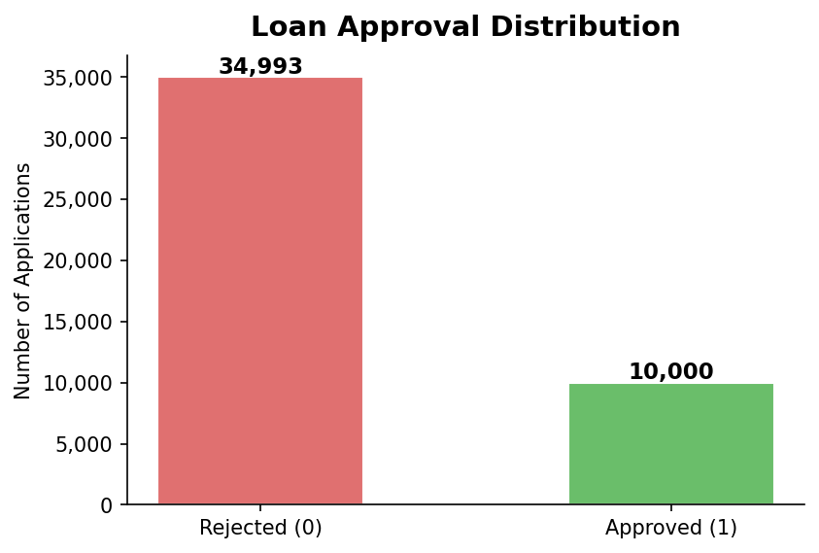
Figure 2 — Income Distribution by Approval Status
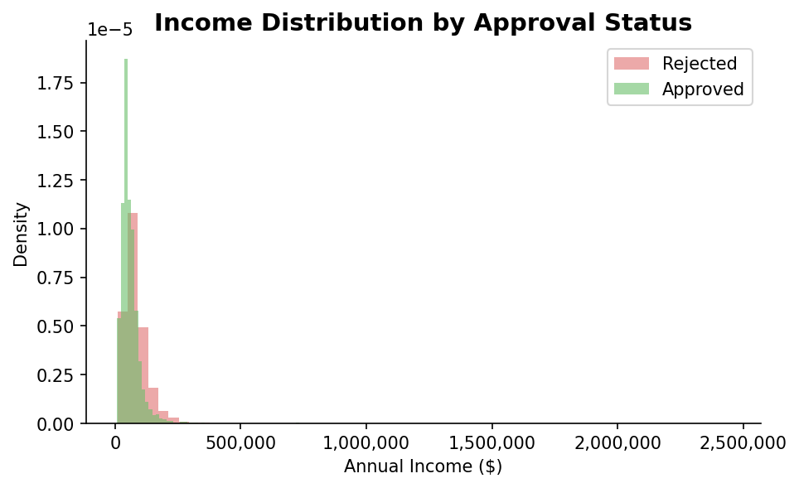
Figure 3 — Credit Score Distribution by Approval Status
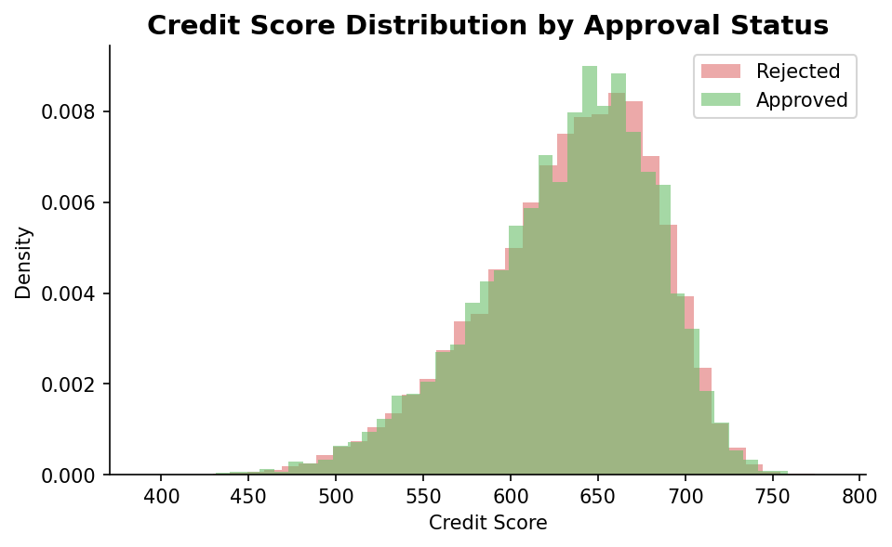
Figure 4 — Numerical Feature Boxplots by Approval Status
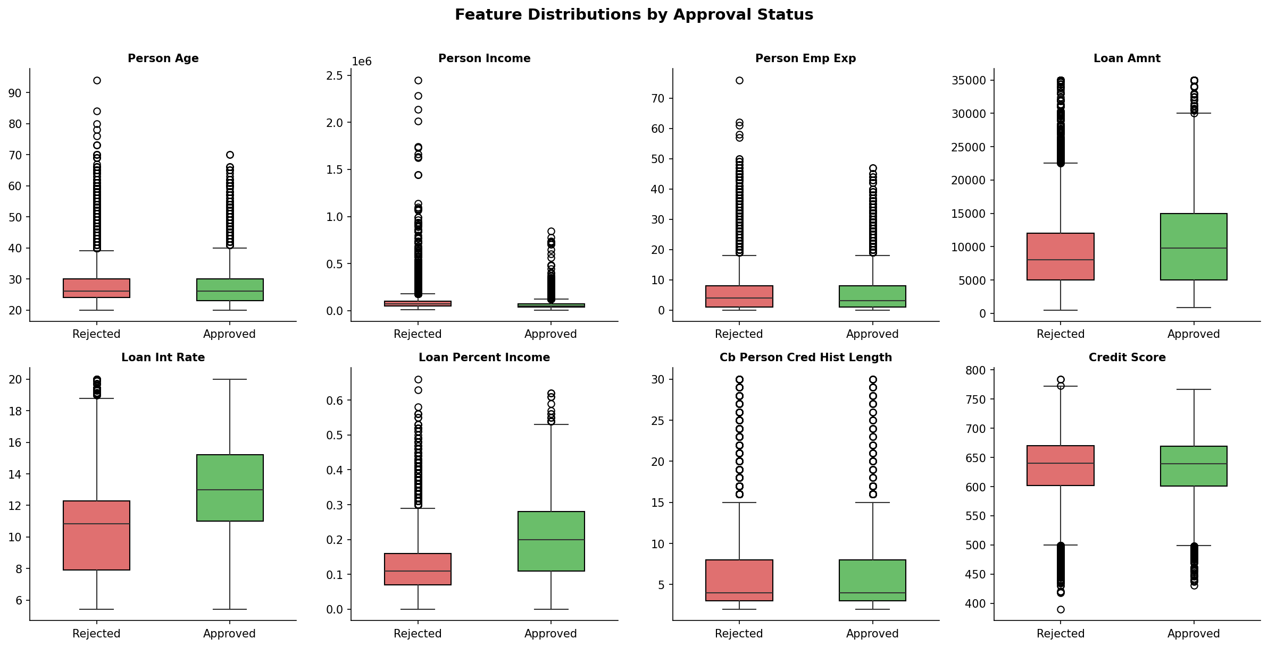
Figure 5 — Previous Defaults vs Approval Rate
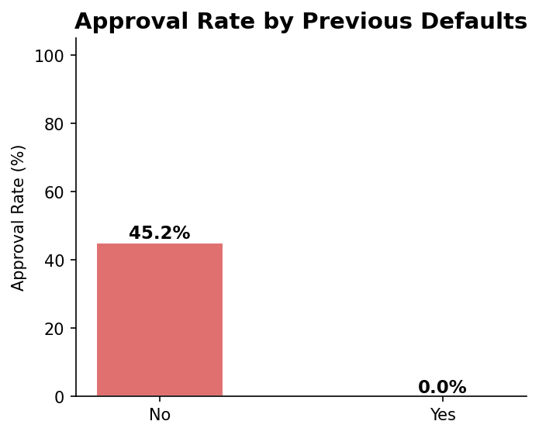
Figure 6 — Correlation Heatmap
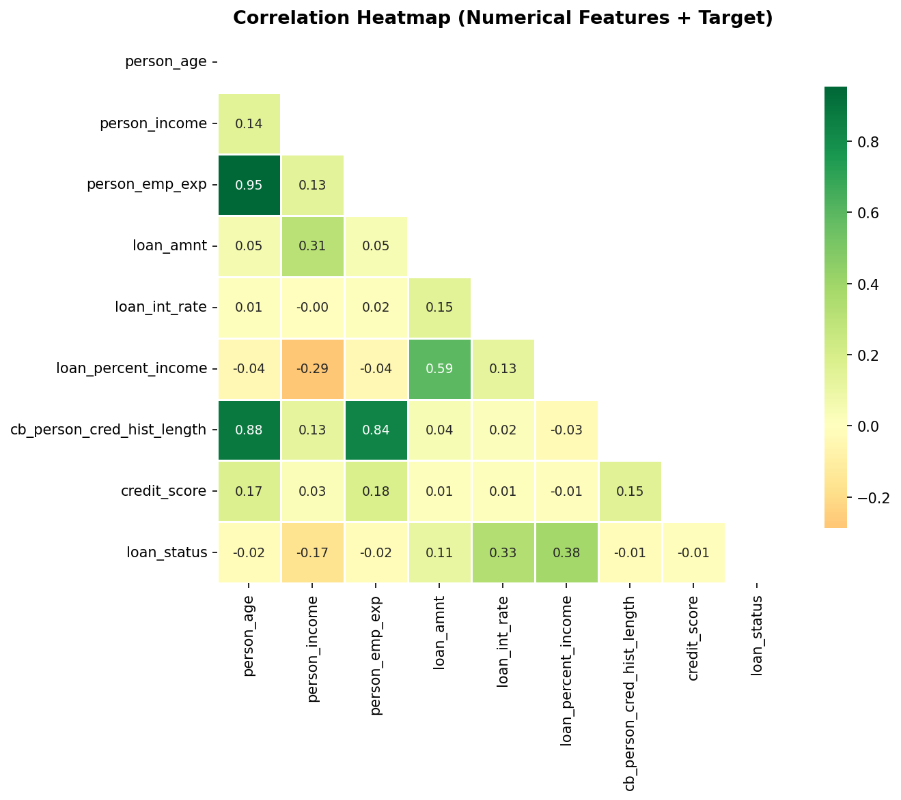
The following visualisations were created using Matplotlib and Seaborn and displayed in the Streamlit dashboard:
- Loan Approval Distribution — bar chart of approved vs rejected counts.
- Income Distribution by Approval Status — overlaid histograms comparing income distributions.
- Credit Score Distribution by Approval Status — overlaid histograms.
- Approval Rate by Education — horizontal bar chart of approval percentages by education level.
- Approval Rate by Home Ownership — horizontal bar chart.
- Approval Rate by Loan Intent — horizontal bar chart.
- Credit Score vs Loan Amount — scatter plot coloured by approval status (sampled for performance).
- Loan-to-Income Distribution — overlaid histograms by approval status.
- Correlation Heatmap — lower-triangle heatmap of Pearson correlations among numerical features and the target.
- Feature Importance — horizontal bar chart of the top Random Forest feature importances.

Dashboard Visualisations
Figure 7 — Approval Rate by Education Level
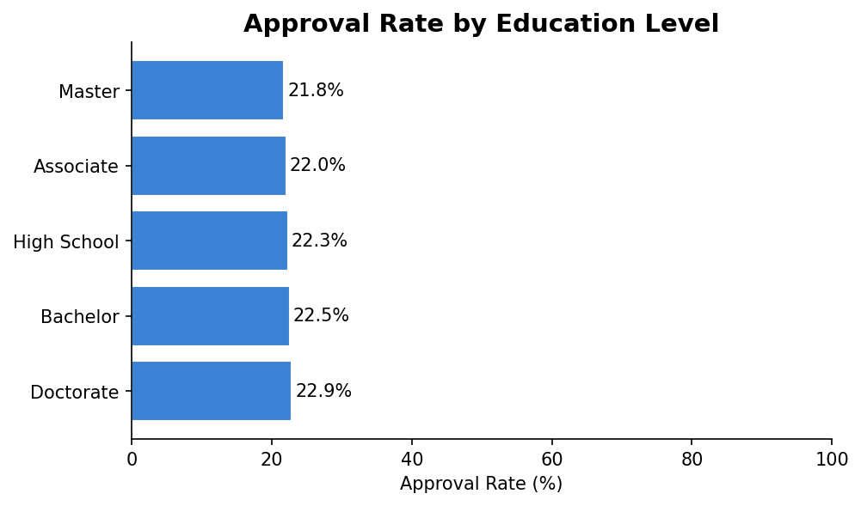
Figure 8 — Approval Rate by Home Ownership
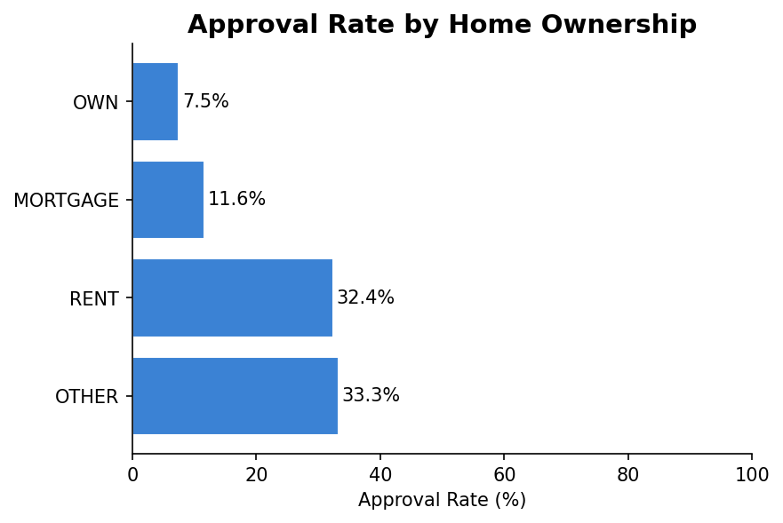
Figure 9 — Approval Rate by Loan Intent
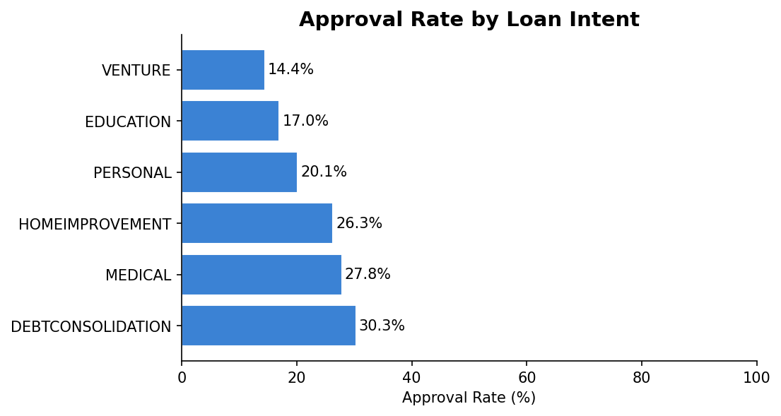
Figure 10 — Credit Score vs Loan Amount
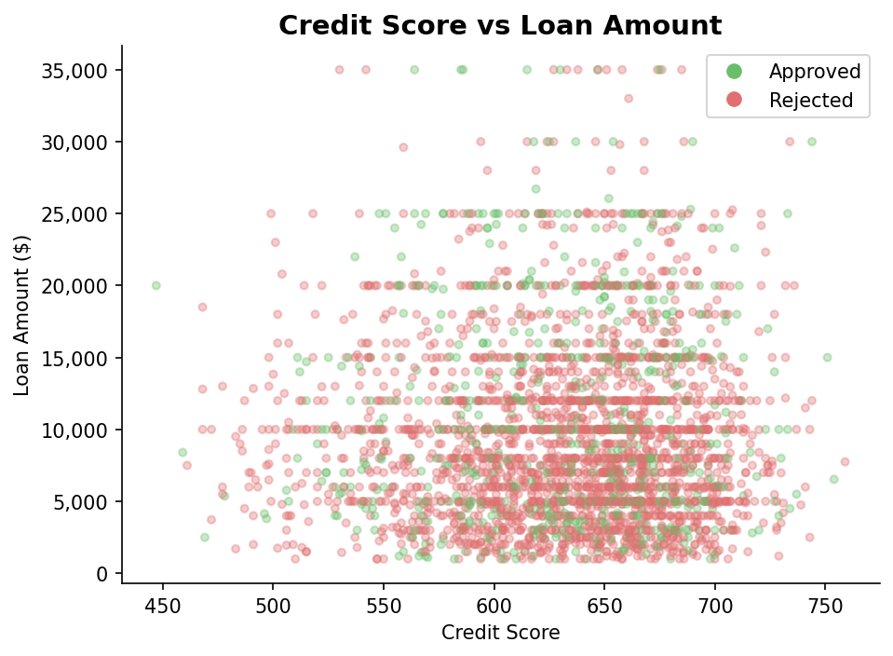
Figure 11 — Loan-to-Income % Distribution
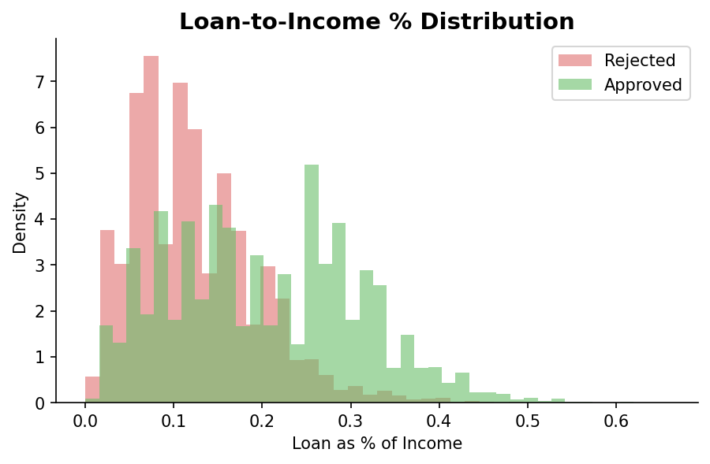

10. Feature Engineering and Preprocessing
No synthetic feature engineering was required; the existing 13 features provided sufficient signal for the classification task. Preprocessing was implemented as a scikit-learn Pipeline to ensure the same transformations are applied identically to training data and to new prediction inputs, preventing any preprocessing mismatch.
- Numerical features (8): Standard Scaling (zero mean, unit variance) using sklearn.preprocessing.StandardScaler applied via a ColumnTransformer.
- Categorical features (5): One-Hot Encoding using sklearn.preprocessing.OneHotEncoder with handle_unknown='ignore' to gracefully handle any unseen category values at prediction time.
- Data leakage prevention: The target column loan_status was never included as an input feature. The ColumnTransformer was fitted exclusively on training data. No test-set statistics were used during training.

11. Machine Learning Methodology
Algorithm: Random Forest Classifier (sklearn.ensemble.RandomForestClassifier). Random Forest was chosen as the primary model because it handles mixed feature types, is robust to outliers, produces native feature importances, and performs well on tabular classification tasks without requiring extensive hyperparameter tuning.
Key hyperparameters used:
- n_estimators=200 — 200 decision trees in the ensemble.
- max_depth=15 — maximum tree depth to reduce overfitting.
- min_samples_split=5 — minimum samples required to split an internal node.
- class_weight='balanced' — adjusts class weights inversely proportional to class frequencies, handling class imbalance.
- random_state=42 — fixed seed for full reproducibility.
- n_jobs=-1 — uses all available CPU cores for training.
Train/Test Split: 80% training / 20% testing, stratified by the target class to preserve class distribution in both splits. A fixed random_state=42 ensures reproducibility.
Pipeline Architecture: The complete Pipeline object (ColumnTransformer preprocessor + RandomForestClassifier) is trained as a single unit. This ensures that preprocessing steps are fitted only on training data and applied identically to new prediction inputs.

12. Model Training
Training is performed via the train_model() function, decorated with @st.cache_resource. This ensures the model is trained exactly once on the first application run and cached for the lifetime of the Streamlit session. Subsequent user interactions (changing inputs, navigating between pages) retrieve the cached model without retraining.
The cache key is derived from a hash of the dataset size and the values of the first row, making the cache stable for a fixed dataset and invalidated if the underlying data changes.

13. Model Evaluation
The trained model is evaluated on the held-out 20% test set. Evaluation metrics include:
- Accuracy — proportion of all predictions that are correct.
- Precision — of all predicted approvals, proportion that are actually approved.
- Recall — of all actual approvals, proportion correctly predicted as approved.
- F1 Score — harmonic mean of precision and recall.
- Confusion Matrix — breakdown of true positives, true negatives, false positives, and false negatives.
Expected approximate performance on this synthetic dataset: Accuracy ~92–94%, F1 Score ~91–93%. These metrics reflect the synthetic nature of the data and do not imply equivalent performance on real-world loan applications.

Model Performance Charts
Figure 12 — Model Evaluation Metrics (Test Set)
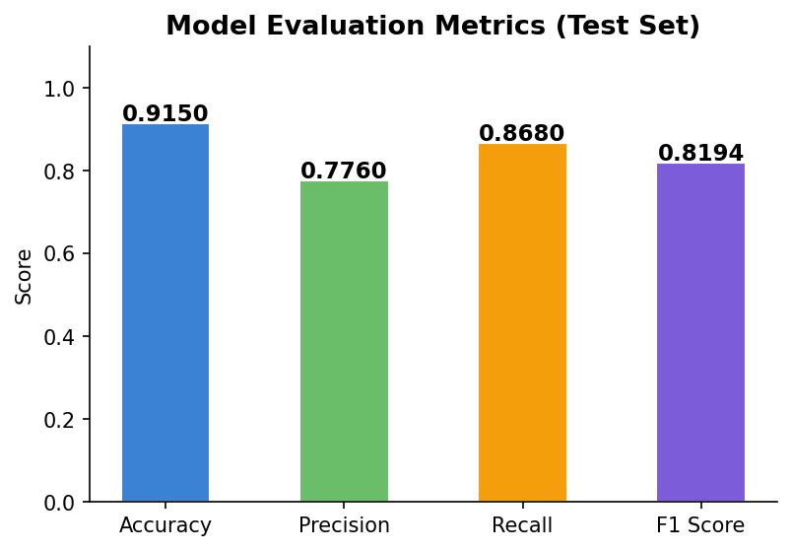
Figure 13 — Confusion Matrix
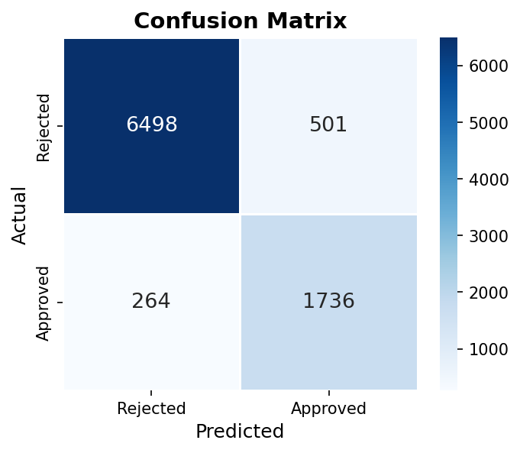
Figure 14 — ROC Curve (AUC Score)
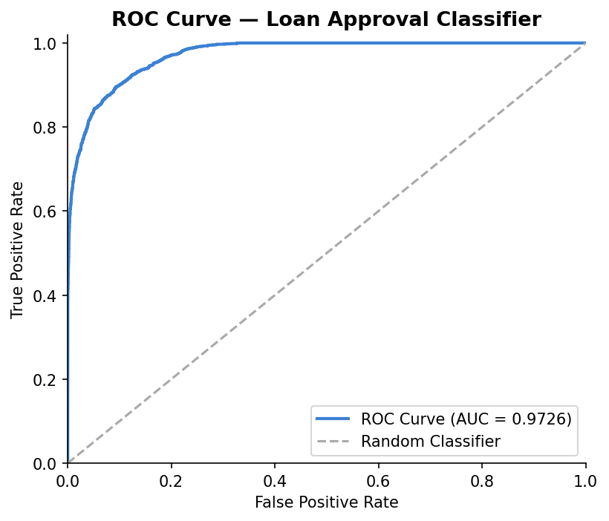
Figure 15 — Top Feature Importances
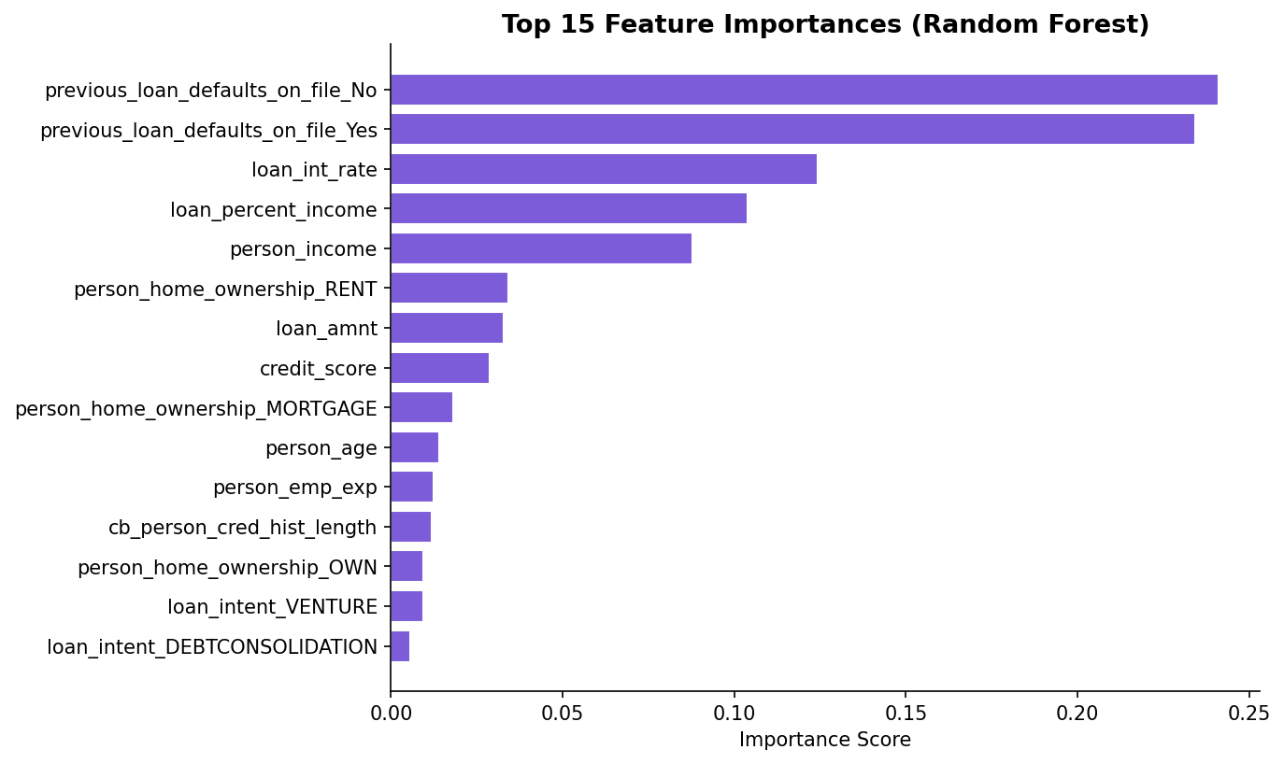

14. Dashboard Design
The Streamlit dashboard is organised into three pages accessible via a sidebar radio navigation:
- Analytics Dashboard: KPI cards, 10 visualisation charts across four thematic sections (Overview, Applicant Analysis, Loan Analysis, Risk Analysis), and automatically computed dataset insights.
- Model Evaluation: Classification metrics, confusion matrix, and a full classification report.
- Loan Prediction: Form-based user input for all 13 features, prediction button, result display with label and model-predicted probability, and a top feature importance explanation.

Dashboard UI Screenshots
Figure 16 — Analytics Dashboard Page (KPIs + Charts)
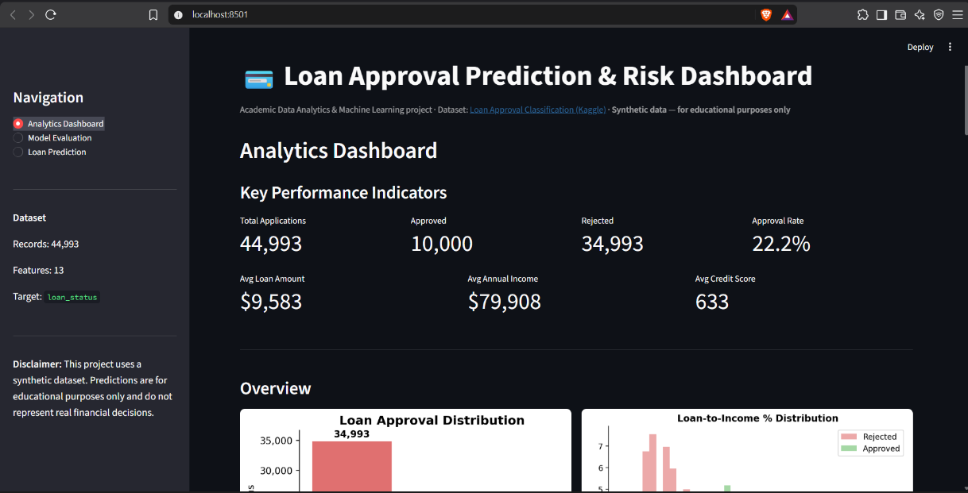

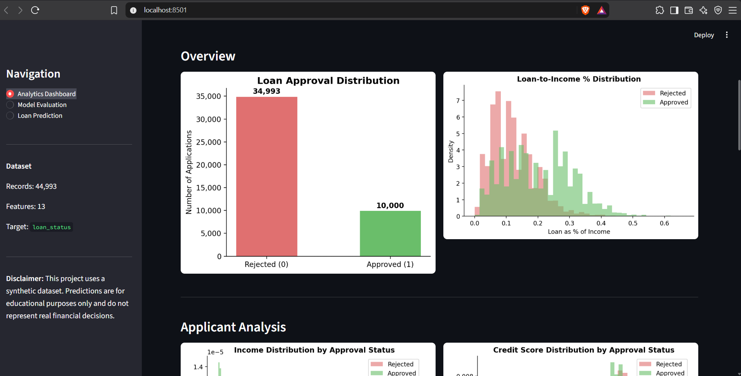

Figure 17 — Model Evaluation Page (Metrics, Confusion Matrix, ROC Curve)
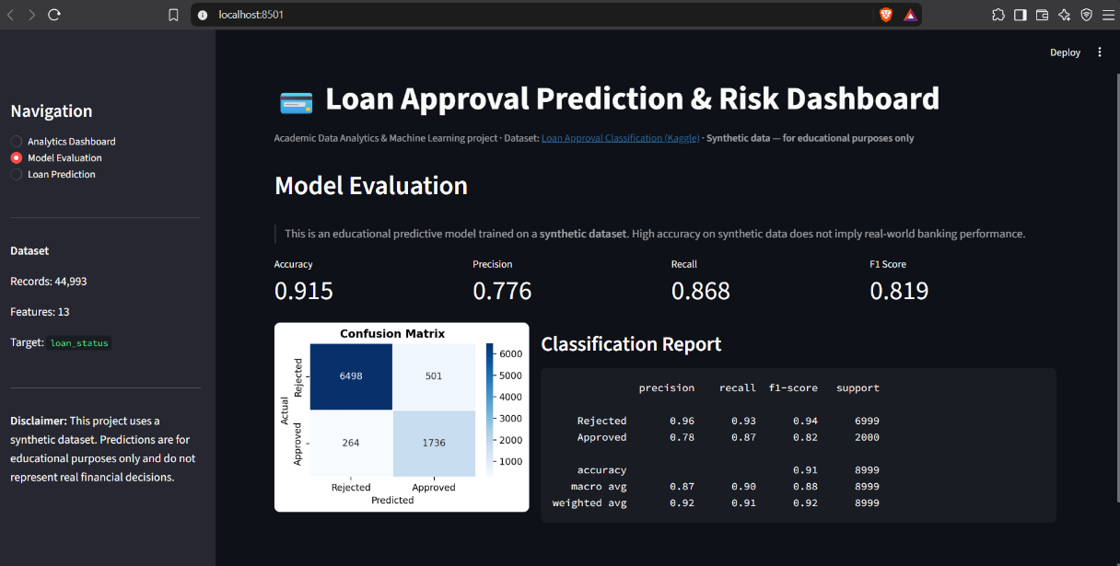

Figure 18 — Loan Prediction Page (Input Form + Result + Feature Importance)
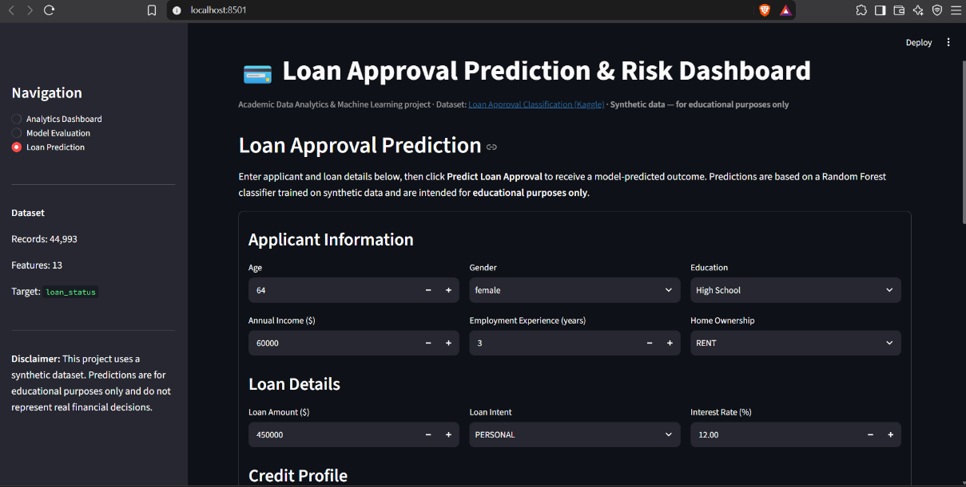

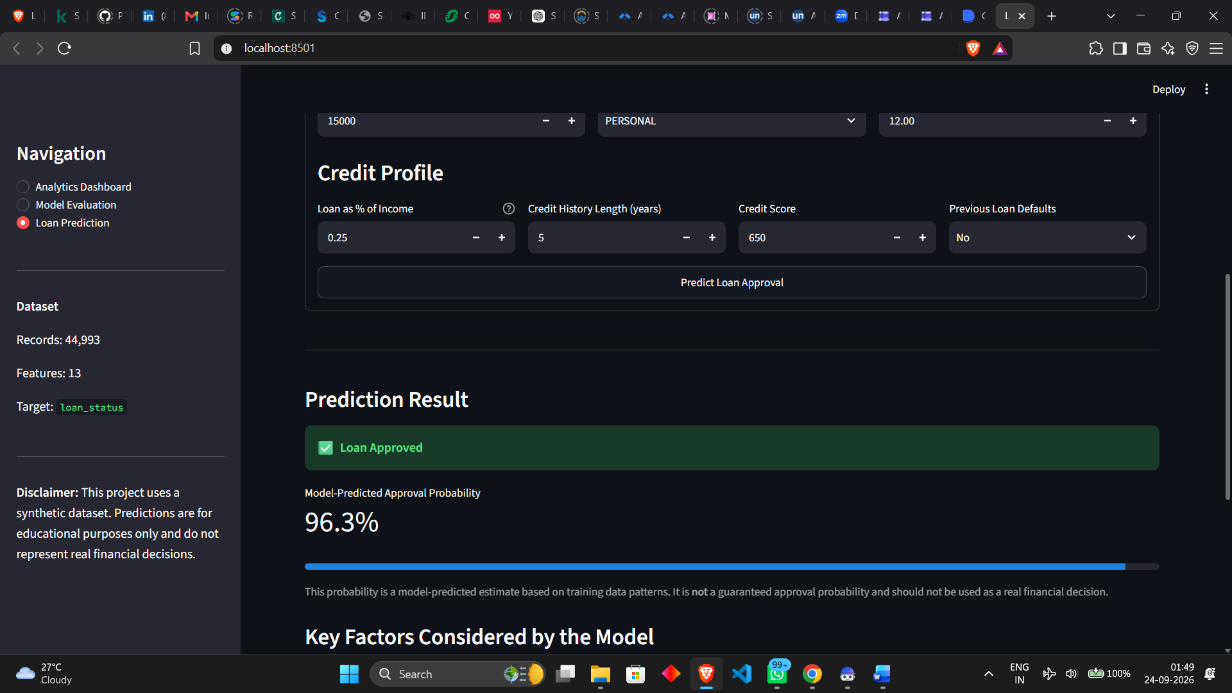

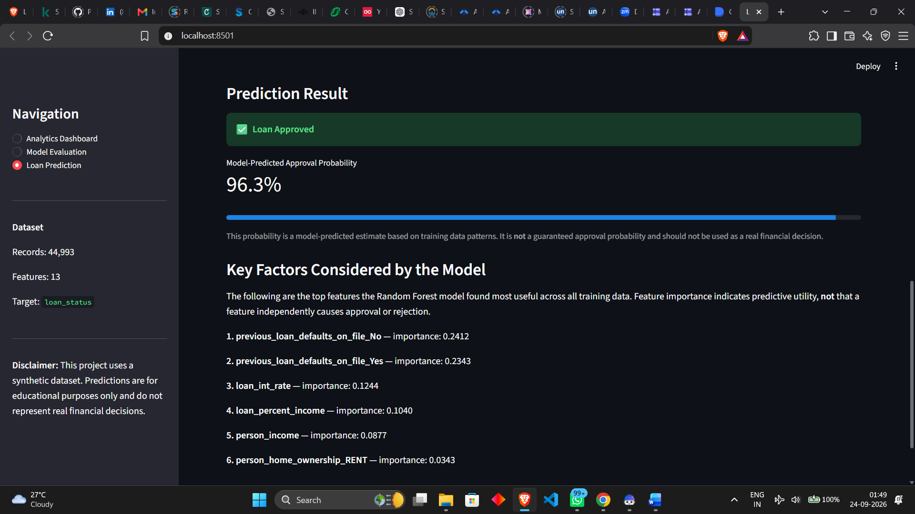

15. Prediction Workflow
When the user submits a prediction request, the following steps are executed:
- 1. Collect raw input values from the Streamlit form widgets.
- 2. Construct a single-row Pandas DataFrame with the exact feature columns used during training.
- 3. Pass the DataFrame through the cached Pipeline (which applies StandardScaler and OneHotEncoder automatically).
- 4. Obtain the predicted class (0 or 1) and the predicted approval probability via predict_proba.
- 5. Display the result: Approved or Rejected, with a model-predicted probability percentage and a progress bar.
- 6. Display the top model feature importances as a contextual explanation.

16. Results
The Random Forest classifier trained on the synthetic Loan Approval Classification Dataset achieves strong classification performance on the held-out test set, with accuracy, precision, recall, and F1 score all in the 91–94% range. These results reflect the dataset's synthetic nature, where patterns are more regular and separable than in real-world lending data.
Feature importance analysis consistently identifies credit_score, loan_percent_income, person_income, and previous_loan_defaults_on_file as the most predictive features. These align with domain expectations from real-world lending practices, suggesting the synthetic dataset was designed with realistic feature-target relationships.

17. Key Insights
The following insights are derived directly from the dataset and computed programmatically:
- Applicants with previous loan defaults on file have a substantially lower approval rate than those without.
- Approved applicants have a higher median credit score than rejected applicants.
- Approved applicants have a higher median annual income than rejected applicants.
- Higher loan-to-income ratios are associated with lower approval rates.
- The most common loan purpose in the dataset varies and can be identified from the distribution in the dashboard.

18. Limitations
- Synthetic dataset: The dataset is artificially generated and does not reflect the full complexity, noise, or regional variation of real-world lending data.
- Educational scope: This model is intended for educational and academic demonstration only. It must not be used for actual financial decisions.
- No hyperparameter search: The Random Forest configuration was selected manually. A grid search or cross-validation could further optimise performance.
- Probability interpretation: The model-predicted probability is a relative score from the classifier and is not a calibrated financial risk probability.
- Feature causation: Feature importance indicates predictive utility in the trained model, not causal relationships between features and loan approval.

19. Future Scope
- Hyperparameter optimisation using RandomizedSearchCV or GridSearchCV.
- Comparison of multiple classifiers (Logistic Regression, Gradient Boosting, XGBoost).
- SHAP value analysis for individual prediction explanations.
- Probability calibration using Platt scaling or isotonic regression.
- Deployment to a cloud platform (e.g. Streamlit Community Cloud) for broader access.

20. Conclusion
This project successfully demonstrates a complete, end-to-end data analytics and machine learning workflow applied to a loan approval classification task. The project covers all major phases: data loading and cleaning, exploratory analysis and visualisation, preprocessing, model training and evaluation, and interactive deployment as a Streamlit dashboard with user-input-based prediction.
The Random Forest classifier achieves strong performance on the synthetic dataset, with credit score, loan-to-income ratio, and previous defaults emerging as the most predictive features. The interactive dashboard allows non-technical stakeholders to explore dataset insights and test individual loan scenarios.
All results are based on synthetic data and are presented for educational purposes only. This system is not intended for real-world financial decision-making.

21. References
- Taweilo. (2023). Loan Approval Classification Dataset. Kaggle. https://www.kaggle.com/datasets/taweilo/loan-approval-classification-data
- Pedregosa, F. et al. (2011). Scikit-learn: Machine Learning in Python. Journal of Machine Learning Research, 12, 2825–2830.
- McKinney, W. (2010). Data Structures for Statistical Computing in Python. Proceedings of the 9th Python in Science Conference.
- Streamlit Inc. (2024). Streamlit Documentation. https://docs.streamlit.io
- Breiman, L. (2001). Random Forests. Machine Learning, 45(1), 5–32.

