-------------------
Myntra Application
-------------------
This is a Myntra clone application.Myntra is a major Indian fashion e-commerce company. It is a one stop shop for
all your fashion and lifestyle needs. This clone is developed using the frontend framework - react, mobile app framework -
react native & backend framework - springboot.

-----------------
Backend TechStack
-----------------
framework - SpringBoot
Server - Tomcat Server
Database - MySQL
ORM - Hibernate
Images management website - cloudinary

---
HLD
---

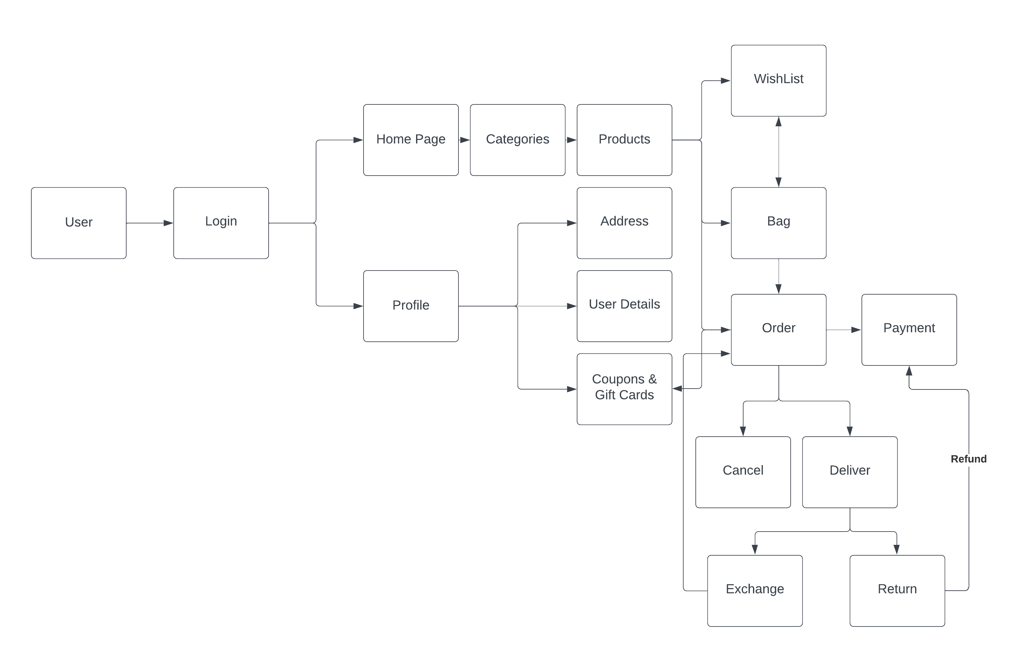

---
LLD
---

------------
Login/Signup
------------

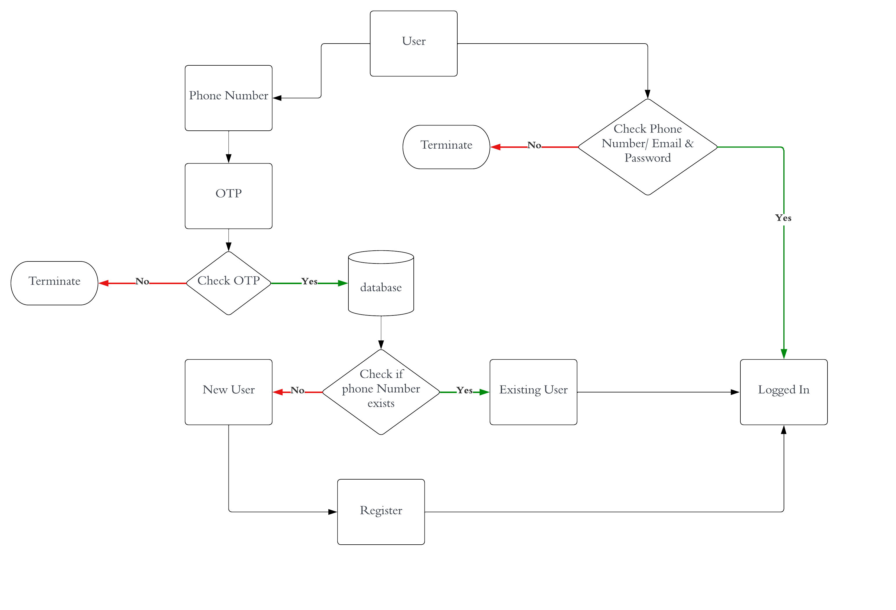

-------
Profile
-------
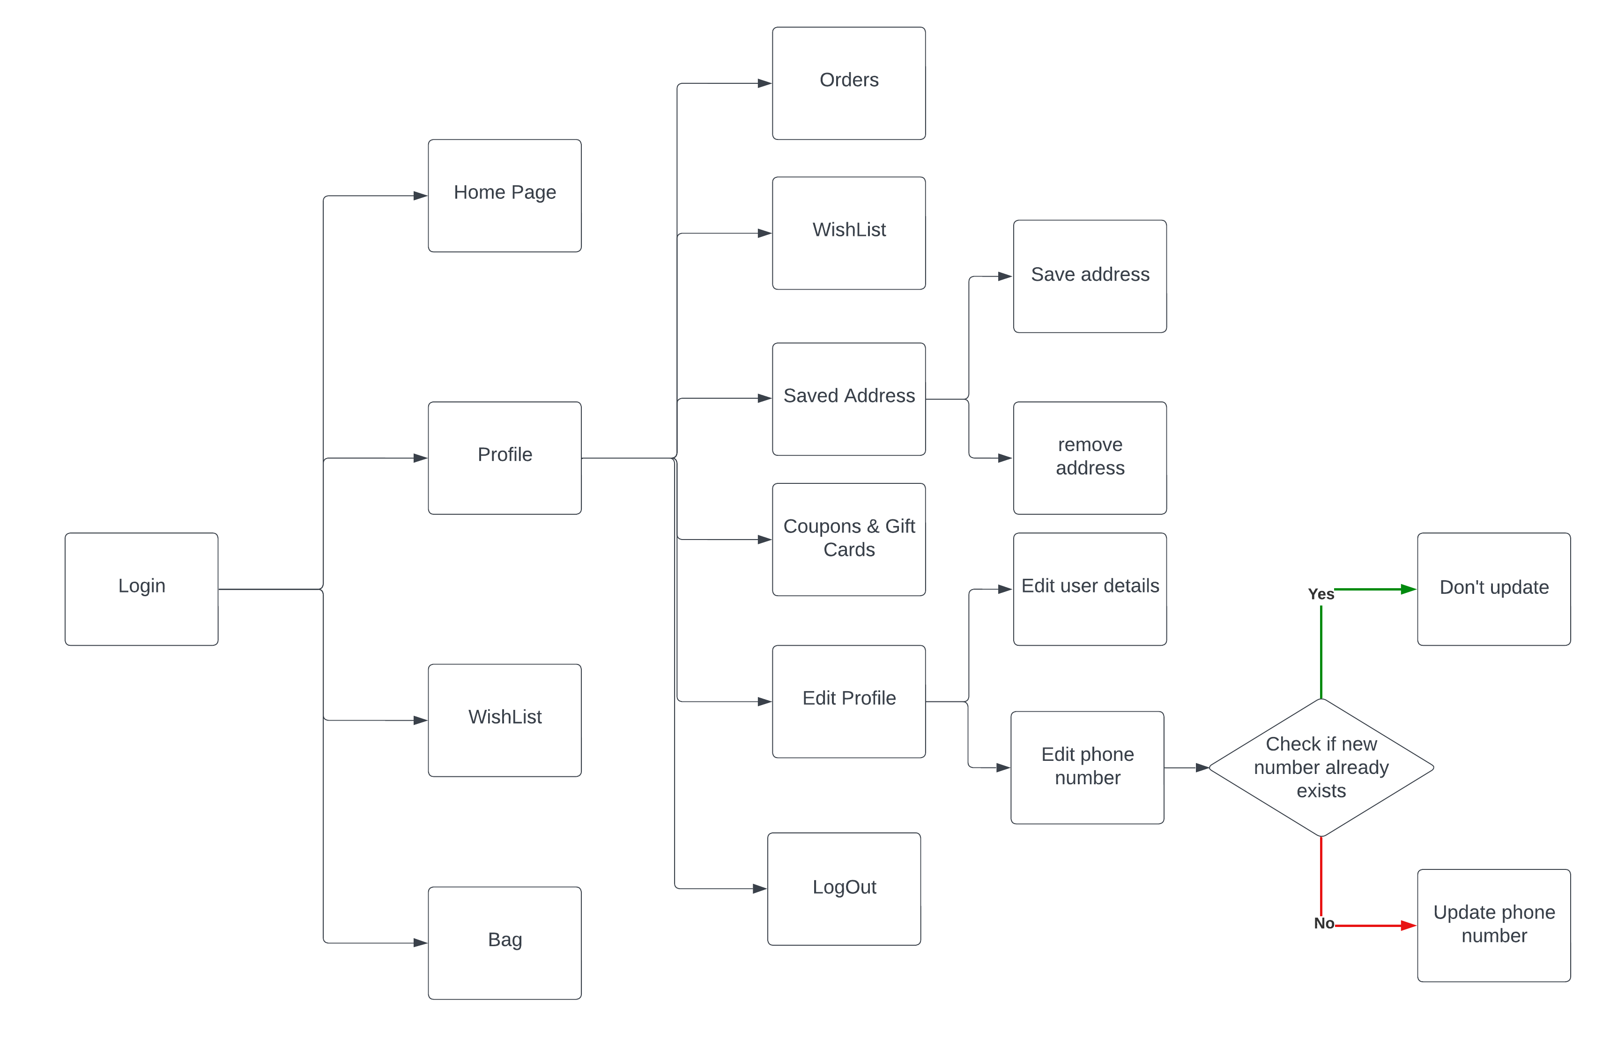
--------
Products
--------

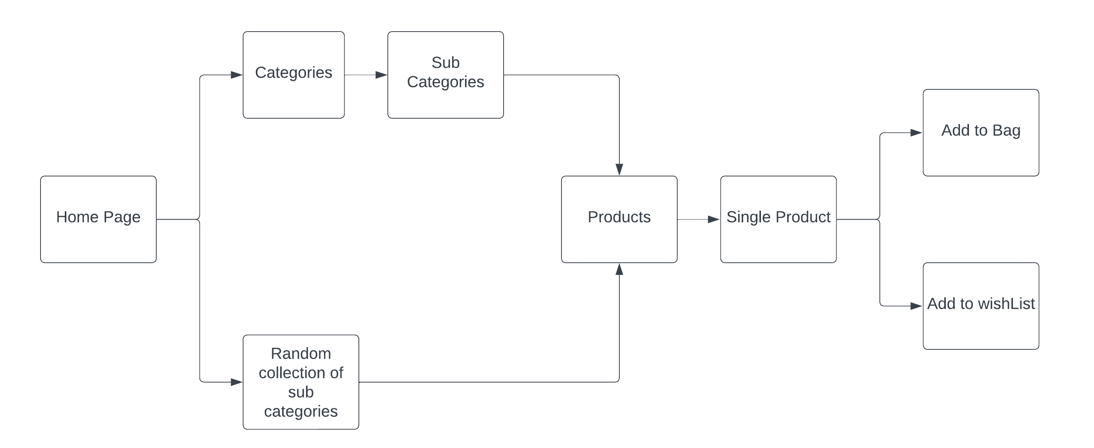

--------------
WishList & Bag
--------------

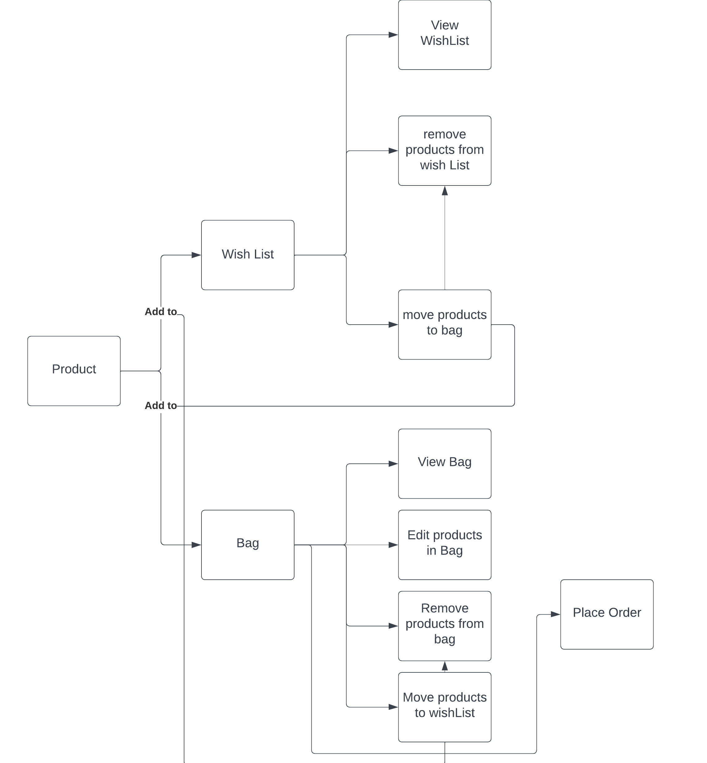

---------------
Database schema
---------------

