CatBoost × LinOSS Fusion: Complementary Feature-Based and Oscillatory State-Space Detectors for Second-Resolution EEG Seizure Detection
S. Srinivasan, Kritansh Patro
[Affiliation placeholder]
Abstract
Automatic seizure detection in long scalp-EEG recordings is usually evaluated on units of 12 s or 60 s, although clinical review needs an onset and an offset in seconds. We study a detector that scores every second of a recording and combines two branches that read the EEG in different ways. The first branch is a bidirectional oscillatory state-space model (LinOSS) that reads 19 unfiltered referential electrodes as one 0–99 Hz log-spectrum per second and integrates their evolution over windows of 240 s with learned damped oscillators. The second branch is a committee of 50 gradient-boosted tree models (CatBoost) that reads 588 hand-crafted features of 60 s windows of 16 filtered bipolar chains, together with summary statistics over ±7 neighbouring windows. A logistic stacker with a product term fuses the two per-second scores; small read-out heads give the same system at 12 s and 60 s. On the official evaluation set of the Temple University Hospital Seizure Corpus (TUSZ v2.0.6; 43 patients, 127.6 h, 359 annotated events) the fusion reaches a per-second AUROC of 0.963 [0.940, 0.978] (95 % patient-bootstrap interval), an AUPRC of 0.748 [0.663, 0.826] and an F1 of 0.676, against 0.948 / 0.607 / 0.572 for the CatBoost branch alone and 0.938 / 0.612 / 0.347 for the LinOSS branch alone. The branches disagree in a structured way: the first crossing of the CatBoost score above its threshold occurs a median of 24.5 s before the annotated onset and its last crossing 18.5 s after the offset, whereas the LinOSS score first crosses 16 s after the onset and last crosses 14 s before the offset; 59.9 % of the false-alarm seconds that only CatBoost raises lie within 60 s of a seizure, against 3.5 % for LinOSS. The fusion acts as a veto on the blurred edges of the CatBoost score. At event point 1, frozen on the development set, it detects 0.507 of the seizures at 3.01 false alarms per 24 h, 3.95 fewer than the CatBoost branch (paired 95 % interval [−8.63, −0.54]). Under SzCORE event scoring, the fusion obtains an event F1 of 0.758, 0.780 and 0.802 at 1 s, 12 s and 60 s, with 2.82, 3.92 and 2.62 false predictions per day. We report that a hypothesis about the spectral content of the false alarms is not supported, that seizures shorter than 10 s are not detected, and that the comparison with published systems is limited by differences in corpus version, split and scorer.
Keywords: seizure detection; scalp EEG; state-space models; gradient boosting; model fusion; TUSZ; SzCORE; false-alarm rate.

1 Introduction
Scalp EEG is the standard record for diagnosing epilepsy and for monitoring seizures in intensive-care and epilepsy-monitoring units, and a single recording can last many hours. Automatic seizure detection is meant to find the seizure periods so that a reviewer does not have to read the whole recording. For that use, the output has to be a set of seizure events with an onset and an offset in seconds, and the number of false alarms per day has to be small, because every false alarm costs reviewer time. A large part of the recent deep-learning literature instead reports window-level discrimination on clips of 12 s or 60 s [1–3], and event-level numbers depend strongly on the scoring rule [4, 5].
Two families of detectors are currently strong on the Temple University Hospital Seizure Corpus (TUSZ) [6]. Graph, state-space and transformer networks learn from spectral or raw representations end to end [1–3, 7–9]. A reproducible gradient-boosting ensemble on clinically motivated features of 60 s windows, with summary statistics over neighbouring windows, reaches competitive window- and event-level performance without a neural network [10]. The two families differ in what they observe (unfiltered log-spectra of 19 referential electrodes versus filtered bipolar chains and hand-crafted features), in the temporal scale at which they integrate (a learned recurrence over minutes versus fixed summary statistics over windows) and in the resolution at which they are trained (one second versus one 60 s window). We therefore ask whether their errors are different enough to be combined.
This paper describes and evaluates such a combination, the CatBoost × LinOSS fusion. Its LinOSS branch is a bidirectional network of oscillatory state-space layers [11] that reads one spectral token per second. Its CatBoost branch is our implementation of the committee of Zabihi et al. [10] with a reduced feature set (588 instead of 941 base features; Appendix A.1). A logistic stacker fuses the two per-second scores, and small read-out heads on the same LinOSS backbone give 12 s and 60 s outputs for comparison with published systems.
Contributions. We make the following contributions.
- A second-resolution fusion architecture (Section 3). Per-second outputs from a LinOSS branch (240 s bidirectional context, sin²-blended overlapping windows) and a CatBoost branch (60 s windows every 15 s, ±7-window statistics) are fused by a logistic stacker with a product term. We state, and measure, the evidence-addition argument behind it (Sections 3.6 and 5.7).
- Changes to the two building blocks (Sections 3.4 and 3.5). We adapt LinOSS to EEG with a per-electrode block, electrode pooling, a time-reversed second layer in every block (bidirectional, non-causal), an exact channel-kernel implementation, and an oscillator-period initialisation matched to the time scale of seizure evolution. We re-implement the CatBoost committee on a reduced feature set and list every deviation from the original (Appendix A.1).
- Multi-resolution read-outs (Section 3.7). One LinOSS backbone gives 1 s, 12 s and 60 s outputs. The 12 s and 60 s outputs use a residual “overlooker” head and a stacker that fuses the CatBoost clip or window logit.
- Evidence that the branches make different mistakes (Section 5.7). Timing at onset and offset, event Venn counts, false-alarm geography, a measured logit correlation, and a spectral hypothesis for the false alarms that we tested and found not supported.
- A fully frozen evaluation (Sections 3.9 and 4). Every choice is made on development data; each test set is scored once; the 1 s results carry patient-level bootstrap intervals; event-level results use the SzCORE scorer [5] and an any-overlap scorer; the comparison with published systems states the corpus version, split and scorer of each row (Section 5.2).
- An all-metric ablation (Section 5.1) of the fusion against each branch alone at 1 s, 12 s and 60 s, on the test and development sets, with per-seed spreads, and a complete account of why the 12 s and 60 s scores are lower than the 1 s scores (Section 5.3).
Section 2 reviews related work. Section 3 describes the method, Section 4 the experimental set-up, Section 5 the results, and Sections 6 and 7 discuss limitations and conclude. The appendices give the deviations from Zabihi et al., the full SzCORE table, per-seed tables, hyperparameters and the rejected alternatives. Code, frozen plan and aggregate results are public (Section 8).

2 Related Work

2.1 Graph, state-space and foundation models for seizure detection
Tang et al. introduced diffusion-convolutional recurrent graph networks with self-supervised pre-training on TUSZ (v1.5.2) and the log-magnitude Fourier representation with 100 frequency bins per second that most later work on 12 s and 60 s clips adopts [1]; GraphS4mer combined graph learning with structured state-space layers [7, 12]. EvoBrain, ODEBrain and HyBrain model time-evolving brain graphs, continuous-time dynamics and spatiotemporal hyperedges respectively, and are evaluated with AUROC and F1 on 12 s and 60 s clips [2, 3, 13]; HyBrain uses a per-channel Mamba backbone [14] and, as a result, serves as the main clip-level comparator in this paper. A temporal-graph analysis of recurrent versus static graph encoders is given in [15]. DGDCN combines dynamic graph convolution with dilated temporal convolution on TUSZ v2.0.1 [16]. General-purpose EEG foundation models (BIOT, LaBraM, EEGPT) are pre-trained on large corpora and fine-tuned [17–19]; HyBrain reports them as baselines for seizure detection [3]. DeepSOZ localises the seizure onset zone jointly in time and space [20].
Two recent systems score continuous recordings directly. SeizureTransformer (an EEG U-Net with a transformer encoder, 41.0 M parameters) outputs a probability for every time step [8]. LookAroundNet scores a 16 s target segment with additional context before and after it and shows that the amount and placement of context matter [9]. Both use the SzCORE event scoring; neither combines a feature-based model with a network.

2.2 Feature-based ensembles
Before deep networks, seizure detection on the TUH corpora relied on hand-crafted features and shallow classifiers; the CNN/LSTM hybrids that followed were evaluated with the NEDC scoring rules [4, 21, 22]. Zabihi et al. revisited the feature route with three CatBoost [23] committees on 60 s windows with a 15 s stride, features from four scalp regions, summary statistics over ±7 windows, and an “alarm-budget” operating-point rule fixed on the development set; on TUSZ v2.0.3 they report a window AUROC of 0.919 and an event sensitivity of 0.749 at 0.682 false alarms per hour [10]. We use their window design, label rule and event post-processing as the CatBoost branch and as the 60 s read-out.

2.3 Oscillatory and state-space sequence models
Structured state-space models (S4, Mamba) process long sequences with linear recurrences [12, 14]. Rusch and Rus proposed LinOSS, whose recurrence is the discretisation of forced harmonic oscillators; the implicit discretisation is dissipative and stable as long as the diagonal state matrix is non-negative [11]. Their benchmarks (long time-series classification, regression) contain no EEG. Mamba-style layers have been used for seizure detection in HyBrain [3]; to our knowledge, oscillatory layers have not been reported on seizure detection before this work.

2.4 Evaluation standards
The same detector can obtain very different scores under different scoring rules. Ziyabari et al. define five rules for the TUH corpora; for one CNN/LSTM system, they report a sensitivity of 30.83 % under the overlap rule and 12.48 % under time-aligned event scoring [4]. SzCORE defines event scoring with tolerances (30 s before and 60 s after an annotated event, any overlap counts, events closer than 90 s are merged) and sample scoring at 1 Hz, and provides software and a public benchmark [5]. A large benchmark on a private epilepsy-monitoring data set with 28 algorithms reports a best event F1 of 32 %, which documents a generalisation gap between published and held-out performance [24]. Zabihi et al. fix an alarm budget on the development set (maximise event sensitivity subject to window specificity ≥ 0.93 and at most 0.69 false alarms per hour) and report patient-level bootstrap intervals [10]. We adopt a development-frozen operating-point policy and the patient-level bootstrap, and report both an any-overlap scorer and SzCORE.

3 Method

3.1 Overview
The system (Figure 1) has two parallel branches and a stacker. The LinOSS branch (OscSeq) turns every second of a recording into one spectral token per electrode, processes the sequence of tokens with a stack of bidirectional oscillatory state-space layers and outputs one seizure logit per second. The CatBoost branch cuts the recording into windows of 60 s every 15 s, computes 588 hand-crafted features per window (plus 11 context statistics per feature over ±7 windows), and outputs one probability per window by averaging three committees of gradient-boosted trees. The window probability is spread over the seconds that the window covers. The stacker is a logistic regression on the logits of the two per-second scores and on two smoothed versions of the LinOSS logit. Its output, p(t), is the fused probability of second t; an event rule turns it into seizure events. For comparison with published work on 12 s clips and 60 s windows, small “overlooker” heads on the per-second LinOSS summaries and a second stacker give the same system at those resolutions.
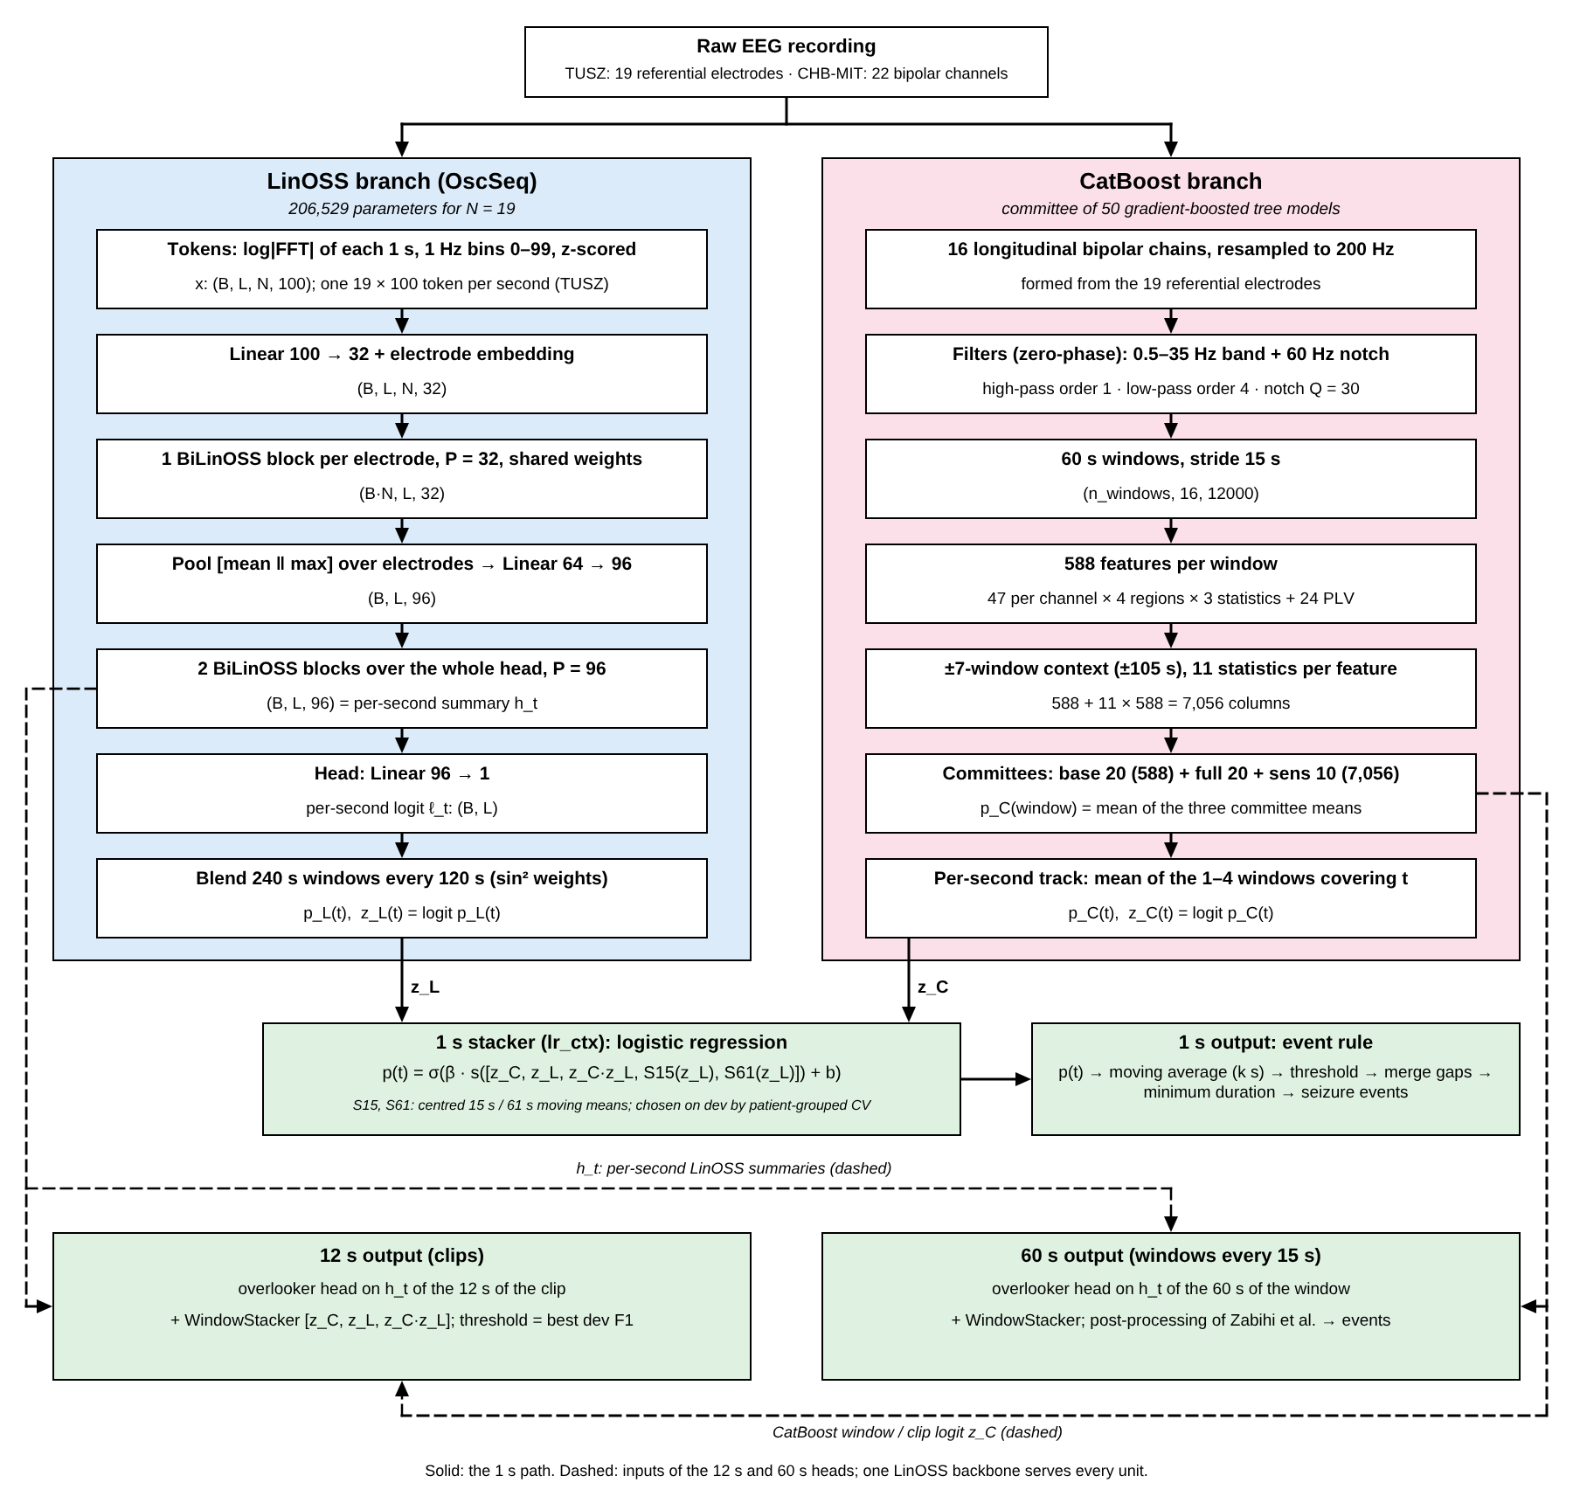
Figure 1. Architecture of the CatBoost × LinOSS fusion. Left (blue): the LinOSS branch, with tensor shapes (B: batch, L: seconds per segment, N: electrodes). Right (pink): the CatBoost branch. Bottom (green): the 1 s stacker and event rule, and the 12 s and 60 s read-out heads. Solid arrows: the 1 s path. Dashed arrows: inputs of the 12 s and 60 s heads, namely the per-second LinOSS summaries h_{t} and the CatBoost window or clip logit z_{C}. A single LinOSS backbone serves every resolution. Symbols are defined in Sections 3.4–3.7.
The two branches are designed to look at the same recording differently (Table 1). The LinOSS branch sees the broad-band spectrum (0–99 Hz) of the unfiltered referential electrodes at a resolution of one second, and its oscillators integrate that spectrum over minutes with periods that are learned. The CatBoost branch sees a filtered (0.5–35 Hz) bipolar montage, summarised by clinically motivated features over 60 s, and integrates over neighbouring windows with fixed summary statistics. Because the inputs, the time scales and the learning algorithms differ, the errors are expected to be partly independent; Section 5.7 tests this.
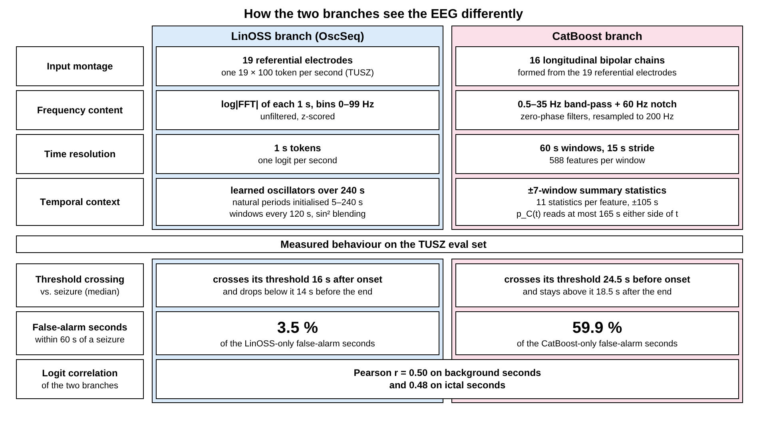
Figure 2. How the two branches see the EEG differently. Top: design differences in input montage, frequency content, time resolution and temporal context (N = 19 on TUSZ). Bottom: measured behaviour on the TUSZ eval set (Section 5.7): median time of the first threshold crossing relative to the onset and of the last crossing relative to the offset, the share of branch-specific false-alarm seconds within 60 s of a seizure, and the Pearson correlation of the two logits. The table that follows gives the exact design values.
Table 1. Differences between the two branches on TUSZ. N = 19 electrodes. “Context reach” is the largest distance between a second t and the signal that its per-second score depends on.
Property | LinOSS branch (OscSeq) | CatBoost branch
Channels | 19 referential electrodes, as recorded | 16 longitudinal bipolar chains formed from the 19 electrodes
Filtering | none (rectangular 1 s window) | 60 Hz notch (Q = 30), 0.5 Hz high-pass (order 1), 35 Hz low-pass (order 4), zero-phase
Frequency range | 0–99 Hz, 1 Hz bins | 0.5–35 Hz
Representation | z-scored natural log |FFT| of each 1 s step, N × 100 values per second | 588 hand-crafted features per window (47 per channel in 4 regions × 3 statistics, plus 24 phase-locking values)
Time unit | 1 s token | 60 s window, stride 15 s
Temporal integration | learned oscillators (initial periods 5–240 s), bidirectional, windows of 240 s every 120 s, sin²-blended | 11 summary statistics per feature over ±7 windows (±105 s); 7,056 columns
Context reach | at most 239 s before or after t | at most 165 s before or after t
Learner | one network, 206,529 parameters; 5 seeds | 50 gradient-boosted tree models in 3 committees
Per-second score | weighted mean of the 1–3 windows covering t | mean of the 1–4 windows covering t

3.2 Data and preprocessing

3.2.1 TUSZ v2.0.6
We use the Temple University Hospital EEG Seizure Corpus v2.0.6 [6, 25] with its official split into training, development (dev) and evaluation (eval) sets, which are disjoint in patients. The eval set is the test set. Annotations are the per-recording seizure intervals (“bi” files); a second is labelled positive if it overlaps a merged seizure interval [a, b), using the seconds from ⌊a⌋ to ⌈b⌉. Table 2 gives the split statistics of the recordings that we score.
Table 2. TUSZ v2.0.6 statistics of the recordings used (development and evaluation sets). “Token store”: recordings with all 19 electrodes (channel rule below); the training set keeps 4,969 recordings. “Scored”: recordings of the token store that also contain at least one 60 s CatBoost window, which are the recordings and seconds of the 1 s test. The last two rows give the units of the 12 s and 60 s tests.
Quantity | Dev | Eval (test)
Recordings in the token store | 1,666 | 880
Recordings scored (1 s test) | 1,439 | 850
Scored hours | 244.09 | 127.57
Ictal seconds scored | 24,144 | 24,190
Annotated events scored | 384 | 359
Ictal fraction of scored seconds | — | 0.0527
Patients | — | 43
Patients with at least one scored event | — | 30
12 s clips (HyBrain lists), positives in brackets | 73,387 (2,354) | 38,384 (2,340)
60 s windows (stride 15 s), positives in brackets | — | 28,067 (2,407)
Dashes: not stated in the result files. The dev set is harder than the eval set; Section 5.10 gives the metrics on both.
Channel rule. The LinOSS token store follows the channel rule of the HyBrain code [3]: a recording is kept only if all 19 electrodes of the standard 10–20 subset are present, matched by the EDF label before the hyphen. In TUSZ v2.0.6 the electrodes that are missing are always FZ or PZ. The rule keeps 1,666 of 2,203 dev recordings and all 880 eval recordings. Both branches are scored on the recordings of the token store; the CatBoost branch is additionally restricted to recordings with at least one complete 60 s window, which removes a tail of fewer than 15 s from each scored recording from the 1 s test.
LinOSS tokens. Each 1 s step of 200 samples is mapped to the natural logarithm of the magnitude of its 200-point FFT, using the rectangular window and no filtering; bins 0–99 are kept (0–99 Hz at 1 Hz spacing), zeros are replaced by 10⁻⁸, and the values are z-scored with a global scalar mean (3.9595) and standard deviation (1.5625) from the training set of the HyBrain authors. Recordings with another sampling rate are resampled to 200 Hz by FFT. A second of seizure produces one token of shape 19 × 100. The preprocessing follows the HyBrain code so that a 12 s window starting at second 12k equals their clip k.
CatBoost signals. The 16 longitudinal bipolar chains (FP1–F7, F7–T3, T3–T5, T5–O1, FP2–F8, F8–T4, T4–T6, T6–O2, FP1–F3, F3–C3, C3–P3, P3–O1, FP2–F4, F4–C4, C4–P4, P4–O2) are formed from the unfiltered referential signals resampled to 200 Hz, scaled to volts, and filtered with zero-phase filters (60 Hz notch, Q = 30; 0.5 Hz Butterworth high-pass, order 1; 35 Hz Butterworth low-pass, order 4). All TUSZ recordings of the four montage folders are used for CatBoost training; missing electrodes are zero-filled.

3.2.2 CHB-MIT under the HyBrain protocol
For the comparison with HyBrain we use the CHB-MIT Scalp EEG Database v1.0.0 [26–28], cases chb01–chb22, 256 Hz bipolar recordings. The 22 bipolar channels are those of the HyBrain code, in their order. Clips of 12 s and the split are those of the authors’ released marker lists (repository github.com/hhyy0401/seizure at a pinned commit): each patient’s clips are split at random, within the patient, into 70 %, 15 % and 15 % for training, development and test, with seed 123. Of 655 recordings of chb01–chb22, 624 are processed and 31 are skipped because a required channel is missing; none of the skipped recordings occurs in the authors’ lists. Table 3 gives the resulting counts.
Table 3. CHB-MIT clip counts under the HyBrain protocol. Positive clips are those labelled seizure in the authors’ lists.
Quantity | Train | Dev | Test
12 s clips | 189,831 | 40,679 | 40,676
Positive clips | 653 | 155 | 162
Seizure seconds inside the listed clips | — | 1,594 | 1,701
Seconds inside the listed clips | — | 488,148 | 488,112
The store holds 3,254,653 seconds from 624 recordings. Tokens are z-scored with the mean and standard deviation of the train clips (4.3713 and 1.6075), an affine rescaling fitted on train only.
Within-patient split. Clips of the same patient and of the same recording appear in train, dev and test. The test numbers therefore measure detection in patients already seen in training, not generalisation to new patients. They are not comparable with patient-disjoint results such as TUSZ. We follow this protocol only to compare with the published HyBrain numbers, and we prevent leakage of temporal context by scoring each clip alone with both branches (Section 3.3).
Annotation note. Six clips of one recording (chb09_08, clips 766–771) are listed as negative by the authors but contain a seizure according to the PhysioNet summary file, which writes the second seizure of that recording as “Seizure 2 Start Time: 9196” followed by “Seizure 1 End Time: 9267” (a typographical error in the source file). We use the authors’ clip labels for training and scoring, so the protocol is unchanged; per-second labels used for LinOSS training and the 1 s point-wise task come from the summary file and include this seizure.

3.3 What “context” means, and overlapping windows
“Context” is the signal around a second (or clip, or window) that a model may read when it scores it. Both branches are offline and non-causal: the whole recording is available, and a score may depend on the future as well as the past. Figure 3 draws all context lengths on one time axis.
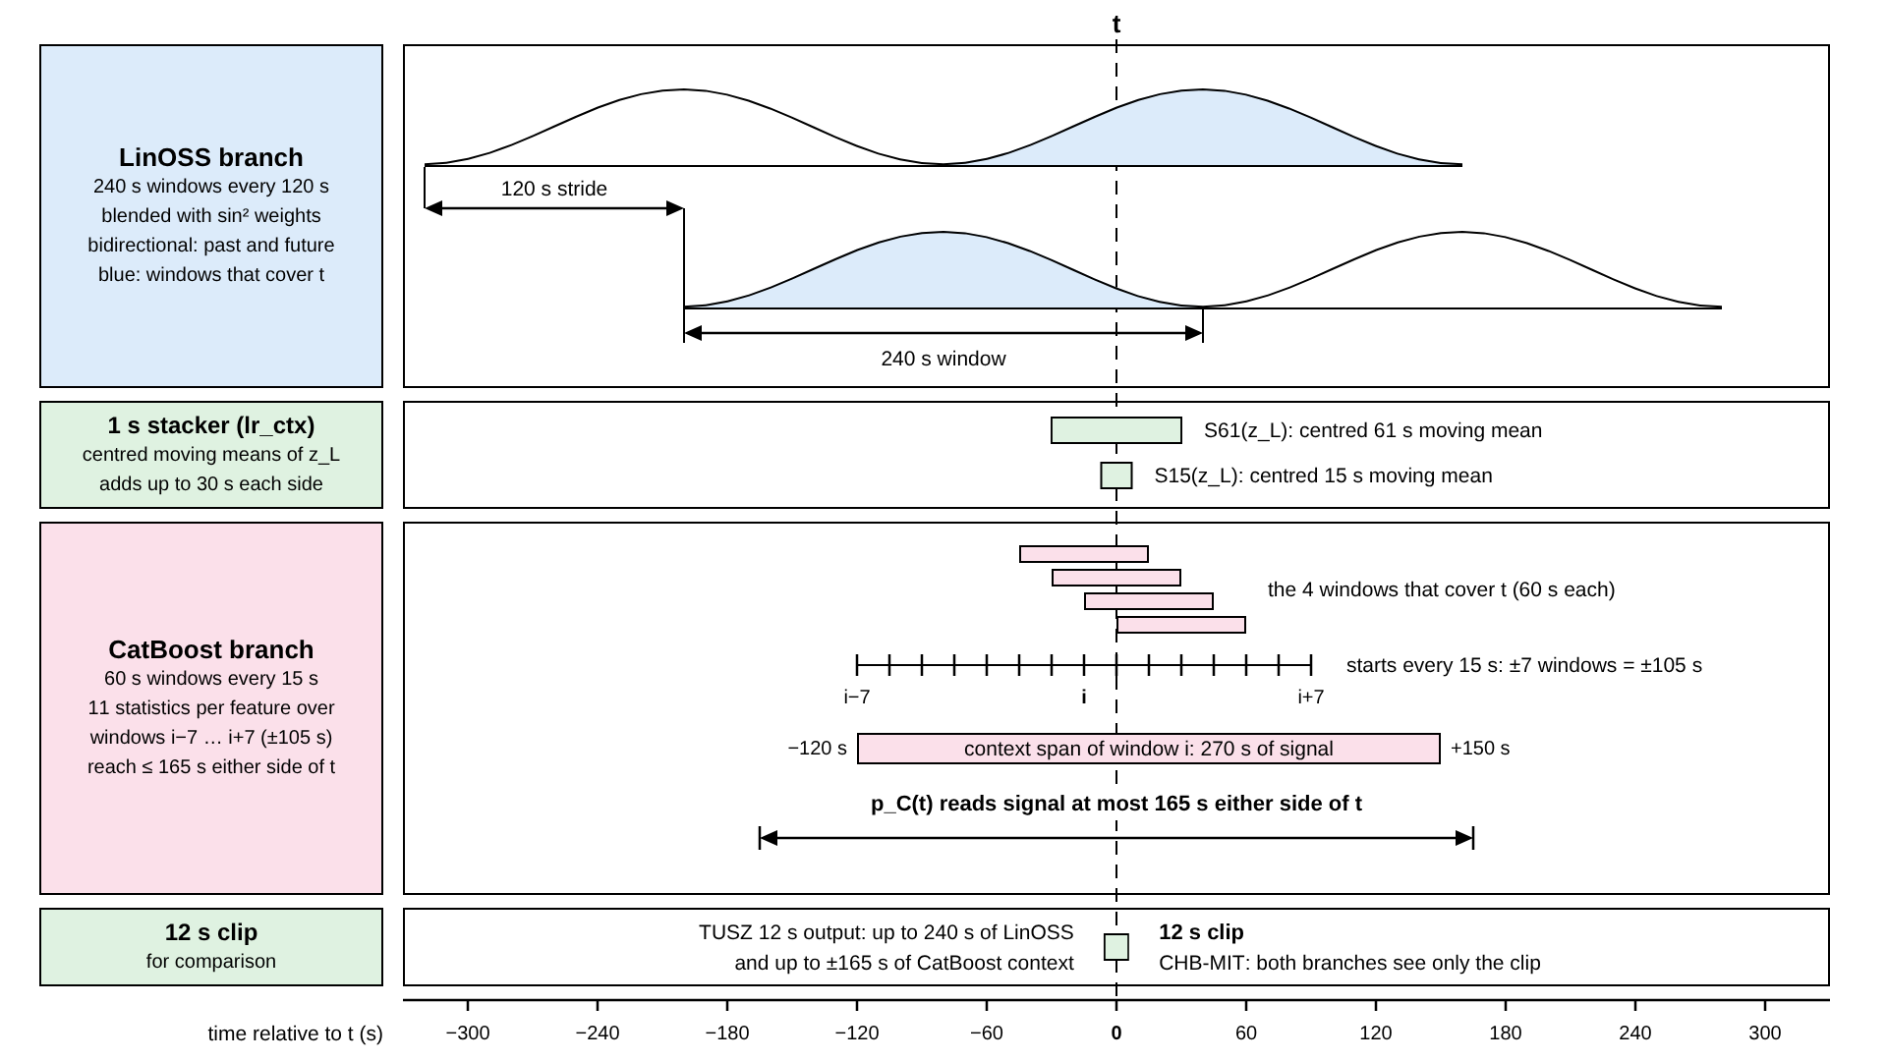
Figure 3. Context seen around one second t, on TUSZ (times in seconds relative to t). Top: LinOSS windows of 240 s every 120 s; the weight of each window (the sin² curve, Eq. (1)) is highest at its centre; blue: the windows that cover t. Middle: the centred 15 s and 61 s moving means of the LinOSS logit that the stacker adds. Bottom: the four CatBoost windows of 60 s that cover t, the ±7-window context of one window i (270 s of signal), and the resulting reach of p_{C}(t) of at most 165 s on either side. Last row: the 12 s output on TUSZ uses the LinOSS and CatBoost context, whereas on CHB-MIT both branches see only the clip.
LinOSS: windows of 240 s, blended. Training segments have a length of L = 240 s. At scoring time, a recording is cut into windows of 240 s every 120 s, plus one window aligned to the end of the recording so that every second is covered. Inside a window, every second sees the whole window, past and future, because every block contains a forward and a time-reversed LinOSS layer (Section 3.4). A second is covered by one to three windows. Let w index the windows that cover second t, s_{w} be the start of window w, τ_{w} = t − s_{w} the position of t in window w and ℓ_{w}(τ) the logit of position τ in window w. The per-second probability is the weighted mean
p_{L}(t) = Σ_{w ∋ t} ω(τ_{w}) σ(ℓ_{w}(τ_{w})) / Σ_{w ∋ t} ω(τ_{w}), τ_{w} = t − s_{w},
ω(τ) = 0.05 + sin²(π(τ + 0.5)/L) (1)
where σ is the logistic function. The weight is 0.05 at a window edge and 1.05 at its centre, so seconds whose bidirectional context is one-sided are down-weighted. The 5-seed ensemble is the mean of the five probabilities. Because every window covers at most 239 s on either side of any of its seconds, p_{L}(t) depends on tokens at most 239 s before or after t. Per-epoch model selection uses windows of 240 s every 240 s (plus the end-aligned window); the final dev and eval tracks use the stride of 120 s.
CatBoost: windows of 60 s every 15 s, ±7-window statistics. Windows of 60 s start every 15 s (75 % overlap). For the “full” committee, each of the 588 base features of window i receives 11 statistics computed over the centred run of windows i − 7 … i + 7, truncated at the recording edges (Section 3.5). Those windows start up to ±105 s from window i and together span 270 s of signal. The CatBoost probability of second t is the mean over the windows w whose span contains t:
p_{C}(t) = mean{ p_{C}(w) : t_{w} ≤ t < t_{w} + 60 } (2)
These are one to four windows, which start in (t − 60, t] and whose context windows reach (t − 165, t + 165]. Thus p_{C}(t) depends on signal at most 165 s before or after t. Recordings are covered by the windows that fit entirely inside the signal, so the last fewer than 15 s of a recording are not scored in the 1 s test.
Context added after the branches. The 1 s stacker adds the centred 15 s and 61 s moving means of the LinOSS logit, which extend its reach by up to 30 s on each side, and the 1 s event rule smooths the fused probability with a centred moving average of k ∈ {1, 5, 15, 31, 61} seconds before thresholding. The 12 s and 60 s outputs on TUSZ read per-second LinOSS summaries computed from the same 240 s windows and the CatBoost scores with ±7-window context, so a 12 s clip is scored with up to 240 s of LinOSS context and up to ±165 s of CatBoost context. The comparison with HyBrain at 12 s is therefore a system-level comparison and not a matched-input comparison (Section 5.2).
CHB-MIT: no context. In the within-patient split, the neighbours of a test clip are in most cases training or development clips of the same recording. A statistic over neighbouring clips, or a state-space window spanning several clips, would read training-clip signal when scoring a test clip, and seizure labels are strongly correlated in time. We therefore fix that each 12 s clip is seen alone by both branches: LinOSS is trained on listed training clips with L = 12 and scores each listed clip from its own 12 s; CatBoost features are computed on the clip itself, without context statistics.

3.4 The LinOSS branch

3.4.1 Oscillatory layer
A linear oscillatory state-space (LinOSS) layer [11] drives P forced harmonic oscillators from an H-dimensional input u(t) (the input to the layer at time t):
y″(t) = −A y(t) + B u(t), x(t) = Re(C y(t)) + D ⊙ u(t) (3)
Here y(t) ∈ ℂ^{P} is the oscillator position, A = diag(ReLU(Â)) ≥ 0 is a diagonal matrix of squared angular frequencies, B ∈ ℂ^{P×H} and C ∈ ℂ^{H×P} are complex input and output matrices stored as real and imaginary parts, D ∈ ℝ^{H} is a skip weight, ⊙ is the element-wise product and x(t) is the layer output. Each oscillator has its own step Δt = σ(ŝ) ∈ (0, 1), with ŝ a learned parameter. With one token per second, one step corresponds to one second.
Implicit discretisation. We use the implicit (IM) discretisation throughout. With the state s_{n} = (z_{n}, y_{n}) of an oscillator at step n and z = y′, the updates z_{n} = z_{n−1} + Δt(−A y_{n} + B u_{n}) and y_{n} = y_{n−1} + Δt z_{n} are solved for (z_{n}, y_{n}), which gives the linear recurrence
s_{n} = M s_{n−1} + f B u_{n}, M = S [ 1, −Δt A ; Δt, 1 ], f = S [ Δt ; Δt² ], S = 1/(1 + Δt² A) (4)
(rows of the matrices separated by semicolons)
The eigenvalues of M are λ = S(1 ± iΔt√A), so
|λ|² = 1/(1 + Δt² A) ≤ 1, θ = arg λ = arctan(Δt√A), T = 2π/θ (5)
Every IM oscillator is therefore stable and damped. Per step it rotates by θ, and at one token per second its natural period is T seconds. Damping and frequency are coupled: a larger Δt√A gives both a shorter period and a stronger decay.
Period initialisation (our change). The official LinOSS initialises A and Δt independently. We instead choose the natural periods. For each oscillator, ŝ is drawn from U(0, 1) as in the official code (Δt ∈ (0.5, 0.731)), the period T is drawn log-uniformly from [5 s, 240 s], and A is solved from T and Δt by inverting Eq. (5):
A = ( tan(2π/T) / Δt )² (6)
This requires θ < π/2, i.e. T > 4 steps, and the code rejects smaller minimum periods. The range 5–240 s covers the time scales on which a seizure builds up, evolves and ends: from a few seconds (individual rhythmic bursts and spike-wave complexes in the spectral envelope) to the length of a 240 s training segment. Initial periods are therefore spread over the range of context that the model may use. B and C are initialised as in the official code (uniform in ±1/√H and ±1/√P) when periods are not specified; with periods specified, only A is set from them.
Exact computation. Because the recurrence is time-invariant, a layer is a causal convolution of B u with the impulse response of the position, h_{p}[k] = (M_{p}^{k} f_{p})_{y}, i.e. y_{p,n} = Σ_{k=0}^{n} h_{p}[k] (B u)_{p,n−k}. The kernel columns M^{k} f are built by repeated squaring of M, with ⌈log₂ L⌉ doublings (8 for L = 240) and no eigendecomposition, so the computation is stable at A = 0. On CPU, each oscillator’s sequence is convolved with its own kernel (direct Toeplitz product for L ≤ 64, otherwise FFT). On GPU, the P oscillators are folded into one real H × H × L kernel K[g, h, k] = Σ_{p} h_{p}[k] Re(C_{gp} B_{ph}), which is exact because h and u are real, and applied with a real FFT of length 2L; this avoids the (N, 2P, L) state tensor that ran out of memory on a T4 GPU at 2,400 steps. Unit tests check both paths against the step-by-step recurrence (tolerance 10⁻⁴) and against each other (tolerance 10⁻⁹ in double precision).

3.4.2 Bidirectional block
A BiLinOSS block (Figure 4) applies the oscillatory layer in both time directions. For a block input x ∈ ℝ^{N×L×H} and a mask m (1 for a real second, 0 for padding),
ĥ = BN(x) ⊙ m, s = LinOSS→(ĥ) + flip( LinOSS←(flip ĥ) ),
x′ = x + Drop( GLU( Drop( GELU(s) ) ) ) (7)
where BN is batch normalisation without affine parameters, flip reverses the time axis, the two LinOSS layers have separate oscillators, Drop is dropout with p = 0.1, and GLU(v) = W₁v ⊙ σ(W₂v). Padded steps are zeroed before the state-space layers, so padding never feeds the oscillators. Except for the time-reversed layer, this is the official LinOSS block; the time-reversed layer is what makes the model non-causal.
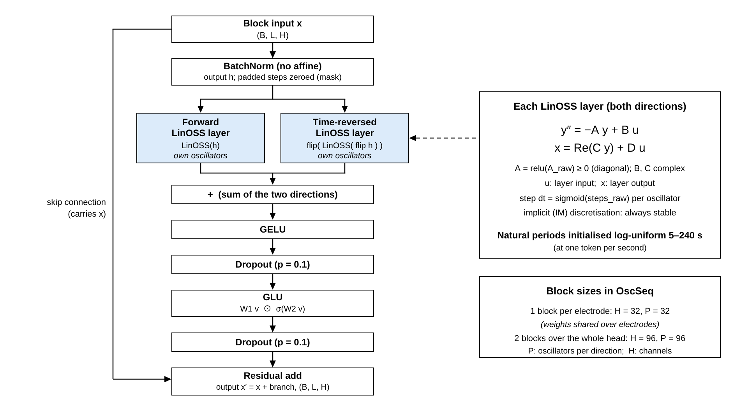
Figure 4. One BiLinOSS block. The input x (B: batch, L: seconds, H: channels) is batch-normalised and padded steps are zeroed (mask). A forward and a time-reversed LinOSS layer, each with its own oscillators, are summed, followed by GELU, dropout, a gated linear unit (GLU), dropout, and a residual connection. The panel on the right states the layer equation (A ≥ 0 diagonal, B and C complex, step Δt = sigmoid of a learned parameter) and the sizes of the blocks used in OscSeq.

3.4.3 Network
The network, OscSeq, is listed in Table 4. A shared linear map lifts each 100-bin spectrum to 32 dimensions and a learned electrode embedding is added. One BiLinOSS block, whose weights are shared by all electrodes, runs along time for each electrode separately. The electrode axis is then pooled by the concatenation of the mean over electrodes (widespread activity) and the maximum over electrodes (focal activity), which assumes no seizure location, and a linear layer maps the 64 pooled values to 96. Two BiLinOSS blocks with H = P = 96 then run along time over the whole head, and a linear head gives the per-second logit ℓ_{t}. The 96-dimensional output of the last block, h_{t}, is the per-second summary used by the 12 s and 60 s heads.
Table 4. Layer table of OscSeq for N = 19 electrodes. B: batch; L: seconds per segment (240 on TUSZ, 12 on CHB-MIT); P: oscillators per layer and direction; H: channels. A LinOSS layer has 4PH + 2P + H parameters (A: P; B, C: 2PH each; D: H; steps: P). A GLU has 2(H² + H) parameters. BatchNorm has no affine parameters.
# | Layer | Output shape | Parameters | Note
0 | Input: z-scored log|FFT| tokens, 1 Hz bins 0–99 | (B, L, N, 100) | —
1 | Linear(100 → 32), shared over electrodes | (B, L, N, 32) | 3,232
2 | Electrode embedding (added; zero-initialised) | (B, L, N, 32) | 608 | 19 × 32
3 | Reshape: one sequence per electrode | (B·N, L, 32) | —
4 | 1 BiLinOSS block, H = 32, P = 32 per direction, weights shared over electrodes | (B·N, L, 32) | 10,496 | 2 × 4,192 + 2,112
5 | Pool [mean over electrodes ; max over electrodes], Linear(64 → 96) | (B, L, 96) | 6,240
6 | 2 BiLinOSS blocks, H = 96, P = 96 per direction; output = summary h_{t} | (B, L, 96) | 185,856 | 2 × 92,928
7 | Head: Linear(96 → 1); output = per-second logit ℓ_{t} | (B, L) | 97
 | Total |  | 206,529 | 206,625 for N = 22
There are six LinOSS layers in all, with 2 × 32 + 4 × 96 = 448 oscillators. For CHB-MIT, N = 22 channels, which adds 3 × 32 = 96 embedding parameters.

3.4.4 How a state-space model helps
The tokens already resolve the EEG rhythms: each 1 Hz bin of the spectrum is an amplitude, so the front end does not need to learn filters. What a seizure adds is a slow evolution of those spectra over seconds to minutes (the build-up of rhythmic activity, its frequency drift, its termination). A bank of linear damped oscillators is a natural integrator for this: an oscillator with natural period T responds most strongly to modulations of the spectral envelope that repeat with period near T and forgets older input at a rate set by its damping, and the layer is a causal convolution with an explicit, learned impulse response (Figure 5a) whose length is not limited by a window size. A bidirectional pair then lets each second integrate evidence from before and after it within the 240 s window, which is what allows the LinOSS branch to switch on late and off early with sharp edges (Section 5.7), whereas the CatBoost branch integrates over a fixed set of neighbouring windows.
The periods are learned. Over the five seeds, the 2,240 oscillators have learned periods whose quantiles at 0, 10, 50 and 90 % are 4.97, 7.47, 32.4 and 83.0 s; 0.04 % are below and 0.18 % above the initial range of 5–240 s (one oscillator has A = 0 and an infinite period). The distribution moves towards shorter periods (median about 32 s) while a tail of slow oscillators remains (Figure 5b). We take this as descriptive evidence that the range of time scales that we initialise is used and not as evidence of a causal role of a particular period.
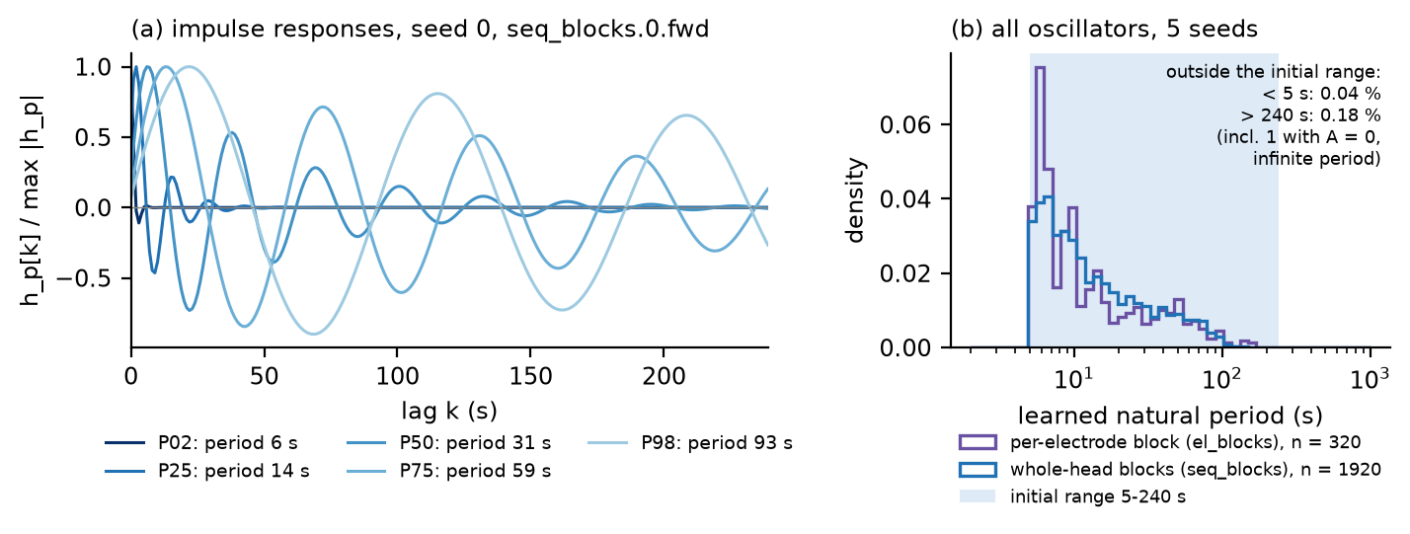
Figure 5. Learned oscillators. (a) Normalised impulse responses h_{p}[k] of five trained oscillators of the forward layer of the first whole-head block of seed 0, selected at the 2nd, 25th, 50th, 75th and 98th percentile of the period (periods 6, 14, 31, 59 and 93 s); the lag k is in seconds (one step is one second). Damped oscillations with different periods and decay rates show the range of time scales that a layer integrates. (b) Density of the learned natural periods of all 2,240 oscillators of the five seeds (320 in the per-electrode blocks, 1,920 in the whole-head blocks) on a logarithmic axis; the shaded band is the initial range of 5–240 s.
What we changed relative to the original LinOSS. The oscillatory layer, its implicit discretisation and the block structure are those of Rusch and Rus [11]. Our changes are: (i) the period-based initialisation of A (Eq. (6)); (ii) a second, time-reversed layer in each block, making the model bidirectional and non-causal; (iii) the per-electrode block with shared weights, the electrode embedding and the mean/max electrode pooling; (iv) the exact channel-kernel computation on GPU; (v) the input path (unfiltered log-spectra of 1 s steps), the per-second output and the overlap blending of Eq. (1); and (vi) the application to EEG, which the original paper does not contain.

3.5 The CatBoost branch
The CatBoost branch is our implementation of the committee of Zabihi et al. [10], which follows their windows, label rule, committees and operating-point rule, but with a reduced feature set (588 instead of 941 base features) and other deviations that are listed in Appendix A.1 (Table 34). It is not a copy of the published system and its results are not those of the published system.

3.5.1 Features
Each 60 s window of the 16 filtered chains yields 47 base features per channel (Table 5). Spectra use Welch’s method with nperseg = max(256, min(W, 4 f_{s})) and 50 % overlap (W: window length in samples; f_{s} = 200 Hz). The bands are δ 0.5–4, θ 4–8, α 8–13 and β 13–30 Hz, and total power is taken over 0.5–30 Hz. Each per-channel feature is summarised over four scalp regions of four chains each (left anterior: FP1–F7, F7–T3, FP1–F3, F3–C3; left posterior: T3–T5, T5–O1, C3–P3, P3–O1; right anterior: FP2–F8, F8–T4, FP2–F4, F4–C4; right posterior: T4–T6, T6–O2, C4–P4, P4–O2) by three statistics, the median, the 95th percentile and their difference (“focality”), which gives 47 × 4 × 3 = 564 columns. Phase-locking values (PLV) in four bands (2–4, 4–8, 8–13, 13–30 Hz) give 24 more: the mean pairwise PLV within five chain groups (all 16 chains; left temporal, left parasagittal, right temporal and right parasagittal chains) and the leading eigenvalue of the 16 × 16 PLV matrix divided by 16. The total is 564 + 24 = 588 base columns. Non-finite values are set to 0.
Table 5. Base features per channel (47 in total). Counts in the last column.
Family | Features | Count
Time domain | RMS, line length, zero-crossing rate, Hjorth activity, mobility, complexity | 6
Relative band power | δ, θ, α, β power over total power (Welch) | 4
Band ratios | θ/δ, β/θ, (α + β)/(δ + θ) | 3
Spectral shape | normalised spectral entropy (0.5–30 Hz); aperiodic slope (least-squares slope of log₁₀ P against log₁₀ f, f ≥ 1 Hz); α peak frequency (8–13 Hz) | 3
Dominant frequency | frequency, half-power bandwidth, Q = frequency / bandwidth | 3
Dynamics over 5 s sub-windows | dominant-frequency SD, CV and slope (Hz/min); line-length CV | 4
Band crest and flatness | max/mean and geometric/arithmetic mean of the PSD in each of δ, θ, α, β | 8
θ rhythmicity | maximum normalised autocorrelation of the 4–8 Hz band-passed signal at lags 1/8–1/4 s | 1
Wavelet (db4, 5 levels) | relative energy of A5 (δ), D5 (θ), D4 (α), D3 (β); log energy of the 6 sub-bands; wavelet entropy | 11
Envelope (Hilbert) | mean and CV of the 4–30 Hz and 8–30 Hz envelopes | 4
Total per channel |  | 47

3.5.2 Context statistics
For the “full” and “sens” committees, each of the 588 base features f of window i, with window start times t_{i}, receives the 11 statistics of Table 6, computed per recording, centred, with k = 7 and truncated at the recording edges. Undefined values are NaN, which CatBoost handles natively. With context there are 588 + 11 × 588 = 7,056 columns.
Table 6. The 11 context statistics per base feature f (window i, k = 7).
Statistic | Definition
ctx_mean, ctx_min, ctx_max | rolling mean, minimum and maximum of f over windows i − 7 … i + 7
ctx_std | rolling standard deviation (ddof = 0) over the same windows
ctx_range | ctx_max − ctx_min
ctx_z | (f_{i} − ctx_mean) / (ctx_std + 10⁻⁶)
d1_rate | (f_{i} − f_{i−1}) / (t_{i} − t_{i−1})
d1_mean_pm7, d1_std_pm7 | rolling mean and SD (ddof = 0) of d1_rate over ±7 windows
d2_rate | (f_{i+1} − 2 f_{i} + f_{i−1}) / (median stride)²
long_slope_pm7 | (f_{i+7} − f_{i−7}) / (t_{i+7} − t_{i−7})

3.5.3 Labels, committees and training
Window labels. A window is positive if its overlap with some merged seizure is at least min(9 s, 0.2 × the duration of that seizure) [10].
Committees. The model is CatBoost [23] with 2,000 iterations, learning rate 0.05, depth 6, L2 regularisation 3, logistic loss, class weights [1, clip(n_{neg} / n_{pos}, 1, 20)] and early stopping after 200 rounds on the held-out training fold. Folds are patient-grouped 10-fold splits of the training windows; each repeat permutes the patient identifiers with its own seed before splitting. Three committees are trained (Table 7): base (588 columns, 2 repeats × 10 folds = 20 models), full (7,056 columns, 20 models) and sens (7,056 columns, 10 models, with parameters found by Optuna [29]: 50 trials of the TPE sampler, seed 0, run once on one 80/20 patient-grouped split of the training data, maximising validation sensitivity at threshold 0.5; search space: learning rate 0.01–0.2 on a log scale, depth 4–10, L2 1–30 on a log scale, bagging temperature 0–5, random strength 0–5). The window score is the equal mean of the three committee means:
p_{C}(w) = ⅓ ( q_{base}(w) + q_{full}(w) + q_{sens}(w) ) (8)
where q_{k}(w) is the mean probability of the models of committee k. Dev and eval data are never used in training. On CHB-MIT the “full” committee does not exist (there is no context), so the committee is base (20 models) plus sens (10 models) on the 588 clip features, and the score is the equal mean of the two committee means. The TUSZ committee of 50 models was trained once in a development study that preceded this repository and is reused here, not retrained: its GPU training is not bit-reproducible, whereas scoring it with the code of this repository reproduces the earlier scores exactly (28,067 eval windows, maximum absolute difference 0). The eval features re-extracted from the EDF files with the code of this repository are bit-identical to the development features; the dev and train features are the development features (their extraction is deterministic CPU code).
Table 7. CatBoost committees on TUSZ.
Committee | Columns | Models | Notes
base | 588 | 20 | 2 repeats × 10 patient-grouped folds
full | 7,056 | 20 | base features + 11 context statistics each; 2 × 10 folds
sens | 7,056 | 10 | 1 × 10 folds; parameters from Optuna (50 TPE trials)

3.6 The fusion stacker
All stacker inputs are logits z = log(p / (1 − p)) with p clipped to [10⁻⁵, 1 − 10⁻⁵]. Let z_{C} = logit p_{C}(t) and z_{L} = logit p_{L}(t), and let s(·) denote standardisation by the mean and standard deviation of the fitting set. Three candidates are fitted on dev:
- late: p = w · σ(a_{C} z_{C} + b_{C}) + (1 − w) · σ(a_{L} z_{L} + b_{L}), with w ∈ {0, 0.1, …, 1}; each σ(a z + b) is a one-feature logistic (Platt) calibration;
- lr: p = σ( βᵀ s([z_{C}, z_{L}, z_{C} z_{L}]) + b );
- lr_ctx: p = σ( βᵀ s([z_{C}, z_{L}, z_{C} z_{L}, S₁₅(z_{L}), S₆₁(z_{L})]) + b ),
where β and b are the coefficients and the intercept of a logistic regression and S_{k} is the centred k-second moving mean within the recording (at the edges, the mean of the seconds that are available). The product term is justified below. The two moving means give the stacker temporal context beyond that of the two branches.
Why a product term, and why fusion helps. Suppose that the two branch outputs c and l were conditionally independent given the label y. By Bayes’ rule, the posterior log-odds are the sum of the branch log-odds minus the prior log-odds:
log [ P(y=1 | c, l) / P(y=0 | c, l) ] = z_{C} + z_{L} − log [ P(y=1) / P(y=0) ] (9)
A logistic stacker on [z_{C}, z_{L}] has exactly this form, with fitted weights instead of 1 and a fitted intercept instead of the prior term. The branches are only partly independent, so when both are confident at once part of the evidence is shared. The product z_{C} z_{L} lets the stacker discount that shared part instead of counting agreement twice; the fitted product weight is negative in every stacker of the official run (all 1 s stackers that include it and all 12 s and 60 s window stackers; for example, −0.538 for the 5-seed mean, in standardised units, next to 1.157 for z_{C} and 1.023 for z_{L}).
Separation gain. Consider two scores s₁ and s₂ with the same class-mean difference Δ, the same within-class standard deviation σ and within-class correlation ρ. Each alone separates the classes by d = Δ/σ. Their sum has mean difference 2Δ and within-class variance 2σ²(1 + ρ), so
d_{sum} = 2Δ / ( σ √(2(1 + ρ)) ) = d √( 2 / (1 + ρ) ) (10)
The gain is 1 for ρ = 1 (nothing to gain), √2 ≈ 1.41 for ρ = 0 (two independent views) and about 1.15 for ρ = 0.5. This is an idealisation (equal strength, Gaussian scores); the stacker fits the actual weights. We measure ρ on the eval set in Section 5.7: the Pearson correlation between z_{C} and z_{L} is 0.498 on background seconds and 0.478 on ictal seconds, which implies gains of 1.156 and 1.163.
Window stacker. For 12 s clips and 60 s windows, the stacker is the logistic regression p = σ(βᵀ s([z_{C}, z_{L}, z_{C} z_{L}]) + b) fitted on dev windows that have a CatBoost score. A window without a CatBoost score (a 12 s clip in a recording shorter than 60 s, or in the uncovered tail) uses a one-feature logistic regression on z_{L} fitted on all windows.

3.7 Read-outs at 1 s, 12 s and 60 s, and event post-processing
1 s read-out and events. The fused probability p(t) is a per-second score. To obtain events (rule frozen on dev), p(t) is smoothed with a centred moving average of k seconds within the recording, seconds with smoothed p above a threshold θ form runs, runs whose gap is at most g seconds are merged, and events shorter than a minimum duration d are dropped. The parameters (k, θ, g, d) are chosen on dev for each model at two operating points: point 1 maximises event sensitivity subject to at most 16.56 false alarms per 24 h on dev, and point 2 subject to at most 33.12 per 24 h (twice the budget). A true event is detected if any predicted second overlaps it (any-overlap, no tolerance); a predicted event that contains no seizure second is one false alarm; FA/24 h = false alarms / scored hours × 24. The frozen rule of the fusion at point 1 is k = 61 s, θ = 0.1802, g = 60 s, d = 10 s.
The overlooker (12 s and 60 s). For a unit (clip or window) of U seconds (U = 12 or 60) with per-second LinOSS summaries h_{t} ∈ ℝ⁹⁶ and head logits ℓ_{t} = w_{h}ᵀ h_{t} + b_{h}, the overlooker computes a log-mean-exp base logit and a learned correction:
base = log( (1/U) Σ_{t} exp(ℓ_{t}) ) (11)
g_{t} = GELU(W₁ LN(h_{t})) ∈ ℝ³², a = softmax_{t}( vᵀ g_{t} + c_{v} ),
z_{L}(w) = base + cᵀ [ Σ_{t} a_{t} g_{t} ‖ max_{t} g_{t} ] + c₀ (12)
where LN is layer normalisation, ‖ is concatenation, W₁ ∈ ℝ^{32×96}, v ∈ ℝ³², c ∈ ℝ⁶⁴ and c_{v}, c₀ are scalars. The log-mean-exp lies between the mean and the maximum of the per-second logits. The correction weights c and c₀ are initialised to zero, so before training the overlooker equals plain pooling, and training can only learn a correction from there. It has 3,394 parameters (192 + 3,104 + 33 + 65), independent of N. The LinOSS backbone is not fine-tuned for the 12 s and 60 s tasks: the same per-second network serves every resolution, and h_{t} are the blended per-second summaries.
CatBoost logits for units. For a 12 s clip the CatBoost logit is the log-mean-exp of the logits of its seconds that have a CatBoost value, z_{C}(clip) = log((1/12) Σ_{t} exp(logit p_{C}(t))); it is NaN if none has one. For a 60 s window it is the logit of the committee score of the window itself. The unit stacker of Section 3.6 fuses z_{C} with the overlooker logit z_{L}(w). The 12 s threshold is the best dev F1.
60 s event post-processing (a port of the inference script of Zabihi et al. [10]). Per recording: (1) a centred moving average over the window probabilities (smoothing in seconds converted to a number of windows, forced odd); (2) a threshold; (3) dilation of each positive window by a number of windows on each side; (4) each positive window contributes the interval [t₀, t₀ + 60 s], and intervals whose gap is at most a merge gap are merged; (5) events shorter than 10 s are dropped. A true seizure is detected if a predicted event overlaps it by at least 10 s; a predicted event that overlaps no seizure is one false alarm; FA/h = false alarms divided by the summed recording durations in hours. The parameters are chosen on dev over the grid of Section 3.9 to maximise event sensitivity subject to a window specificity of at least 0.93 and at most 0.69 false alarms per hour (the alarm-budget rule of Zabihi et al.), with ties broken by time recall and event PPV.

3.8 Training procedure
LinOSS (Algorithm 1). The objective is the per-second binary cross-entropy over the real (unpadded) seconds of a batch, ℒ = Σ_{t} m_{t} BCE(ℓ_{t}, y_{t}) / max(Σ_{t} m_{t}, 1), with no class weights; the seizure share is controlled by the sampling. Each epoch has 6,000 segments of 240 s (batch 32): 3,000 segments centred on a randomly drawn seizure second (placed at a uniform position in the segment) and 3,000 segments from recordings drawn with probability proportional to their length, with uniform starts. Segments are augmented by a hemisphere swap (probability 0.5) and a gain s ~ U(0.8, 1.2), which in the log-spectral token space is the shift log(s)/σ_{tok} (log|FFT(s x)| = log s + log|FFT(x)|; σ_{tok} = the token standard deviation). The optimiser is AdamW (learning rate 3·10⁻⁴, weight decay 0.01 on weight matrices and 0 on the oscillator parameters B, C, A, steps, D, biases and the electrode embedding), with a linear warm-up of 300 steps and a cosine schedule over 30 epochs, gradient-norm clipping at 5 and an exponential moving average of the weights with decay 0.998. Training stops after at most 30 epochs or 6 epochs without improvement of the dev per-second AUPRC; the EMA weights of the best epoch are kept. Five seeds (0–4) are trained and the ensemble is the mean probability.
Algorithm 1. Training of one LinOSS seed (TUSZ).
seed everything; model <- OscSeq(n_el = 19, periods = (5, 240))
AdamW(lr 3e-4; wd 0.01 on weight matrices, 0 on B, C, A, steps, D, biases, electrode embedding)
schedule <- cosine over 30 epochs with linear warm-up min(1, (step+1)/300); EMA(0.998)
for epoch = 1..30 while fewer than 6 epochs without improvement:
rng <- default_rng((seed, epoch, 7)) # epoch fully determined: exact resume
3,000 segments: a train seizure second at a uniform position of a 240 s segment
3,000 segments: a recording drawn proportional to its length, uniform start
shuffle; zero-pad short segments with mask 0
for each batch of 32 segments:
augment (hemisphere swap p = 0.5; token shift log(U(0.8, 1.2)) / sigma_tok)
loss <- masked per-second BCE; backward; clip grad norm at 5; step; EMA update
score dev with the EMA weights (240 s windows every 240 s, blended)
metric <- per-second AUPRC; if metric > best: best <- metric; save best EMA weights
load best weights; write dev and eval per-second probabilities (240 s windows every 120 s, blended)
eval labels are never read during training or selection

Reproducibility of training. The training of the five seeds on a Kaggle T4 reproduced the earlier development run exactly: the same best epochs, the same dev metrics and bit-identical dev probabilities (maximum absolute difference 0 over 885,199 seconds). Training is therefore deterministic for this recipe on that image. The official TUSZ results agree with the development run: for the 1 s fusion and the 60 s unit, every numeric leaf of the result files is equal (maximum absolute difference 0), and for the 12 s unit the maximum absolute difference is 0.00044 (231 numeric values compared; the largest difference is in the F1 of the LinOSS 5-seed overlooker mean, 23 metrics differ by more than 10⁻⁶ and none by more than 10⁻³), well inside the acceptance bound of 0.01 of the pre-registered rule.
CHB-MIT (clip mode). LinOSS is trained with L = 12 on the listed training clips only (half of each epoch’s samples from positive and half from negative clips), with the hemisphere swap defined by the mirror pairs of the 22 bipolar channels (the eight chain pairs and T7–FT9 ↔ FT10–T8; the midline channels and P7–T7 are unchanged) and the gain shift with the standard deviation of the CHB-MIT tokens. All other settings are those of the TUSZ recipe. Dev and test are scored clip by clip. CatBoost is trained on the 588 clip features with the base and sens committees.
Overlookers and unit stackers. For each LinOSS seed the per-second summaries h_{t} are exported for train, dev and eval. An overlooker (correction weights initialised to zero) is trained on training units (12 s: [12k, 12k + 12), positive if it contains any seizure second; 60 s: every 15 s with the label rule above) with all positive units and four times as many fresh random negative units per epoch, AdamW (learning rate 10⁻³, weight decay 0.01), batches of 512, at most 15 epochs and 4 epochs of patience, keeping the state with the best dev AUPRC (epoch 0, plain pooling, is a candidate). The five overlookers are averaged in logit space, the window stacker is fitted on dev units (out-of-fold, 5-fold patient-grouped, for the dev rows) and refitted on all dev units for the test.

3.9 Model selection, frozen operating points and test-look history
Rule. Every choice is made on dev or train only: epochs, stacker form and coefficients, thresholds, event post-processing and overlooker epochs. The test sets are read only by the scoring step of each stage, once per stage, after the dev selection has been written to disk (path.md, §4.1). The settings of the LinOSS recipe (period range, learning rate, EMA, segments per epoch, seeds) and the CatBoost design were fixed on dev in the development study before this repository was started and are not re-tuned here.
1 s fusion. For each LinOSS configuration (each seed and the 5-seed mean) and each candidate of Section 3.6, the out-of-fold per-second AUPRC is computed with 5-fold patient-grouped cross-validation on dev. A later non-“late” candidate replaces the current best only if it beats it by more than 0.002 (ties within 0.002 go to the simpler candidate). The chosen stacker is refitted on all of dev. Table 8 gives the out-of-fold AUPRC of the candidates for the 5-seed mean; the chosen stackers per configuration are lr_ctx for seeds 0 and 4 and for the mean, and lr for seeds 1–3. The per-second F1 threshold is the best dev F1. For the event rule, the grid is k ∈ {1, 5, 15, 31, 61} s, g ∈ {0, 10, 30, 60} s, d ∈ {1, 10} s and 40 thresholds at the quantiles 0.90–0.9995 of the smoothed dev track, selected for each model separately. Dev rows of the fusion are the out-of-fold rows.
Table 8. Dev selection of the 1 s stacker for the 5-seed mean of LinOSS: out-of-fold per-second AUPRC (5-fold patient-grouped cross-validation on dev) of each candidate. For “late”, w is the weight of the CatBoost calibrated probability; only the best of the 11 weights is shown.
Candidate | Out-of-fold AUPRC | Note
late (best of the 11 weights w) | 0.3025 | weighted mean of two calibrated probabilities
lr | 0.3190 | logistic regression on [z_{C}, z_{L}, z_{C} z_{L}]
lr_ctx (chosen) | 0.3245 | adds S₁₅(z_{L}), S₆₁(z_{L}); beats lr by more than 0.002
Official coefficients of the chosen stacker for [z_{C}, z_{L}, z_{C} z_{L}, S₁₅, S₆₁] in standardised units: 1.157, 1.023, −0.538, 0.863, −0.755; intercept −5.926.
12 s and 60 s. Overlooker epochs are chosen by dev AUPRC (best epochs per seed: 5, 5, 8, 1, 2 at 12 s and 3, 7, 4, 1, 1 at 60 s). The 12 s threshold is the best dev F1 of each score. The 60 s post-processing grid is: threshold at 15 quantiles 0.80–0.995 of the dev score (plus 0.44 for CatBoost alone) × smoothing {15, 30, 45} s × dilation {0, 20, 30} s × merge gap {20, 40, 60} s; a setting is feasible if the window specificity is at least 0.93 and the false-alarm rate at most 0.69 per hour, and the feasible setting with the highest event sensitivity (then time recall, then event PPV) is chosen. The frozen setting of the fusion is a threshold of 0.2734, smoothing 15 s, dilation 20 s and merge gap 40 s.
CHB-MIT. The stackers (on dev clips, or dev seconds for the point-wise task) and the dev-F1 thresholds are written to disk before the test is read; dev rows are 5-fold patient-grouped out-of-fold predictions.
Test-look history. Table 9 states how often each test set was scored. In addition, the analyses of Sections 5.4–5.8 (bootstrap, seizure-type and duration strata, per-patient sensitivity, complementarity, resolution analysis, visual cases) read the frozen eval outputs and select nothing. A development study that preceded this repository also scored the TUSZ eval set with the same recipe; the official from-scratch run reproduces its outputs (agreement with the development run, Section 3.8), so TUSZ eval has been scored once in each of the two runs with identical outputs. We have no record of a setting changed after a test result; the log of this repository (PROGRESS.md) records every amendment, all made before the corresponding test result.
Table 9. Test-set looks. “Guard”: how the code prevents a second scoring.
Stage | Test set | Guard / note
LinOSS training (T4) | TUSZ eval | never reads eval labels; writes eval probabilities only
CatBoost scoring (T3) | TUSZ eval | skips an existing score file; the committee is the development committee (identical scores)
1 s fusion (T5) | TUSZ eval | the eval stage refuses to run if the eval result file exists
12 s and 60 s units (T6) | TUSZ eval | the eval stage refuses to run if the eval result file exists
SzCORE (T7) | TUSZ eval | applied to the frozen T5/T6 outputs; an overwrite guard was added before the run
CHB-MIT (C3) | CHB-MIT test | refuses to run if the test result file exists; scored once

4 Experimental Setup

4.1 Tests and protocols
Every test has a fixed unit, label and metric set (Table 10). On TUSZ, the same frozen system is read out at 1 s, 12 s and 60 s. The 1 s test scores every second of the scored recordings. The 12 s test scores the clips of the HyBrain authors’ lists (a clip is positive if it contains any seizure second), so that it can be compared with the 12 s results of HyBrain [3]. The 60 s test uses the windows, labels and event rule of Zabihi et al. [10]. SzCORE event scoring is applied to the frozen outputs of all three. On CHB-MIT the tasks are the 12 s clip detection and the 1 s point-wise detection of HyBrain.
Table 10. Tests. Event points 1 and 2 are the dev-frozen rules of Section 3.7. “Any-overlap”: a true event is detected if any predicted second overlaps it.
Test | Unit | Label | Metrics
TUSZ 1 s | one second; seconds covered by both branches (a prefix of each recording) | second overlaps a seizure interval | AUROC, AUPRC; F1, precision, recall, specificity at the dev-F1 threshold; any-overlap event sensitivity, FA/24 h, event precision, time recall and PPV at points 1 and 2
TUSZ 12 s | HyBrain clip [12k, 12k + 12) | clip contains a seizure second (authors’ label) | AUROC, AUPRC, F1, precision, recall, specificity at the dev-F1 threshold
TUSZ 60 s | 60 s window every 15 s | overlap ≥ min(9 s, 20 % of the seizure) | AUROC, AUPRC, F1 at the dev window threshold; event sensitivity (≥ 10 s overlap), FA/h, event PPV, time recall and PPV
SzCORE | events from each read-out | seizure intervals | event sensitivity, precision, F1, FP/day; sample sensitivity, precision, F1
CHB-MIT 12 s | HyBrain clip | authors’ clip label | AUROC, AUPRC, F1, precision, recall at the dev-F1 threshold
CHB-MIT 1 s | each second of the listed clips | second inside a summary-file seizure | same

4.2 Metrics
Threshold-free metrics. The area under the receiver-operating-characteristic curve (AUROC) and the area under the precision–recall curve (AUPRC) are computed on the pooled units of the test set. AUROC does not depend on the class prevalence; AUPRC does (the prevalence of the 1 s test is 0.0527, that of the 12 s test 0.0610 and that of the 60 s test 0.0858), so AUPRC values are comparable only within a test.
Threshold-dependent metrics. Precision, recall (sensitivity), specificity and F1 are computed at a threshold fixed on dev: the best dev F1 for 1 s and 12 s, and the window threshold of the dev post-processing rule for 60 s. For a single branch the dev-F1 threshold can be far from optimal on the eval set (the dev set is harder, Section 5.10), so single-branch F1 values depend on this transfer and should be read together with AUROC and AUPRC.
Event metrics. At 1 s, event sensitivity is the share of annotated events that overlap any predicted second; a false alarm is a predicted event without any seizure second; FA/24 h = false alarms ÷ scored hours × 24; event precision is the share of predicted events that are not false alarms; time recall and time PPV are computed on seconds. At 60 s the scorer of Zabihi et al. requires an overlap of at least 10 s and reports FA/h. These any-overlap scorers use no tolerance around the annotation.
SzCORE. We use the package timescoring 0.0.7 [5] with its default parameters, read from the installed package: tolerance 30 s before and 60 s after an annotated event, any overlap counts (minimum overlap 0), hypothesis events longer than 300 s are split, and events closer than 90 s are merged. Annotations are built at 1 Hz from boolean per-second masks, and event and sample counts are summed over recordings: sensitivity = TP/N_{ref}, precision = TP/(TP + FP), F1 = 2TP/(2TP + FP + (N_{ref} − TP)), FP/day = FP / (scored seconds / 86,400). The reference event count is lower than under the any-overlap scorer because SzCORE merges seizures less than 90 s apart (280 reference events at 1 s and 60 s, 281 at 12 s, against 359 any-overlap events). The hypothesis events are the dev-chosen event rule at 1 s (points 1 and 2), each clip above its dev-F1 threshold marking its 12 seconds at 12 s, and the 60 s post-processing converted to seconds at 60 s. All settings are frozen on dev; SzCORE is applied without re-tuning.
Seeds and ensembles. The LinOSS branch is trained with five seeds. The headline rows are the 5-seed ensemble (mean probability), for which the fusion is refitted on the mean track. Per-seed rows give the mean and the sample standard deviation (n = 5) of the per-seed systems, each with its own stacker, thresholds and rule. CHB-MIT ensembles average the per-second logits.
Confidence intervals. The unit of resampling is the patient (all of a patient’s recordings, with replacement; 2,000 resamples, seed 0), because events, false alarms and per-second errors cluster within patients. Intervals are 95 % percentile intervals. Differences between systems are computed on the same resamples (paired). Frozen thresholds and rules are not refitted in the resamples, so the intervals reflect the sampling of test patients and not the variability of model selection. For complementarity statistics the unit is the recording.

4.3 Comparison policy and implementation
Published baselines are copied from the cited papers, with the protocol, corpus version and scorer of each; we never use our own reproductions of other systems. The corpus version, patient split, unit length and scorer differ among the published sources, and we state this in a caveat column of every comparison table; the comparisons are therefore context and not a ranking.
The LinOSS stages ran on Kaggle (two NVIDIA T4 GPUs; CatBoost training on CHB-MIT on one T4), the CatBoost scoring and all analyses on a local CPU machine. The software environment is pinned in the repository (Python 3.13). Unit tests (19 in total at the time of the official run) cover the oscillatory layer against the step-by-step recurrence, the stackers and 15 synthetic SzCORE cases.

5 Results

5.1 Ablation: fusion against each branch alone
Table 11, Table 12, Table 13 and Table 14 compare the fusion (5-seed ensemble) with each branch alone, where “w/o LinOSS” is the CatBoost branch and “w/o CatBoost” is the 5-seed LinOSS branch, at 1 s, 12 s and 60 s on TUSZ eval. Each row uses the thresholds and rules frozen on dev for that model. The 60 s values are read from the ablation file, which was computed from the outputs of the S1 reproduction gate; they equal the official 60 s result file to within 2·10⁻⁵ (Section 8).
Table 11. 1 s test on TUSZ eval (test): fusion (5-seed ensemble) against each branch alone. F1, precision, recall and specificity at the best dev-F1 threshold of each model. The last two rows give the mean ± sample standard deviation over the five seeds (n = 5) of the fusion and of the LinOSS branch. Best of the first three rows in bold.
Model | AUROC | AUPRC | F1 | Precision | Recall | Specificity
CatBoost × LinOSS fusion (5-seed ensemble) | 0.963 | 0.748 | 0.676 | 0.828 | 0.571 | 0.993
w/o LinOSS (= CatBoost branch) | 0.948 | 0.607 | 0.572 | 0.507 | 0.657 | 0.964
w/o CatBoost (= LinOSS branch, 5-seed ensemble) | 0.938 | 0.612 | 0.347 | 0.805 | 0.221 | 0.997
Fusion, per seed (mean ± sd, n = 5) | 0.958 ± 0.002 | 0.710 ± 0.011 | 0.644 ± 0.030 | 0.785 ± 0.025 | 0.548 ± 0.046 | 0.992 ± 0.002
LinOSS branch, per seed (mean ± sd, n = 5) | 0.910 ± 0.010 | 0.482 ± 0.036 | 0.394 ± 0.092 | 0.662 ± 0.088 | 0.293 ± 0.094 | 0.991 ± 0.006

Table 12. 12 s test on TUSZ eval (test): fusion (5-seed ensemble) against each branch alone. F1, precision, recall and specificity at the best dev-F1 threshold of each model. The last two rows give the mean ± sample standard deviation over the five seeds (n = 5) of the fusion and of the LinOSS branch. Best of the first three rows in bold.
Model | AUROC | AUPRC | F1 | Precision | Recall | Specificity
CatBoost × LinOSS fusion (5-seed ensemble) | 0.952 | 0.747 | 0.651 | 0.858 | 0.525 | 0.994
w/o LinOSS (= CatBoost branch) | 0.940 | 0.637 | 0.592 | 0.561 | 0.626 | 0.968
w/o CatBoost (= LinOSS branch, 5-seed ensemble) | 0.933 | 0.679 | 0.521 | 0.842 | 0.377 | 0.995
Fusion, per seed (mean ± sd, n = 5) | 0.948 ± 0.002 | 0.713 ± 0.016 | 0.641 ± 0.016 | 0.791 ± 0.039 | 0.540 ± 0.015 | 0.991 ± 0.002
LinOSS branch, per seed (mean ± sd, n = 5) | 0.910 ± 0.005 | 0.563 ± 0.041 | 0.491 ± 0.094 | 0.703 ± 0.028 | 0.384 ± 0.101 | 0.990 ± 0.002

Table 13. 60 s test on TUSZ eval (test): fusion (5-seed ensemble) against each branch alone. F1, precision, recall and specificity at the window threshold of the dev post-processing rule of each model. The last two rows give the mean ± sample standard deviation over the five seeds (n = 5) of the fusion and of the LinOSS branch. Best of the first three rows in bold.
Model | AUROC | AUPRC | F1 | Precision | Recall | Specificity
CatBoost × LinOSS fusion (5-seed ensemble) | 0.939 | 0.765 | 0.675 | 0.890 | 0.543 | 0.994
w/o LinOSS (= CatBoost branch) | 0.927 | 0.709 | 0.635 | 0.753 | 0.550 | 0.983
w/o CatBoost (= LinOSS branch, 5-seed ensemble) | 0.923 | 0.707 | 0.585 | 0.865 | 0.442 | 0.994
Fusion, per seed (mean ± sd, n = 5) | 0.935 ± 0.003 | 0.746 ± 0.012 | 0.658 ± 0.027 | 0.850 ± 0.017 | 0.538 ± 0.038 | 0.991 ± 0.002
LinOSS branch, per seed (mean ± sd, n = 5) | 0.903 ± 0.008 | 0.619 ± 0.037 | 0.489 ± 0.068 | 0.790 ± 0.050 | 0.358 ± 0.075 | 0.991 ± 0.003

Table 14. Event-level metrics on TUSZ eval (test). 1 s: any-overlap scorer at event points 1 and 2 (dev budgets of 16.56 and 33.12 false alarms per 24 h): event sensitivity, false alarms per 24 h (FA/24 h) and event precision. 60 s: the scorer of Zabihi et al. (≥ 10 s overlap) with the dev-frozen post-processing rule: event sensitivity, false alarms per hour (FA/h) and event PPV. The 12 s test has no event metric (isolated clips). Lower is better for FA.
 | 1 s, point 1 |  |  | 1 s, point 2 |  |  | 60 s
Model | Sens. | FA/24 h | Prec. | Sens. | FA/24 h | Prec. | Sens. | FA/h | PPV
CatBoost × LinOSS fusion (5-seed ensemble) | 0.507 | 3.01 | 0.912 | 0.641 | 11.10 | 0.756 | 0.574 | 0.117 | 0.899
w/o LinOSS (= CatBoost branch) | 0.538 | 6.96 | 0.791 | 0.632 | 14.86 | 0.664 | 0.557 | 0.210 | 0.822
w/o CatBoost (= LinOSS branch, 5-seed ensemble) | 0.301 | 2.63 | 0.885 | 0.588 | 13.17 | 0.748 | 0.543 | 0.148 | 0.872
Fusion, per seed (mean ± sd, n = 5) | 0.524 ± 0.024 | 3.95 ± 0.81 | 0.891 ± 0.017 | 0.632 ± 0.016 | 12.87 ± 0.98 | 0.717 ± 0.016 | 0.569 ± 0.023 | 0.157 ± 0.026 | 0.866 ± 0.020
LinOSS branch, per seed (mean ± sd, n = 5) | 0.236 ± 0.077 | 5.27 ± 2.34 | 0.758 ± 0.065 | 0.425 ± 0.045 | 14.11 ± 1.70 | 0.664 ± 0.019 | 0.454 ± 0.069 | 0.215 ± 0.063 | 0.812 ± 0.034

1 s. The fusion improves the threshold-free metrics over both branches (AUROC 0.963 against 0.948 for CatBoost and 0.938 for LinOSS; AUPRC 0.748 against 0.607 and 0.612), and the F1 at the dev-frozen threshold from 0.572 (CatBoost) and 0.347 (LinOSS) to 0.676. The gain comes with a different trade-off: the CatBoost branch has the highest recall at its dev threshold (0.657, against 0.571 for the fusion) but a precision of only 0.507 (0.828 for the fusion), whereas the LinOSS branch has a high precision (0.805) and a low recall (0.221). Seed ensembling matters for LinOSS: its per-seed AUROC is 0.910 ± 0.010 and the 5-seed ensemble reaches 0.938; for the fusion, the per-seed AUROC is 0.958 ± 0.002, so even the single-seed fusion is above the CatBoost branch (0.948) and the ensemble is above the single-seed fusion.
Events (1 s). At event point 1 the fusion detects 0.507 of the events at 3.01 FA/24 h, against 0.538 at 6.96 for CatBoost and 0.301 at 2.63 for LinOSS. The fusion thus more than halves the false alarms of the CatBoost branch at a sensitivity that is not significantly different (Section 5.5), and it is far more sensitive than the LinOSS branch at a similar false-alarm rate. At point 2 the three models detect 0.641, 0.632 and 0.588 of the events at 11.10, 14.86 and 13.17 FA/24 h. The fusion has the lowest false-alarm rate and the highest event precision at both points among the three models, except that the LinOSS branch at point 1 has a slightly lower false-alarm rate (2.63) with a much lower sensitivity.
12 s and 60 s. The ordering is the same at 12 s (AUROC 0.952, AUPRC 0.747, F1 0.651 for the fusion against 0.940, 0.637 and 0.592 for CatBoost and 0.933, 0.679 and 0.521 for LinOSS) and at 60 s (AUROC 0.939, AUPRC 0.765, F1 0.675; CatBoost 0.927, 0.709, 0.635; LinOSS 0.923, 0.707, 0.585). The 60 s event metrics follow the same pattern: the fusion has the highest event sensitivity (0.574), the lowest false-alarm rate (0.117 FA/h against 0.210 for CatBoost and 0.148 for LinOSS) and the highest event PPV (0.899). The seed-wise rows show the same ordering, and the standard deviation over seeds is smaller than the gap between the single-seed fusion and either branch for AUROC and AUPRC at every resolution.
Table 15. CHB-MIT test (HyBrain protocol, within-patient split): fusion against each branch, 12 s clips and 1 s point-wise. Specificity is derived exactly from the counts of the result file (12 s: 40,676 clips, 162 positive; 1 s: 488,112 seconds, 1,701 positive). The last two rows give the per-seed mean ± sample standard deviation (n = 5).
12 s clips
Model | AUROC | AUPRC | F1 | Precision | Recall | Specificity
CatBoost × LinOSS fusion (5-seed ensemble) | 0.990 | 0.629 | 0.641 | 0.736 | 0.568 | 0.999
w/o LinOSS (= CatBoost branch) | 0.953 | 0.546 | 0.548 | 0.685 | 0.457 | 0.999
w/o CatBoost (= LinOSS branch, 5-seed ensemble) | 0.988 | 0.615 | 0.663 | 0.642 | 0.685 | 0.998
Fusion, per seed (mean ± sd, n = 5) | 0.983 ± 0.003 | 0.621 ± 0.029 | 0.623 ± 0.024 | 0.657 ± 0.077 | 0.600 ± 0.044 | 0.999 ± 0.000
LinOSS branch, per seed (mean ± sd, n = 5) | 0.975 ± 0.004 | 0.475 ± 0.060 | 0.515 ± 0.038 | 0.588 ± 0.066 | 0.468 ± 0.081 | 0.999 ± 0.001
1 s point-wise
CatBoost × LinOSS fusion (5-seed ensemble) | 0.992 | 0.675 | 0.684 | 0.724 | 0.649 | 0.999
w/o LinOSS (= CatBoost branch) | 0.968 | 0.614 | 0.592 | 0.684 | 0.521 | 0.999
w/o CatBoost (= LinOSS branch, 5-seed ensemble) | 0.989 | 0.628 | 0.664 | 0.698 | 0.633 | 0.999
Fusion, per seed (mean ± sd, n = 5) | 0.988 ± 0.002 | 0.692 ± 0.023 | 0.667 ± 0.021 | 0.718 ± 0.009 | 0.623 ± 0.029 | 0.999 ± 0.000
LinOSS branch, per seed (mean ± sd, n = 5) | 0.978 ± 0.003 | 0.481 ± 0.053 | 0.528 ± 0.036 | 0.570 ± 0.049 | 0.493 ± 0.043 | 0.999 ± 0.000

CHB-MIT. The fusion has the highest AUROC (0.990 at 12 s, 0.992 at 1 s) and AUPRC (0.629 and 0.675) of the three models. At 12 s the gain over the LinOSS branch is small (AUROC 0.988 for LinOSS) and, at the dev-frozen threshold, the LinOSS ensemble has a higher F1 (0.663 against 0.641); the paired bootstrap intervals include zero for the AUROC, AUPRC and F1 differences between fusion and LinOSS at 12 s (Section 5.5). CatBoost, which sees only the 12 s clip with no context, is the weakest branch. Here the benefit of the fusion is therefore mainly over the CatBoost branch at 12 s, and over both branches at 1 s point-wise in AUPRC.

5.2 Comparison with published systems
The tables below put our results next to published values. Published values are copied from the papers and are, with one exception noted in the captions, not reproduced by us. They differ from ours (and from each other) in the TUSZ version, the patient split, the unit, the amount of context and the scorer, which each table states. We therefore draw no ranking from them; we use them to place our numbers in the range of the literature.
Table 16. Per-second detection on TUSZ. Our rows: TUSZ v2.0.6 eval, 43 patients, continuous recordings (127.57 h). F1, sensitivity (Sens.) and precision (Prec.) are at the dev-frozen threshold (our first row) or from the SzCORE sample-based scorer at 1 Hz. “n.r.”: not reported. HyBrain scores a per-second head inside 12 s or 60 s clips, not continuous recordings, with the TUSZ version not reported.
System | AUROC | F1 | Sens. | Prec. | Corpus, split, unit | Scorer
Ours: fusion (5-seed) | 0.963 | 0.676 | 0.571 | 0.828 | TUSZ v2.0.6 eval; continuous | per-second, dev-F1 threshold
Ours: fusion, SzCORE sample-based (event point 1) | – | 0.658 | 0.594 | 0.737 | TUSZ v2.0.6 eval; continuous | SzCORE sample
SeizureTransformer [8] | 0.876 | 0.5730 | 0.4724 | 0.7281 | TUSZ v2.0.3 predefined test; time-step; AUROC = per-recording mean | SzCORE sample
LookAroundNet, ensemble [9] | – | 0.618 | 0.467 | 0.916 | TUSZ own split (579/53/43 patients), release n.r.; 16 s segments, 2 s stride | SzCORE sample
HyBrain point-wise, 12 s clips [3] | 0.913 ± 0.005 | 0.491 ± 0.029 | – | – | TUSZ (version n.r.), EvoBrain protocol; 12 s clips | AUROC, F1 at dev-F1 threshold
HyBrain point-wise, 12 s clips, λ = 0.3 | 0.926 ± 0.004 | 0.548 ± 0.042 | – | – | as above | as above
HyBrain point-wise, 60 s clips | 0.918 ± 0.007 | 0.512 ± 0.020 | – | – | as above; 60 s clips | as above
HyBrain point-wise, 60 s clips, λ = 0.3 | 0.938 ± 0.004 | 0.575 ± 0.049 | – | – | as above | as above
The SzCORE sample-based F1 of our fusion is computed from the events produced by the dev-frozen event rule (event point 1), whereas the F1 of the first row uses the per-second probability thresholded at the best dev F1; both are given because published systems report one or the other.
Table 17. Clip-level detection on 12 s clips. Our rows: TUSZ v2.0.6 eval, the HyBrain authors’ clip list (38,384 clips, 2,340 positive), thresholds frozen on dev; the fused system uses up to 240 s of LinOSS and ±165 s of CatBoost context around each clip. HyBrain rows are the values of Table 2 of [3] (re-runs of the baselines by the HyBrain authors, three seeds; TUSZ version not reported; each clip is scored from the clip alone). Rows marked † are from the original papers.
System | AUROC | F1 | Corpus, split, context
Ours: fusion (5-seed ensemble) | 0.952 | 0.651 | TUSZ v2.0.6 eval; clip + context (system level)
Ours: fusion, per seed (mean ± SD) | 0.948 ± 0.002 | 0.641 ± 0.016 | same
Ours: CatBoost branch alone | 0.940 | 0.592 | same
Ours: LinOSS branch alone (5-seed) | 0.933 | 0.521 | same
HyBrain, K = 1 | 0.899 ± 0.006 | 0.551 ± 0.008 | TUSZ (n.r.); clip alone
HyBrain, K = 3 | 0.880 ± 0.006 | 0.540 ± 0.002 | same
EvoBrain [2] (HyBrain re-run) | 0.897 ± 0.005 | 0.558 ± 0.020 | same
GRU-GCN (HyBrain re-run) | 0.894 ± 0.005 | 0.527 ± 0.059 | same
DCRNN [1] (HyBrain re-run) | 0.896 ± 0.003 | 0.513 ± 0.006 | same
GraphS4mer [7] (HyBrain re-run) | 0.884 ± 0.002 | 0.461 ± 0.001 | same
EEGPT [19] (HyBrain re-run) | 0.884 ± 0.004 | 0.438 ± 0.010 | same
LaBraM [18] (HyBrain re-run) | 0.863 ± 0.010 | 0.398 ± 0.034 | same
EvoBrain† | 0.877 ± 0.005 | 0.539 ± 0.009 | TUSZ v1.5.2, official split
DCRNN with pre-training† | 0.866 ± 0.016 | – | TUSZ v1.5.2, 5 overlapping patients removed
ODEBrain† [13] | 0.881 ± 0.006 | 0.496 ± 0.017 | TUSZ (version, split n.r.); 12 s sequences, 1 s step
DGDCN† [16] | 0.887 | – | TUSZ v2.0.1, official split; sensitivity 84.8 %, specificity 76.6 %

Table 18. Window-level detection on 60 s windows and event-level performance. Our rows: TUSZ v2.0.6 eval, 60 s windows every 15 s with the label rule of Zabihi et al. (28,067 windows), dev-frozen window threshold and event post-processing; context as in Table 17. Zabihi et al. row: TUSZ v2.0.3 eval, 836 recordings, 127.58 h, 291 events, 60 s windows every 15 s, [10]. HyBrain and other rows: non-overlapping 60 s clips. † from the original papers (TUSZ v1.5.2 unless stated).
System | AUROC | AUPRC | F1 | Window sens. / spec. | Event sens. @ FA/h | Corpus, scorer
Ours: fusion (5-seed ensemble) | 0.939 | 0.765 | 0.675 | 0.543 / 0.994 | 0.574 @ 0.117 | TUSZ v2.0.6; ≥ 10 s overlap
Ours: fusion, per seed (mean ± SD) | 0.935 ± 0.003 | 0.746 ± 0.012 | 0.658 ± 0.027 | 0.538 ± 0.038 / 0.991 ± 0.002 | 0.569 ± 0.023 @ 0.157 ± 0.026 | same
Ours: CatBoost branch alone | 0.927 | 0.709 | 0.635 | 0.550 / 0.983 | 0.557 @ 0.210 | same
Ours: LinOSS branch alone | 0.923 | 0.707 | 0.585 | 0.442 / 0.994 | 0.543 @ 0.148 | same
Zabihi et al. CatBoost ensemble [10] | 0.919 | 0.753 | – | 0.701 / 0.952 | 0.749 @ 0.682 | TUSZ v2.0.3; ≥ 10 s overlap
HyBrain, K = 3 | 0.908 ± 0.006 | – | 0.636 ± 0.023 | – | – | TUSZ (n.r.); clips
GRU-GCN (HyBrain re-run) | 0.907 ± 0.001 | – | 0.640 ± 0.012 | – | – | same
EvoBrain (HyBrain re-run) | 0.888 ± 0.018 | – | 0.583 ± 0.038 | – | – | same
DCRNN (HyBrain re-run) | 0.895 ± 0.011 | – | 0.574 ± 0.019 | – | – | same
GraphS4mer† [7] | 0.906 ± 0.012 | 0.723 ± 0.023 | 0.680 ± 0.012 | 0.718 / 0.933 | – | TUSZ v1.5.2; clips
DCRNN with pre-training† | 0.875 ± 0.016 | – | – | – | – | TUSZ v1.5.2; clips
DGDCN† | 0.904 | – | – | 0.943 / 0.687 | – | TUSZ v2.0.1; clips
Our window sensitivity and specificity are at the window threshold of the dev post-processing rule, which maximises event sensitivity under a window specificity of at least 0.93 on dev; the operating points of the rows are therefore not matched. Zabihi et al. fix their threshold at 0.44 with a different post-processing grid.
Table 19. CHB-MIT, HyBrain protocol. Our rows: the authors’ clip lists (40,676 test clips, 162 positive, within-patient split), thresholds frozen on dev. HyBrain rows are the values of Tables 2 and 3 of [3] (three seeds; baselines re-run by the HyBrain authors). The 1 s point-wise column of the HyBrain rows is the “12 s” column of their Table 3.
System | 12 s AUROC | 12 s F1 | Point-wise AUROC | Point-wise F1
Ours: fusion (5-seed ensemble) | 0.990 | 0.641 | 0.992 | 0.684
Ours: fusion, per seed (mean ± SD) | 0.983 ± 0.003 | 0.623 ± 0.024 | 0.988 ± 0.002 | 0.667 ± 0.021
Ours: CatBoost branch alone | 0.953 | 0.548 | 0.968 | 0.592
Ours: LinOSS branch alone (5-seed) | 0.988 | 0.663 | 0.989 | 0.664
HyBrain, K = 3 (point-wise: base) | 0.924 ± 0.003 | 0.191 ± 0.009 | 0.910 ± 0.003 | 0.228 ± 0.017
HyBrain, K = 1 | 0.917 ± 0.005 | 0.182 ± 0.033 | – | –
HyBrain point-wise, λ = 0.3 | – | – | 0.929 ± 0.006 | 0.232 ± 0.015
HyBrain point-wise, λ = 1.0 | – | – | 0.909 ± 0.008 | 0.247 ± 0.009
EvoBrain (HyBrain re-run) | 0.917 ± 0.005 | 0.232 ± 0.041 | – | –
EEGPT (HyBrain re-run) | 0.911 ± 0.016 | 0.266 ± 0.025 | – | –
GraphS4mer (HyBrain re-run) | 0.899 ± 0.015 | 0.185 ± 0.046 | – | –
GRU-GCN (HyBrain re-run) | 0.907 ± 0.005 | 0.171 ± 0.025 | – | –
BIOT (HyBrain re-run) | 0.903 ± 0.018 | 0.054 ± 0.090 | – | –
The test set contains 0.40 % positive clips, which depresses the F1 of every system. Our split is the authors’ within-patient list; we did not verify that the published HyBrain numbers were produced on exactly these lists, and we did not rerun HyBrain.
Reading the comparisons. (i) At 12 s on TUSZ our fusion has a higher AUROC (0.952) and F1 (0.651) than the HyBrain rows of Table 17, but our system reads context that HyBrain does not, the corpus versions differ, and the single branches already reach 0.940 (CatBoost) and 0.933 (LinOSS). The part of the difference that is due to context cannot be separated from the part due to the system with the evidence at hand. (ii) At 60 s our window AUROC (0.939) and AUPRC (0.765) are above those of Zabihi et al. on v2.0.3 (0.919 and 0.753), but our window sensitivity at the frozen threshold (0.543) is below theirs (0.701), which reflects a different operating point, and the published event operating point has a higher sensitivity (0.749 against 0.574) at a higher false-alarm rate (0.682 against 0.117 FA/h; Section 5.4 shows the full curves). (iii) On CHB-MIT, the numbers of our rows are far above those of HyBrain, for the within-patient clip-level split described in Section 3.2.2; this difference is not a measure of generalisation and we do not interpret it as superiority over HyBrain.

5.3 Why 12 s and 60 s score lower than 1 s
The same frozen fusion has a lower AUROC at 12 s (0.952) and at 60 s (0.939) than at 1 s (0.963), and a lower F1 at 12 s (0.651) than at 1 s (0.676); the F1 at 60 s (0.675) is about equal to the 1 s value, but F1 depends on the prevalence of each test (0.0527, 0.0610 and 0.0858), so only the AUROC is directly comparable across resolutions. The coarser unit does not make the problem easier. We decompose the difference using the results of the resolution analysis (Table 20).
Partially ictal units. A 12 s clip or a 60 s window is positive if it contains any (12 s) or enough (60 s) seizure, so many positive units are only partly ictal. Of the positive 1 s units, 2.9 % are boundary (first or last) seconds of a seizure; of the positive 12 s clips 27.1 % are only partly ictal, and of the positive 60 s windows 71.8 %. The median ictal fraction of a positive 60 s window is 0.63. At the frozen threshold, the fusion recalls 0.611 of the fully ictal 12 s clips but only 0.293 of the partly ictal ones; the figures are 0.642 and 0.505 at 60 s and 0.582 and 0.199 at 1 s (interior against edge seconds). A model that localises seizures sharply, as the LinOSS branch does, assigns a low score to a unit in which only a few seconds are ictal.
Table 20. Resolution analysis of the fusion on TUSZ eval (frozen thresholds). “Boundary units”: positive units that are only partly ictal (1 s: first or last second of a seizure). “Recall full / boundary”: share of fully ictal and of boundary positive units above the frozen threshold. “AUROC vs. pure background”: AUROC of the positive units of each kind against background units that contain no ictal second. “Unit/label effect” and “head effect”: change in AUROC from the per-second track (on the seconds of the same units) to the pooled per-second track (log-mean-exp) and from the pooled track to the trained head (Section 3.7), on units fully scored at 1 s.
Quantity | 1 s | 12 s | 60 s
Units | 459,255 | 38,384 | 28,067
Positives | 24,190 | 2,340 | 2,407
Prevalence | 0.0527 | 0.0610 | 0.0858
Boundary share of positive units | 0.029 | 0.271 | 0.718
Recall, fully ictal units | 0.582 | 0.611 | 0.642
Recall, boundary units | 0.199 | 0.293 | 0.505
AUROC vs. pure background, fully ictal | 0.965 | 0.976 | 0.987
AUROC vs. pure background, boundary | 0.891 | 0.886 | 0.922
Fusion AUROC on all units | 0.963 | 0.952 | 0.939
Unit/label effect on AUROC | – | −0.0103 | −0.0261
Head effect on AUROC | – | +0.0001 | +0.0023
Unit/label effect on AUPRC | – | −0.0075 | +0.0110
Head effect on AUPRC | – | +0.0067 | +0.0055
Recall by longest seizure < 12 s | 0.000 | 0.000 | 0.000
Recall by longest seizure 12–60 s | 0.550 | 0.484 | 0.474
Recall by longest seizure 60–180 s | 0.649 | 0.623 | 0.658
Recall by longest seizure ≥ 180 s | 0.488 | 0.462 | 0.507
False-positive rate, background within 60 s of a seizure | 0.0578 | 0.0495 | 0.0386
False-positive rate, background farther away | 0.0028 | 0.0026 | 0.0033
The 60 s column is computed from the outputs of the S1 reproduction gate, which equal the official 60 s outputs (Section 8).
Unit and label effect against head effect. To separate the effect of the unit and label definition from the effect of the read-out head, we pool the fused per-second track over each unit with the same log-mean-exp as the overlooker (a pooled track involves no 12 s or 60 s training) and compare it with the per-second track and with the trained head on the units that are fully scored at 1 s. The per-second AUROC on the seconds of the 12 s units is 0.9626; pooling them gives 0.9523 and the trained head 0.9524. At 60 s the figures are 0.9626, 0.9365 and 0.9388. The AUROC loss from 1 s to 12 s is thus −0.0103 from the unit and label definition and +0.0001 from the head, and from 1 s to 60 s it is −0.0261 from the unit and label definition and +0.0023 from the head. The head is not the cause of the lower score; it recovers a little in AUPRC and in F1 over the pooled track (F1 0.633 pooled against 0.651 for the trained head at 12 s; 0.647 against 0.675 at 60 s).
Other causes. The prevalence rises from 1 s to 60 s (Table 20), which changes the F1 and the AUPRC but not the AUROC; short seizures are lost more often when they are only part of a unit; and background units near a seizure (within 60 s) have a much higher false-positive rate than distant background at every resolution (for example 0.0495 against 0.0026 at 12 s), and these peri-ictal background units are a larger share of the negatives for the coarser units. Of the 360 eval seizures, 60 are shorter than 12 s and 209 are shorter than 60 s. In summary, the coarser read-outs score lower on a like-for-like basis because their positive units are mostly partly ictal and their negative units include more peri-ictal seconds, while the clean-unit scores are higher than the 1 s scores (the AUROC of the fusion on fully ictal units against pure background is 0.976 at 12 s and 0.987 at 60 s, against 0.963 at 1 s on all units).

5.4 Event-level performance and false alarms
Table 21 gives the SzCORE event scores of the frozen outputs (the full table, with sample-based scores and counts, is in Appendix A.3). The reference contains 280 events at 1 s and 60 s (281 at 12 s) over 127.57 h (1 s), 128.56 h (12 s) and 128.29 h (60 s).
Table 21. SzCORE event scoring of the frozen TUSZ eval outputs (timescoring 0.0.7, default parameters): event sensitivity, event precision, event F1, false predictions per day (FP/day), and the counts of true positives (TP) and false positives (FP). “Point 1” and “point 2” are the dev-frozen event rules of the 1 s read-out.
Read-out | Model | Sens. | Prec. | F1 | FP/day | TP | FP
1 s, point 1 | CatBoost | 0.654 | 0.836 | 0.733 | 6.77 | 183 | 36
 | LinOSS | 0.396 | 0.881 | 0.547 | 2.82 | 111 | 15
 | Fusion | 0.643 | 0.923 | 0.758 | 2.82 | 180 | 15
1 s, point 2 | CatBoost | 0.746 | 0.713 | 0.729 | 15.80 | 209 | 84
 | LinOSS | 0.746 | 0.768 | 0.757 | 11.85 | 209 | 63
 | Fusion | 0.789 | 0.807 | 0.798 | 9.97 | 221 | 53
12 s | CatBoost | 0.690 | 0.792 | 0.738 | 9.52 | 194 | 51
 | LinOSS | 0.658 | 0.856 | 0.744 | 5.79 | 185 | 31
 | Fusion | 0.687 | 0.902 | 0.780 | 3.92 | 193 | 21
60 s | CatBoost | 0.682 | 0.853 | 0.758 | 6.17 | 191 | 33
 | LinOSS | 0.671 | 0.891 | 0.766 | 4.30 | 188 | 23
 | Fusion | 0.704 | 0.934 | 0.802 | 2.62 | 197 | 14

Inside our system. At 12 s and 60 s the fusion has the lowest false-prediction rate of the three models (3.92 and 2.62 FP/day, against 9.52 and 6.17 for CatBoost and 5.79 and 4.30 for LinOSS) together with the highest event F1 (0.780 and 0.802) and the highest event precision. At 1 s and point 1, the fusion and the LinOSS branch have the same false-prediction rate (2.82 FP/day, 15 and 15 false positives) but the fusion detects 0.643 of the events against 0.396; the CatBoost branch detects 0.654 at 6.77 FP/day. At point 2, the fusion has the highest event sensitivity (0.789), precision and F1 (0.798) and the lowest FP/day (9.97). The 1 s any-overlap result is consistent: 3.01 FA/24 h for the fusion against 6.96 for CatBoost (Table 14).
Against published systems. Table 22 places the SzCORE numbers next to the published TUSZ systems that use the same scorer and report a false-prediction rate. The lowest published value in the table is 3.4 FP/day (the LookAroundNet ensemble, event F1 77.8 %). Our fusion is below it at the 60 s read-out (2.62 FP/day, event F1 0.802) and at the 1 s read-out at point 1 (2.82 FP/day, event F1 0.758), and above it at the 12 s read-out (3.92 FP/day, event F1 0.780) and at point 2 (9.97 FP/day), so the claim of the lowest false-prediction rate holds at two of our four read-outs and not at the others. The event sensitivity of the LookAroundNet ensemble (69.2 %) is close to that of our 60 s read-out (0.704), and SeizureTransformer reports a higher event sensitivity (0.7168) with a lower precision (0.6312), without FP/day. These statements are limited to the stated comparators and protocols: the LookAroundNet row is evaluated on a patient split that its authors define (the TUSZ release is not named), SeizureTransformer on TUSZ v2.0.3 with a validation-tuned post-processing, and our numbers on TUSZ v2.0.6 eval with a development set that is harder than the eval set (Section 5.10), so that frozen false-alarm budgets are conservative on eval. We therefore regard the low false-alarm rates as supported within our own system (Section 5.1) and as competitive with, and at two read-outs below, the lowest published value that we compare with, but not as established against systems that we did not compare.
Table 22. SzCORE event scores on TUSZ: our frozen fusion and published systems. † values as printed in LookAroundNet’s comparison of SzCORE benchmark entries (column assignment of this row reconstructed from a layout-extracted table in our notes; to be verified against the source). n.r.: not reported.
System | Sens. | Prec. | F1 | FP/day | Corpus, split, notes
Ours: fusion, 60 s read-out | 0.704 | 0.934 | 0.802 | 2.62 | TUSZ v2.0.6 eval; SzCORE; dev-frozen
Ours: fusion, 1 s read-out, point 1 | 0.643 | 0.923 | 0.758 | 2.82 | same
Ours: fusion, 1 s read-out, point 2 | 0.789 | 0.807 | 0.798 | 9.97 | same
Ours: fusion, 12 s read-out | 0.687 | 0.902 | 0.780 | 3.92 | same
Ours: CatBoost branch, 60 s read-out | 0.682 | 0.853 | 0.758 | 6.17 | same
Ours: LinOSS branch, 60 s read-out | 0.671 | 0.891 | 0.766 | 4.30 | same
LookAroundNet, ensemble [9] | 0.692 | 0.890 | 0.778 | 3.4 | TUSZ own split (579/53/43 patients), release n.r.; 3 context alignments; 5 models averaged
LookAroundNet, single (−32, 32) | 0.742 | 0.703 | 0.721 | 12.7 | same
SeizureTransformer [8] | 0.7168 | 0.6312 | 0.6713 | n.r. | TUSZ v2.0.3 predefined test; trained with Siena; threshold 0.8
EEG-U-Transformer entry† | 0.573 | 0.497 | 0.636 | 19.3 | SzCORE benchmark entry; TUSZ
EventNet entry† | 0.539 | 0.432 | 0.592 | 28.4 | SzCORE benchmark entry; TUSZ
These systems differ in corpus release, patient split, training data and operating-point policy; the rows are context and not a ranking.
FROC curves. Figure 6 shows the 1 s event FROC of the three models with their frozen operating points, and Figure 7 the 60 s FROC of the fusion against the curve published by Zabihi et al. In both figures the frozen post-processing is held fixed and only the threshold is swept on eval, so a curve is an analysis and not a selection. At 60 s, the fusion reaches an event sensitivity of 0.691 at the false-alarm rate of the published operating point (0.682 FA/h), against 0.646 for the CatBoost branch and 0.666 for the LinOSS branch, and it needs 2.48 FA/h (CatBoost 2.47, LinOSS 2.60) to reach the published sensitivity of 0.749. Up to about 0.3 FA/h the fusion curve lies on the published curve; above that the published curve is higher, and the published operating point lies above all three of our curves. The published curve is digitized from Fig. 3 of Zabihi et al. (34 markers located by colour detection and grid calibration, with an estimated error of about ±0.02) and is drawn only as a visual reference; it is for TUSZ v2.0.3. The fusion’s frozen operating point, 0.574 event sensitivity at 0.117 FA/h, is far to the left of the published one: the dev rule allows up to 0.69 FA/h, but the false-alarm rate on eval is much lower than on dev, so the rule selects a conservative point (Section 5.10).
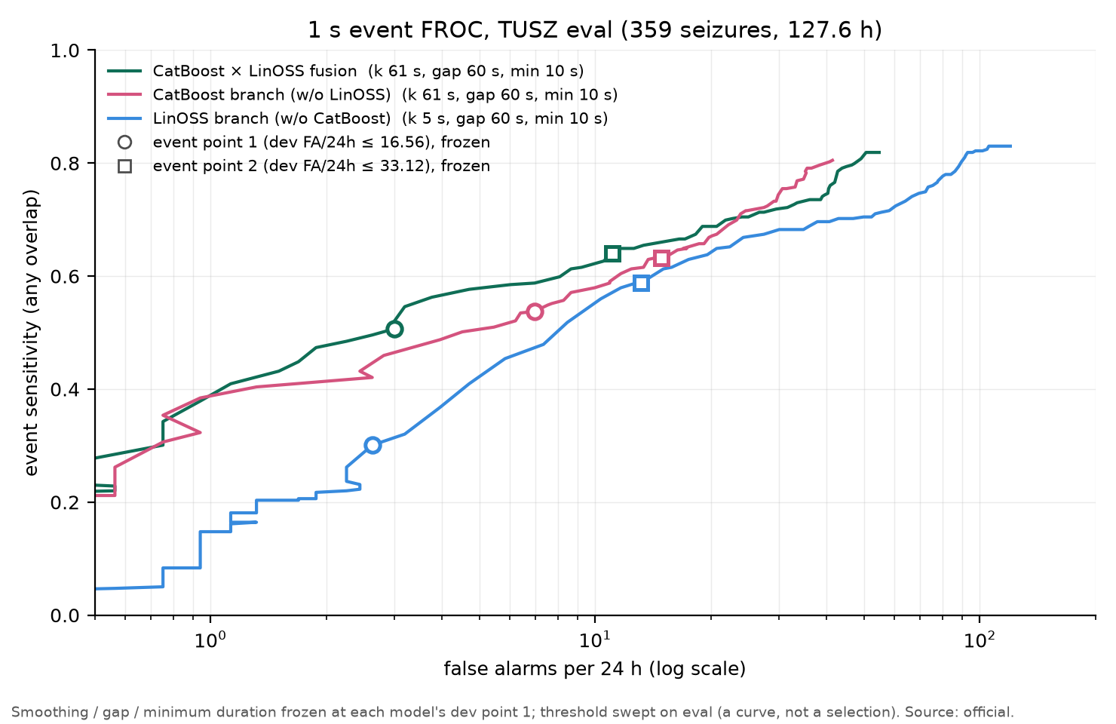
Figure 6. Event-level FROC (event sensitivity against false alarms per 24 h, logarithmic axis) at 1 s on TUSZ eval (359 events, 127.6 h) for the fusion, the CatBoost branch and the LinOSS branch. For each model, smoothing, gap and minimum duration are frozen at its dev point 1 and the threshold is swept on eval. Circles and squares mark the frozen event points 1 and 2.
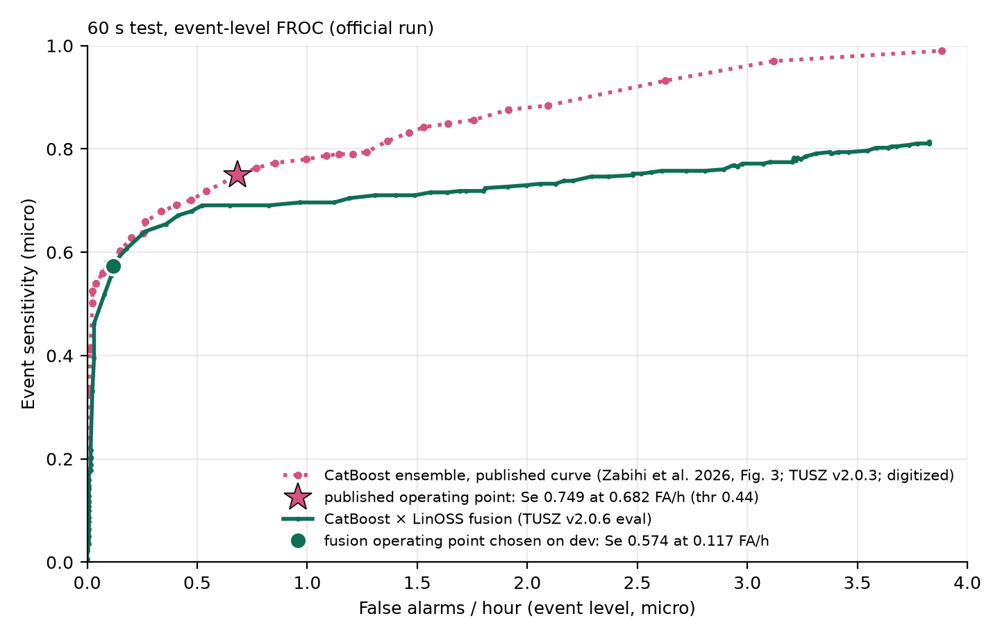
Figure 7. Event-level FROC at 60 s of the fusion (solid; official run) against the published CatBoost ensemble of Zabihi et al. (dotted markers; TUSZ v2.0.3; digitized from their Fig. 3 and drawn only as a visual reference). The star is the published operating point (event sensitivity 0.749 at 0.682 FA/h, threshold 0.44); the filled circle is the operating point of the fusion chosen on dev (event sensitivity 0.574 at 0.117 FA/h). The two curves are for different TUSZ versions.
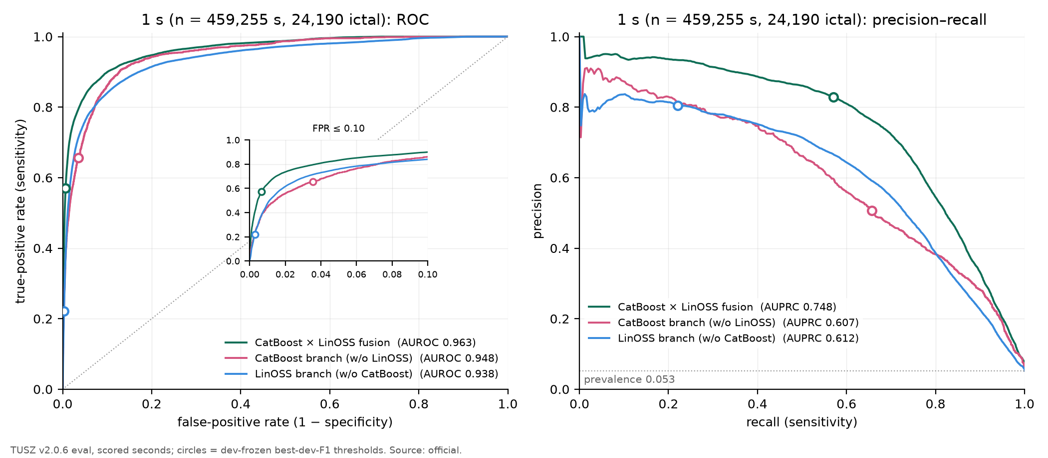
Figure 8. ROC (left, with a zoom on false-positive rates up to 0.10) and precision–recall curves (right) at 1 s on TUSZ eval (459,255 scored seconds, 24,190 ictal) for the fusion and each branch alone. Circles: the dev-frozen best-F1 thresholds. The dotted line in the right panel is the prevalence.
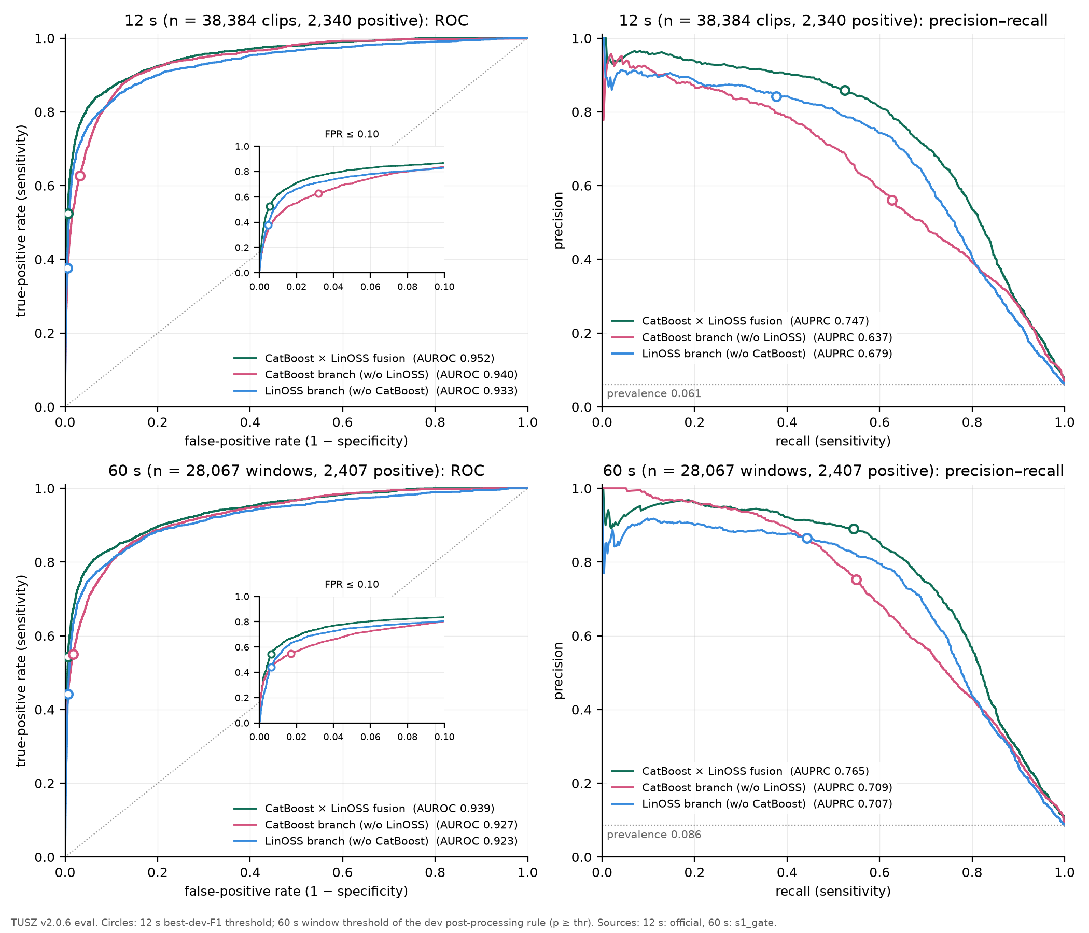
Figure 9. ROC and precision–recall curves at 12 s (top; 38,384 clips, 2,340 positive) and 60 s (bottom; 28,067 windows, 2,407 positive) on TUSZ eval. Circles: the 12 s best-dev-F1 thresholds and the 60 s window thresholds of the dev post-processing rule. The 60 s curves are computed from the outputs of the S1 gate, which equal the official ones (Section 8).

5.5 Statistical confidence
Table 23 gives patient-level bootstrap intervals for the three TUSZ models and Table 24 paired differences (Section 4.2). The TUSZ eval set has 43 patients, of which 30 have at least one event, so the intervals of event-level metrics are wide.
Table 23. Patient-level bootstrap (2,000 resamples of 43 eval patients; 95 % percentile intervals) for the 1 s test: point estimate and interval.
Metric | Fusion | CatBoost branch | LinOSS branch (5-seed)
AUROC | 0.963 [0.940, 0.978] | 0.948 [0.924, 0.968] | 0.938 [0.906, 0.957]
AUPRC | 0.748 [0.663, 0.826] | 0.607 [0.522, 0.731] | 0.612 [0.455, 0.721]
F1 | 0.676 [0.554, 0.758] | 0.572 [0.492, 0.680] | 0.347 [0.236, 0.434]
Event sensitivity, point 1 | 0.507 [0.289, 0.709] | 0.538 [0.323, 0.740] | 0.301 [0.148, 0.431]
FA/24 h, point 1 | 3.01 [1.03, 6.06] | 6.96 [2.80, 12.32] | 2.63 [1.32, 4.36]
Event sensitivity, point 2 | 0.641 [0.384, 0.855] | 0.632 [0.407, 0.835] | 0.588 [0.357, 0.782]
FA/24 h, point 2 | 11.10 [4.59, 19.80] | 14.86 [7.88, 22.45] | 13.17 [5.67, 22.29]

Table 24. Paired differences on the same resamples (fusion minus branch): point difference and 95 % interval. Intervals that exclude zero are in bold.
Metric | Fusion − CatBoost | Fusion − LinOSS
AUROC | +0.015 [+0.005, +0.025] | +0.025 [+0.014, +0.041]
AUPRC | +0.141 [+0.059, +0.183] | +0.136 [+0.047, +0.269]
F1 | +0.104 [−0.004, +0.185] | +0.329 [+0.246, +0.417]
Event sensitivity, point 1 | −0.031 [−0.091, +0.006] | +0.206 [+0.077, +0.328]
FA/24 h, point 1 | −3.95 [−8.63, −0.54] | +0.38 [−1.21, +2.48]
Event sensitivity, point 2 | +0.008 [−0.057, +0.085] | +0.053 [+0.014, +0.093]
FA/24 h, point 2 | −3.76 [−9.19, +0.94] | −2.07 [−11.10, +5.62]

The fusion is better than the CatBoost branch in AUROC (+0.015, interval [+0.005, +0.025]) and AUPRC (+0.141, [+0.059, +0.183]) with intervals that exclude zero, and has fewer false alarms at point 1 (−3.95 FA/24 h, [−8.63, −0.54]). The F1 difference (+0.104) and the event-sensitivity differences at both points have intervals that include zero: with the evidence at hand, the fusion reduces false alarms and improves ranking without a demonstrable change of sensitivity at a given event point. Against the LinOSS branch the improvement is significant in AUROC, AUPRC, F1 and event sensitivity at both points, with no significant change in false alarms at either point. The intervals of the absolute event metrics of the fusion are wide (event sensitivity 0.289–0.709 at point 1) because 43 patients, some with many events (the maximum is 75 events in one patient), dominate the pooled counts (Section 5.6).
Table 25. CHB-MIT test: patient-level bootstrap (2,000 resamples of 22 patients; 95 % percentile intervals) of the 12 s and 1 s point-wise metrics, and paired differences. Because the split is within patient, every patient contributes to training; the intervals reflect the sampling of test clips by patient and not generalisation to new patients.
Metric | Fusion | LinOSS | CatBoost | Fusion − LinOSS | Fusion − CatBoost
12 s AUROC | 0.990 [0.983, 0.995] | 0.988 [0.979, 0.994] | 0.953 [0.915, 0.979] | +0.002 [−0.000, +0.006] | +0.037 [+0.013, +0.072]
12 s AUPRC | 0.629 [0.479, 0.745] | 0.615 [0.468, 0.731] | 0.546 [0.349, 0.706] | +0.014 [−0.010, +0.037] | +0.083 [+0.004, +0.178]
12 s F1 | 0.641 [0.476, 0.751] | 0.663 [0.554, 0.744] | 0.548 [0.358, 0.681] | −0.022 [−0.097, +0.024] | +0.093 [+0.043, +0.160]
1 s AUROC | 0.992 [0.987, 0.997] | 0.989 [0.980, 0.995] | 0.968 [0.940, 0.986] | +0.003 [+0.001, +0.008] | +0.024 [+0.008, +0.050]
1 s AUPRC | 0.675 [0.515, 0.782] | 0.628 [0.483, 0.736] | 0.614 [0.414, 0.761] | +0.047 [+0.006, +0.074] | +0.061 [−0.022, +0.155]
1 s F1 | 0.684 [0.529, 0.786] | 0.664 [0.542, 0.748] | 0.592 [0.399, 0.719] | +0.021 [−0.043, +0.071] | +0.093 [+0.045, +0.167]

On CHB-MIT the fusion’s advantage over the CatBoost branch is significant in AUROC at 12 s (+0.037) and at 1 s, while over the LinOSS branch the differences at 12 s are not significant in any of the three metrics, and at 1 s the AUROC (+0.003) and AUPRC (+0.047) differences are positive with intervals that exclude zero.

5.6 Seizure type, duration and patients
We stratify the 359 eval events by the majority seizure type of the per-channel annotations of each event (every event has a single type) and by duration (Table 26, Table 27). Event sensitivities are at the frozen event point 1, any-overlap.
Table 26. Event sensitivity by seizure type (majority per-channel label of the event) at the dev-frozen event points. Point 1: fusion, CatBoost, LinOSS; point 2: fusion and CatBoost. Group “focal” = fnsz, cpsz, spsz; group “generalized” = gnsz, absz, tcsz, tnsz, mysz.
 |  | Point 1 |  |  | Point 2
Type | Events | Fusion | CatBoost | LinOSS | Fusion | CatBoost
Focal non-specific (fnsz) | 152 | 0.441 | 0.493 | 0.250 | 0.658 | 0.612
Generalized non-specific (gnsz) | 108 | 0.787 | 0.787 | 0.472 | 0.880 | 0.870
Absence (absz) | 49 | 0.000 | 0.020 | 0.000 | 0.000 | 0.082
Complex partial (cpsz) | 41 | 0.610 | 0.585 | 0.463 | 0.659 | 0.683
Tonic–clonic (tcsz) | 8 | 0.625 | 1.000 | 0.000 | 1.000 | 1.000
Tonic (tnsz) | 1 | 0.000 | 0.000 | 0.000 | 0.000 | 0.000
All focal-type | 193 | 0.477 | 0.513 | 0.295 | 0.658 | 0.627
All generalized-type | 166 | 0.542 | 0.566 | 0.307 | 0.620 | 0.639
All events | 359 | 0.507 | 0.538 | 0.301 | 0.641 | 0.632

Table 27. Event sensitivity by event duration at the dev-frozen event points (columns as in the previous table).
 |  | Point 1 |  |  | Point 2
Duration | Events | Fusion | CatBoost | LinOSS | Fusion | CatBoost
< 10 s | 50 | 0.000 | 0.020 | 0.000 | 0.000 | 0.080
10–30 s | 86 | 0.128 | 0.267 | 0.047 | 0.302 | 0.360
30–60 s | 72 | 0.694 | 0.736 | 0.403 | 0.833 | 0.833
60–180 s | 131 | 0.817 | 0.779 | 0.489 | 0.947 | 0.885
≥ 180 s | 20 | 0.700 | 0.700 | 0.550 | 1.000 | 0.800

Detection is concentrated in seizures longer than 30 s. For events of 60–180 s the fusion has the highest sensitivity of the three models at both points (0.817 at point 1, 0.947 at point 2). In the strata of short events, the CatBoost branch is better than the fusion: for events of 10–30 s the sensitivity is 0.267 for CatBoost against 0.128 for the fusion, and for fnsz events 0.493 against 0.441. The fusion matches CatBoost on gnsz events (0.787 for both) and is better on cpsz events (0.610 against 0.585). The median signed latency of all detected events (start of the first predicted event overlapping the event minus the annotated onset; negative: before onset) is −5.0 s for the fusion, −24.0 s for CatBoost and 16.5 s for LinOSS; the negative values reflect the centred smoothing, which looks ahead, and are not predictions.
Absence and short seizures (limitation). The 49 absence events and the 50 events shorter than 10 s are not detected by the fusion at point 1 (sensitivity 0.000 and 0.000) and almost not by any branch (CatBoost 0.020 and 0.020; at point 2 the CatBoost branch detects 0.082 of the absence events). The windows and smoothing of both branches, designed for events of tens of seconds, are too coarse for events of a few seconds; the complementarity analysis shows that of the 49 absence events, 48 are missed by both branches at point 1 (Section 5.7). A detector for absence seizures would need a shorter time scale; we do not claim to address them.
Patients. Of the 43 eval patients, 30 have events; the number of events per patient has quartiles 1.0, 2.0, 6.5, 14.8, 75.0 (minimum, first quartile, median, third quartile, maximum), so a few patients dominate the pooled event sensitivity. The per-patient event sensitivity of the fusion has a median of 0.517 (CatBoost 0.700, LinOSS 0.033), and 8 patients (CatBoost 8, LinOSS 15) have no event detected (Figure 10). Against the CatBoost branch the fusion has a higher per-patient sensitivity in 4 patients, an equal one in 18 and a lower one in 8, and fewer false alarms in 9 patients and more in 2. Per-patient sensitivity is therefore lower for the fusion than for CatBoost in more patients than it is higher, in line with the pooled sensitivity at point 1; the false alarms of the fusion (16, in 8 patients) are fewer than those of CatBoost (37, in 14 patients). Patients are identified only by rank, in accordance with the corpus data-use agreement.
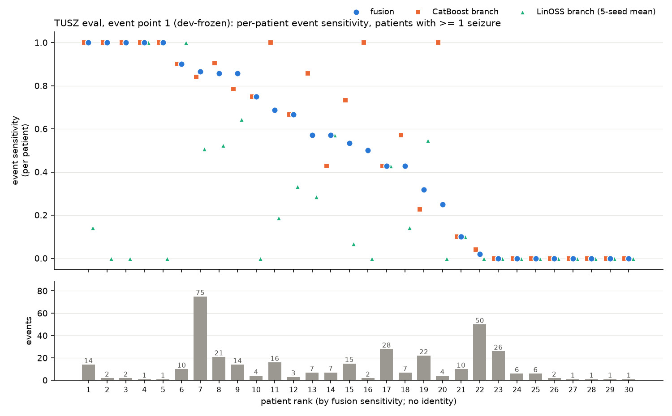
Figure 10. Per-patient event sensitivity at event point 1 on TUSZ eval for the 30 patients with at least one event (top), ordered by the sensitivity of the fusion, and the number of events of each patient (bottom). Patients are shown by rank only. The LinOSS branch alone (triangles) misses most events in many patients; the CatBoost branch (squares) and the fusion (circles) are close, with the fusion lower in some patients.

5.7 Evidence that the branches make different mistakes
We test the premise of the fusion with five analyses of the official eval outputs. Every model is evaluated at its own dev-frozen point; bootstrap intervals use the recording as unit (2,000 resamples). The analyses are post-hoc and select nothing.

5.7.1 Which events each branch detects
Figure 11 and Table 28 classify the 359 events by which branch detects them. At point 1, 89 events are detected by both branches, 104 only by CatBoost, 19 only by LinOSS and 147 by neither. The fusion detects all of the first group, 82 of the second, 11 of the third and none of the fourth: it detects no event that neither branch detects (0), and it misses 30 events that at least one branch detects. At point 2, the groups are 191, 36, 20 and 112, and the fusion detects 191, 23, 13 and 3. The events that only LinOSS detects are longer and more focal than those that only CatBoost detects (median duration 100 against 63 s, Mann–Whitney p = 0.008; median labelled channels 8 against 15, p = 0.015); the events that neither detects are short (median 16 s) and include 48 of the 49 absence events. These are post-hoc subgroup tests without correction for multiple comparisons.
Table 28. Events by which branch detects them at the dev-frozen event points (any-overlap). “Fusion detects”: number of the group also detected by the fusion. “Median latency”: median signed start of the first detecting event relative to the annotated onset for the branches that detect the group (negative: before).
Group | Events, pt 1 | Fusion detects | Events, pt 2 | Fusion detects | Median duration (s), pt 1 | Median latency (s), pt 1
Both | 89 | 89 | 191 | 191 | 68 | CatBoost −8.0; LinOSS 15.0; fusion −5.0
CatBoost only | 104 | 82 | 36 | 23 | 63 | CatBoost −45.0; fusion −6.0
LinOSS only | 19 | 11 | 20 | 13 | 100 | LinOSS 20.0; fusion 9.0
Neither | 147 | 0 | 112 | 3 | 16 | –

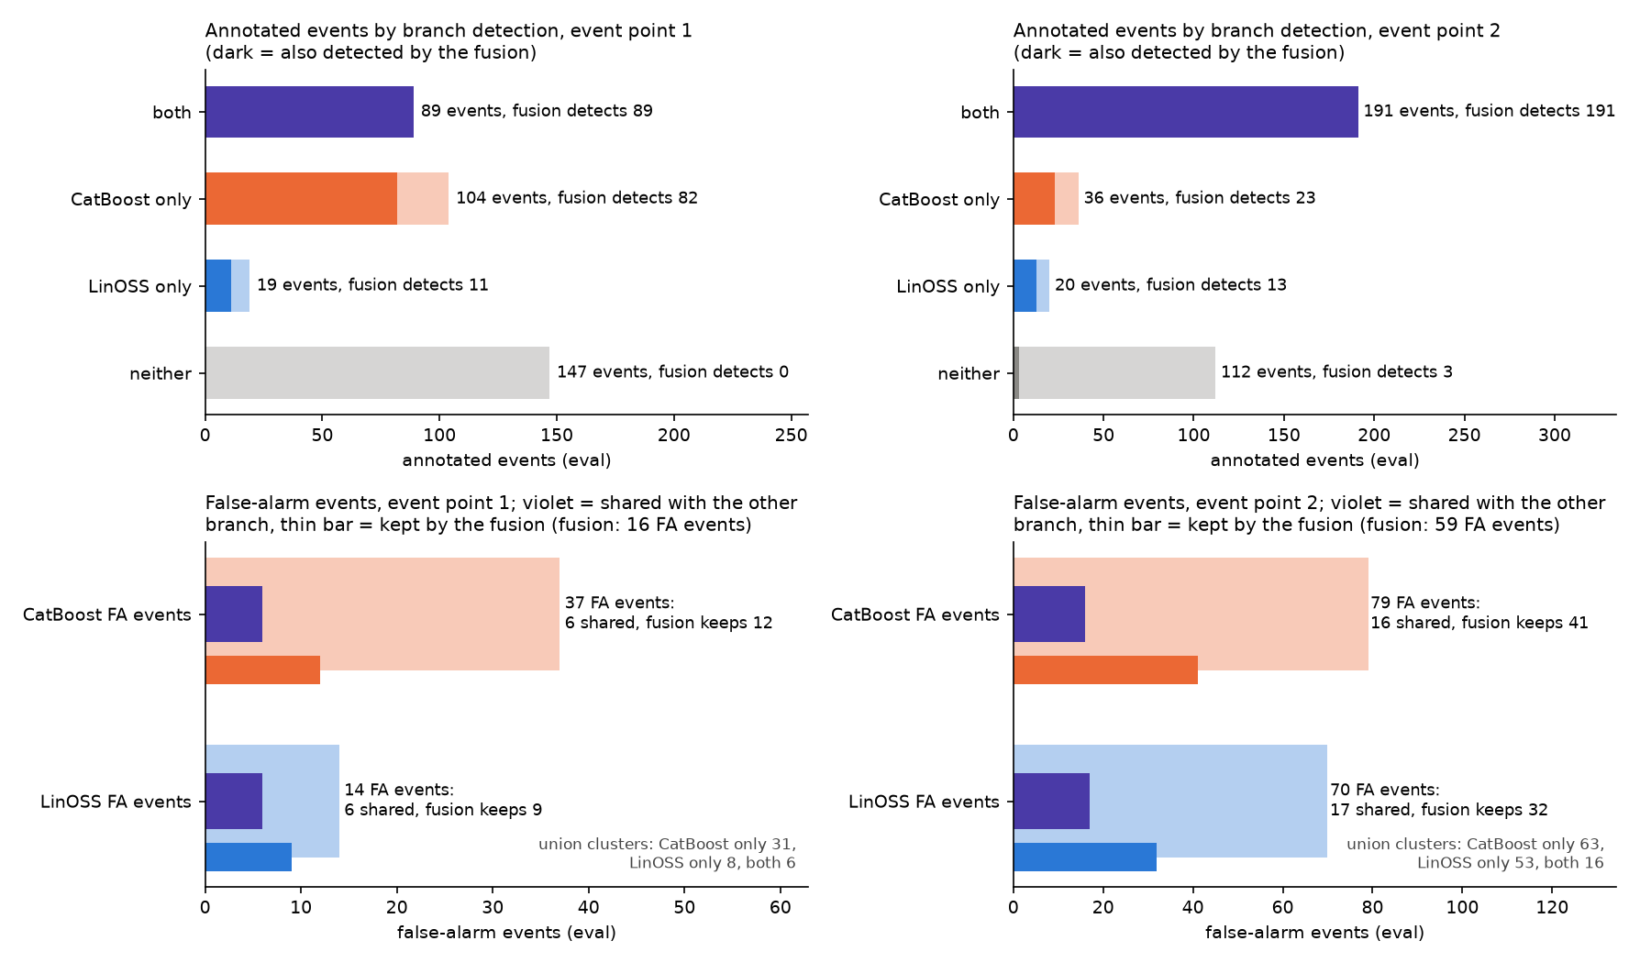
Figure 11. Events and false alarms by branch at the dev-frozen event points 1 (left) and 2 (right) on TUSZ eval. Top: annotated events grouped by which branch detects them (both, CatBoost only, LinOSS only, neither); the dark part of each bar is the number also detected by the fusion. Bottom: false-alarm events of each branch; violet is the part shared with the other branch (overlapping false-alarm events), and the thin bar is the number kept by the fusion. The number of false-alarm events of the fusion is given in the panel titles.

5.7.2 Timing at onset and offset
The most direct difference is in time (Figure 12, Table 30). Aligning the 151 events of at least 60 s at the annotated onset, the mean CatBoost probability rises slowly from a high baseline (0.39 before the seizure) and reaches half of its plateau −20 s relative to the onset, with a 10–90 % rise time of 99 s, whereas the mean LinOSS probability starts from a low baseline (0.10), reaches half-maximum 7 s after the onset and rises in 28 s. At the offset the pattern is mirrored. Per event, the raw CatBoost track crosses its dev-F1 threshold a median of −24.5 s from the onset (91 of 210 events cross more than 30 s before the onset) and leaves it 18.5 s from the offset, so its decision blurs the seizure edges by tens of seconds on both sides, as expected from the 60 s windows with ±105 s of context. The LinOSS track crosses 16 s after the onset and leaves −14 s from the offset (it is late at the onset and early at the offset). For the 118 events that both reach, LinOSS minus CatBoost is +46.3 s at the onset (95 % interval +30.3 to +61.8) and −49.6 s at the offset (−61.9 to −36.4). The fusion inherits the sharp edges of LinOSS (rise time 30 s; median crossing 4 s at the onset and −2 s at the offset) while keeping the sensitivity of CatBoost to events that LinOSS alone detects late or not at all.
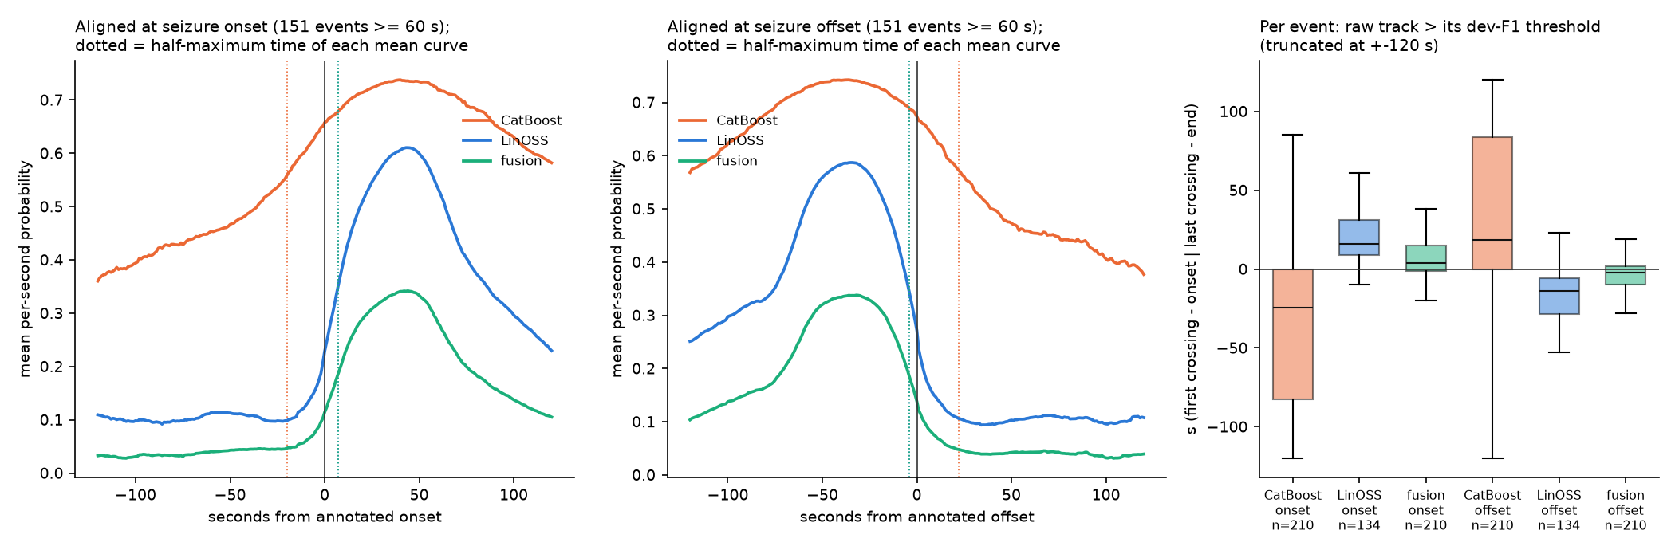
Figure 12. Timing of the three scores around the seizure edges on TUSZ eval. Left and middle: mean per-second probability of CatBoost, LinOSS and the fusion, aligned at the annotated onset and offset of the 151 events of at least 60 s; dotted verticals mark the half-maximum time of each mean curve. The CatBoost score begins to rise tens of seconds before the onset and falls tens of seconds after the offset; the LinOSS and fusion curves switch on and off within about 30 s. Right: per event, the time of the first crossing of the dev-F1 threshold relative to the onset, and of the last crossing relative to the offset (boxes: quartiles; whiskers truncated at ±120 s); n is the number of events that the track reaches.

5.7.3 False alarms: where they are, and what they contain
At the dev-F1 thresholds, the CatBoost branch raises 15,478 false-alarm seconds, the LinOSS branch 1,294 and the fusion 2,864; 410 seconds are false alarms of both branches, and the fusion keeps all of them. Only 2.6 % of the CatBoost false-alarm seconds are also false alarms of LinOSS, and 31.7 % in the other direction, so the false alarms are largely branch-specific. They differ in geography: 59.9 % of the false-alarm seconds that only CatBoost raises (9,019 of 15,068) lie within 60 s of an annotated seizure, against 3.5 % of those that only LinOSS raises (31 of 884). CatBoost’s false alarms are mostly the blurred edges of true seizures, that is, its timing error seen from the background side; LinOSS’s are mostly remote from any seizure. The fusion discards most branch-specific false alarms: it keeps 15.0 % of the CatBoost-only and 15.7 % of the LinOSS-only false-alarm seconds. At the event level (point 1) CatBoost has 37 false-alarm events, LinOSS 14 and the fusion 16; 6 are shared between the branches, and the fusion keeps 12 of the CatBoost and 9 of the LinOSS false-alarm events.
A hypothesis that is not supported. Because the LinOSS branch reads the unfiltered 0–99 Hz spectrum and the CatBoost branch the 0.5–35 Hz band, we hypothesised that false alarms that only LinOSS raises carry more power at 30 Hz and above (muscle or electrode artefact outside the CatBoost band) than false alarms that only CatBoost raises, which should carry more low-frequency power. We tested this before looking at the outcome, on the electrode-mean log-spectra of false-alarm seconds relative to the recording’s background, in remote false-alarm seconds (at least 120 s from any seizure) at the dev-F1 thresholds, and in the unshared false-alarm events at both event points (Table 29, Figure 13). The difference LinOSS-only minus CatBoost-only is not significant in any band, and in the remote seconds its sign for the high band is opposite to the hypothesis (−1.66 dB, interval −4.58 to +4.51); in the event-level comparison at point 2 the high-frequency minus low-frequency contrast is positive (+1.59 dB) but its interval −0.44 to +3.58 includes zero. We conclude that the spectral content of the false alarms does not explain the complementarity. What separates the two branches’ false alarms is geography (near a seizure or remote) and timing, not the frequency band; the broader input band of LinOSS is not what makes its false alarms different. The analysis has little power for LinOSS-only events (there are few of them, 14 LinOSS false-alarm events at point 1), and the intervals are wide.
Table 29. Hypothesis test on the spectral content of false alarms: LinOSS-only minus CatBoost-only band power relative to the recording’s background (dB of amplitude), with 95 % intervals over recordings. All intervals include zero except where marked: none is marked. The hypothesis predicted positive values in the 30 Hz and higher bands and a positive high-minus-low contrast.
Band | Remote FA seconds | Unshared FA events, point 1 | Unshared FA events, point 2
δ 0.5–4 Hz | −0.32 [−2.88, +3.16] | +0.62 [−5.49, +7.95] | +0.43 [−1.35, +2.39]
θ 4–8 Hz | −0.45 [−2.48, +2.89] | +0.32 [−4.98, +6.86] | +0.43 [−1.49, +2.48]
α 8–13 Hz | −0.42 [−1.86, +3.62] | +0.56 [−3.93, +6.61] | +1.02 [−1.00, +3.19]
β 13–30 Hz | −0.29 [−2.43, +4.45] | +1.14 [−5.09, +9.18] | +1.88 [−0.40, +4.31]
γ 30–45 Hz | −0.80 [−3.46, +5.09] | +1.02 [−6.55, +11.05] | +2.28 [−0.60, +5.19]
45–99 Hz (excluding 59–61) | −1.66 [−4.58, +4.51] | +0.08 [−7.70, +10.09] | +1.75 [−1.32, +4.83]
high minus low contrast | −0.85 [−2.28, +2.73] | +0.08 [−2.94, +4.61] | +1.59 [−0.44, +3.58]

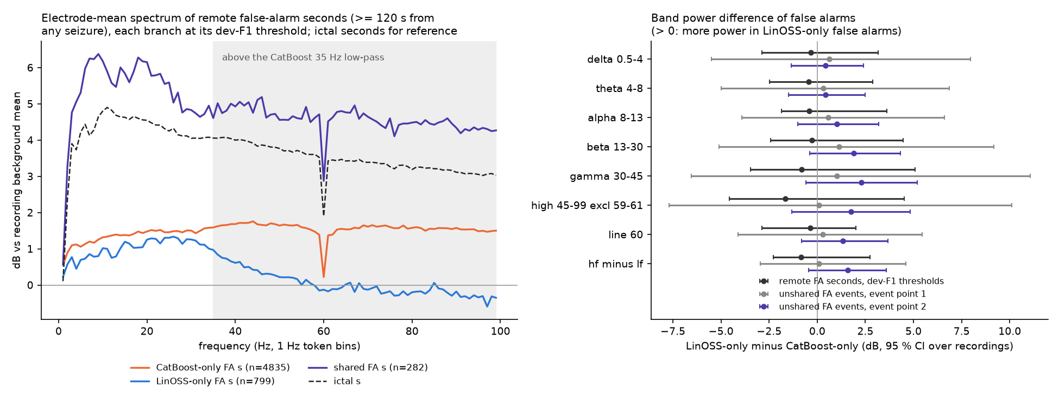
Figure 13. Spectral content of false alarms. Left: electrode-mean spectrum (dB of amplitude relative to the recording’s background mean, 1 Hz token bins) of remote false-alarm seconds (at least 120 s from any seizure) that only CatBoost raises (orange; n = 4,835), only LinOSS raises (blue; n = 799) or both raise (violet; n = 282), with ictal seconds for reference (dashed); the grey band is above the 35 Hz low-pass of the CatBoost branch. Right: LinOSS-only minus CatBoost-only band power with 95 % intervals over recordings for remote false-alarm seconds and for unshared false-alarm events at the two event points. Every interval includes zero.

5.7.4 Where the scores disagree, and the measured gain
The logits of the two branches are only moderately correlated: the Pearson correlation of z_{C} and z_{L} is 0.498 on 435,065 background seconds and 0.478 on 24,190 ictal seconds (Spearman 0.531 and 0.386); per patient (background seconds) the median is 0.36 (interquartile range 0.18 to 0.49). By seizure type the ictal correlation is 0.48 for fnsz, 0.61 for cpsz, 0.26 for gnsz and −0.17 for absz (330 seconds); the branches agree least on generalized and absence seizures. With Eq. (10), the correlation implies an idealised separation gain of 1.156 (1.163 with the ictal correlation). As an empirical counterpart, we measure the share of ictal seconds that each score catches at a fixed background budget: at a background budget of 1 % (the threshold of each score is set so that 1.000 % of the background seconds are above it), the share of ictal seconds caught is 0.445 for CatBoost, 0.474 for LinOSS and 0.636 for the fusion. The two quantities are not directly comparable. The idealisation assumes equally strong Gaussian scores; here the scores are neither Gaussian nor equally strong, and the stacker also uses the product term and the smoothed LinOSS logits, so we use the gain only as a qualitative guide.
Figure 14 shows the joint distribution of the two logits and what the stacker does with it. Among the ictal seconds, 18.210 % are above both dev-F1 thresholds (the fusion marks all of them), 47.466 % only CatBoost’s (the fusion marks 72.775 % of them), 3.886 % only LinOSS’s (marked: 89.574 %) and 30.438 % neither (marked: 2.743 %). Among the background seconds, the corresponding shares are 3.463 % for the CatBoost-only quadrant, of which the fusion marks 14.952 %, and 0.203 % for the LinOSS-only quadrant (marked: 15.724 %). The fusion therefore behaves as a soft AND with a veto: where CatBoost fires and LinOSS does not, it keeps most ictal seconds but removes most background seconds; where LinOSS fires and CatBoost does not, it keeps most of both, which is a small group; and it almost never fires where neither does (the stacker’s decision boundary is the curved line in the figure).
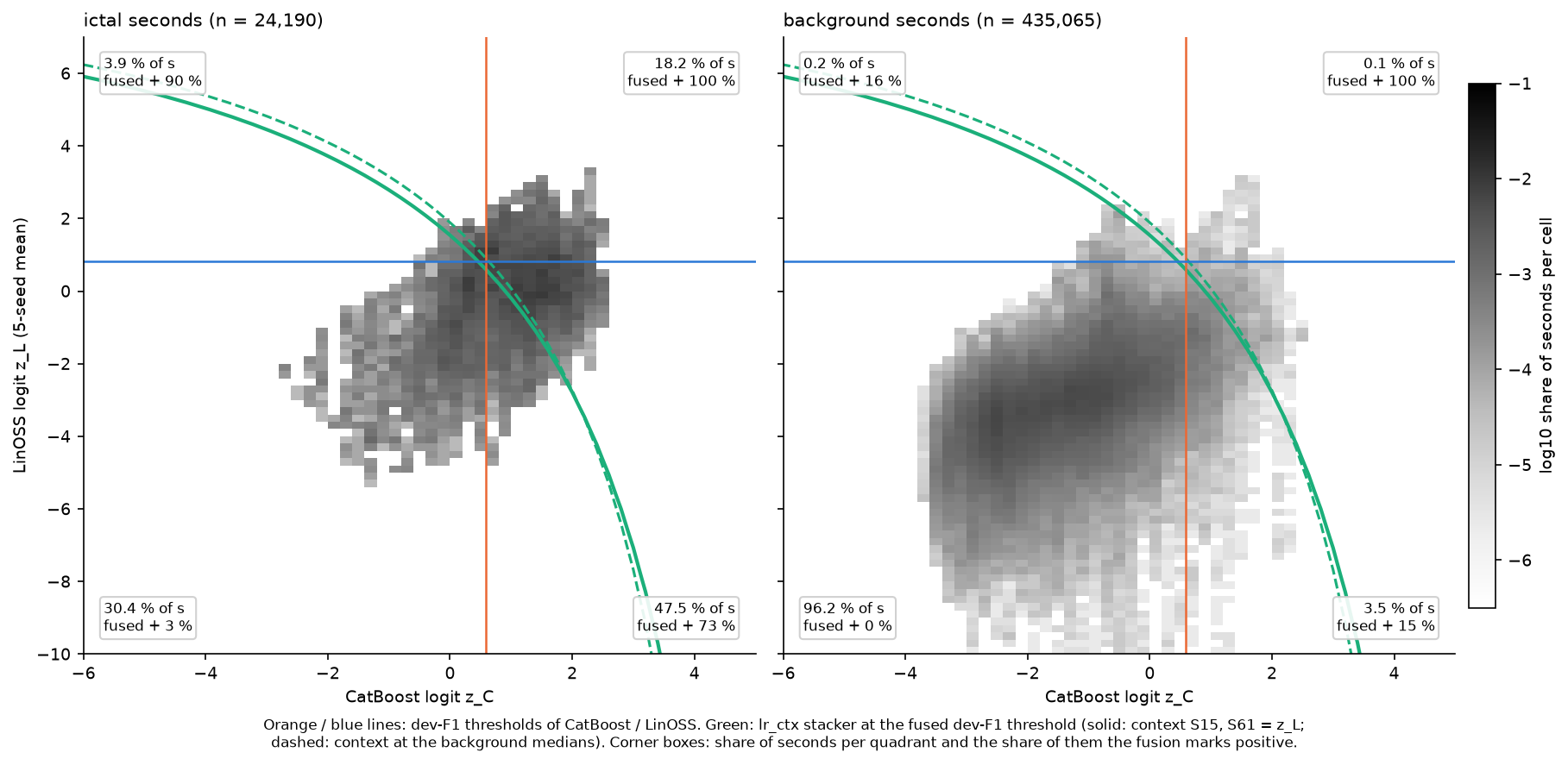
Figure 14. Joint distribution of the CatBoost logit z_{C} (horizontal) and the LinOSS 5-seed logit z_{L} (vertical) for ictal seconds (left) and background seconds (right) on TUSZ eval (grey scale: log₁₀ share of seconds per cell). Orange and blue lines: the dev-F1 thresholds of the two branches. Green curve: decision boundary of the lr_ctx stacker at the dev-F1 threshold of the fusion (solid: context terms S₁₅ and S₆₁ equal to z_{L}; dashed: at the background medians). Corner boxes: the share of seconds in each quadrant and the share of them that the fusion marks positive.
Table 30. Summary of the complementarity measurements on TUSZ eval (each model at its own dev-frozen point). Times in seconds; negative: before the annotated onset or offset.
Measurement | CatBoost | LinOSS | Fusion
Median time of first threshold crossing relative to onset (s) | −24.5 | 16.0 | 4.0
Median time of last threshold crossing relative to offset (s) | 18.5 | −14.0 | −2.0
10–90 % rise time of the mean onset curve (s) | 99 | 28 | 30
Events detected, point 1 | 193 | 108 | 182
False-alarm seconds at the dev-F1 threshold | 15,478 | 1,294 | 2,864
False-alarm events, point 1 | 37 | 14 | 16
Share of own-only false-alarm seconds within 60 s of a seizure (%) | 59.9 | 3.5 | –
Ictal seconds caught at a 1 % background budget | 0.445 | 0.474 | 0.636
Pearson correlation of z_{C} and z_{L}: 0.498 (background), 0.478 (ictal).

5.8 Visual evidence
Figure 15 shows the three per-second scores on three recordings whose seizure durations are at the 25th, 50th and 75th percentile of the seizure seconds of the eval set (a seizure of 65 s, 107 s and 227 s, in recordings of which 5, 12 and 5 min are scored); the fusion detects the seizure in all three. The recordings are chosen by rule (the recording closest to each percentile among 106 recordings with at least one detected seizure), not by appearance, but they do come from recordings with a detected seizure and therefore illustrate successful behaviour. They show the timing pattern of Section 5.7.2: the CatBoost score (red) is high before the seizure and decays slowly after it, the LinOSS score (blue) rises and falls with the seizure and in the longest example only slowly after its onset, and the fused score is a smoothed, sharper version.
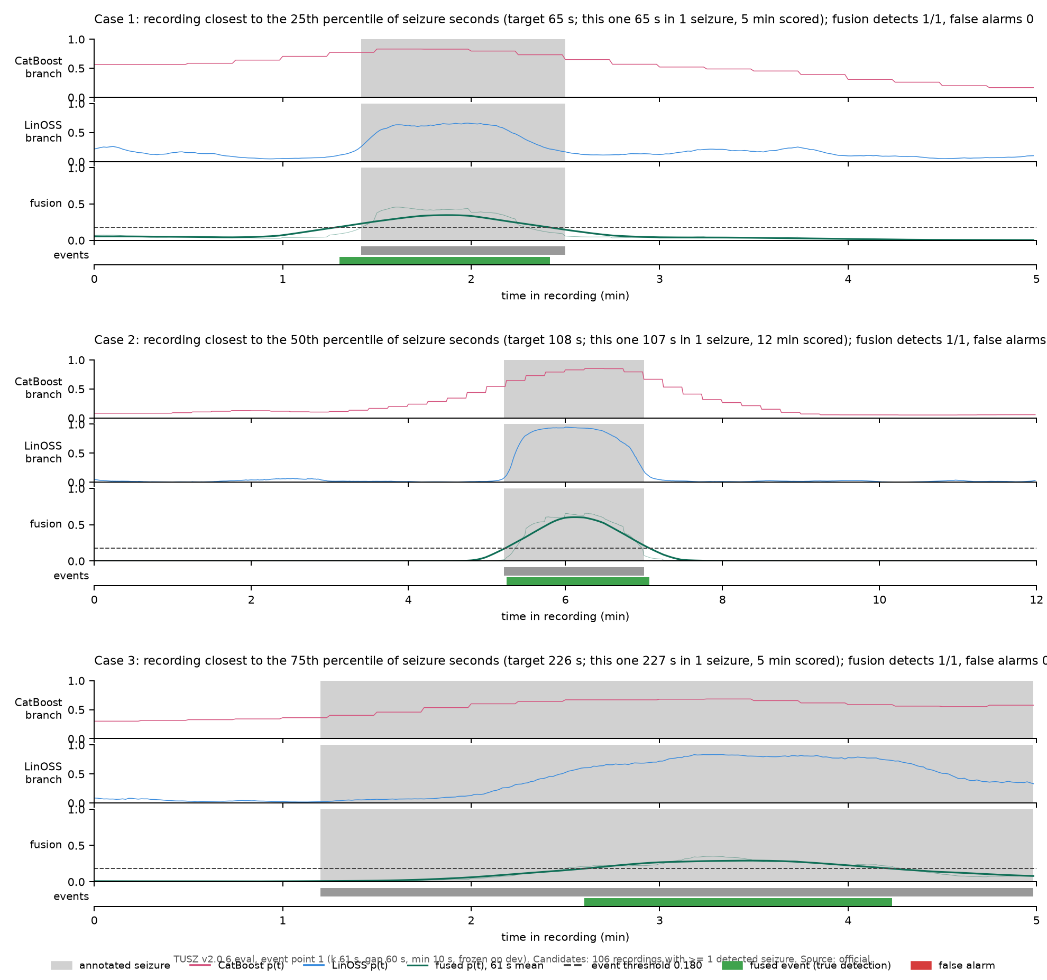
Figure 15. Detection timelines on TUSZ eval for three recordings chosen by rule: the recording whose seizure duration is closest to the 25th (top), 50th (middle) and 75th (bottom) percentile of the seizure seconds. In each case, top to bottom: CatBoost per-second probability (red), LinOSS probability (blue), fused probability (green, dark: 61 s mean; light: raw) with the event threshold of point 1 (dashed), and the annotated seizure (grey) with the predicted event (green). The grey shading marks the annotated seizure. Event point 1 of the fusion (k = 61 s, gap 60 s, minimum 10 s) frozen on dev.
Figure 16 (cases A–D) and Figure 17 (case A at full size) show 240 s of the 19 referential channels with the annotation and the detection, following the rules fixed in advance (path.md §5): the data are the official eval run at event point 1; the display filter is 0.5–35 Hz with a dotted line every second; blue marks annotated seizure seconds, green detected seconds, teal both and red a false alarm; in the electrode cells, the colour is shown where the LinOSS occlusion importance of the electrode is at least 0.5 times the maximum in the window (each electrode’s 100 tokens are set to the global mean in every second and the drop of the 5-seed logit is averaged over seeds; this explains the LinOSS branch only). The cases are selected by rule from 359 annotated events and 16 false alarms: (A) a focal-type event of 30–180 s on at most half of the channels, detected, with the median latency (44 candidates; median latency 9 s; selected: complex partial, 145 s, labelled on 7 of 22 channels, latency +9 s, coverage 94 %); (B) a generalized-type event labelled on all channels, detected, with the median latency (50 candidates; median latency −10 s; selected: generalized non-specific, 75 s, 22 of 22 channels, latency −10 s, coverage 100 %); (C) a false alarm of median duration (16 candidates; selected: 44 s); (D) a missed or partly detected focal-type event of median duration (107 candidates; selected: focal non-specific, 27 s, 13 of 22 channels, coverage 0 %). In case A the annotated electrodes are CZ and right parasagittal and temporal electrodes, and the occlusion importance attributes the detection mainly to C4 and FZ; the detection starts 9 s after the annotated onset. In case B all channels are annotated and the event is detected before the annotated onset (negative latency), which the centred smoothing makes possible. In case C, a false alarm of 44 s, the occlusion importance attributes the alarm to P3 and F4. Case D is a 27 s focal seizure that the fusion does not detect; a strong artefact precedes it in the window. No recording or patient identifier is printed.
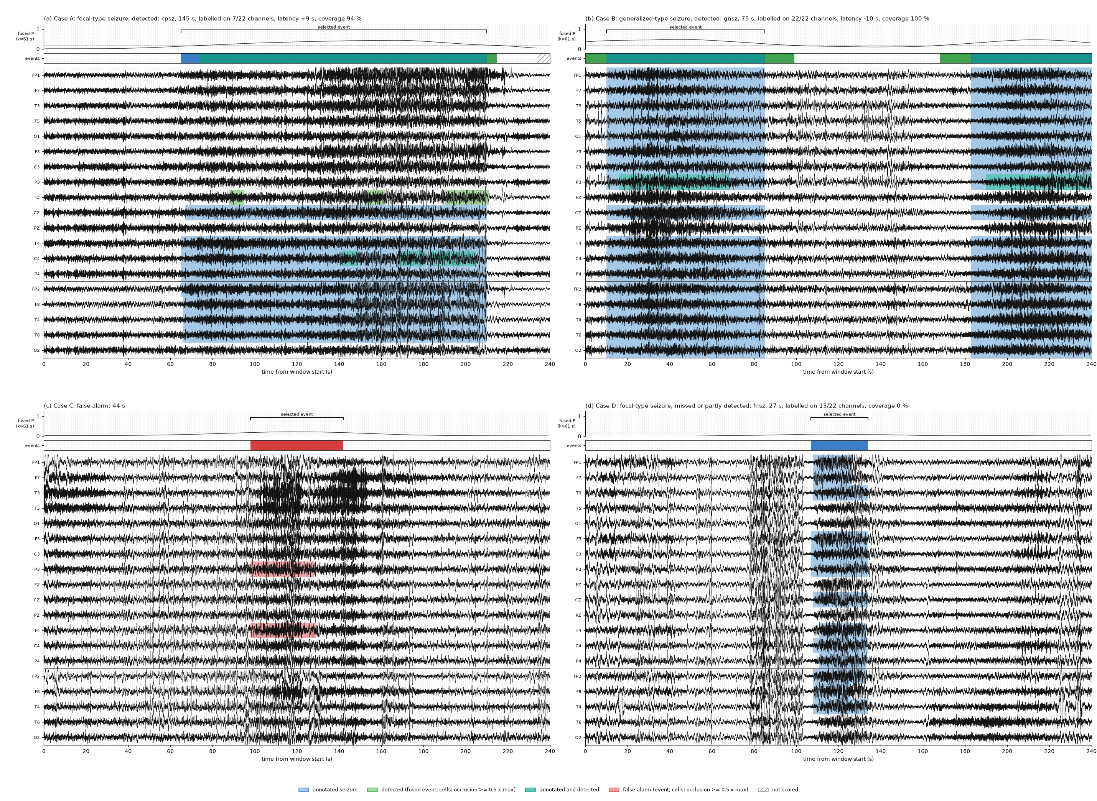
Figure 16. Four evidence cases on TUSZ eval (event point 1 of the fusion, official run), selected by fixed rules. Each panel: 240 s of the 19 referential channels (0.5–35 Hz display filter, each trace scaled by its robust standard deviation; one row is 8 robust SD), the smoothed fused probability with the dev-frozen threshold (dashed) and the selected event (bracket), an event band, and channel cells. Blue: annotated seizure (per-channel annotations mapped to electrodes, OR rule); green: detected by the fusion (cells: electrodes where the LinOSS occlusion importance is at least 0.5 times the window maximum); teal: annotated and detected; red: false alarm; hatched: not scored. (a) Focal-type seizure (complex partial), detected, median latency among such events. (b) Generalized-type seizure, detected, median latency. (c) False alarm of median duration. (d) Focal-type seizure missed by the fusion, median duration.
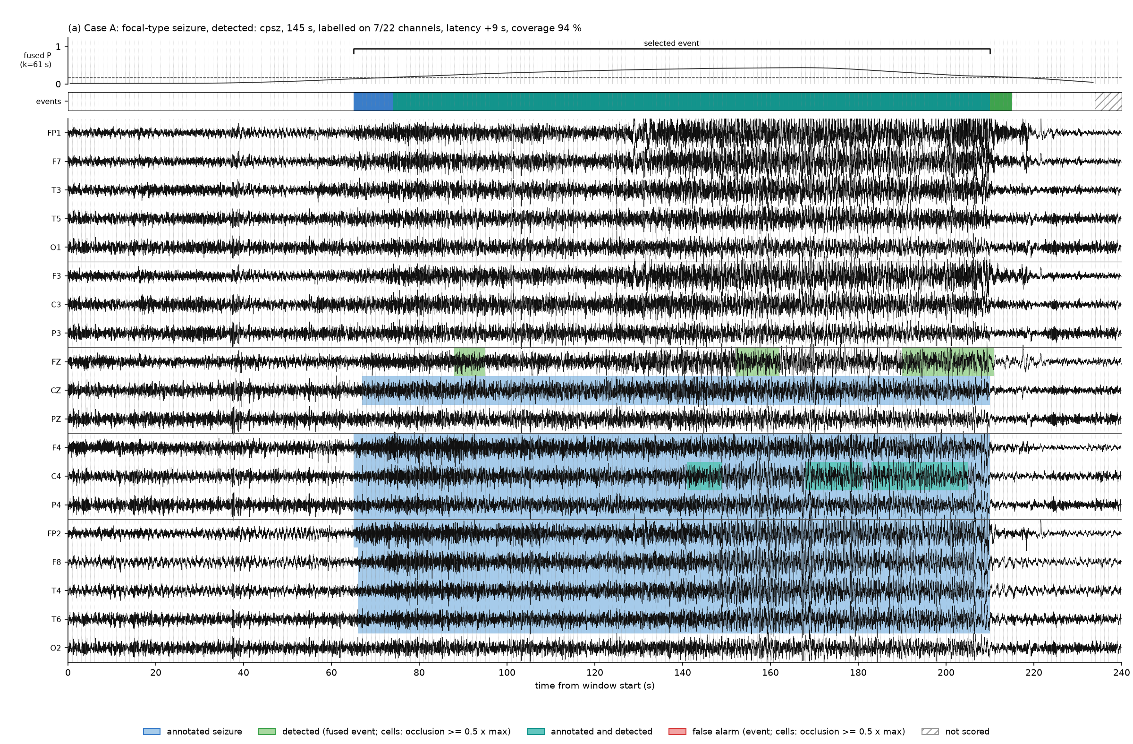
Figure 17. Case A of the evidence figure at full size: a 145 s complex-partial seizure labelled on 7 of 22 channels (right parasagittal and temporal chains and CZ), detected by the fusion with a latency of +9 s (event coverage 94 %). The row groups are, from top to bottom: left temporal chain, left parasagittal chain, midline, right parasagittal chain, right temporal chain. The trace is the raw EEG with a 0.5–35 Hz display filter and a dotted line every 1 s (the scoring unit); colours as in the previous figure.

5.9 Efficiency
Table 31 gives the measured cost of the final system, from the logs of the training and scoring runs. LinOSS was trained on one NVIDIA T4 GPU (16 GB; on Kaggle), the CatBoost scoring and the overlookers ran on CPU. An epoch is 6,000 segments of 240 s on TUSZ and 6,000 clips of 12 s on CHB-MIT, batch size 32; the CatBoost committee is not epoch-based.
Table 31. Computational cost of the final system on a T4 GPU and on CPU. Per-epoch times are medians with the interquartile range; inference times are per 12 s clip or per 60 s window.
Quantity | TUSZ | CHB-MIT
LinOSS training time per epoch (s) | 28.1 (27.5–28.5; 86 epochs) | 10.7 (10.1–11.4; 118 epochs)
LinOSS peak GPU memory (MB) | 777 | 201
LinOSS inference per 12 s (ms) | 0.145 (240 s windows every 120 s, batch 64) | 0.089 (clips, batch 512)
CatBoost committee training | two Kaggle GPU sessions (50 models, Optuna for the sens committee; the development committee); the second took 126.7 min, the first was not timed | 900.6 s in total (20 base + 10 sens, GPU T4)
CatBoost inference per 12 s clip (ms) | – | 0.057 (30 models, 4 CPU cores, precomputed features)
Feature extraction per 12 s clip (ms) | – | 66.7 (tokens and 588 features, one CPU core)

Table 32 compares the cost at 60 s with the efficiency table of HyBrain [3], whose values we copy; the hardware (their RTX A6000 against our T4), the definition of an epoch and the inclusion of feature extraction differ, so the table is an order-of-magnitude comparison. The LinOSS backbone is small and fast (0.199 ms per window and per seed on the GPU, plus 0.071 ms for the overlooker), but the 5-seed system including the CatBoost committee (5.106 ms per window on 6 CPU threads, which includes the ±7-window context statistics) takes 6.45 ms per window, dominated by the CatBoost committee; a single seed takes 5.38 ms. The peak GPU memory of the LinOSS training (777 MB) is 2.34 times the 332.2 MB of HyBrain, because our training segments are 240 s long. Feature extraction (CPU) is excluded from the 60 s figures; for a 12 s clip it costs 66.7 ms on one core and is therefore the largest single cost of the CHB-MIT pipeline.
Table 32. Efficiency at 60 s. Training time per epoch (s), inference per 60 s segment (ms) and peak GPU memory (MB). Ours: one T4, TUSZ; the epoch is 6,000 segments of 240 s; inference includes the CatBoost committee on CPU and excludes feature extraction. HyBrain rows are copied from Table 6 of [3] (their epoch definition; RTX A6000).
System | Training (s / epoch) | Inference (ms / segment) | Peak memory (MB)
Ours: full 5-seed system | 28.1 | 6.45 | 777
Ours: single seed | 28.1 | 5.38 | 777
HyBrain, K = 3 | 30.32 | 0.218 | 332.8
EvoBrain | 57.99 | 4.781 | 3981.7
GRU-GCN | 31.13 | 2.340 | 4605.5
DCRNN | 240.2 | 3.869 | 71.2
GraphS4mer | 30.29 | 0.181 | 340.4
EEGPT | 151.2 | 4.425 | 1022.1
LaBraM | 212.9 | 9.429 | 3576.7
BIOT | 86.07 | 3.264 | 1850.7
LSTM | 31.30 | 0.013 | 88.0

5.10 Development set against evaluation set
The dev set is the set on which every choice is made; its scores for the fusion use out-of-fold stacker rows (5-fold, patient-grouped), so they are not in-sample for the stacker, but the LinOSS epochs and the CatBoost design were chosen on dev and the dev scores are therefore optimistic in that respect. Even so, the dev scores are lower than the eval scores for every model and every metric of Table 33: the dev set is harder. For example, the fusion’s 1 s AUPRC is 0.325 on dev against 0.748 on eval, and its AUROC 0.923 against 0.963. The dev set has 24,144 ictal seconds in 878,730 scored seconds, and the eval set 24,190 in 459,255; AUPRC depends on this prevalence, AUROC does not, and AUROC is lower on dev too. In AUROC the order fusion, CatBoost, LinOSS holds on both sets at all three read-outs, and in AUPRC the fusion is highest on both sets at all three read-outs (Table 33).
The difference between the sets has a consequence for the frozen operating points. At event point 1 the dev budget is 16.56 FA/24 h and the fusion’s out-of-fold dev rate is 16.13 (CatBoost 16.22, LinOSS 16.13), whereas on eval the same rules give 3.01, 6.96 and 2.63; the 60 s false-alarm rate of the fusion is 0.616 FA/h on dev (budget 0.69) and 0.117 on eval. Frozen budgets are therefore conservative on eval, and the low false-alarm rates on eval are partly a property of the eval set. This is why we compare false-alarm rates mainly between models that share the same set and rules (Sections 5.1 and 5.4), and not as an absolute clinical figure. Conversely, the single-branch F1 at the dev-F1 threshold transfers poorly (for example, LinOSS at 1 s: 0.326 on dev, 0.347 on eval), so the dev-F1 threshold of a single branch is a poor guide on eval; we did not analyse the cause further.
Table 33. Development set (out-of-fold stacker rows) against evaluation set for the three models and the three read-outs: AUROC, AUPRC and F1 at the dev-frozen threshold. The complete dev tables are in Appendix A.4.
 | Dev |  |  | Eval
Model | AUROC | AUPRC | F1 | AUROC | AUPRC | F1
1 s
Fusion | 0.923 | 0.325 | 0.366 | 0.963 | 0.748 | 0.676
CatBoost branch | 0.914 | 0.260 | 0.320 | 0.948 | 0.607 | 0.572
LinOSS branch | 0.894 | 0.302 | 0.326 | 0.938 | 0.612 | 0.347
12 s
Fusion | 0.923 | 0.354 | 0.391 | 0.952 | 0.747 | 0.651
CatBoost branch | 0.909 | 0.289 | 0.345 | 0.940 | 0.637 | 0.592
LinOSS branch | 0.907 | 0.348 | 0.382 | 0.933 | 0.679 | 0.521
60 s
Fusion | 0.921 | 0.392 | 0.455 | 0.939 | 0.765 | 0.675
CatBoost branch | 0.907 | 0.359 | 0.384 | 0.927 | 0.709 | 0.635
LinOSS branch | 0.904 | 0.389 | 0.423 | 0.923 | 0.707 | 0.585

6 Discussion

6.1 Key findings
- The fusion improves ranking and reduces false alarms; its sensitivity at an event point is not demonstrably higher than that of CatBoost. At 1 s, AUROC rises from 0.948 (CatBoost) and 0.938 (LinOSS) to 0.963, and AUPRC from 0.607 and 0.612 to 0.748 (Table 11); the paired intervals of the gain over CatBoost exclude zero for AUROC, AUPRC and false alarms at point 1 and include zero for F1 and for event sensitivity (Table 24). The same ordering holds at 12 s and 60 s (Table 12, Table 13).
- The two branches differ mainly in timing and in where their false alarms lie. The CatBoost score crosses its threshold a median of −24.5 s from the onset and 18.5 s from the offset, and 59.9 % of its own-only false-alarm seconds lie within 60 s of a seizure; LinOSS crosses 16 s after the onset and 3.5 % of its own-only false-alarm seconds are near a seizure (Figure 12, Table 30). The logit correlation is 0.50 (background) and 0.48 (ictal). The stacker acts as a soft AND with a veto, which sharpens the CatBoost edges (Figure 14).
- A spectral explanation of the complementarity is not supported. Our tested hypothesis that LinOSS-only false alarms carry more high-frequency power did not hold (Table 29, Figure 13): all intervals include zero. The complementarity we can document is one of time scale and of the geometry of the false alarms.
- Low false-alarm rates are supported within the system and conditionally against the literature. Under SzCORE the fusion has the lowest FP/day of the three models at 12 s and 60 s (3.92 and 2.62), ties the LinOSS branch at 1 s point 1 (2.82) with a much higher sensitivity, and is below the lowest published value that we compare with (3.4 FP/day) at 60 s and at 1 s point 1 but not at 12 s (Table 21, Table 22). The published FROC curve of the CatBoost ensemble is above ours at more than about 0.3 FA/h (Figure 7).
- The lower scores at 12 s and 60 s are caused by the units, not by the heads. Positive units are 27.1 % (12 s) and 71.8 % (60 s) partly ictal, against 2.9 % of 1 s units, and the head effect on the AUROC is at most 0.0023 (Table 20).
- Short seizures and absence seizures are not detected. Fusion sensitivity is 0.000 for events shorter than 10 s (50 events) and 0.000 for absence events (Table 26, Table 27).
- On CHB-MIT, within-patient, the fusion has the highest AUROC and AUPRC but its gain over LinOSS at 12 s is not significant (Table 15, Table 25).

6.2 Why the combination works, and when it does not
The measurements support a specific picture. CatBoost integrates over ±165 s with fixed statistics, which makes it sensitive (it detects 193 events at point 1, against 108 for LinOSS) but temporally blurred: its probability is above the threshold before the seizure and after it. LinOSS, trained at one-second resolution with learned oscillators, has sharp edges but a lower sensitivity at its dev-frozen threshold. A logistic stacker with a negative product weight and smoothed LinOSS context gives a score that is high only if both agree, so CatBoost’s long edges are vetoed where LinOSS is silent, and LinOSS’s missed events are recovered where CatBoost is high. Consequently, the fusion’s event sensitivity at a given event point is similar to that of CatBoost (a significant difference is not shown), whereas its false alarms are fewer and its ranking is better. The gain is therefore better described as a reduction of the false alarms that come from the CatBoost edges than as an increase in the number of seizures found. The complementarity limits the gain: 147 of 359 events are detected by neither branch, so the fusion cannot detect them, and none of them is detected (0).

6.3 Limitations
- TUSZ version and protocol differences. Our data are TUSZ v2.0.6; the CatBoost paper uses v2.0.3, SeizureTransformer v2.0.3, DGDCN v2.0.1, the graph-network papers v1.5.2 or do not state the version, and LookAroundNet uses its own patient split. Published numbers are context, not a ranking (Section 5.2). We did not re-run any competing system.
- Within-patient CHB-MIT split. The HyBrain clip lists put the same patient’s clips in training and test, with one fixed split; the CHB-MIT numbers do not measure generalisation to new patients, and the very high AUROC values reflect this. We cannot confirm that the published HyBrain numbers were produced on exactly these lists.
- Offline, non-causal context. The LinOSS windows read up to 239 s on either side of a second and the CatBoost features up to 165 s, so the system cannot give real-time alarms; the event latencies of Table 26 include the look-ahead of the smoothing. A causal variant would need a unidirectional LinOSS and one-sided statistics, and its performance would differ.
- Short seizures. Events shorter than 10 s and absence seizures are not detected (Section 5.6); the coarse windows are a design limitation, not only a data limitation.
- CatBoost cost. The committee of 50 models with ±7-window context dominates the inference time (5.11 of 6.45 ms per 60 s window, on CPU) and the feature extraction on CPU is the largest single cost on CHB-MIT (66.7 ms per 12 s clip).
- Reduced CatBoost feature set. Our CatBoost branch has 588 base features, not the 941 of the reference implementation, and omits several families, among them alpha-burst and asymmetry features that the original paper reports as important (Appendix A.1); it is not the published system and its performance may differ from it.
- Dev–eval gap and conservative budgets. The dev set is harder than the eval set (Section 5.10); false-alarm rates on eval are lower than the dev budgets and are not a clinical estimate.
- Statistical power. The eval set has 43 patients, 30 with events, and a few patients contribute many events; event-level intervals are wide (Table 23). Subgroup tests (Section 5.7) are post-hoc and uncorrected.
- Re-use of the development study. The TUSZ eval set was scored in the development study that preceded this repository, and the CatBoost committee is the development committee (Section 3.5); the recipe was fixed on dev data in that study (Section 3.9).
- No clinical validation or external datasets. We evaluate on two public corpora; we do not evaluate on other devices, montages or patient populations, and we do not estimate the effect on reviewer workload.
- Digitized baseline curve. The published FROC curve of Zabihi et al. in Figure 7 is digitized from a figure with an estimated error of about 0.02 and is used only as a visual reference.

6.4 Outlook
Three directions follow from the measurements. A shorter time scale (windows of a few seconds and a CatBoost variant on short windows) is needed for absence seizures and events shorter than 10 s. A causal version of both branches would test how much of the gain survives without look-ahead. A feature-level fusion (the CatBoost features as additional inputs to the LinOSS head, or LinOSS summaries as inputs to CatBoost) might exploit the complementarity more directly than a score-level stacker; we did not test it.

7 Conclusion
We have described and evaluated a second-resolution seizure detector that fuses an oscillatory state-space branch (LinOSS) with a gradient-boosted feature branch (CatBoost). On TUSZ v2.0.6 eval the fusion reaches a per-second AUROC of 0.963 and AUPRC of 0.748, with 3.01 false alarms per 24 h at an event sensitivity of 0.507, and SzCORE event F1 of 0.758, 0.780 and 0.802 at 1 s, 12 s and 60 s. The branches make different mistakes: CatBoost is early at onset and late at offset, and its false alarms lie near seizures, whereas LinOSS is late at onset and early at offset, and the fusion uses each to correct the other’s edges; a spectral explanation of the false alarms was not supported. The comparison with published systems is limited by corpus, split and scorer, and the system does not detect seizures shorter than 10 s. All choices are frozen on development data, each test set is scored once, and the code, plan and aggregate results are public.

8 Reproducibility and Data Availability
Code and plan. The code, the frozen plan (path.md, written before any run in the repository and never edited; deviations are labelled amendments in an append-only log), the log of every check and result (PROGRESS.md), the technical documentation and the aggregate results are in the public repository https://github.com/S-Srinivasan-06/research_final_eeg_sz. Each result file in the repository carries a provenance record (the git commit, the SHA-256 of the configuration, the date and the command that produced it).
Bit-identical reproduction. Before the official run, the code of the repository was checked against the development study: the token store rebuilt from the EDF files is bit-identical on eval (880 of 880 recordings), dev (1,666 of 1,666) and train (4,969 of 4,969), with no differing label second; the CatBoost features re-extracted from the EDF files for eval are bit-identical (28,067 windows × 595 columns); rescoring of the committee gives identical scores; the five LinOSS seeds retrained from scratch give bit-identical dev probabilities; and the official 1 s, 12 s and 60 s result files agree with the development run (maximum absolute difference 0.00044 over all compared metrics; Section 3.8). The one exception to retraining from scratch is the CatBoost committee, whose GPU training is not bit-reproducible and which is reused. The 60 s rows of the ablation and resolution files and the 60 s ROC and precision–recall curves were produced from the S1-gate outputs, which equal the official outputs to within 2·10⁻⁵ in AUROC and AUPRC.
Data. TUSZ v2.0.6 is available from the Neural Engineering Data Consortium of Temple University after registration and signature of the TUH EEG data-use agreement (isip.piconepress.com/projects/nedc/html/tuh_eeg/). TUSZ-derived data (tokens, features, model weights trained on TUSZ, per-recording outputs) are not distributed and the repository contains aggregate results only. CHB-MIT v1.0.0 is open on PhysioNet (physionet.org/content/chbmit/1.0.0/; Open Data Commons Attribution License 1.0). The clip lists of the HyBrain authors are downloaded from github.com/hhyy0401/seizure at the commit pinned in the repository (they are not redistributed). The stage-by-stage commands (tokens, features, committee, five LinOSS seeds, fusion, overlookers, SzCORE, CHB-MIT) are given in the technical documentation, with the commands for the Kaggle GPU kernels; the computing environment is pinned in the repository.

9 Ethics Statement
This work uses two existing, de-identified public EEG corpora (TUSZ under its data-use agreement; CHB-MIT under an open licence). No new data were collected from humans and no attempt was made to identify any individual. In accordance with the TUSZ data-use agreement, no recording or patient identifiers are printed in this paper or in the repository (patients appear only by rank), and no TUSZ-derived data are released. The detector is a research prototype for offline triage of recorded EEG; it is not a medical device, has not been clinically validated, and misses short and absence seizures (Section 5.6). It should not be used for clinical decisions. A missed seizure is the main foreseeable harm of any use outside research.
Author contributions, funding and competing interests: [to be completed by the authors].

References
[1] S. Tang, J. A. Dunnmon, K. Saab, X. Zhang, Q. Huang, F. Dubost, D. L. Rubin and C. Lee-Messer. Self-supervised graph neural networks for improved electroencephalographic seizure analysis. International Conference on Learning Representations (ICLR), 2022. arXiv:2104.08336.
[2] R. Kotoge, Z. Chen, T. Kimura, Y. Matsubara, T. Yanagisawa, H. Kishima and Y. Sakurai. EvoBrain: dynamic multi-channel EEG graph modeling for time-evolving brain networks. Advances in Neural Information Processing Systems (NeurIPS), 2025. arXiv:2509.15857.
[3] H. Kim, S. Y. Jhin, N. Park and N. Imam. Spatiotemporal hyperedges for EEG seizure detection and prediction (HyBrain). arXiv:2609.37730, 2026; listed as ACM CIKM 2026, doi:10.1145/3799682.3840918 (the arXiv v1 text does not print the venue). Code: github.com/hhyy0401/seizure.
[4] S. Ziyabari, V. Shah, M. Golmohammadi, I. Obeid and J. Picone. Objective evaluation metrics for automatic classification of EEG events. arXiv:1712.10107, 2017.
[5] J. Dan, U. Pale, A. Amirshahi, W. Cappelletti, T. M. Ingolfsson, X. Wang, A. Cossettini, A. Bernini, L. Benini, S. Beniczky, D. Atienza and P. Ryvlin. SzCORE: Seizure Community Open-source Research Evaluation framework for the validation of electroencephalography-based automated seizure detection algorithms. Epilepsia, 66:14–24, 2025. arXiv:2402.13005. Software: timescoring 0.0.7, github.com/esl-epfl/epilepsy_performance_metrics.
[6] V. Shah, E. von Weltin, S. Lopez, J. R. McHugh, L. Veloso, M. Golmohammadi, I. Obeid and J. Picone. The Temple University Hospital Seizure Detection Corpus. Frontiers in Neuroinformatics, 12:83, 2018. doi:10.3389/fninf.2018.00083.
[7] S. Tang, J. A. Dunnmon, L. Qu, K. K. Saab, T. Baykaner, C. Lee-Messer and D. L. Rubin. Modeling multivariate biosignals with graph neural networks and structured state space models (GraphS4mer). Conference on Health, Inference, and Learning (CHIL), PMLR 209, pp. 50–71, 2023. arXiv:2211.11176.
[8] K. Wu, Z. Zhao and B. Yener. Large EEG-U-Transformer for time-step level detection without pre-training (SeizureTransformer). arXiv:2504.00336, v3, 2025.
[9] Þ. Sverrisson and S. Guðmundsson. LookAroundNet: extending temporal context with transformers for clinically viable EEG seizure detection. arXiv:2601.06016, 2026.
[10] M. Zabihi, E. J. Gilmore, K. Ding and E. S. Rosenthal. A transparent AI assurance and benchmarking framework for EEG seizure detection on TUSZ seeded with a reproducible gradient-boosting ensemble. Scientific Reports, 16:11283, 2026. doi:10.1038/s41598-026-41358-w.
[11] T. K. Rusch and D. Rus. Oscillatory state-space models. International Conference on Learning Representations (ICLR), 2025. arXiv:2410.03943.
[12] A. Gu, K. Goel and C. Ré. Efficiently modeling long sequences with structured state spaces. International Conference on Learning Representations (ICLR), 2022. arXiv:2111.00396.
[13] H. Jia, Z. Chen, L. Zhu, R. Kotoge, J. Pradeepkumar, Y. Matsubara, J. Sun, Y. Sakurai and T. Matsubara. ODEBrain: continuous-time EEG graph for modeling dynamic brain networks. International Conference on Learning Representations (ICLR), 2026. arXiv:2602.23285.
[14] A. Gu and T. Dao. Mamba: linear-time sequence modeling with selective state spaces. arXiv:2312.00752, 2023.
[15] J. Gao and B. Ribeiro. On the equivalence between temporal and static equivariant graph representations. Proceedings of the 39th International Conference on Machine Learning, PMLR 162, pp. 7052–7076, 2022. arXiv:2103.07016.
[16] X. Zhang, C. Dai and Y. Guo. Dynamic graph convolutional network with dilated convolution for epilepsy seizure detection. Bioengineering, 12(8):832, 2025. doi:10.3390/bioengineering12080832.
[17] C. Yang, M. B. Westover and J. Sun. BIOT: biosignal transformer for cross-data learning in the wild. Advances in Neural Information Processing Systems 36, pp. 78240–78260, 2023. arXiv:2305.10351.
[18] W.-B. Jiang, L.-M. Zhao and B.-L. Lu. Large brain model for learning generic representations with tremendous EEG data in BCI (LaBraM). International Conference on Learning Representations (ICLR), 2024. arXiv:2405.18765.
[19] G. Wang, W. Liu, Y. He, C. Xu, L. Ma and H. Li. EEGPT: pretrained transformer for universal and reliable representation of EEG signals. Advances in Neural Information Processing Systems 37, pp. 39249–39280, 2024.
[20] D. M. Shama, J. Jing and A. Venkataraman. DeepSOZ: a robust deep model for joint temporal and spatial seizure onset localization from multichannel EEG data. Medical Image Computing and Computer Assisted Intervention (MICCAI), LNCS, pp. 184–194, Springer, 2023. doi:10.1007/978-3-031-43993-3_18.
[21] M. Golmohammadi, S. Ziyabari, V. Shah, S. Lopez de Diego, I. Obeid and J. Picone. Deep architectures for automated seizure detection in scalp EEGs. arXiv:1712.09776, 2017.
[22] M. Golmohammadi, S. Ziyabari, V. Shah, E. Von Weltin, C. Campbell, I. Obeid and J. Picone. Gated recurrent networks for seizure detection. IEEE Signal Processing in Medicine and Biology Symposium (SPMB), 2017. arXiv:1801.02471.
[23] L. Prokhorenkova, G. Gusev, A. Vorobev, A. V. Dorogush and A. Gulin. CatBoost: unbiased boosting with categorical features. Advances in Neural Information Processing Systems 31, 2018.
[24] J. Dan, A. Shahbazinia, C. Kechris and D. Atienza. Quantifying the generalization gap in seizure detection: a large-scale empirical benchmark via the SzCORE challenge. Proceedings of the 43rd International Conference on Machine Learning, PMLR 306, 2026. arXiv:2505.18191.
[25] I. Obeid and J. Picone. The Temple University Hospital EEG data corpus. Frontiers in Neuroscience, 10:196, 2016. doi:10.3389/fnins.2016.00196.
[26] J. Guttag. CHB-MIT Scalp EEG Database (version 1.0.0). PhysioNet, 2010. doi:10.13026/C2K01R. Open Data Commons Attribution License v1.0.
[27] A. Shoeb. Application of machine learning to epileptic seizure onset detection and treatment. PhD thesis, Massachusetts Institute of Technology, 2009. hdl.handle.net/1721.1/54669.
[28] A. L. Goldberger, L. A. N. Amaral, L. Glass, J. M. Hausdorff, P. Ch. Ivanov, R. G. Mark, J. E. Mietus, G. B. Moody, C.-K. Peng and H. E. Stanley. PhysioBank, PhysioToolkit, and PhysioNet: components of a new research resource for complex physiologic signals. Circulation, 101(23):e215–e220, 2000. doi:10.1161/01.CIR.101.23.e215.
[29] T. Akiba, S. Sano, T. Yanase, T. Ohta and M. Koyama. Optuna: a next-generation hyperparameter optimization framework. Proceedings of the 25th ACM SIGKDD International Conference on Knowledge Discovery and Data Mining (KDD), 2019.

Appendix A Supplementary Material

A.1 The CatBoost branch compared with Zabihi et al.
Table 34 lists every difference between our CatBoost branch and the system described by Zabihi et al. [10] that we know of, and Table 35 the feature families that we have not implemented. The published paper does not state its feature count in the main text and its feature definitions are in a supplement that we did not have; the figure of 941 base features is the value recorded in our repository documentation for the reference implementation, and the families listed as omitted are those that the documentation records as not yet ported.
Table 34. Differences between our CatBoost branch and the CatBoost ensemble of Zabihi et al.
Item | Zabihi et al. | This work
TUSZ release | v2.0.3 | v2.0.6
Base features | 941 (reference implementation, as recorded in our documentation) | 588 (564 regional + 24 PLV)
Bipolar derivations | text states 18; 16 named | 16 longitudinal chains
Resampling to 200 Hz | MNE resampler (as recorded in our documentation) | scipy.signal.resample_poly
Missing electrodes | not described in the main text | zero-filled; FZ and PZ are not part of the chains
Windows, labels, context | 60 s, stride 15 s; overlap ≥ min(9 s, 0.2 × seizure); ±7 windows | the same
Committees | base 20, full 20, high-sensitivity 10 (10 folds; 2 repeats for the first two) | the same sizes
Optuna for the high-sensitivity committee | per fold | once, on one 80/20 patient-grouped split of the training data (50 TPE trials, seed 0); the 10 fold models then use the best parameters
CatBoost hyperparameters | not reported in the main text | 2,000 iterations, learning rate 0.05, depth 6, L2 3; class weights [1, clip(n_{neg}/n_{pos}, 1, 20)]; early stopping 200 rounds
Training of the committee | train set only | train set only; TUSZ committee trained once in the development study and reused (scores reproduced exactly)
Event post-processing | one dev-selected setting: threshold 0.44, smoothing over 3 windows, dilation 2 windows (±30 s), merge gap ≤ 40 s, drop < 10 s; detection if ≥ 10 s overlap | same operations and scorer; the parameters are selected on dev by the same alarm-budget rule over a grid (Section 3.9); the 12 s and 1 s read-outs are additional
Context features | 11 statistics over ±7 windows | the same 11 statistics (Table 4)
Final score | equal mean of the three committees | the same

Table 35. Feature families recorded as not implemented in our CatBoost branch.
Family | Note
3 Hz spike-wave index (SWI) | not implemented
Sharpness asymmetry; hemispheric and anterior–posterior asymmetry indices | not implemented; the published paper lists posterior left–right theta asymmetry among the SHAP-important features
Alpha burst fraction | not implemented; alpha burstiness is among the most important features reported by Zabihi et al.
Posterior coherence and PLV | not implemented (our PLV features use chain groups, not posterior pairs)
Teager–Kaiser energy operator (TKEO) | not implemented
Median and 95 % edge frequency; temporal summaries; 5 s sub-window band powers | not implemented
The implemented families and their counts are in Table 5 of Section 3.5.1.

A.2 Hyperparameters
Table 36. Hyperparameters of every stage.
Stage | Setting
LinOSS model | n_bins 100; embedding 32; per-electrode block H = 32, P = 32 (1 block); whole-head blocks H = 96, P = 96 (2 blocks); implicit discretisation; dropout 0.1; periods log-uniform 5–240 s; 206,529 parameters (N = 19)
LinOSS optimisation | AdamW, learning rate 3·10⁻⁴, 300 warm-up steps, cosine schedule over 30 epochs, weight decay 0.01 (0 on B, C, A, steps, D, biases, electrode embedding); EMA 0.998; gradient clipping 5; batch 32; 6,000 segments of 240 s per epoch (3,000 seizure-centred + 3,000 length-proportional); at most 30 epochs, patience 6; best epoch by dev per-second AUPRC; seeds 0–4
LinOSS augmentation | hemisphere swap, p = 0.5; gain U(0.8, 1.2) as a token shift log(s)/σ_{tok}
LinOSS scoring | 240 s windows every 120 s (+ end-aligned window); weights 0.05 + sin²(π(τ + 0.5)/L); per-epoch dev windows every 240 s
CatBoost | 2,000 iterations, learning rate 0.05, depth 6, L2 3, Logloss; class weights [1, clip(n_{neg}/n_{pos}, 1, 20)]; early stopping 200; GroupKFold(10) by patient; repeats seeded by seed + 1000·r; model seed fold + 1 + 100·r
Optuna (sens) | 50 TPE trials, seed 0; one 80/20 patient-grouped split; objective: validation sensitivity at threshold 0.5; learning rate 0.01–0.2 (log), depth 4–10, L2 1–30 (log), bagging temperature 0–5, random strength 0–5
1 s stacker | candidates late (w ∈ {0, 0.1, …, 1}), lr, lr_ctx (S₁₅, S₆₁); 5-fold patient-grouped CV by out-of-fold AUPRC; tie rule 0.002; logit clip 10⁻⁵
1 s event rule | k ∈ {1, 5, 15, 31, 61} s; gap ∈ {0, 10, 30, 60} s; min duration ∈ {1, 10} s; 40 thresholds at quantiles 0.90–0.9995; budgets 16.56 and 33.12 FA/24 h
Overlooker | 3,394 parameters; AdamW, learning rate 10⁻³, weight decay 0.01; batch 512; at most 15 epochs, patience 4; positives + 4× negatives per epoch; torch seed 100 + r
60 s rule | threshold at 15 quantiles 0.80–0.995 (+ 0.44 for CatBoost alone) × smoothing {15, 30, 45} s × dilation {0, 20, 30} s × merge gap {20, 40, 60} s; window specificity ≥ 0.93, FA/h ≤ 0.69; minimum predicted event 10 s; overlap ≥ 10 s
SzCORE | timescoring 0.0.7, default parameters (30 s / 60 s tolerance, 90 s merge, 300 s split)
Bootstrap | 2,000 patient-level resamples, seed 0, percentile intervals

A.3 Full SzCORE table
Table 37. Complete SzCORE table (timescoring 0.0.7, default parameters; TUSZ v2.0.6 eval). Event: sensitivity, precision, F1, FP/day, true positives (TP), false positives (FP) and number of reference events (N_{ref}). Sample (1 Hz): sensitivity, precision and F1. Scored hours: 127.57 (1 s), 128.56 (12 s), 128.29 (60 s).
 |  | Event |  |  |  |  |  |  | Sample
Read-out | Model | Sens. | Prec. | F1 | FP/day | TP | FP | N_{ref} | Sens. | Prec. | F1
1 s, pt 1 | CatBoost | 0.654 | 0.836 | 0.733 | 6.77 | 183 | 36 | 280 | 0.602 | 0.525 | 0.561
 | LinOSS | 0.396 | 0.881 | 0.547 | 2.82 | 111 | 15 | 280 | 0.200 | 0.790 | 0.320
 | Fusion | 0.643 | 0.923 | 0.758 | 2.82 | 180 | 15 | 280 | 0.594 | 0.737 | 0.658
1 s, pt 2 | CatBoost | 0.746 | 0.713 | 0.729 | 15.80 | 209 | 84 | 280 | 0.738 | 0.420 | 0.535
 | LinOSS | 0.746 | 0.768 | 0.757 | 11.85 | 209 | 63 | 280 | 0.535 | 0.670 | 0.595
 | Fusion | 0.789 | 0.807 | 0.798 | 9.97 | 221 | 53 | 280 | 0.791 | 0.546 | 0.646
12 s | CatBoost | 0.690 | 0.792 | 0.738 | 9.52 | 194 | 51 | 281 | 0.655 | 0.507 | 0.571
 | LinOSS | 0.658 | 0.856 | 0.744 | 5.79 | 185 | 31 | 281 | 0.421 | 0.814 | 0.555
 | Fusion | 0.687 | 0.902 | 0.780 | 3.92 | 193 | 21 | 281 | 0.569 | 0.805 | 0.667
60 s | CatBoost | 0.682 | 0.853 | 0.758 | 6.17 | 191 | 33 | 280 | 0.692 | 0.381 | 0.491
 | LinOSS | 0.671 | 0.891 | 0.766 | 4.30 | 188 | 23 | 280 | 0.652 | 0.409 | 0.503
 | Fusion | 0.704 | 0.934 | 0.802 | 2.62 | 197 | 14 | 280 | 0.730 | 0.429 | 0.540

A.4 Development-set tables
Table 38. 1 s test on TUSZ dev (selection set; stacker rows are out-of-fold): fusion (5-seed ensemble) against each branch alone. Thresholds: best dev F1. The last two rows give the mean ± sample standard deviation over the five seeds (n = 5) of the fusion and of the LinOSS branch. Best of the first three rows in bold.
Model | AUROC | AUPRC | F1 | Precision | Recall | Specificity
CatBoost × LinOSS fusion (5-seed ensemble) | 0.923 | 0.325 | 0.366 | 0.315 | 0.437 | 0.973
w/o LinOSS (= CatBoost branch) | 0.914 | 0.260 | 0.320 | 0.226 | 0.549 | 0.947
w/o CatBoost (= LinOSS branch, 5-seed ensemble) | 0.894 | 0.302 | 0.326 | 0.348 | 0.308 | 0.984
Fusion, per seed (mean ± sd, n = 5) | 0.918 ± 0.002 | 0.293 ± 0.022 | 0.351 ± 0.015 | 0.307 ± 0.013 | 0.411 ± 0.035 | 0.974 ± 0.003
LinOSS branch, per seed (mean ± sd, n = 5) | 0.868 ± 0.013 | 0.236 ± 0.042 | 0.296 ± 0.028 | 0.275 ± 0.049 | 0.327 ± 0.030 | 0.974 ± 0.008

Table 39. 12 s test on TUSZ dev (selection set; stacker rows are out-of-fold): fusion (5-seed ensemble) against each branch alone. Thresholds: best dev F1. The last two rows give the mean ± sample standard deviation over the five seeds (n = 5) of the fusion and of the LinOSS branch. Best of the first three rows in bold.
Model | AUROC | AUPRC | F1 | Precision | Recall | Specificity
CatBoost × LinOSS fusion (5-seed ensemble) | 0.923 | 0.354 | 0.391 | 0.355 | 0.435 | 0.974
w/o LinOSS (= CatBoost branch) | 0.909 | 0.289 | 0.345 | 0.256 | 0.533 | 0.949
w/o CatBoost (= LinOSS branch, 5-seed ensemble) | 0.907 | 0.348 | 0.382 | 0.376 | 0.388 | 0.979
Fusion, per seed (mean ± sd, n = 5) | 0.918 ± 0.002 | 0.311 ± 0.022 | 0.368 ± 0.011 | 0.320 ± 0.015 | 0.434 ± 0.031 | 0.969 ± 0.004
LinOSS branch, per seed (mean ± sd, n = 5) | 0.884 ± 0.006 | 0.282 ± 0.022 | 0.339 ± 0.027 | 0.305 ± 0.039 | 0.385 ± 0.029 | 0.970 ± 0.006

Table 40. 60 s test on TUSZ dev (selection set; stacker rows are out-of-fold): fusion (5-seed ensemble) against each branch alone. Thresholds: window threshold of the dev rule. Precision, recall and specificity at the window threshold are not stored for the dev set (shown as –). The last two rows give the mean ± sample standard deviation over the five seeds (n = 5) of the fusion and of the LinOSS branch. Best of the first three rows in bold.
Model | AUROC | AUPRC | F1 | Precision | Recall | Specificity
CatBoost × LinOSS fusion (5-seed ensemble) | 0.921 | 0.392 | 0.455 | – | – | –
w/o LinOSS (= CatBoost branch) | 0.907 | 0.359 | 0.384 | – | – | –
w/o CatBoost (= LinOSS branch, 5-seed ensemble) | 0.904 | 0.389 | 0.423 | – | – | –
Fusion, per seed (mean ± sd, n = 5) | 0.917 ± 0.003 | 0.383 ± 0.012 | 0.438 ± 0.010 | – | – | –
LinOSS branch, per seed (mean ± sd, n = 5) | 0.884 ± 0.006 | 0.339 ± 0.018 | 0.374 ± 0.037 | – | – | –

Table 41. Event-level metrics on TUSZ dev (out-of-fold stacker rows). 1 s: any-overlap scorer at event points 1 and 2 (dev budgets of 16.56 and 33.12 false alarms per 24 h): event sensitivity, false alarms per 24 h (FA/24 h) and event precision. 60 s: the scorer of Zabihi et al. (≥ 10 s overlap) with the dev-frozen post-processing rule: event sensitivity, false alarms per hour (FA/h) and event PPV. The 12 s test has no event metric (isolated clips). Lower is better for FA.
 | 1 s, point 1 |  |  | 1 s, point 2 |  |  | 60 s
Model | Sens. | FA/24 h | Prec. | Sens. | FA/24 h | Prec. | Sens. | FA/h | PPV
CatBoost × LinOSS fusion (5-seed ensemble) | 0.492 | 16.13 | 0.471 | 0.628 | 32.84 | 0.348 | 0.504 | 0.616 | 0.476
w/o LinOSS (= CatBoost branch) | 0.484 | 16.22 | 0.427 | 0.682 | 32.45 | 0.341 | 0.468 | 0.673 | 0.406
w/o CatBoost (= LinOSS branch, 5-seed ensemble) | 0.333 | 16.13 | 0.427 | 0.560 | 32.35 | 0.379 | 0.522 | 0.628 | 0.487
Fusion, per seed (mean ± sd, n = 5) | 0.489 ± 0.012 | 16.24 ± 0.36 | 0.475 ± 0.013 | 0.640 ± 0.025 | 32.70 ± 0.27 | 0.345 ± 0.009 | 0.501 ± 0.022 | 0.651 ± 0.027 | 0.458 ± 0.011
LinOSS branch, per seed (mean ± sd, n = 5) | 0.306 ± 0.040 | 16.13 ± 0.25 | 0.412 ± 0.028 | 0.461 ± 0.059 | 32.64 ± 0.33 | 0.329 ± 0.024 | 0.443 ± 0.054 | 0.641 ± 0.052 | 0.452 ± 0.013

Table 42. CHB-MIT development set (HyBrain protocol): AUROC, AUPRC and F1 at the dev-F1 threshold; ensemble rows use out-of-fold stackers.
Task | Model | AUROC | AUPRC | F1
12 s clips | CatBoost branch | 0.941 | 0.497 | 0.518
 | LinOSS (5-seed) | 0.982 | 0.531 | 0.571
 | Fusion (5-seed) | 0.985 | 0.550 | 0.597
1 s point-wise | CatBoost branch | 0.956 | 0.547 | 0.543
 | LinOSS (5-seed) | 0.985 | 0.518 | 0.549
 | Fusion (5-seed) | 0.989 | 0.570 | 0.606

A.5 Per-seed results
Table 43. Per-seed results at 1 s on TUSZ eval (each seed with its own dev-frozen stacker, thresholds and event rule). LinOSS: the branch alone; fusion: the stacker on CatBoost and that seed. Event columns: point 1.
 | LinOSS alone |  | Fusion
Seed | AUROC | AUPRC | AUROC | AUPRC | F1 | Event sens. | FA/24 h
Seed 0 | 0.909 | 0.472 | 0.958 | 0.700 | 0.593 | 0.487 | 3.20
Seed 1 | 0.915 | 0.433 | 0.957 | 0.710 | 0.655 | 0.515 | 3.57
Seed 2 | 0.918 | 0.494 | 0.961 | 0.704 | 0.667 | 0.538 | 4.14
Seed 3 | 0.894 | 0.478 | 0.956 | 0.709 | 0.644 | 0.552 | 5.27
Seed 4 | 0.915 | 0.532 | 0.957 | 0.728 | 0.660 | 0.526 | 3.57

Table 44. LinOSS seeds on TUSZ: best epoch (and the epoch after which training stopped), and dev per-second AUROC and AUPRC of the best epoch (885,199 dev seconds) and the selection metric (AUPRC on the training-time dev windows). From the training logs.
Seed | Best epoch (stopped) | Dev AUROC | Dev AUPRC | Selection metric
Seed 0 | 14 (20) | 0.8751 | 0.2639 | 0.2506
Seed 1 | 15 (21) | 0.8693 | 0.1984 | 0.1779
Seed 2 | 9 (15) | 0.8655 | 0.1801 | 0.1692
Seed 3 | 20 (26) | 0.8477 | 0.2676 | 0.2469
Seed 4 | 8 (14) | 0.8815 | 0.2649 | 0.2510

Table 45. LinOSS seeds on CHB-MIT: best epoch (stopped), dev per-second AUROC and AUPRC inside the 40,679 dev clips. Seeds 0, 3 and 4 ran to the 30-epoch cap.
Seed | Best epoch | Dev AUROC | Dev AUPRC
Seed 0 | 29 of 30 | 0.9677 | 0.5061
Seed 1 | 16 (22) | 0.9636 | 0.3763
Seed 2 | 10 (16) | 0.9651 | 0.3600
Seed 3 | 25 of 30 | 0.9687 | 0.3888
Seed 4 | 29 of 30 | 0.9680 | 0.4107

Table 46. Per-seed results on CHB-MIT test: 12 s clip AUROC and F1 of LinOSS alone and of the fusion, and 1 s point-wise AUROC of LinOSS alone and AUROC and F1 of the fusion.
 | 12 s: LinOSS |  | 12 s: fusion |  | 1 s: LinOSS | 1 s: fusion
Seed | AUROC | F1 | AUROC | F1 | AUROC | AUROC | F1
Seed 0 | 0.972 | 0.539 | 0.981 | 0.660 | 0.976 | 0.987 | 0.695
Seed 1 | 0.981 | 0.498 | 0.988 | 0.618 | 0.982 | 0.991 | 0.655
Seed 2 | 0.977 | 0.500 | 0.983 | 0.595 | 0.979 | 0.988 | 0.651
Seed 3 | 0.975 | 0.471 | 0.984 | 0.612 | 0.976 | 0.989 | 0.652
Seed 4 | 0.970 | 0.568 | 0.981 | 0.632 | 0.975 | 0.987 | 0.683

A.6 Frozen operating points
Table 47. Dev-frozen 1 s thresholds and event rules (official run): best-F1 threshold, and for event points 1 and 2 the smoothing k (s), threshold θ, gap g (s) and minimum duration d (s).
 |  | Point 1 |  |  |  | Point 2
Model | F1 thr. | k | θ | g | d | k | θ | g | d
CatBoost branch | 0.6431 | 61 | 0.6619 | 60 | 10 | 1 | 0.5916 | 60 | 1
LinOSS (5-seed) | 0.6941 | 5 | 0.7205 | 60 | 10 | 5 | 0.4872 | 60 | 10
Fusion (5-seed) | 0.1925 | 61 | 0.1802 | 60 | 10 | 61 | 0.0891 | 60 | 1

A.7 Rejected alternatives
Alternatives rejected on development data before this repository existed. The following nine variants were evaluated on dev in the development study and not adopted (path.md §4.9): test-time augmentation; a window stride of 60 s instead of 120 s; a context of 480 s at inference; 10 seeds instead of 5; a gradient-boosted stacker; additional stacker inputs; hysteresis event rules; Optuna-tuned post-processing; and the use of the 1 s-pooled input in the 12 s and 60 s stackers. The dev numbers of these comparisons belong to the development study and are not stored in this repository (the technical documentation marks each of them as a placeholder), so we do not report them; they are rejections by decision, not documented by numbers here. The comparisons that this repository does contain are the following.
- Stacker candidates (Section 3.9, Table 8): the weighted mean of calibrated probabilities (“late”, best out-of-fold AUPRC 0.3025), the logistic regression on [z_{C}, z_{L}, z_{C} z_{L}] (0.3190), and the same with the smoothed LinOSS logits (0.3245, chosen).
- Plain pooling against the trained overlooker head (dev, 5-seed mean with CatBoost): at 12 s, AUROC 0.921, AUPRC 0.337, F1 0.383 for log-mean-exp pooling against 0.923, 0.354 and 0.391 for the trained overlooker; at 60 s, AUROC 0.917, AUPRC 0.368 against 0.921 and 0.392. The overlooker is retained because it is at least as good on dev at every resolution; the differences are modest.

A.8 Annotation note (chb09_08)
The HyBrain clip labels and the labels derived from the PhysioNet summary files disagree for a few clips: the label agreement is 0.9999737 on the training clips (5 clips), 1.0 on dev and 0.9999754 on test (1 clip). The disagreeing clips are k = 766–771 of recording chb09_08, listed as 0 by the authors and as 1 in our per-second labels. The cause is a typographical error in the PhysioNet summary file chb09-summary.txt, which writes the second seizure of chb09_08 as “Seizure 2 Start Time: 9196” followed by “Seizure 1 End Time: 9267”. Our parser pairs the start with the next end and labels seconds 9196–9267 as seizure; the authors’ list does not contain this seizure. The clip labels used for scoring are the authors’ labels, so the protocol is unchanged; the discrepancy is recorded and not corrected. One further finding concerns the channel P7–T7, which equals −(T7–P7) to within one quantisation step (0.39 µV, measured on one recording); it is kept so that the input matches that of the authors.

