📦 Step 1: Extract the Toolchain

Command- tar -xvzf riscv-toolchain-rv32imac-x86_64-ubuntu.tar.gz

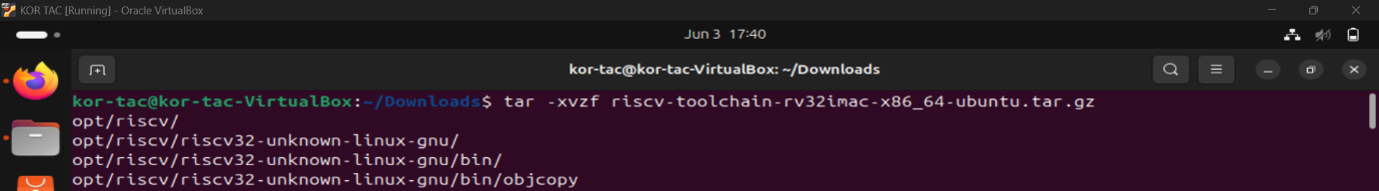

🛠️ Step 2: Add Toolchain to PATH

Command - nano ~/.bashrc



Scroll to the **bottom** and **add this line**:

**export PATH=/home/kor-tac/Downloads/opt/bin:$PATH**

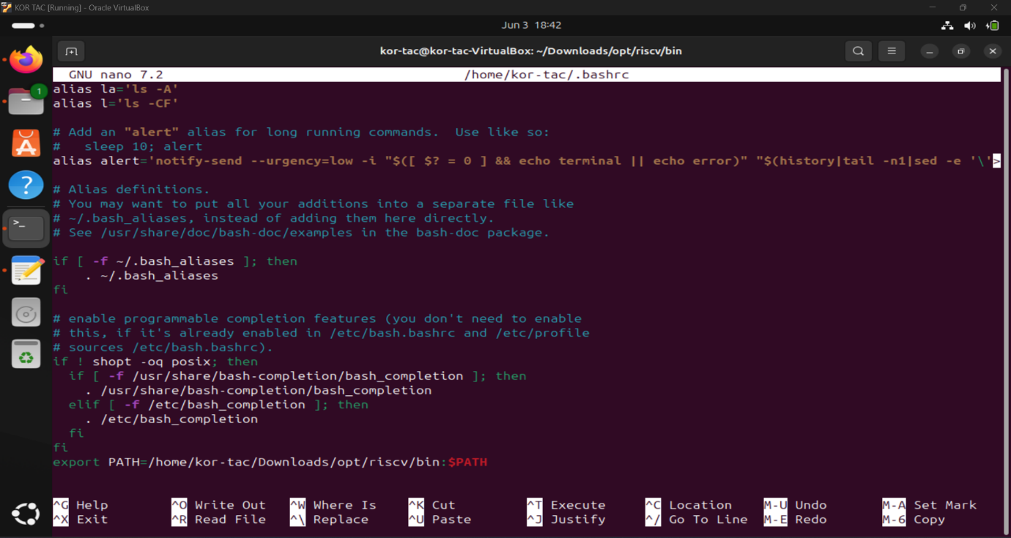

Then:

* Press Ctrl+O, Enter to save
* Press Ctrl+X to exit

To save the File added to Path

Command- source ~/.bashrc

Step 3: Verify Installation

Command- riscv32-unknown-elf-gcc –version

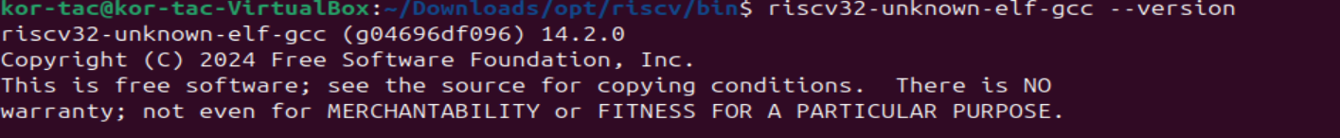

Command - riscv32-unknown-elf-objdump –version

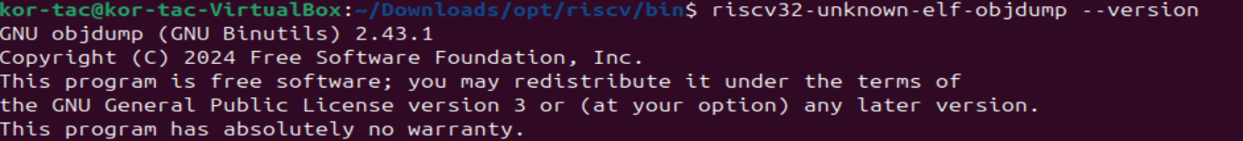

Command- riscv32-unknown-elf-gdb –version

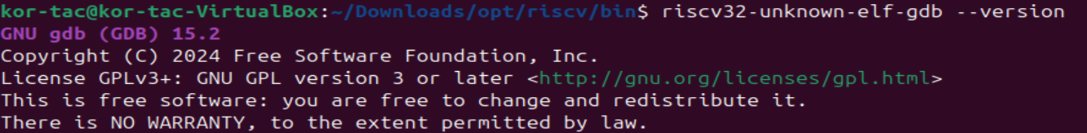

If this error occurs “riscv32-unknown-elf-gdb: error while loading shared libraries: libpython3.10.so.1.0: cannot open shared object file: No such file or directory”

Then type the commands

sudo add-apt-repository ppa:deadsnakes/ppa

sudo apt update

sudo apt install python3.10 python3.10-dev

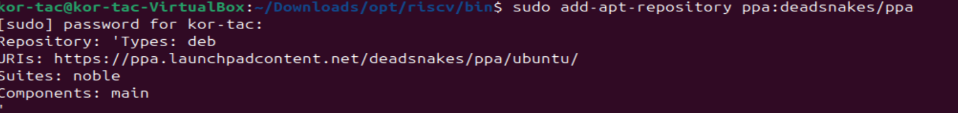

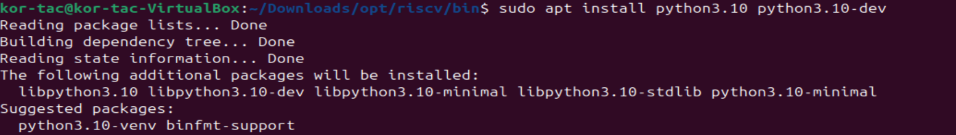

Then re check the RISC V toolchain again