**Customer Compliant Triage and Routing Agent**

**Name: Subramanian S**

**Dept: M.Sc. DCS**

**Reg no: 71762133044**

**1. Introduction**

The AI-Based Automated Complaint Management System is an intelligent platform designed to automate the process of complaint generation, classification, routing, and resolution tracking.

The system leverages Large Language Models (LLMs) to analyze emails and complaints, extract relevant keywords, determine sentiment, and route them to appropriate departments for action.

**2. Objectives**

* Automatically generate and send complaint and general emails.
* Extract key details (keywords, sentiment, and intent) from emails using LLM.
* Classify and route complaints to the appropriate department.
* Store all complaints and processed data in an SQLite database.
* Maintain structured logs of LLM prompts and responses for audit purposes.

**3. System Workflow**

1. Complaint Generation – The system randomly generates complaint or general emails.  
2. Email Processing – The AI model reads new emails via IMAP and analyzes content.  
3. Keyword Extraction & Sentiment Analysis** – LLM identifies important terms and assesses tone (positive/negative/neutral).  
4. Classification & Routing – Based on extracted data, complaints are categorized (e.g., technical, service, billing) and routed accordingly.  
5. Database Storage – All complaint data, sentiment scores, routing details, and metadata are stored in an SQLite database.  
6. Logging – The system records logs for every process step, including LLM prompts and responses.

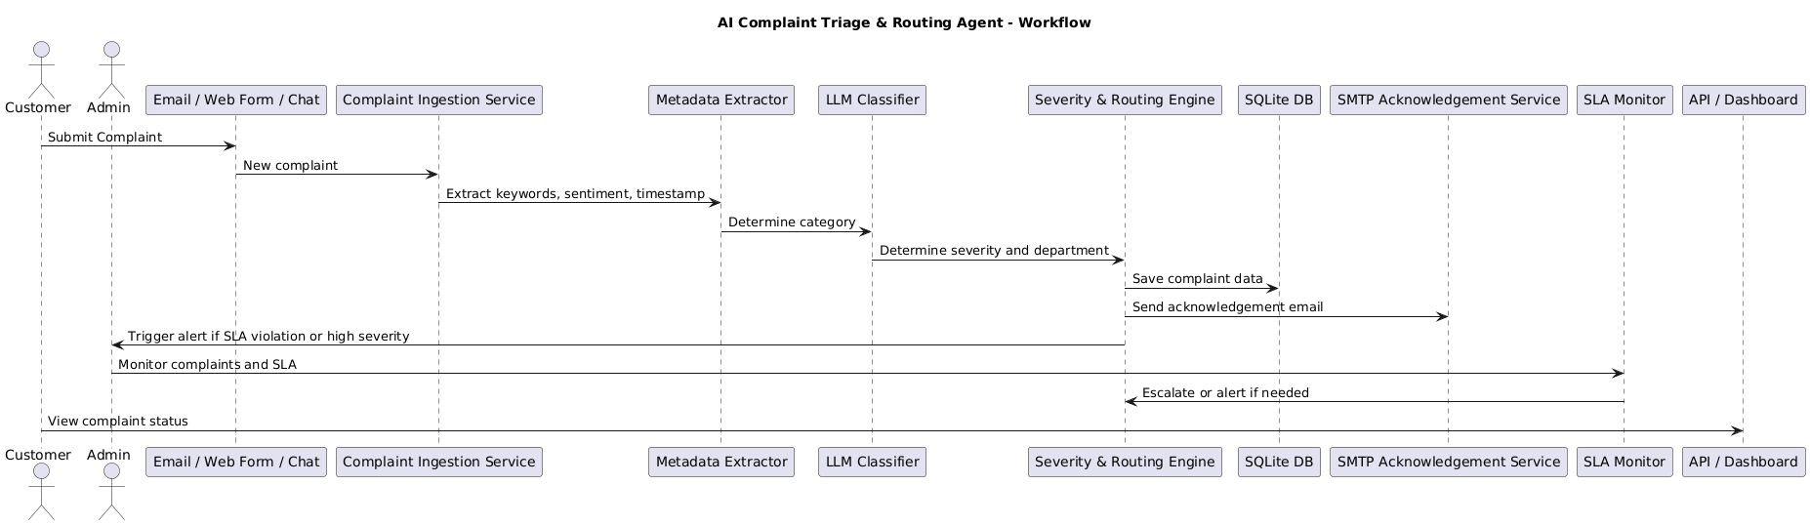

**4. System Architecture**

The architecture consists of the following layers:

* Frontend (Email Simulation) – Gmail
* Backend (Processing Engine) – Fetches emails, uses LLM to process and classify data.
* Database Layer – Stores complaints, metadata, and routing information.
* Logging Layer– Maintains a log file capturing system events, LLM inputs, and responses.

**5. Technologies Used**

* Programming Language: Python 3.x
* Database: SQLite3
* AI Model: GPT-4.1-mini (via GitHub Models API)
* Email Handling: SMTP & IMAP (Gmail)
* Logging: Python logging module
* Libraries: requests, smtplib, imaplib, email, sqlite3, json, logging

**6. Database Design**

Table: complaints  
- id (INTEGER PRIMARY KEY)  
- sender_email (TEXT)  
- subject (TEXT)  
- message (TEXT)  
- keywords (TEXT)  
- sentiment (TEXT)  
- classification (TEXT)  
- route_to (TEXT)  
- timestamp (TEXT)

**7. Logging Mechanism**

The system maintains a detailed log file recording each major event, including:

* Email received/sent timestamps
* LLM prompt and response logs
* Complaint classification and routing information

This ensures traceability and aids debugging or audit requirements.

8. Example Workflow

1. The system sends a random complaint email: “Internet connection is unstable for the last 2 days.”  
2. The backend fetches this email and sends it to the LLM API.  
3. The LLM extracts keywords: ["Internet", "unstable", "2 days"], sentiment: “Negative”, and classifies it as “Technical Issue”.  
4. The system routes the complaint to the “Network Support” department.  
5. The processed result is stored in complaints.db and logged in logs.txt.

9. Conclusion

This project demonstrates an AI-driven automation framework for managing customer complaints efficiently.

By integrating LLMs with traditional email systems and databases, the platform streamlines operations, enhances customer satisfaction, and ensures intelligent complaint routing and response management.

GitHub link: <https://github.com/S-Subramanian-44/Customer-Compliant-Triage-and-Routing-Agent>