A. Overall CTOR

**query**: SELECT ROUND( SUM(CASE WHEN CLICK_FLG='Y' THEN 1 ELSE 0 END)/COUNT(*)*100,2) CTOR FROM capstone WHERE OPEN_FLG='Y;

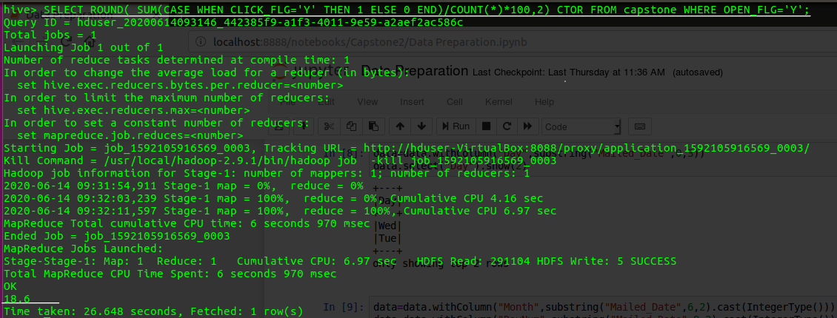

B. CTOR by Gender

**query**: SELECT ROUND( SUM(CASE WHEN CLICK_FLG='Y' THEN 1 ELSE 0 END)/COUNT(*)*100,2) CTOR FROM capstone WHERE OPEN_FLG='Y' GROUP BY I1_GNDR_CODE;

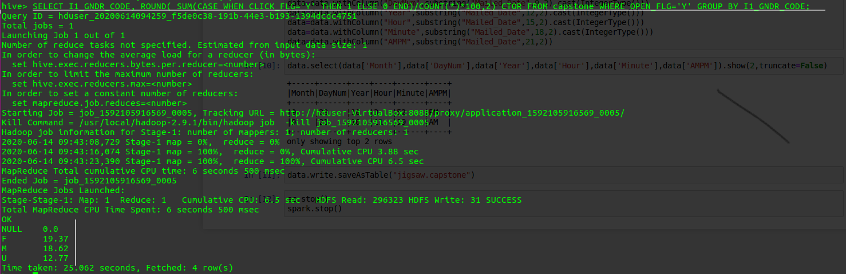

C. CTOR by Time of the day (use mailed_date column)

**query**:SELECT I1_GNDR_CODE, ROUND( SUM(CASE WHEN CLICK_FLG='Y' THEN 1 ELSE 0 END)/COUNT(*)*100,2) CTOR FROM capstone WHERE OPEN_FLG='Y' AND ;

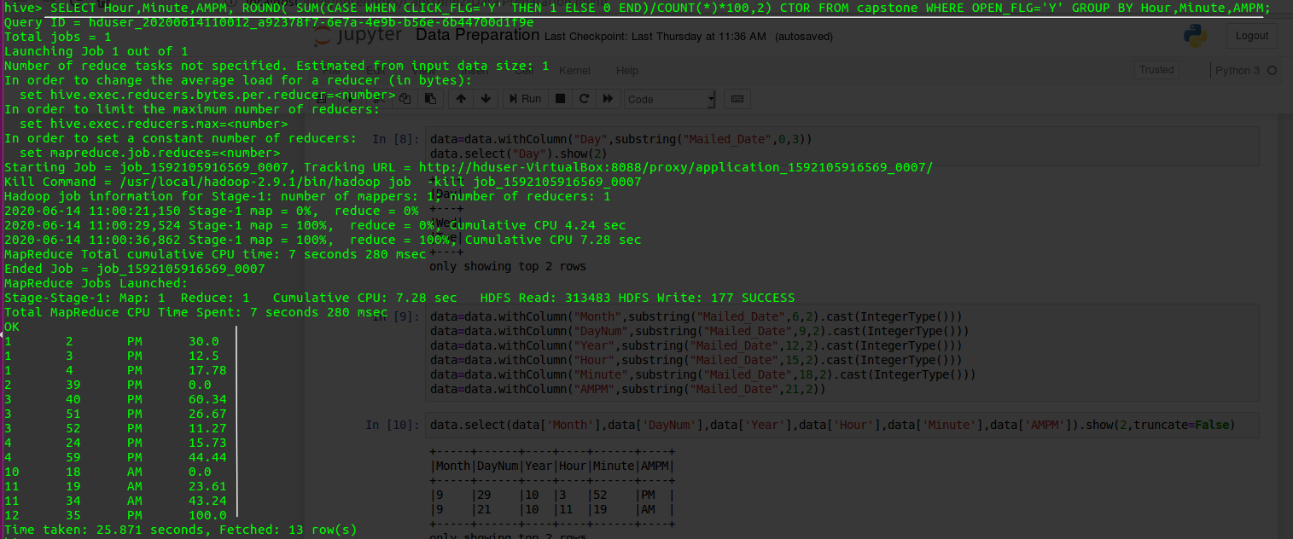

D. CTOR by Day of the week (use mailed_date column)

**query**:SELECT Day, ROUND( SUM(CASE WHEN CLICK_FLG='Y' THEN 1 ELSE 0 END)/COUNT(*)*100,2) CTOR FROM capstone WHERE OPEN_FLG='Y' GROUP BY Day;

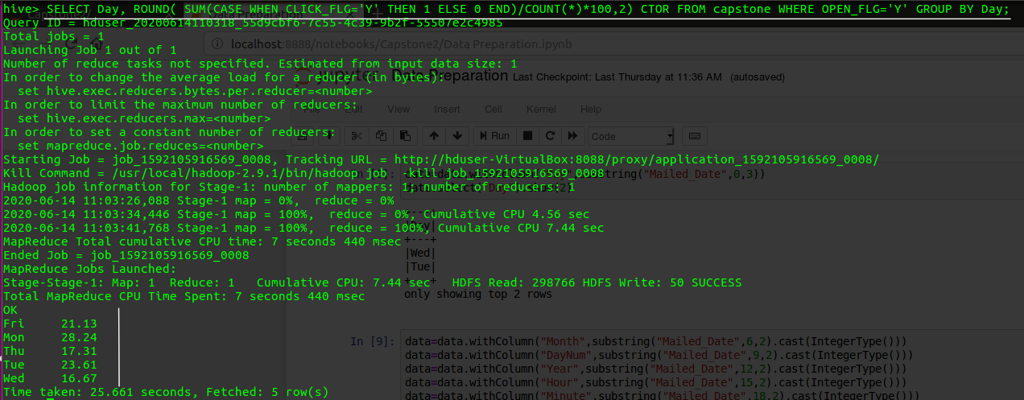

E. CTOR by Month (use mailed_date column)

**query**:SELECT Month, ROUND( SUM(CASE WHEN CLICK_FLG='Y' THEN 1 ELSE 0 END)/COUNT(*)*100,2) CTOR FROM capstone WHERE OPEN_FLG='Y' GROUP BY Month;

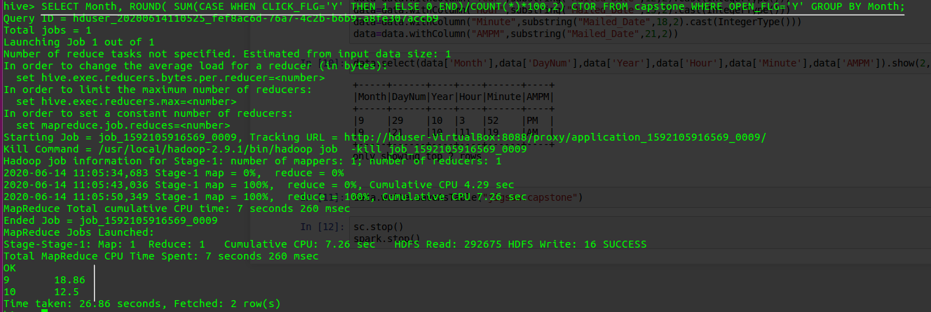

F. CTOR by Lead’s Income Group (use TRW_INCOME_CD_V4 column)

**query**:SELECT TRW_INCOME_CD_V4, ROUND( SUM(CASE WHEN CLICK_FLG='Y' THEN 1 ELSE 0 END)/COUNT(*)*100,2) CTOR FROM capstone WHERE OPEN_FLG='Y' GROUP BY TRW_INCOME_CD_V4;

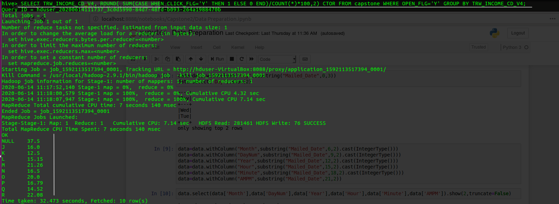

G. CTOR by Lead’s Ethnicity (use ASIAN_CD column)

**query**:SELECT ASIAN_CD, ROUND( SUM(CASE WHEN CLICK_FLG='Y' THEN 1 ELSE 0 END)/COUNT(*)*100,2) CTOR FROM capstone WHERE OPEN_FLG='Y' GROUP BY ASIAN_CD;

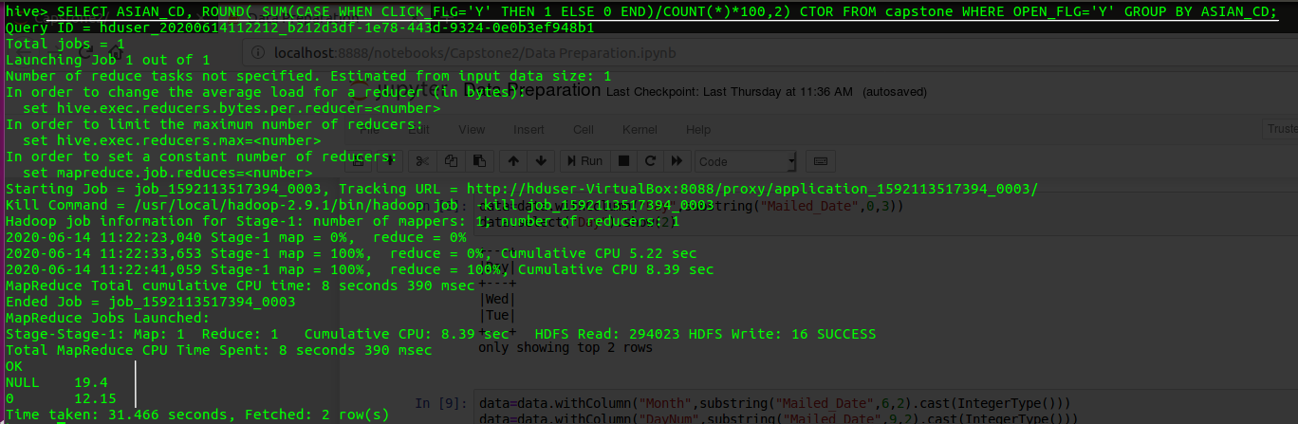

H. CTOR by Lead’s Household Status (use I1_INDIV_HHLD_STATUS_CODE column)

**query**: SELECT I1_INDIV_HHLD_STATUS_CODE ,ROUND( SUM(CASE WHEN CLICK_FLG='Y' THEN 1 ELSE 0 END)/COUNT(*)*100,2) CTOR FROM capstone WHERE OPEN_FLG='Y' GROUP BY I1_INDIV_HHLD_STATUS_CODE;

