**A. Find count of leads with information about members of their household. If a lead has information about 3 members, and another has information about 2 members and another has none, then the answer to this question is 1.**

**QUERY:** select SUM(CASE WHEN statcd_hh_mem1 IS NOT NULL OR statcd_hh_mem2 IS NOT NULL OR statcd_hh_mem3 IS NOT NULL OR statcd_hh_mem4 IS NOT NULL OR statcd_hh_mem5 IS NOT NULL OR statcd_hh_mem6 IS NOT NULL OR statcd_hh_mem7 IS NOT NULL OR statcd_hh_mem8 IS NOT NULL THEN 1 ELSE 0 END) from capstone;

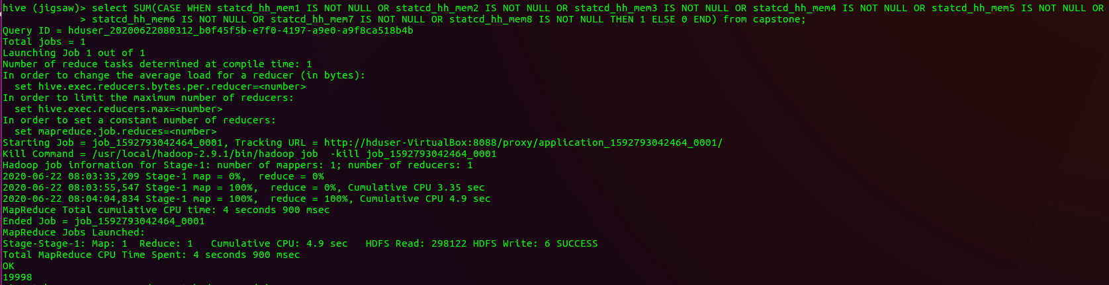

**B. Find count of total number of household members information is available. For example, if a lead has 3 household members, and another has about 2 members, and the other has none, then the total count of household members is 3+2+0 = 5**

**QUERY:**  select SUM( (CASE WHEN statcd_hh_mem1 IS NOT NULL THEN 1 ELSE 0 END) + (CASE WHEN statcd_hh_mem2 IS NOT NULL THEN 1 ELSE 0 END )+(CASE WHEN statcd_hh_mem3 IS NOT NULL THEN 1 ELSE 0 END) + (CASE WHEN statcd_hh_mem4 IS NOT NULL THEN 1 ELSE 0 END) + ( CASE WHEN statcd_hh_mem5 IS NOT NULL THEN 1 ELSE 0 END) + (CASE WHEN statcd_hh_mem6 IS NOT NULL THEN 1 ELSE 0 END) + (CASE WHEN statcd_hh_mem7 IS NOT NULL THEN 1 ELSE 0 END) + (CASE WHEN statcd_hh_mem8 IS NOT NULL THEN 1 ELSE 0 END) ) from capstone;

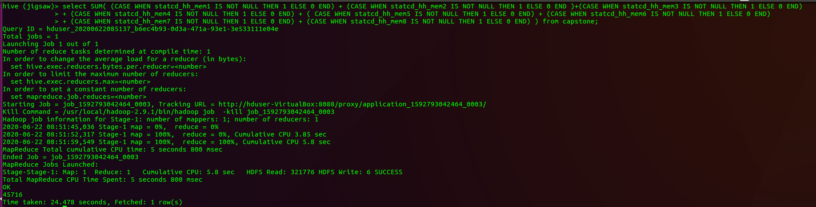

**C. Find count of household members by type (Head of Household, Spouse etc)**

**UNION ALL** : CREATE TABLE statcd_hh_mem AS SELECT statcd_hh_mem1 FROM capstone UNION ALL SELECT statcd_hh_mem2 FROM capstone UNION ALL SELECT statcd_hh_mem3 FROM capstone UNION ALL SELECT statcd_hh_mem4 FROM capstone UNION ALL SELECT statcd_hh_mem5 FROM capstone UNION ALL SELECT statcd_hh_mem6 FROM capstone UNION ALL SELECT statcd_hh_mem7 FROM capstone UNION ALL SELECT statcd_hh_mem8 FROM capstone;

**DESCRIBE**: DESCRIBE statcd_hh_mem;

**GROUP BY**: SELECT statcd_hh_mem1,count(*) total FROM statcd_hh_mem GROUP BY statcd_hh_mem1;

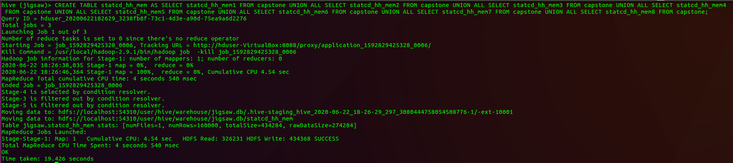

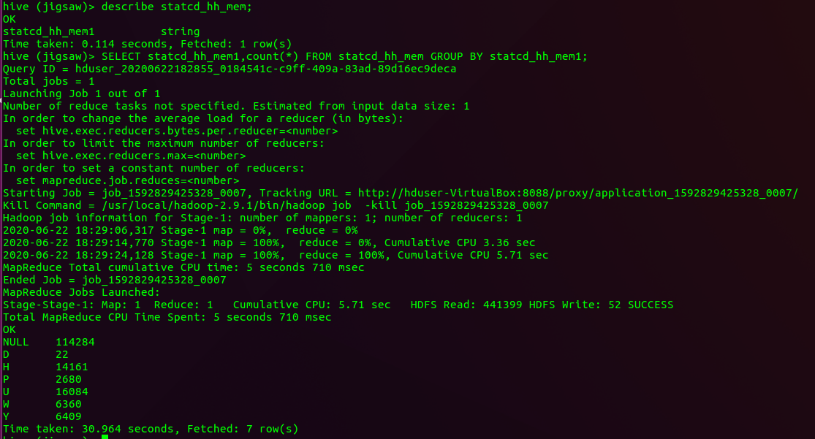

**D. %age of household members type. For example, if there are 5 Head of Household, 10 Spouse and 85 in the other categories, then the %age of Spouses is 10.**

**QUERY:** SELECT 100*COUNT(statcd_hh_mem1)/45716 FROM statcd_hh_mem WHERE statcd_hh_mem1='W';

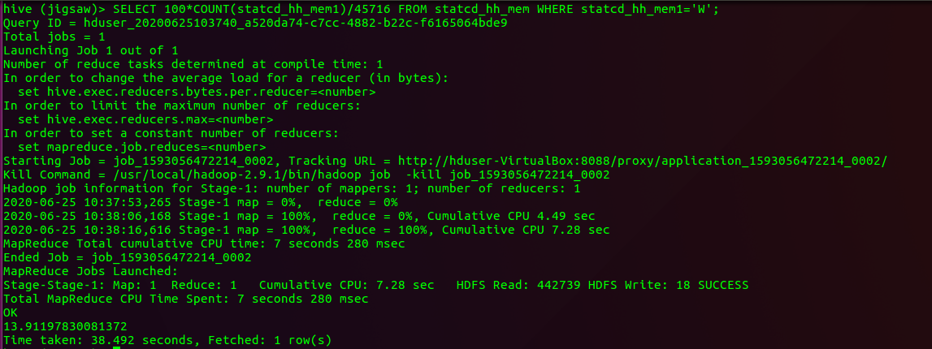

**E. How many known households have children?**

**QUERY:** SELECT NUMBER_OF_CHLDRN_18_OR_LESS FROM capstone LIMIT 10;

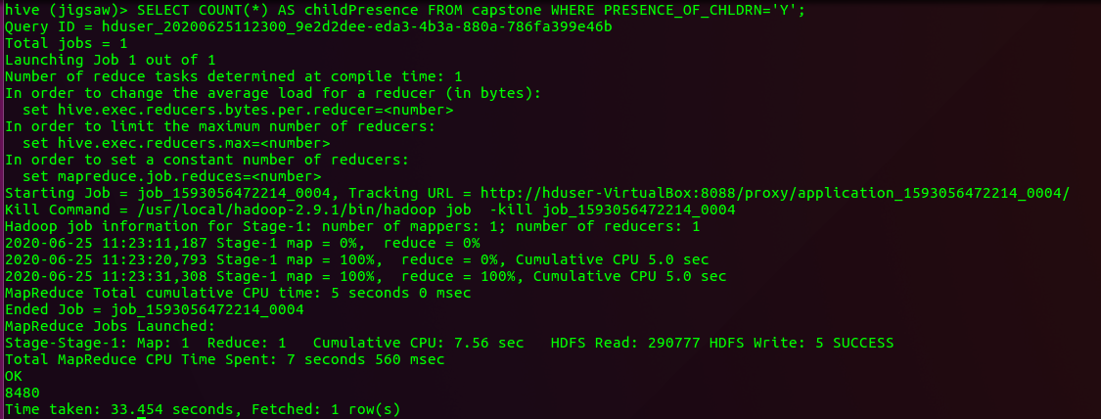

**F. Overall, how many children are there?**

**QUERY:** SELECT SUM(CASE WHEN PRESENCE_OF_CHLDRN='Y' THEN NUMBER_OF_CHLDRN_18_OR_LESS ELSE 0 END ) AS totalChildren FROM capstone;

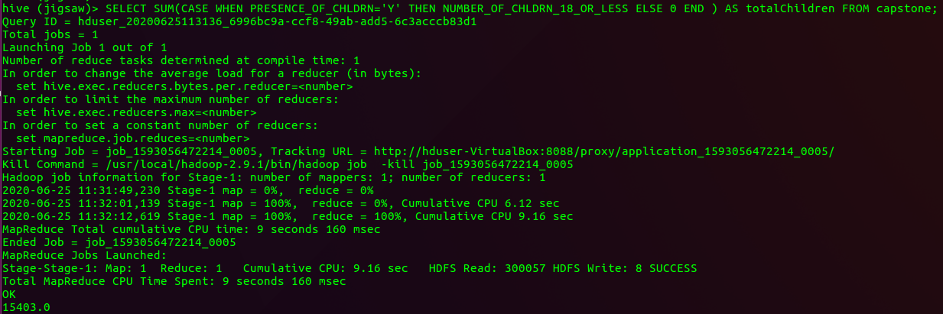

**G. How many of the children are male and how many are female?**

**UNION:** CREATE TABLE childGenderr AS SELECT GNDR_OF_CHLDRN_0_3 FROM capstone UNION ALL SELECT GNDR_OF_CHLDRN_4_6 FROM capstone UNION ALL SELECT GNDR_OF_CHLDRN_7_9 FROM capstone UNION ALL SELECT GNDR_OF_CHLDRN_10_12 FROM capstone UNION ALL SELECT GNDR_OF_CHLDRN_13_18 FROM capstone gender;

**DESCRIBE:** DESCRIBE childGender;

**QUERY:** SELECT gndr_of_chldrn_0_3,COUNT(*) FROM childGender GROUP BY gndr_of_chldrn_0_3;

