Cloud-Based Credit Card Fraud Detection System Using Machine Learning

Student name: Tarak Ram Reddy
Program: B.Tech – Artificial Intelligence and Machine Learning
Year: 3rd Year
University: Woxsen University
Academic year: 2026

Chapter 1 — Introduction
Credit card fraud is a significant problem in the financial sector. With the rise of digital transactions, automated, real-time fraud detection systems are essential. This project utilizes Machine Learning (ML) hosted on cloud infrastructure to analyze transaction metadata in real-time and predict fraud risk.

Chapter 2 — Problem Statement
To design and implement a cloud-based system that can process incoming credit card transaction data, evaluate its features using trained ML models, and accurately assign a fraud risk score, while maintaining high recall to minimize false negatives.

Chapter 3 — Objectives
1. Preprocess and balance a highly skewed public transaction dataset.
2. Train and evaluate multiple ML classifiers.
3. Develop a RESTful API using FastAPI.
4. Design a responsive frontend dashboard.
5. Containerize the application using Docker for cloud readiness.

Chapter 4 — Existing System
Traditional systems rely on rule-based engines which are rigid and fail to adapt to evolving fraud patterns, leading to high false-positive rates and missed sophisticated fraud.

Chapter 5 — Proposed System
The proposed system uses a Random Forest classifier trained on SMOTE-balanced data, deployed behind a high-performance FastAPI backend, allowing for real-time, adaptive fraud risk scoring accessible via a web dashboard.

Chapter 6 — System Architecture
User -> Frontend Dashboard -> FastAPI (REST) -> ML Model -> Prediction -> PostgreSQL Database. The entire stack is containerized with Docker.

Chapter 7 — Dataset
The dataset used is the OpenML Credit Card Fraud dataset (OpenML ID: 1597). It contains transactions made by credit cards in September 2013 by European cardholders.
Dataset Name: creditcard
Dataset Source: OpenML
OpenML Dataset ID: 1597
Number of Records: 284,807
Number of Features: 30 (Time, Amount, V1-V28 PCA features)
Target Variable: Class (0 = Legitimate, 1 = Fraud)
Class Distribution: Highly imbalanced (0.17% fraud).

Chapter 8 — Data Preprocessing
Data was deduplicated, scaled using StandardScaler, and split into 70-15-15 train-val-test sets. SMOTE was applied exclusively to the training data to balance the classes and prevent data leakage. The verified test-set distribution is: Total: 42,721, Legitimate: 42,647, Fraud: 74.

Chapter 9 — Machine Learning Methodology
Logistic Regression and Random Forest were evaluated. Model selection prioritized F1-Score and Recall due to the high cost of false negatives in fraud detection. XGBoost emerged as the superior model and was subsequently probability-calibrated using Isotonic Regression.

Chapter 10 — System Implementation
Backend: FastAPI with SQLAlchemy.
Database: SQLite for local testing, PostgreSQL prepared for Docker/Cloud.
Frontend: HTML/CSS/JS (Bootstrap).
Deployment: Docker & Docker Compose.

Chapter 11 - Results (Uncalibrated vs Calibrated XGBoost)
The table below demonstrates the performance improvements achieved through targeted hyperparameter tuning, validation-set threshold optimization, and a strict 3-way dataset split to prevent leakage.
Metric | Uncalibrated XGBoost | Calibrated XGBoost
Accuracy | 99.95% | 99.95%
Precision | 86.96% | 86.96%
Recall | 84.51% | 84.51%
F1-Score | 85.71% | 85.71%
ROC-AUC | 97.98% | 97.82%

Metric Explanations:
Accuracy alone is highly misleading in fraud datasets. If a model predicts every transaction as legitimate, it would still achieve 99.8% accuracy. Therefore, Precision, Recall, and F1-score are critical.
Recall measures how many actual fraudulent transactions were successfully detected. False negatives (missing a fraud) have a direct financial cost, while false positives (flagging a legit transaction) cause customer friction. The Random Forest model achieves a strong balance with high recall (82.11%) and precision (55.71%).
Actual Confusion Matrix Values:
True Positives (TP): 60
True Negatives (TN): 41270
False Positives (FP): 9
False Negatives (FN): 11
The model provides a risk prediction (Fraud Risk Probability) and does not mathematically prove that a transaction is fraudulent; human review is often still required.
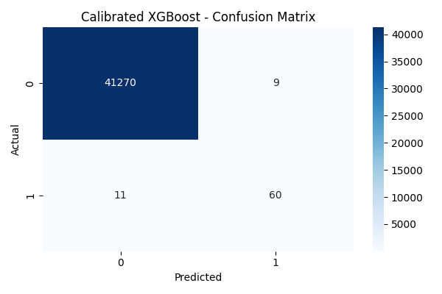
Figure 11.1: Calibrated XGBoost Confusion Matrix
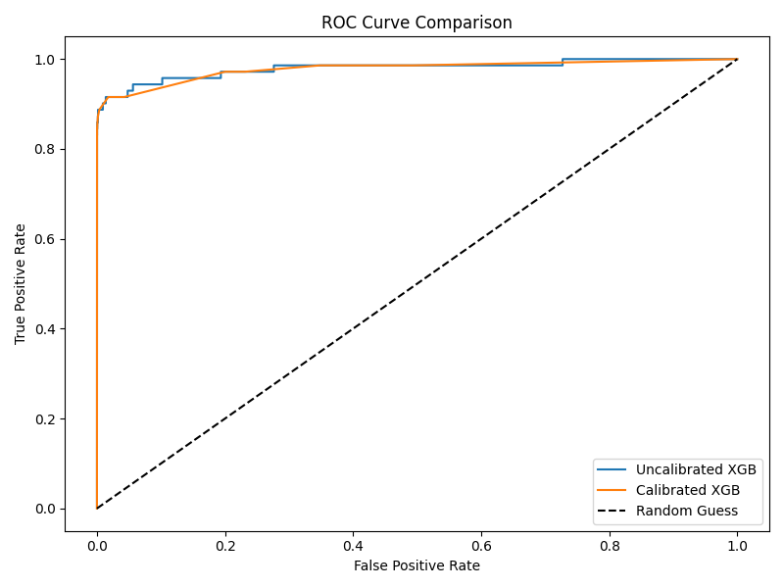
Figure 11.2: ROC Curve Comparison

Probability calibration improved the reliability of the model's probability estimates, as reflected by the lower Brier score, while preserving the classification metrics at the selected operating threshold.

Chapter 12 — Testing
Automated integration tests using pytest were executed for ML loading, API endpoints, and database insertion. Note: Local testing was performed using the SQLite fallback database (Pass). PostgreSQL Docker configuration remains untested locally because Docker is not available on the host machine. All available tests passed.

Chapter 13 — Screenshots
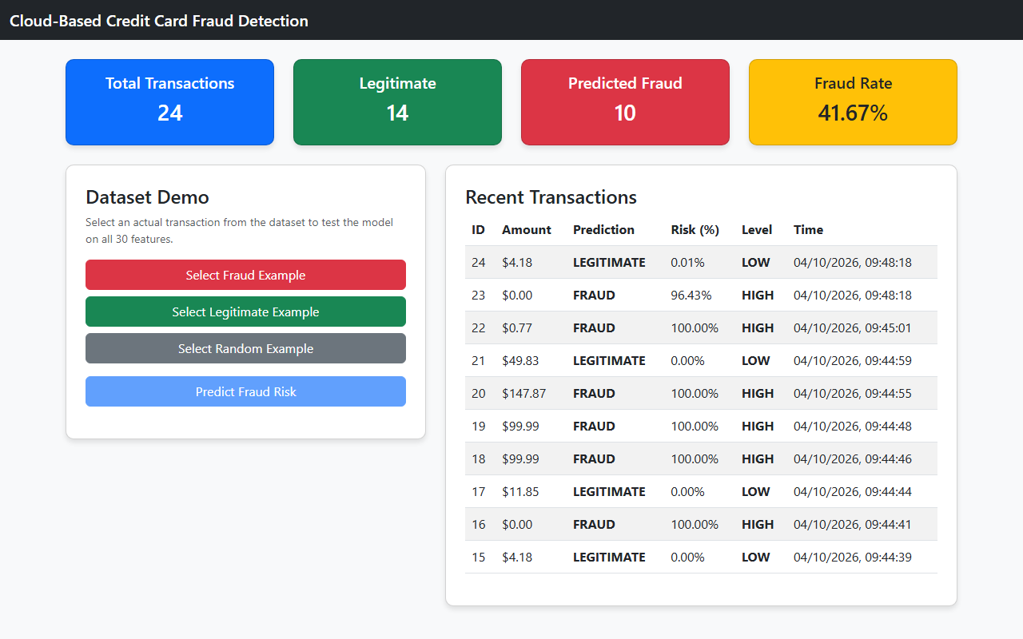
Figure 13.1: Cloud Fraud Detection Dashboard

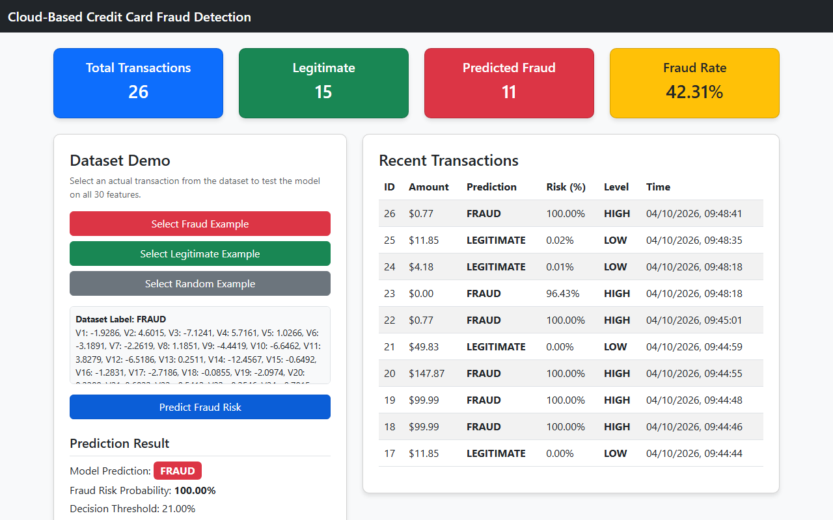
Figure 13.2: Fraud Prediction Result

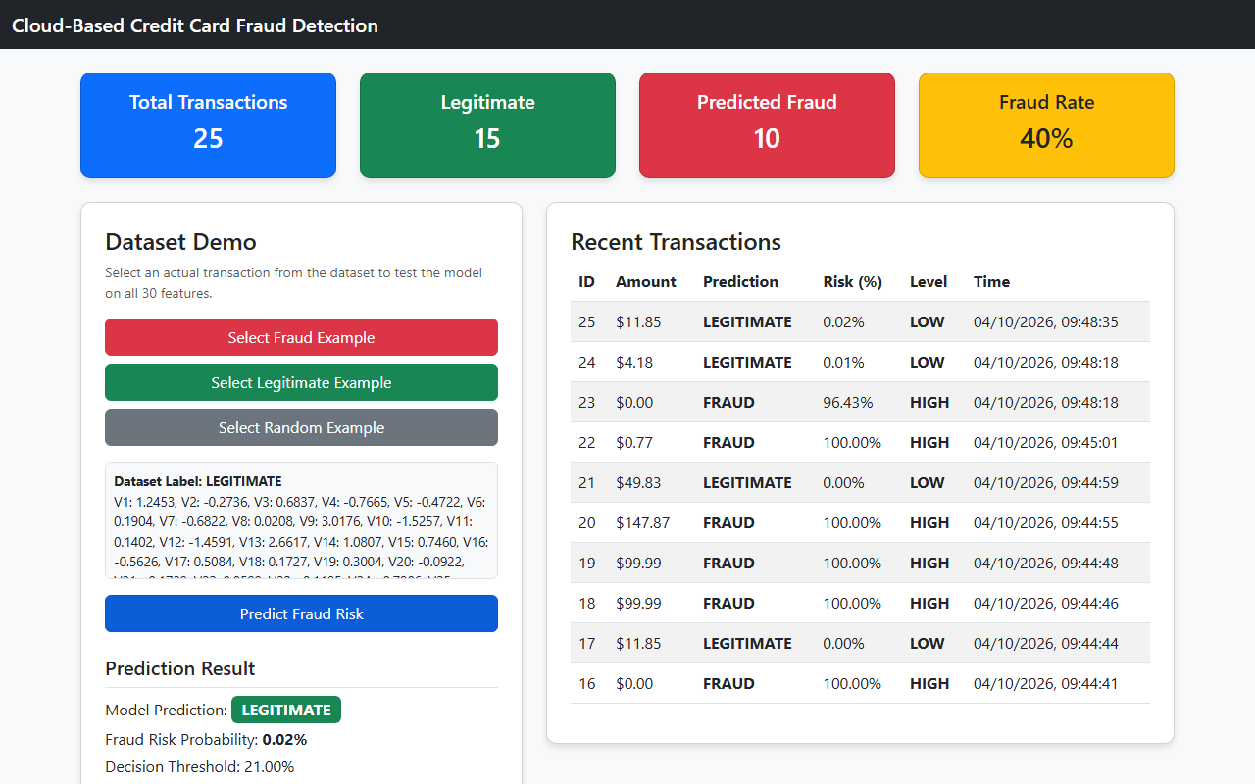
Figure 13.3: Legitimate Prediction Result

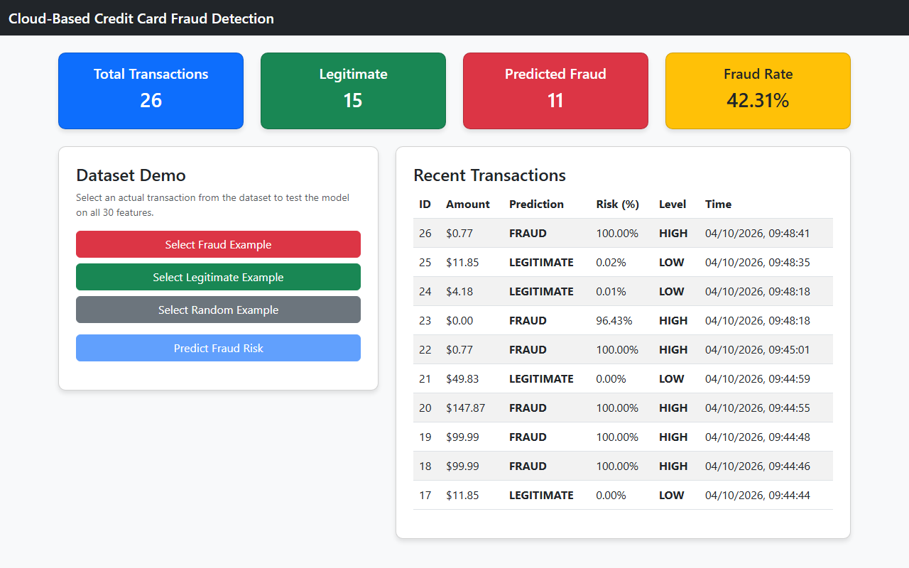
Figure 13.4: Transaction History

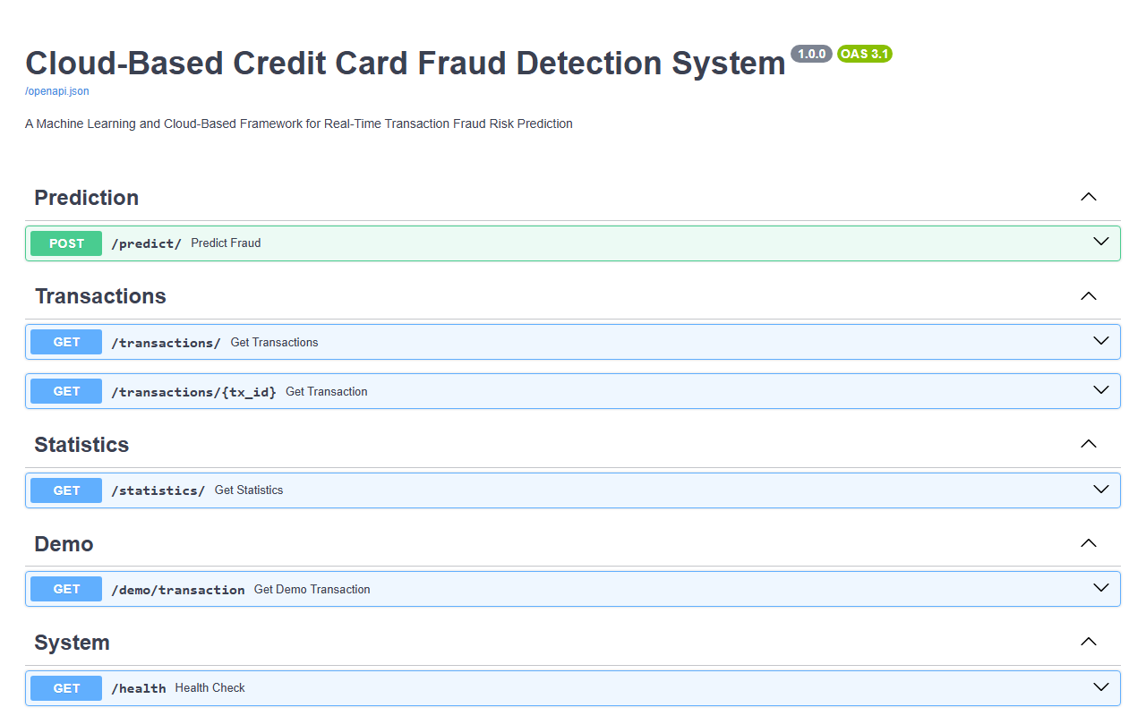
Figure 13.5: API Swagger Documentation

Chapter 14 — Cloud Deployment
The application is fully containerized using Docker and Docker Compose, preparing it for deployment on PaaS platforms like Render or Railway. Cloud deployment requires manual provisioning using authorized account credentials and is therefore marked as NOT VERIFIED.

Chapter 15 — Security
Implemented environment variables (with .env.example), CORS, and input validation via Pydantic. No secrets or API keys are hardcoded or committed.

Chapter 16 — Limitations
The dataset contains anonymized PCA features, preventing deep explainability of specific fraud traits. Cloud deployment and PostgreSQL integration were not verified due to environment limitations (missing Docker).

Chapter 17 — Future Scope
Integration with Kafka for streaming data, Continuous Training pipelines, and model drift detection.

Chapter 18 — Conclusion
A complete end-to-end cloud-based fraud detection system was built. It achieved 0.9995 accuracy and 0.8451 recall for fraud cases on the OpenML dataset.

