**CONTENTS PAGE NO**

1. **INTRODUCTION** 
   1. Overview
   2. Purpose
2. **PROBLEM DEFINITION & DESIGN THINKING**
   1. Empathy Map
   2. Ideation & Brainstorming Map
3. **RESULT**
4. **ADVANTAGES & DISADVANTAGES**
5. **APPLICATIONS**
6. **CONCLUSION**
7. **FUTURE SCOPE**
8. **APPENDIX**
   1. Source Code

**INTRODUCTION**

Sleep tracking is the practice of monitoring and analyzing an individual's sleep patterns and quality using various tools and technologies. It involves gathering data on an individual's sleep duration, sleep stages, sleep quality, and other related parameters to gain insights into their sleep patterns and overall sleep health. Sleep tracking has gained popularity in recent years as people have become more aware of the importance of sleep in overall health and well-being.

**1.2 Overview**

A project that demonstrates the use of Android Jetpack  
Compose to build a UI for a sleep tracking app. The app  
allows users to track their sleep. With the “Sleep Tracker” app,  
you can assess the quality of sleep they have had in a day. It has  
been time and again proven that a good quality sleep is pretty  
essential for effective functioning of both mind and body.

**1.2 Purpose**

“Sleep Tracker” application enables you to start the timer when they are in  
the bed and about to fall asleep. The timer will keep running in the background  
until it is stopped, whenever the user wakes up. Based on the sleep experience,  
you can rate your sleep quality. Finally , the app will display an analysis of the  
kind of sleep , you had the previous night

**PROBLEM DEFINITION & DESIGN THINKING**

**2. Problem definition & design thinking**

. 2.1 Empathy Map

**2.2 Ideation & Brainstorming map**

**RESULT**

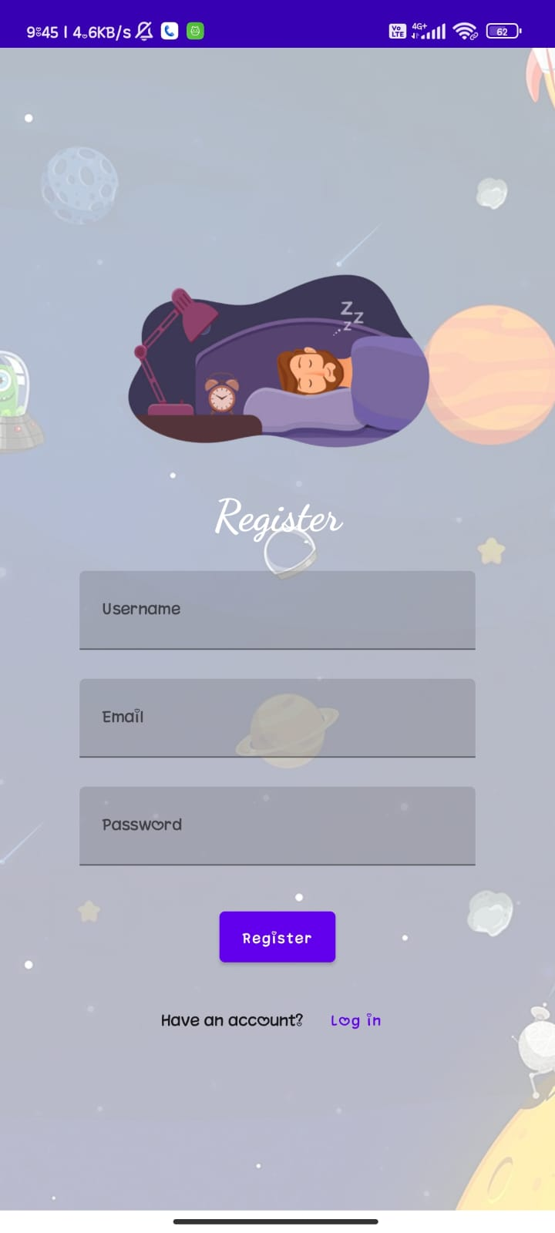

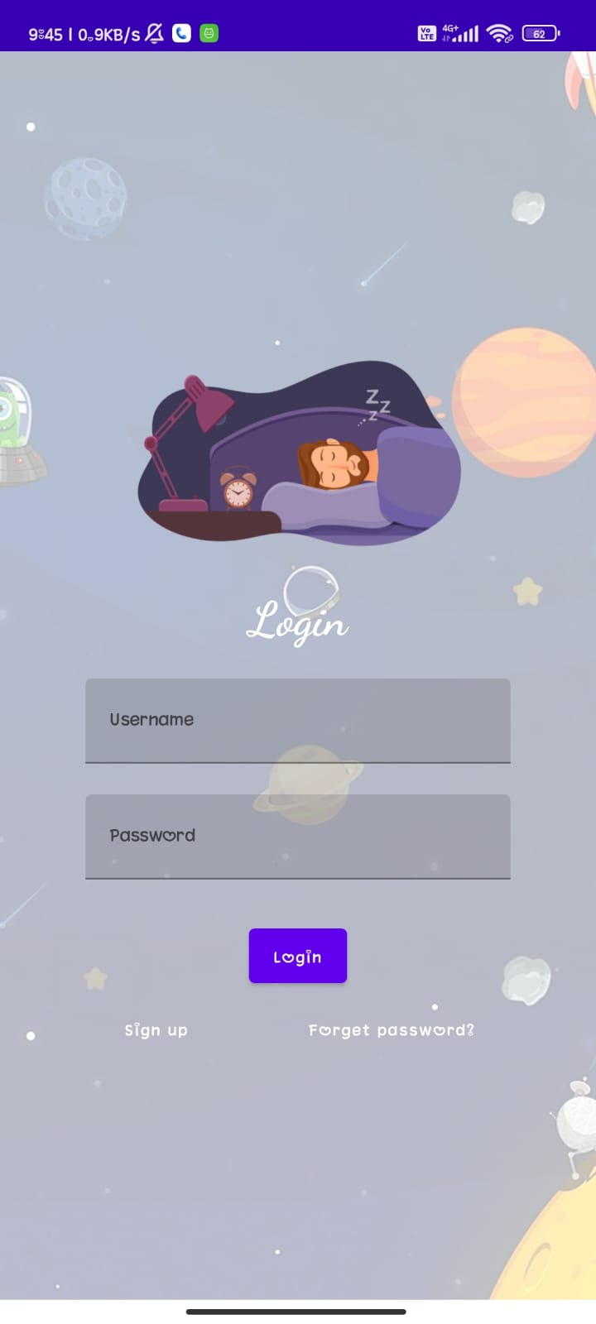

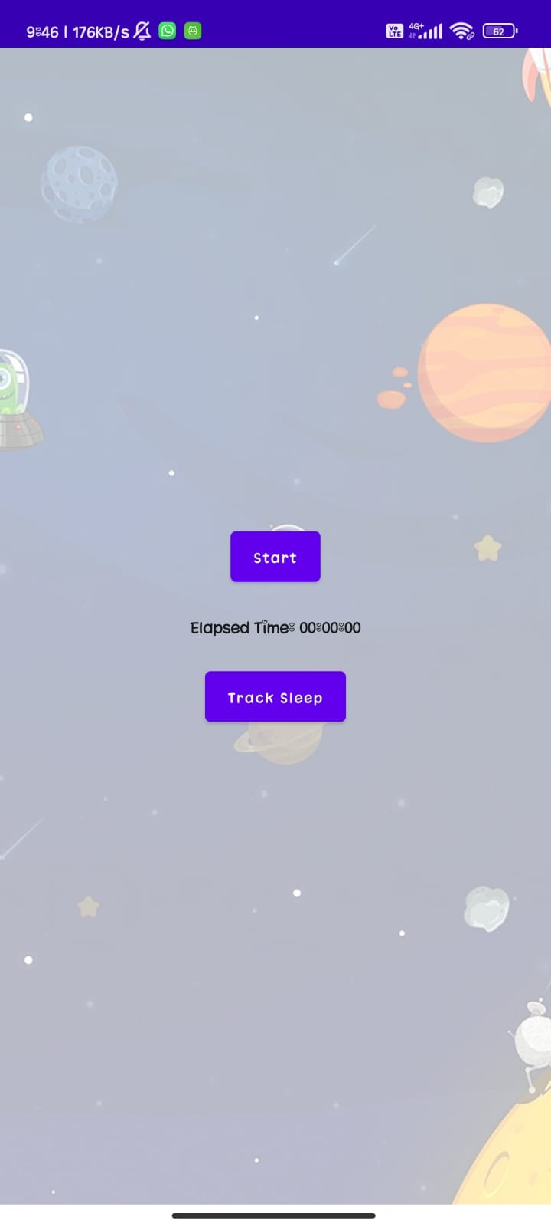

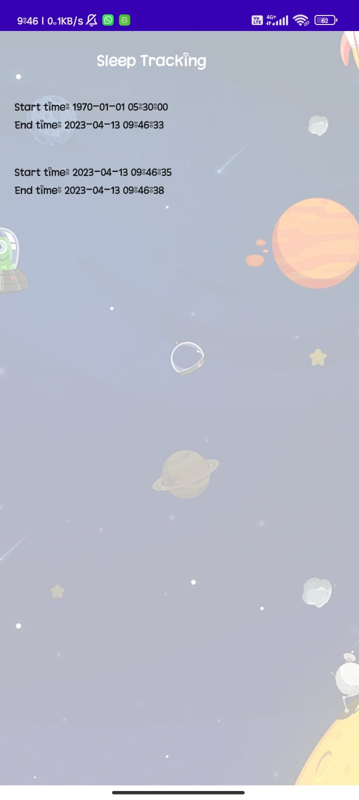

**ADVANTAGES & DISADVANTAGES**

ADVANTAGES:

Getting enough sleep has many benefits.It can help you:

• Get sick less often

• Stay at a healthy weight

• Lower your risk for serious health problems, like diabetes and heart disease

• Reduce stress and improve your mood

• Think more clearly and do better in school and at work

• Get along better with people

• Make good decisions and avoid injuries — for example, drowsy drivers cause thousands of car accidents every year

DISADVANTAGES :

• Stress or anxiety

• Pain

• Certain health conditions, like heartburn or asthma

• Some medicines

• Caffeine (usually from coffee, tea, and soda)

• Alcohol and other drugs  
 • Untreated sleep disorders, like sleep apnea or insomnia.

**APPLICATIONS**

APPLICATION :

• Sleep as Android

Not only is Sleep as Android one of the best sleep-tracking apps, but it's also one of the best alarm clock apps for Android. It does a lot more than that too, and we recommend you install it even if you never use it as a sleep tracker or alarm clock.

For example, this app can play lullabies to help relax your mind and has CAPTCHA wake-up verification so that you don't snooze back to bed. It also has anti-snoring measures, sleep apnea pre-screening, and more. Other notable features include integration with smartwatches, wearable devices, and music from Spotify.

• Sleep Cycle

Sleep Cycle is easily one of the best sleep-tracking apps available on both Android and iOS. In short, Sleep Cycle tracks your sleep cycles and attempts to wake you up during the lightest phase of sleep that's closest to your wake-up time.

• Sleepzy

Sleepzy has detailed statistics that are presented in a more visually pleasing manner. You can also create sleep goals and add sleep notes that nudge you toward a healthier sleep routine. The downside: you have to bear with some intrusive ads now and then.

### **Conclusion**

**Conclusion:**

We conducted a systematic review of research that included sleep tracker-derived data. We summarized the literature, finding highly variable sample sizes and objectives among the published research on this topic. While a large body of evidence touts the benefits of health technologies, it is yet unclear whether these devices are efficacious for accurate sleep measurement. Furthermore, the compelling question as to whether or not sleep tracking and the behavioral feedback it affords users is beneficial for sleep or if this practice perhaps induces anxiety about sleep onset or duration. In this review, we characterize the health sleep tracking devices. Future studies may build on the findings in this review to better understand the effects of sleep tracking when these data are shared with patients. For, the compelling question as to whether sleep tracking is helpful or harmful for patients remains unanswered.

**Future scope**

**Future scope :**

Sleep tracking apps have gained significant popularity in recent years, and their future scope is bright. Here are some potential future developments for sleep tracking apps:

Personalized sleep recommendations: Sleep tracking apps could analyze a user's sleep patterns and provide personalized recommendations for improving their sleep quality. These recommendations could include adjusting sleep times, suggesting relaxation techniques, or even suggesting dietary changes.

Integration with smart homes: Sleep tracking apps could integrate with smart homes, allowing users to adjust their environment to improve sleep quality automatically. For example, the app could adjust the temperature, lighting, or sound levels in the user's bedroom to optimize their sleep environment.

Partnership with health insurance companies: Sleep tracking apps could partner with health insurance companies to provide users with incentives for improving their sleep quality. Insurance companies could offer discounts on premiums to users who consistently achieve high-quality sleep, incentivizing healthier sleep habits.

**APPENDIX**

**Source Code:**