
Applied Software Project Report

By

Tirumal Shrinivas Sutrave

A Master’s Project Report submitted to Scaler Neovarsity - Woolf in partial fulfillment of the requirements for the degree of Master of Science in Computer Science

July, 2025

Scaler Mentee Email ID : sutrave.tirumal@gmail.com
Thesis Supervisor : Naman Bhalla
Date of Submission : 10/07/2025

Certification

I confirm that I have overseen / reviewed this applied project and, in my judgment, it adheres to the appropriate standards of academic presentation. I believe it satisfactorily meets the criteria, in terms of both quality and breadth, to serve as an applied project report for the attainment of Master of Science in Computer Science degree. This applied project report has been submitted to Woolf and is deemed sufficient to fulfill the prerequisites for the Master of Science in Computer Science degree.

Naman Bhalla
…………………
Project Guide / Supervisor

DECLARATION

I confirm that this project report, submitted to fulfill the requirements for the Master of Science in Computer Science degree, completed by me from 30/05/2024 to 15/11/2024, is the result of my own individual endeavor. The Project has been made on my own under the guidance of my supervisor with proper acknowledgement and without plagiarism. Any contributions from external sources or individuals, including the use of AI tools, are appropriately acknowledged through citation. By making this declaration, I acknowledge that any violation of this statement constitutes academic misconduct. I understand that such misconduct may lead to expulsion from the program and/or disqualification from receiving the degree.

Tirumal Shrinivas Sutrave

<Signature of the Candidate> Date: 24 Month 2025

ACKNOWLEDGMENT

I want to take a moment to express my heartfelt gratitude to everyone who supported me throughout my journey in the Scaler program and helped me earn my Master’s degree.
First and foremost, to my wife Radhika and daughter Shreya — thank you for being such an important part of this journey. Your love, patience, and constant encouragement gave me the strength to keep going, even during the toughest times.
To my brother Vaibhav, thank you for your unwavering motivation and belief in me. Your words pushed me forward when I needed it most.
A big thank you to the incredible Scaler instructors and community who played such a vital role in my learning experience. I’m especially grateful to Amir, whose clarity and patience made DSA not just understandable but genuinely enjoyable. To Ujjwal, your structured approach to SQL helped me build a solid understanding of data handling and queries.Ankit Arora, your LLD classes were engaging, insightful, and fun — a true highlight of the program.
And last but not least, Anurag, I sincerely appreciate your consistent persuasion and motivation, which helped me stay focused and complete both the sessions and the project work.
To everyone who helped, inspired, or encouraged me in any way — thank you. This accomplishment is not just mine, but a shared success with all of you who stood by me.

Table of Contents

List of Tables 6
List of Figures 7
Applied Software Project 8
Abstract 8
Project Description 8
Requirement Gathering 9
Class Diagrams 9
Database Schema Design 9
Feature Development Process 11
Deployment Flow 12
Technologies Used 12
Conclusion 13
References 14

List of Tables
(To be written sequentially as they appear in the text)

Table No. | Title | Page No.
1
2

List of Figures
(List of Images, Graphs, Charts sequentially as they appear in the text)

Figure No. | Title | Page No.
1
2

Applied Software Project

Abstract
This capstore project presents the design and implementation of a modular, microservices-based e-Commerce platform using Spring Boot, MySQL, and Docker. The system includes key services such as product catalog, user authentication, product management, and service discovery—each running independently within containerized environments to promote scalability, fault tolerance, and ease of deployment.

Traditional monolithic e-Commerce applications often challenges with scalability and maintenance as the system grows. This project addresses these challenges by adopting a microservices architecture where each service can be developed, deployed, and scaled independently. Spring Boot provides a lightweight framework for building RESTful services, while MySQL supports persistent data storage. Docker containers ensure consistent environments across development and production, and a service discovery mechanism enables dynamic service registration and load balancing.

The platform supports essential e-Commerce functionalities such as secure user authentication using JWT tokens, dynamic product listings, and modular service interaction via REST APIs. The use of a centralized API gateway enhances security and simplifies client-to-service communication.

This architecture reflects modern enterprise needs and is highly adaptable for real-world applications in retail, supply chain, and digital marketplaces. It enables organizations to build and maintain scalable platforms with reduced downtime and faster feature rollout.

The project demonstrates microservices when implemented using Spring Boot and Docker, can modernize existing business processes, offering a robust foundation for further integration with features like payment systems, recommendation engines, and cloud-native deployment.

Project Description

This project involves building a microservices-based e-Commerce platform using Spring Boot, MySQL, and Docker. The platform is designed to simulate the core functions of a typical online retail system, including a product catalog, user authentication, product management, and service discovery. Each component is developed as an independent microservice, communicating via RESTful APIs and running in isolated Docker containers.
The architecture aims to solve common issues in monolithic systems such as tight coupling, scalability limitations, and deployment challenges. By adopting microservices, each service can be maintained, scaled, and deployed independently, which supports agility and resilience in production environments.

The e-commerce backend architecture follows a microservices approach, where each core function of the application is handled by a dedicated, decoupled service. These services communicate through Kafka (message broker) for event-driven interactions and use a combination of API Gateway, Load Balancer, and databases to ensure scalability, fault-tolerance, and responsiveness.

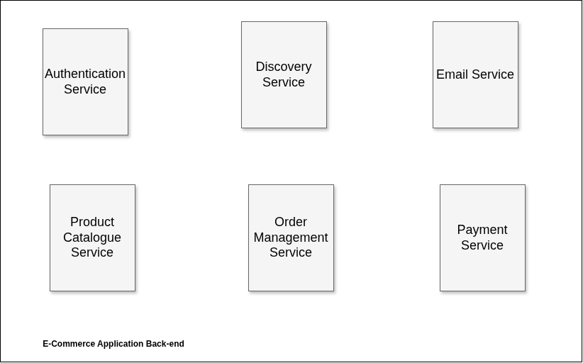
Figure 1.1: E-Commerce application backend block diagram. (Figure captions go below figures.)

1. Authentication Service
Responsibilities: User login, registration, session management, and secure authentication.
Communication: Receives API requests through the API Gateway. Publishes login/signup events to Kafka.
Database: MySQL (for user credentials and metadata).
2. Discovery Service
Responsibilities: Acts as a service registry so that microservices can discover and communicate with each other dynamically (e.g., via Consul or Eureka).
Communication: Used internally by all services to resolve service endpoints.
3. Email (Notification) Service
Responsibilities: Sends transactional emails (e.g., order confirmation, registration success).
Communication: Subscribes to Kafka topics such as "user.signup", "order.placed", and "payment.success".
Integrations: Amazon SES or SMTP server for email delivery.
4. Product Catalogue Service
Responsibilities: Manages product listings, categories, and details.
Communication: Serves client requests routed through API Gateway; publishes product view events to Kafka.
Databases: MySQL (for structured product data),
Elasticsearch (for search functionality with typo correction and filters).

5. Order Management Service
Responsibilities: Handles order creation, history, and tracking.
Communication:
- Listens for cart checkout events via Kafka.
- Sends order confirmation to Notification Service.
- Sends payment initiation events to Payment Service.
Database: MySQL.

6. Payment Service
Responsibilities: Handles payment authorization and transaction processing.
Communication: Receives payment requests via Kafka from Order Service; publishes payment status updates.
Database: MySQL (for transaction logs and receipts).
Typical Workflow Examples

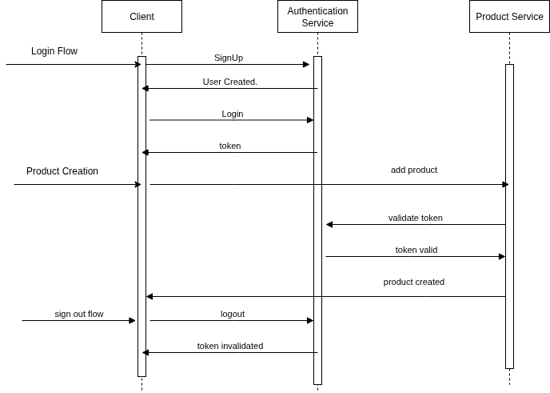
Figure 1.2: Add product flow along with sign up, login and sign out. (Figure captions go below figures.)
The provided sequence diagram illustrates the workflow of client interactions with the Authentication Service and the Product Service in an e-commerce backend. It’s divided into three main flows:

1. Login Flow
This flow covers user registration (sign-up) and authentication (login):

a. SignUp
- The Client sends a SignUp request to the Authentication Service.
- This includes user information like email, password, etc.

b. User Created.
- The Authentication Service processes the registration and creates a new user in the system.
- It sends back a confirmation response, e.g., User Created.

c. Login
- The Client sends a Login request (email and password) to the Authentication Service.

d. Token
- If credentials are valid, the Authentication Service generates and returns an authentication token (usually JWT).
- This token is used to authorize subsequent requests.
2. Product Creation Flow
This flow describes how a product is added to the system securely:

a. add product
- The Client attempts to add a product by sending a request to the Product Service.
- This request includes the authentication token (retrieved during login).

b. validate token
- Before proceeding, the Product Service sends the token to the Authentication Service for validation.

c. token valid
- If the token is valid and the user is authorized, the Authentication Service responds with token valid.

d. product created
- The Product Service creates the product and responds back to the Client with confirmation.

3. Sign Out Flow
This flow handles user logout:

a. logout
- The Client sends a logout request to the Authentication Service.

b. token invalidated
- The Authentication Service invalidates the user’s token (either by blacklisting or token expiry).
- It sends a confirmation back to the Client that the token is no longer valid.

Security Considerations
- Token validation ensures that only authenticated users can add products.
- Token invalidation on logout prevents unauthorized access.

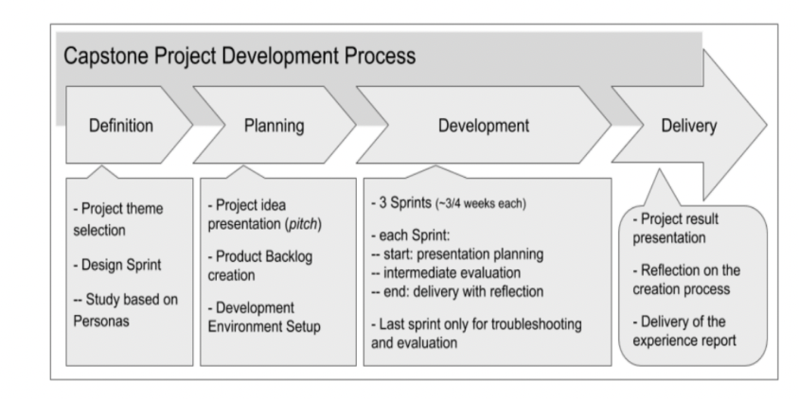
Figure 1.1: Project Development Process (Figure captions go below figures.)

- Describe the requirements - Functional, Non-Functional Requirements

Functional Requirements

1. User Management

1.1. Registration: Allow new users to create an account using their email or social media profiles.
1.2. Login: Users should be able to securely log in using their credentials.
1.3. Profile Management: Users should have the ability to view and modify their profile details.
1.4. Password Reset: Users must have the option to reset their password through a secure link.

2. Product Catalog

2.1. Browsing: Users should be able to browse products by different categories.
2.2. Product Details: Detailed product pages with product images, descriptions, specifications, and other relevant information.
2.3. Search: Users must be able to search for products using keywords.

3. Cart & Checkout

3.1. Add to Cart: Users should be able to add products to their cart.
3.2. Cart Review: View selected items in the cart with price, quantity, and total details.
3.3. Checkout: Seamless process to finalize the purchase, including specifying delivery address and payment method.

4. Order Management

4.1. Order Confirmation: After making a purchase, users should receive a confirmation with order details.
4.2. Order History: Users should be able to view their past orders.
4.3. Order Tracking: Provide users with a way to track their order's delivery status.

5. Payment

5.1. Multiple Payment Options: Support for credit/debit cards, online banking, and other popular payment methods.
5.2. Secure Transactions: Ensure user trust by facilitating secure payment transactions.
5.3. Payment Receipt: Provide users with a receipt after a successful payment.

6. Authentication

6.1. Secure Authentication: Ensure that user data remains private and secure during login and throughout their session.
6.2. Session Management: Users should remain logged in for a specified duration or until they decide to log out.

Functional Requirements

1. Performance
- The system must respond to 95% of API requests within 300 milliseconds under normal load.
- Product search should return results within 500 milliseconds, powered by Elasticsearch.
- Checkout and payment processing must complete within 2 seconds on average.

2. Scalability
- The architecture should support horizontal scaling of services independently (e.g., scale Order Service separately from Product Service).
- The system must handle up to 100,000 concurrent users and scale to support seasonal traffic spikes (e.g., during sales events).
- Kafka ensures scalable event-driven communication across microservices.

3. Availability
- System should maintain 99.9% uptime (SLA), with high availability ensured by:
  - Redundant Load Balancers (ELB)
  - Service replication
  - Failover support in databases and messaging (e.g., Kafka cluster replication)

4. Reliability & Fault Tolerance
- The system should continue operating during component failures (e.g., a single service crash should not take down the system).
- Retry mechanisms should be implemented for failed inter-service communications.
- Circuit breakers and fallbacks should be used to isolate failing services.

5. Security
- All communications should occur over HTTPS (TLS 1.2 or above).
- JWT-based authentication must be enforced for all client-to-service and inter-service requests.
- Sensitive data (passwords, tokens, payment info) must be encrypted at rest and in transit.
- Services must implement RBAC (Role-Based Access Control) where appropriate (e.g., admin vs. user).

6. Maintainability
- Each microservice should follow clean architecture principles and have separate codebases with independent deployment pipelines.
- Code must include unit tests, integration tests, and logging/monitoring hooks.
- Use of centralized logging (e.g., ELK stack) and monitoring tools (e.g., Prometheus + Grafana).

7. Observability
- All services should emit logs, metrics, and traces for:
  - Request performance
  - Errors and exceptions
  - Business events (e.g., order placed, payment failed)
- Use Kafka as a central log/event stream and push critical events to alerting systems (e.g., Slack, PagerDuty).

8. Extensibility
- New services (e.g., a Recommendation Engine or Analytics Service) should be added without disrupting existing services.
- Event-driven communication using Kafka ensures loose coupling and easy integration.

9. Data Consistency
- Microservices should follow an eventual consistency model via Kafka for actions like order creation and payment status.
- Use of idempotent operations in services to handle retries safely.

10. Backup & Disaster Recovery
- Databases must be backed up daily with support for point-in-time recovery.
- Kafka topics must be configured with replication and message retention policies.
- A disaster recovery plan must ensure system restoration within 1 hour (RTO) and maximum 5 minutes data loss (RPO).

11. Compliance
- The system must comply with GDPR, PCI-DSS, and local data protection laws where applicable.
- Support for user data anonymization and deletion on request.

- Describe the Users and Use Cases
  - Include detailed Use Case Diagram / Images to illustrate
- List and detail out the Feature set -
  - Use Tables to list out the feature set

Use the below format as reference when including a table

Table 1.1: < Table caption > (Table captions go above tables.)

Class Diagrams

Describe the Low Level Design of the Project…

Provide class diagrams - Provide proper captions and follow the proper format for including diagrams / figures / images

Tip - Make images using draw.io and paste here following the guidelines for adding images / figures

Database Schema Design

Explain the Low Level Design of the Project in more detail by providing the database schema
design description

Provide the schema design textually as well as diagrammatically

Sample Schema Design described textually -

“”
Tables:

Batches
  - Batch_id
  - Name
  - Start_month
  - Current_instructor
  - Batch_type_id
  - Primary Key(Batch_id)
Students
  - student_id
  - name
  - graduation_year
  - University_name
  - email
  - Phone_number
  - batch_id
  - Buddy_id
  - Primary Key(student_id)
Classes
- Class_id
- Name
- Date
- Time
- Instructor
- Primary Key(Class_id)
Mentors
  - Mentor_id
  - Name
  - Current_company
  - Primary Key(Mentor_id)

Mentor_Sessions
- mentor_session_id
- time
- Duration
- Student_id
- Mentor_id
- Student_rating
- Mentor_rating
  - Primary Key(mentor_session_id)

Batches_Classes
  - Batch_id
  - Class_id
  - Primary Key(Batch_id, Class_id)

Student_batch_history
  - student_id
  - batch_id
  - Shift_date
  - Primary Key(student_id, batch_id)

Batch_type
  - Batch_type_id
  - Batch_type
  - Primary Key(Batch_type_id)

Foreign Keys:

- Batches(batch_type_id) refers Batch_type(batch_type_id)
- Students(batch_id) refers Batches(batch_id)
- Mentor_Sessions(Student_id) refers Students(Student_id)
- Mentor_Sessions(Mentor_id) refers Mentors(Mentor_id)
- Batches_Classes(Batch_id) refers Batches(batch_id)
- Batches_Classes(student_id) refers Students(Student_id)
- Student_batch_history(student_id) refers Students(Student_id)
- Student_batch_history(batch_id) refers Batches(batch_id)

Cardinality of Relations:
- Between Batches and Batch_type -> m:1
- Between Students and Batches -> m:1
- Between Batches and Classes -> m:m
“”

Feature Development Process

Pick One key feature - Talk about its development process, implementation and performance optimisation / metric optimisation achieved…

For example, ‘Book a seat’ feature in developing ‘BookMyShow’ app

Elaborate the request flow to backend
  - API Request Payload
  - Service which picks the request
  - Flow of MVC architecture

Explain the performance improvement / metric optimization achieved.

For example,
- Used Cache to reduce API Response time by X seconds…
- Optimized Query Response time by using Indexing…

Benchmarking of response time without the optimisation and post the optimisation

Deployment Flow

Explain how the deployment will work via AWS (Describe the below) -
- EC2
- VPC
- Security Groups
- RDS
- Cache
- Managed Infra / Elastic Beanstalk

Use diagrams, images to explain better

Technologies Used
Kafka, MySQL, Springboot, Cloud etc…
- For each key technology used in building the project,
  - Detail and describe each of them
  - Elaborate how they can be used in real life
  - Provide example of real-life applications using them

Use diagrams, images to explain better

Tip - Use the internet to improve your project but DO NOT PLAGIARIZE - Include proper references if you are quoting articles from the internet

Conclusion
The Conclusion should include some key points as elaborated below -

- Key Takeaways: Highlight the important concepts and technologies learned from doing the Project
- Practical Applications : Significance of technologies with their real-world applications
- Limitations : Limitations of the technologies, cost implications and suggestions for improvement

References

Include the websites or works or the list of works referred to in a text or consulted by you for writing this report

- Name of the Website, Date and time of referring to the Website, Name of the Author, Title/Topic
- Author Name, Title / Topic, Research Paper Name / Book Name, Year of Publication

Format Guidelines

- Detailed and Elaborate report of 40 pages at least is expected
- Margins - Every page of your document must meet the margin requirements of 1.25 inches on the left and right, and 1 inch on the top and bottom.
- Font:
  - Style: Times New Roman,
  - Font Size:14 (For Headings), 12 (For body text) in black colored text.
  - All text must be the same justification, like left justified or fully justified.
- Line Spacing:
  - Body of the text: 1.5
  - List of Tables/graphs/charts/bibliography: single line.
- Alignment:
  - Title page: Centre
  - Chapter Heading: Centre
  - Subheading: Left
  - Body of the text: Justify
- Titles: All titles and subtitles should be in bold. All tables/graphs/charts/figures should have appropriate titles.
- Numbering of the tables, charts, graphs should be in the following fashion: Second table/graph/chart in the second chapter should be numbered as Table/graph/chart no. 2.02; where the first digit stands for chapter no. and digits after (.) stands for number of table/graph/charts in that chapter. Same numbering should be followed for all other chapters.
- Project -> https://github.com/S-Tirumal/ecommerce
Shrey@2025

