LAB 3 — COMPONENT MODELLING & ARCHITECTURAL PATTERN SELECTION
Problem Statement #25 — Municipal Solid Waste Route Optimizer

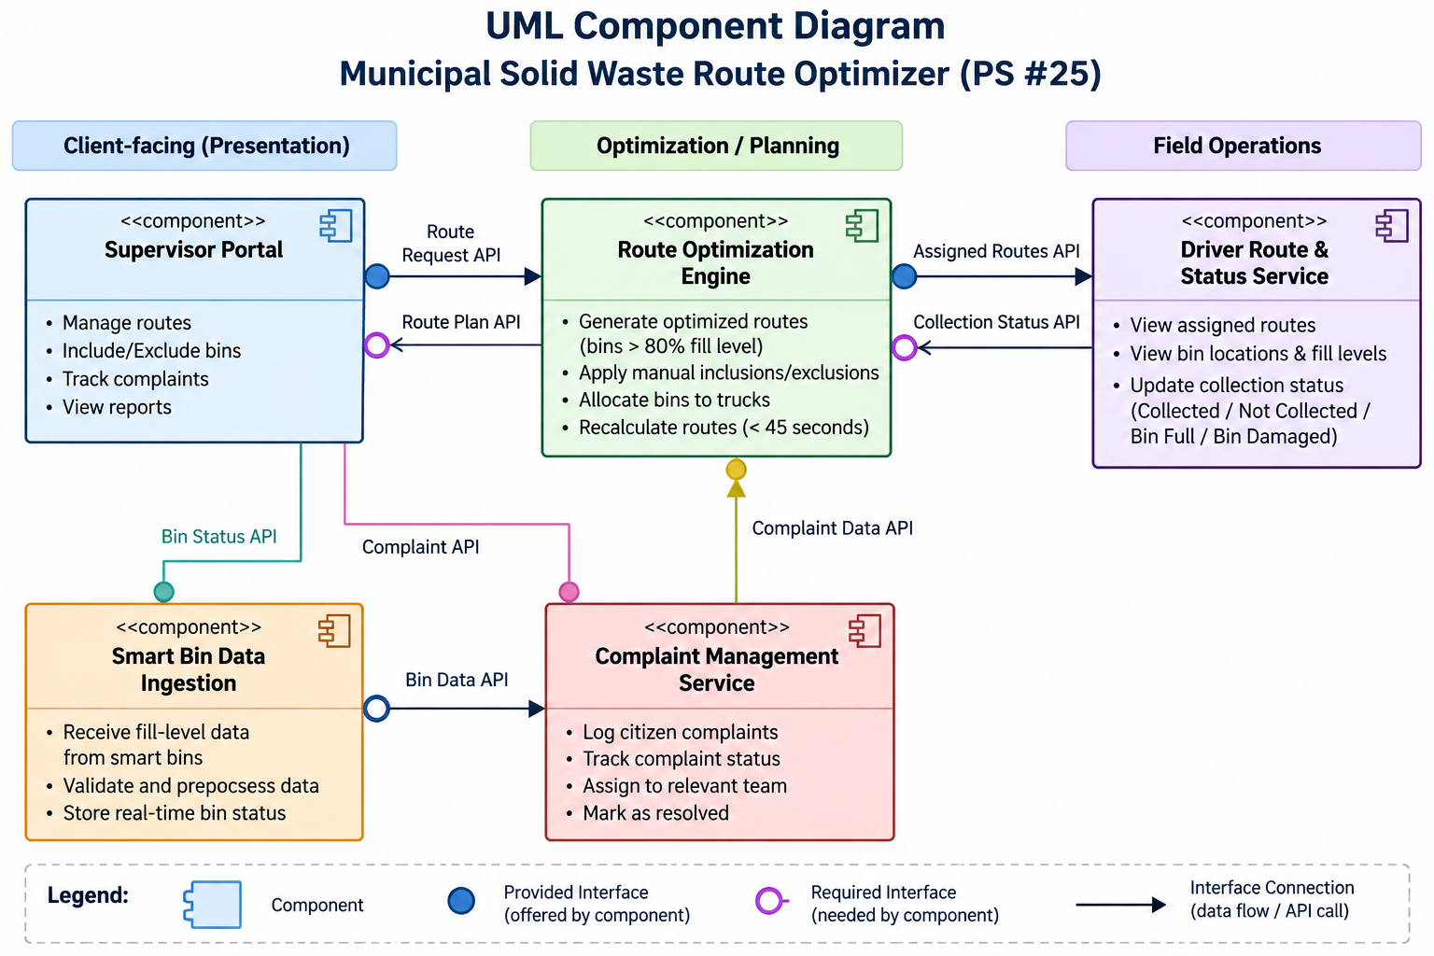
Figure 1. UML Component Diagram — Municipal Solid Waste Route Optimizer (PS #25).
The design separates the system into five independently deployable components: Supervisor Portal, Smart Bin Data Ingestion, Route Optimization Engine, Driver Route & Status Service, and Complaint Management Service. The interfaces show how operational data and service requests move between components.
Key domain rules represented by the architecture include the 80% bin-fill threshold, manual supervisor overrides, driver route/status operations, and missed-pickup complaint tracking. The design also provides clear service boundaries for the encryption and role-based access control requirements.

WRITTEN ARCHITECTURAL JUSTIFICATION
Municipal Solid Waste Route Optimizer — Problem Statement #25
Architecture Selection: We chose Microservices Architecture for the Municipal Solid Waste Route Optimizer.
Architectural Choice: The system contains distinct capabilities—smart-bin data ingestion, route optimization, driver operations, and complaint management—that can be separated into independently deployable services. This fits the scenario because these capabilities have different workloads and can evolve independently.
Reason 1 — Performance and Scalability: NFR-001 requires route recalculation for up to 50 trucks across 10,000 bins in under 45 seconds. The Route Optimization Engine can be scaled independently and given additional compute resources when route calculation is the bottleneck, without scaling the entire application. This directly targets the most demanding computational requirement.
Reason 2 — Fault Isolation and Independent Evolution: Smart-bin ingestion, route optimization, driver status updates, and complaint tracking have different workloads and failure modes. Separating them limits the impact of a failure or change in one service. For example, a temporary problem in complaint handling should not prevent drivers from viewing assigned routes.
Security Advantage: NFR-002 requires encrypted communications and operational data together with role-based access control. Service/API boundaries provide controlled points for authorization: Supervisors can manage routes and complaints, while Drivers can access assigned routes and submit collection-status updates. Encrypted communication between services protects operational and citizen information.
Performance Benefit: Independent scaling and parallel processing improve responsiveness. The computationally intensive Route Optimization Engine can process large route-recalculation workloads without requiring the Supervisor Portal, Driver Service, or Complaint Service to scale at the same rate. This supports the under-45-second target.
Alternatives Considered: Layered Architecture would provide clear separation of concerns and simpler deployment, but independent scaling of the route optimizer would be harder. Client-Server would provide centralized control and consistency, but its central server could become a bottleneck and a single point of failure. Microservices therefore provides the strongest fit for the stated scalability, performance, and fault-isolation needs.

DETAILED COMPONENT & INTERFACE DESIGN RATIONALE
This page provides additional technical reasoning behind the component decomposition and interface choices. It is supplementary to the one-page written justification above.
1. Component Responsibilities
Component | Responsibility and PS #25 mapping
Supervisor Portal | Provides the Sanitation Supervisor interface for generating/confirming routes, applying manual bin inclusion/exclusion, and tracking or resolving missed-pickup complaints.
Smart Bin Data Ingestion | Receives ultrasonic fill-level readings from smart bins and exposes current bin information to the planning process.
Route Optimization Engine | Filters eligible bins using the 80% threshold and manual overrides, then computes optimized daily routes for available trucks.
Driver Route & Status Service | Makes assigned routes, bin locations, and fill-level information available to Truck Drivers and records Collected, Not Collected, Bin Full, or Bin Damaged statuses with timestamp/location.
Complaint Management Service | Stores, tracks, and resolves citizen missed-pickup complaints and keeps complaint status separate from route-calculation logic.
2. Why These Interfaces Are Separated
- RouteAPI separates the Supervisor Portal from route-generation logic. The portal requests route generation while the optimization rules remain encapsulated in the planning service.
- FillLevelAPI allows current smart-bin readings to reach the optimization engine without exposing sensor-ingestion implementation details to the rest of the system.
- RouteAssignmentAPI separates route generation from field execution. Once a route is confirmed, the Driver Service can retrieve the assigned route without directly depending on the optimization algorithm.
- CollectionStatusAPI carries field outcomes back into operational processing. This supports missed-pickup tracking and keeps driver updates distinct from route-generation logic.
- ComplaintAPI gives the Supervisor controlled access to complaint operations without coupling complaint storage and workflow to route optimization.
3. Scenario-to-Architecture Traceability
FR-001 and FR-002 are primarily handled by the Route Optimization Engine because they define route eligibility and supervisor override behavior. FR-003 and FR-004 map to the Driver Route & Status Service because they concern route visibility and field status updates. FR-005 maps to Complaint Management Service because it requires end-to-end complaint tracking and resolution.
NFR-001 is the strongest architectural driver: 10,000 bins and 50 trucks create a computationally intensive route-planning workload, so the optimizer is isolated as a separately scalable service. NFR-002 is addressed by enforcing authentication, authorization, and encrypted communication at service boundaries. The decomposition therefore traces directly from the requirements created in Lab 1 and the functional grouping used in Lab 2.
4. Expected Operational Flow
1) Smart-bin readings enter through Smart Bin Data Ingestion. 2) The Supervisor requests route generation. 3) The Route Optimization Engine selects bins at or above 80%, incorporates manual inclusions/exclusions, and calculates routes. 4) Confirmed routes are exposed through RouteAssignmentAPI to the Driver Route & Status Service. 5) Drivers update collection outcomes. 6) Missed collections can feed the Complaint Management Service so the Supervisor can track and resolve citizen complaints.
5. Design Conclusion
The component model keeps each major business capability cohesive while making service boundaries explicit. The resulting architecture is justified by the actual PS #25 constraints rather than by a generic architecture preference: the route optimizer needs scalable computation, the sensor-ingestion workload can grow independently, driver operations require reliable field access, and complaint management should remain isolated from route calculation.

