LAB 2
Agile Backlog Creation & Sprint Simulation in Jira

NAME:SHREE VERDHAN M
SRN:PES1UG24AM265
Problem Statement #25 — Municipal Solid Waste Route Optimizer
Item | Result
Jira project | monekykong (SCRUM)
Epics | 3
User Stories / work items | 5
Total estimated effort | 26 story points
Sprints simulated | 2
Final assignment items | All 5 Done

1. Epics
Jira ID | Epic | Purpose
SCRUM-6 | Route Planning & Optimization | Enable the sanitation supervisor to generate optimized collection routes based on bin fill levels and manually selected bins.
SCRUM-7 | Truck Collection Operations | Enable truck drivers to access assigned routes and record collection outcomes for each bin.
SCRUM-8 | Complaint Management | Enable sanitation supervisors to track and resolve citizen complaints about missed waste pickups.
The Jira project is configured with Epic, Task and Subtask issue types. The five required User Stories were implemented as Tasks containing the required end-user User Story format and acceptance criteria, while the Epics provide the major functional themes.
2. User Stories, Priority & Story Points
ID | User Story | Priority | Points | Epic
SCRUM-9 | US-1 Generate Optimized Collection Routes | High | 8 | Route Planning
SCRUM-10 | US-2 Manually Include or Exclude Bins | High | 5 | Route Planning
SCRUM-11 | US-3 View Assigned Collection Route | High | 3 | Truck Operations
SCRUM-12 | US-4 Update Bin Collection Status | Medium | 5 | Truck Operations
SCRUM-13 | US-5 Track Missed-Pickup Complaints | Medium | 5 | Complaint Management
Total: 26 story points. Estimates use Fibonacci-style values.
3. Jira Backlog Evidence
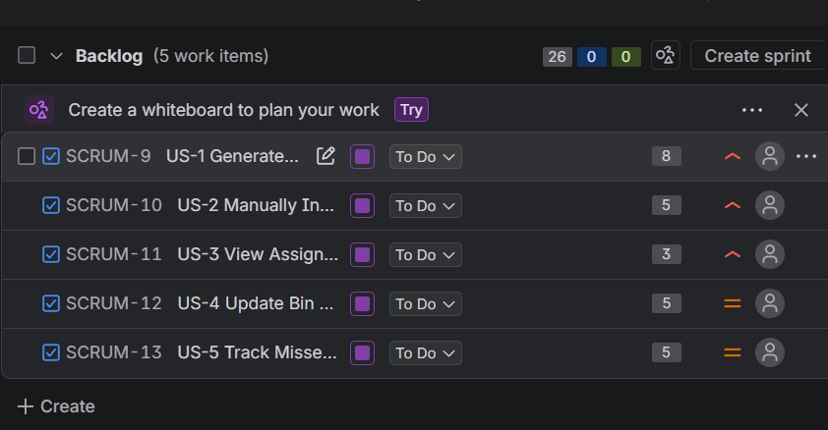
Figure 1. Captured Jira backlog showing the assignment work items and story-point estimates.
4. Sprint Planning
Sprint | Selected work | Points | Final Jira state
Sprint 1 | SCRUM-9, SCRUM-10, SCRUM-11 | 16 | Closed; all Done
Sprint 2 | SCRUM-12, SCRUM-13 | 10 | Closed; all Done
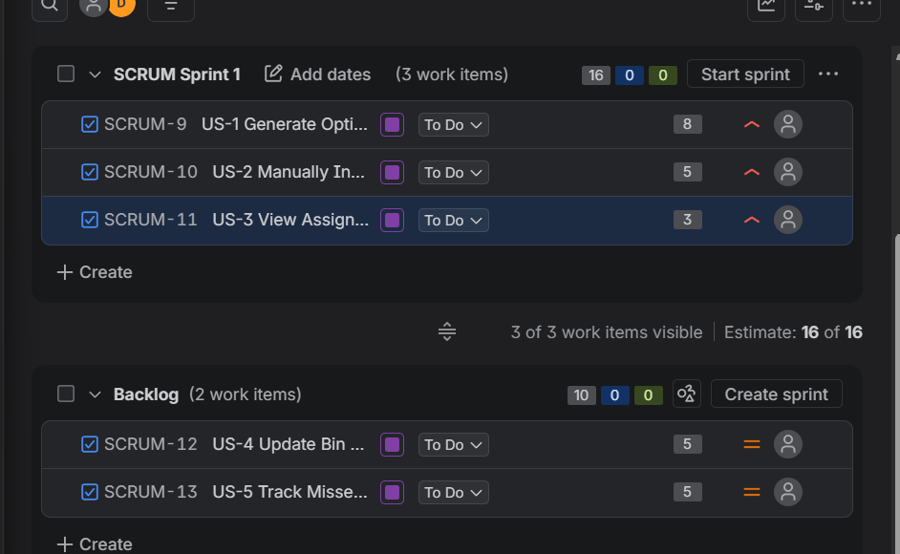
Figure 2. Sprint 1 planning evidence — 3 work items, 16 points.
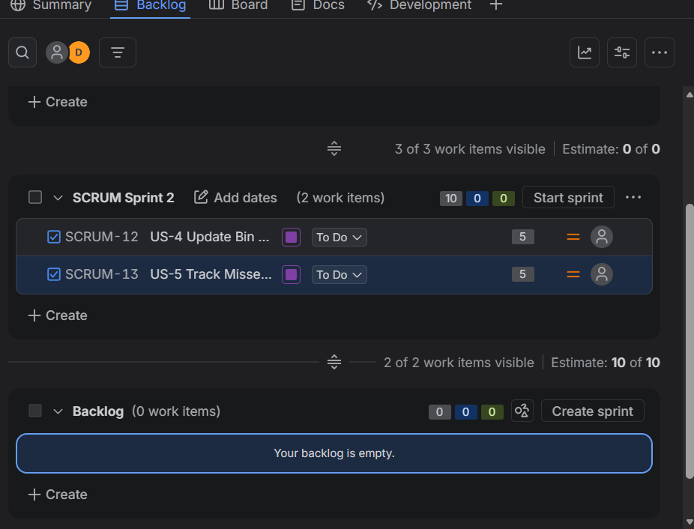
Figure 3. Sprint 2 planning evidence — 2 work items, 10 points.
Live Jira verification confirmed SCRUM-9 through SCRUM-13 are all in Done, with Sprint 1 and Sprint 2 recorded as closed.

5. Burndown Charts
The Lab 2 handout requires the Burndown Chart to track work completion against the planned sprint workload. Both sprint charts were captured directly from Jira.
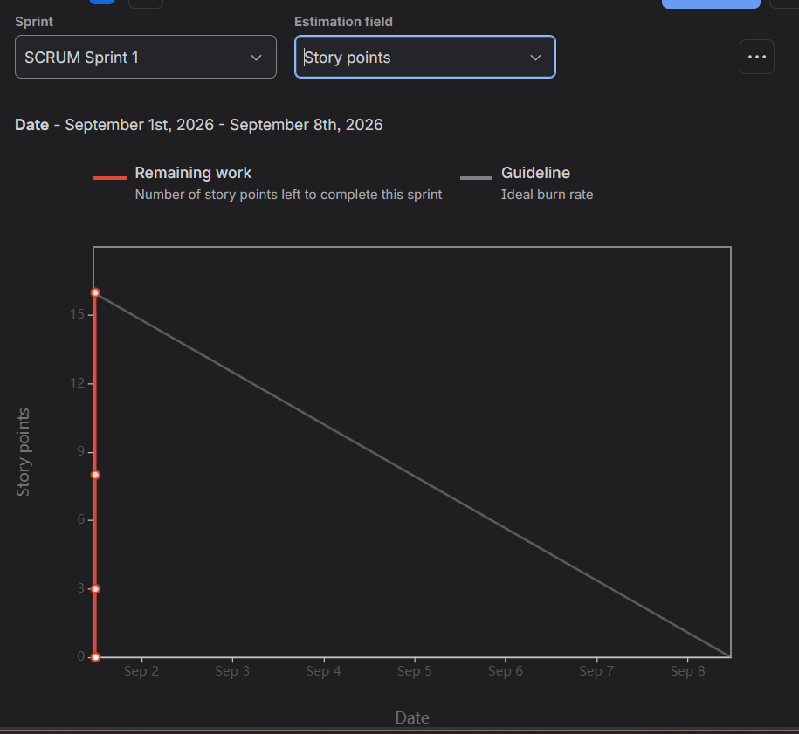
Figure 4. Sprint 1 Burndown Chart — 16-point sprint reaching 0 remaining points.
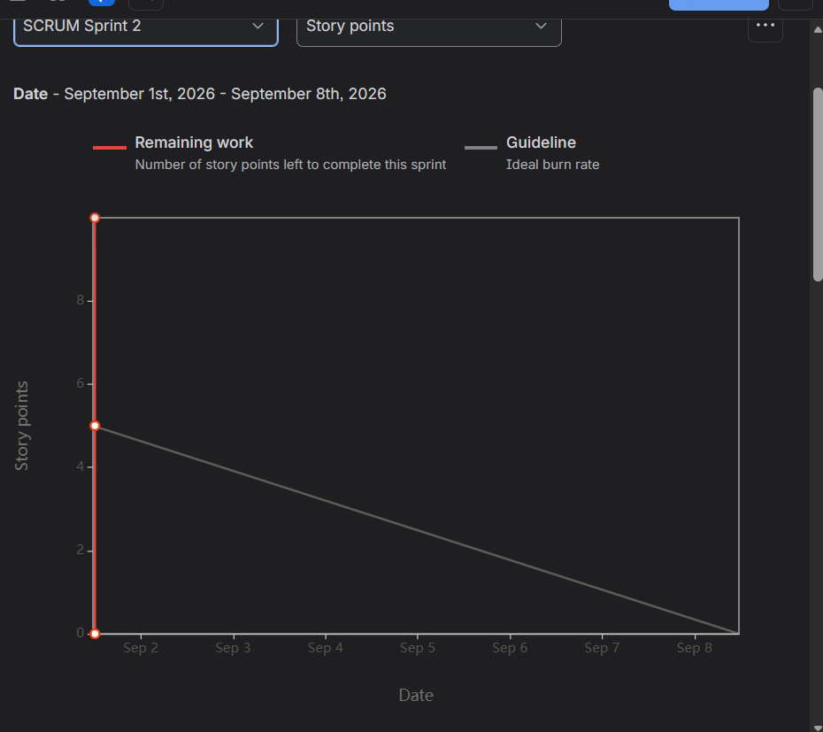
Figure 5. Sprint 2 Burndown Chart — 10-point sprint reaching 0 remaining points.

6. Reflection
1. Did your estimations reflect the actual effort?
The estimates were assigned using Fibonacci-style story points, considering complexity, amount of work, and uncertainty. Route generation received the largest estimate at 8 points because it combines threshold-based selection with route optimization. The smaller operational features were estimated at 3–5 points. All 26 planned points were completed across the two simulated sprints.
2. Was your backlog well-prioritized?
Yes. Route-planning capabilities were assigned High priority because they are central to the waste-collection workflow. Driver collection-status tracking and missed-pickup complaint management were assigned Medium priority because they follow the core route/collection flow.
3. How did your simulated sprint align with your plan?
The work was split into two one-week sprints. Sprint 1 focused on route planning and route visibility (16 points), while Sprint 2 focused on collection-status tracking and complaint management (10 points). Jira records show both sprints closed and all five assignment work items in Done.
4. What insights did the burndown chart give about your team’s capacity?
Both Burndown Charts reached zero remaining work by the end of their respective sprints. This indicates that the simulated workloads were achievable. The exercise provides a preliminary capacity reference of 16 points for Sprint 1 and 10 points for Sprint 2; in a real project, several sprints of historical data would be needed before treating this as stable velocity.
7. Final Jira Verification
Requirement | Verified result
Epics | SCRUM-6, SCRUM-7, SCRUM-8 created
User Stories | SCRUM-9 to SCRUM-13 created with User Story wording and acceptance criteria
Priorities | 3 High, 2 Medium
Story points | 8 + 5 + 3 + 5 + 5 = 26
Sprint 1 | Closed; SCRUM-9/10/11 Done; 16 points
Sprint 2 | Closed; SCRUM-12/13 Done; 10 points
Burndown evidence | Sprint 1 and Sprint 2 charts captured
SUMMARY SC
