LAB 3 — COMPONENT MODELLING & ARCHITECTURAL PATTERN SELECTION
Problem Statement #25 — Municipal Solid Waste Route Optimizer
SHREE VERDHAN M
PES1UG24AM265
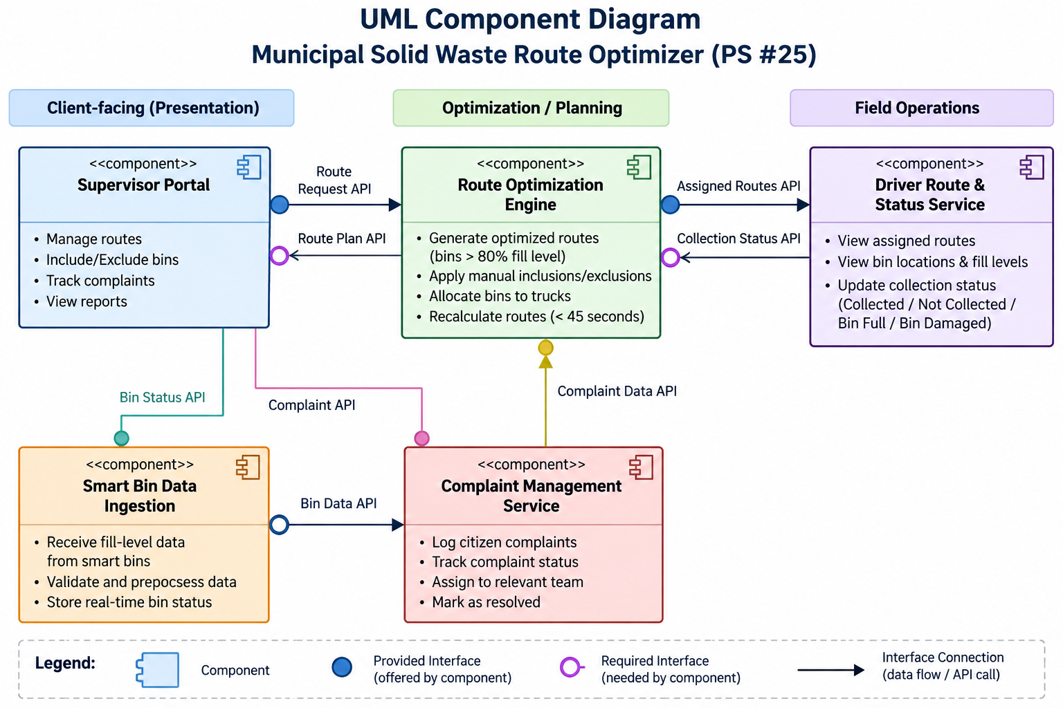
Figure 1. UML Component Diagram — Municipal Solid Waste Route Optimizer (PS #25), with five components and clearly separated provided/required interfaces.
Component Mapping: Supervisor Portal supports the Sanitation Supervisor; Smart Bin Data Ingestion receives ultrasonic fill-level data; Route Optimization Engine generates routes using the 80% threshold and manual overrides; Driver Route & Status Service supports assigned routes and bin-status updates; Complaint Management Service tracks missed-pickup complaints.

WRITTEN ARCHITECTURAL JUSTIFICATION
Municipal Solid Waste Route Optimizer — Problem Statement #25
Architecture Selection: We chose Microservices Architecture for the Municipal Solid Waste Route Optimizer.
Architectural Choice: The system contains distinct operational capabilities—smart-bin ingestion, route optimization, driver operations, and complaint management—that can be separated into independently deployable services. This matches the handout’s definition of microservices as small services that can be independently deployed and scaled.
Reason 1 — Performance & scalability: NFR-001 requires route recalculation for 50 trucks and 10,000 bins in under 45 seconds. The Route Optimization Engine can be scaled independently and given additional compute during heavy route-planning workloads without scaling the entire system.
Reason 2 — Fault isolation & independent evolution: Smart-bin ingestion, route optimization, driver status updates, and complaint tracking have different workloads and failure modes. Separating them limits the effect of a failure or change in one service and allows each service to evolve independently.
Security Advantage: NFR-002 requires encrypted communications/data and role-based access control. Service/API boundaries provide natural enforcement points: Supervisors can manage routes and complaints, while Drivers can access assigned routes and submit collection-status updates. Encrypted service communication protects operational and citizen information.
Performance Benefit: Independent scaling and parallel processing improve responsiveness. In particular, the Route Optimization Engine can handle computationally intensive route recalculation without requiring every other component to scale, directly supporting the 45-second target.
Alternatives Considered: Layered Architecture is simpler and provides strong separation of concerns, but individual high-load components are harder to scale independently. Client-Server offers centralized control and consistency, but introduces a central bottleneck and single-point-of-failure risk. Microservices is therefore the best fit for the stated scalability, performance, and fault-isolation requirements.

