Lab 1: Requirements Engineering & UML Use-Case Modelling
Problem Statement #25 – Municipal Solid Waste Route Optimizer

1. Problem Context and Overview
The Municipal Solid Waste Route Optimizer is a city sanitation management portal that receives ultrasonic fill-level data from smart trash bins, generates optimized daily collection routes for garbage trucks, and supports tracking of missed-pickup citizen complaints.
Actors / Stakeholders
- Sanitation Supervisor – plans and confirms collection routes, manages bin inclusion/exclusion, and handles missed-pickup complaints.
- Truck Driver – views assigned routes and updates the collection status of bins.
2. Functional Requirements (5)
ID | Type | Description | Priority | Acceptance Criteria | Rationale
FR-001 | Functional | The system shall generate optimized daily collection routes including only bins that have exceeded an 80% fill threshold, unless manually included. | High | Pass: Route excludes bins below 80% unless manually tagged. Fail: An overflowing bin is omitted from the driver manifest. | Ensures efficient collection and helps prevent overflow.
FR-002 | Functional | The system shall allow the Sanitation Supervisor to manually include or exclude specific bins from a generated route. | High | Pass: Supervisor can add or remove bins and the route updates. Fail: Route does not reflect the supervisor's changes. | Provides human control for exceptional situations.
FR-003 | Functional | The system shall allow Truck Drivers to view their assigned collection routes with bin locations and fill-level information. | High | Pass: Driver can view the assigned route and bin details. Fail: Driver cannot access route information. | Supports accurate on-ground collection.
FR-004 | Functional | The system shall allow Truck Drivers to update the status of each bin as Collected, Not Collected, Bin Full, or Bin Damaged. | Medium | Pass: Status update is saved with timestamp and location. Fail: Update is not stored. | Maintains operational visibility and accurate records.
FR-005 | Functional | The system shall allow the Sanitation Supervisor to track and resolve missed-pickup citizen complaints. | Medium | Pass: Complaint can be logged, tracked, and marked resolved. Fail: Complaint cannot be tracked end-to-end. | Improves accountability and citizen satisfaction.

3. Non-Functional Requirements (2)
ID | Type | Description | Priority | Acceptance Criteria | Rationale
NFR-001 | Performance | Route recalculation for a fleet of 50 trucks across 10,000 bins shall execute in under 45 seconds. | High | Pass: Benchmark testing confirms execution time below 45 seconds. Fail: Execution exceeds 45 seconds. | Ensures timely route updates and operational efficiency.
NFR-002 | Security | All system communications and operational data shall be encrypted, and role-based access control shall be enforced. | High | Pass: Security audit confirms encryption and RBAC. Fail: Unauthorized users can access protected data. | Protects operational and citizen information.

4. UML Use-Case Diagram
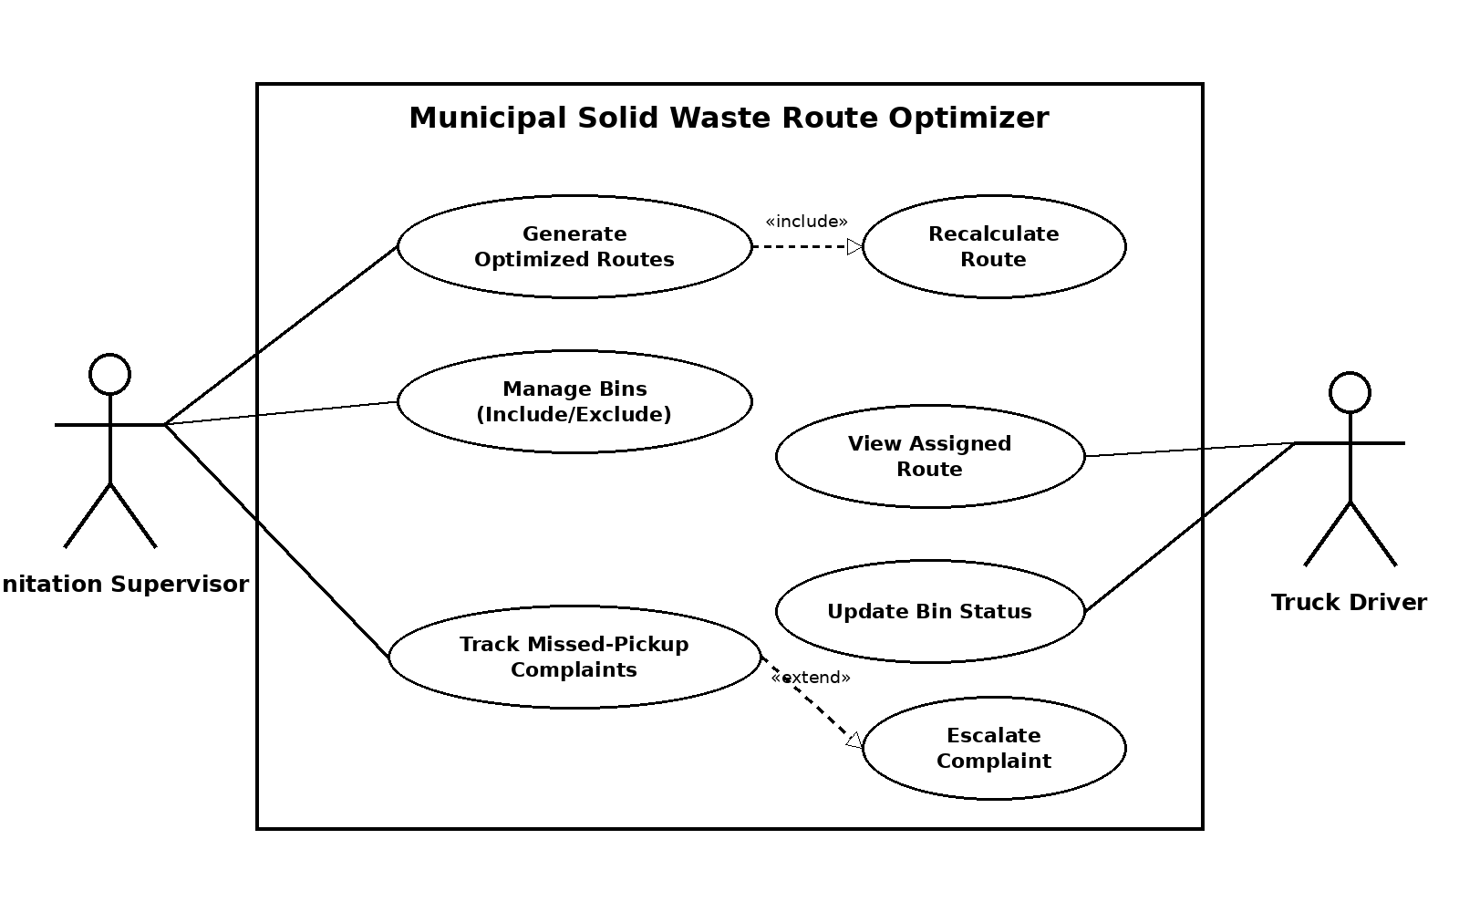
Legend: Solid lines represent actor–use-case associations. A dashed arrow labelled «include» represents required included behavior. A dashed arrow labelled «extend» represents optional or conditional behavior.
5. Use-Case Flow Specification – Generate Optimized Routes
Use Case Name | Generate Optimized Routes
Primary Actor | Sanitation Supervisor
Preconditions | 1. The Sanitation Supervisor is logged in.  2. Latest smart-bin fill-level data is available.  3. Active trucks and relevant road/route data are available.
Postconditions | 1. Optimized routes are generated.  2. Routes are stored and assigned to drivers.  3. Drivers can view their assigned routes.
Main Success Scenario | 1. The Sanitation Supervisor selects “Generate Optimized Routes”.  2. The system retrieves the latest bin fill-level data.  3. The system identifies bins with a fill level of 80% or above.  4. The system also considers any bins manually included by the supervisor.  5. The system performs route optimization using relevant operational constraints.  6. The system generates optimized routes for the available trucks.  7. The system displays the route summary to the supervisor.  8. The supervisor confirms the generated routes.  9. The system assigns the routes to drivers and makes them available for viewing.
Alternate Flow – No Bins Above Threshold | 1. No bins are found at or above the 80% fill threshold.  2. The system displays the message: “No bins require collection today.”  3. The supervisor may manually include specific bins if required.  4. The system regenerates the routes using the manually included bins.

