SDN PROJECT REPORT: ARP & FIREWALL USING MININET + POX

1. Introduction
Software Defined Networking (SDN) is a modern networking paradigm in which the control plane is separated from the data plane. This allows centralized control of the network using a controller.
In this experiment, we use:
- Mininet to simulate the network topology
- POX controller to implement logic using OpenFlow rules
Objectives of the Experiment
- To understand communication between hosts in a network
- To study the working of ARP (Address Resolution Protocol)
- To implement a firewall rule using SDN
- To analyze packets using Wireshark

2. Understanding ARP
ARP (Address Resolution Protocol) is used to map an IP address to a MAC address.
Working of ARP
- A host knows the destination IP address
- It does not know the MAC address
- It sends an ARP Request (broadcast):
  - “Who has 10.0.0.X?”
- The destination host replies with an ARP Reply (unicast):
  - “I am 10.0.0.X”
This process happens before any ICMP (ping) communication.

3. Tools Used
- Mininet – Network simulation
- POX Controller – SDN controller
- OpenFlow – Communication protocol between switch and controller
- Wireshark – Packet capture and analysis
- Ubuntu VM – Execution environment

4. Network Topology
The topology consists of:
- 1 Switch (s1)
- 3 Hosts:
  - h1 → 10.0.0.1
  - h2 → 10.0.0.2
  - h3 → 10.0.0.3
All hosts are connected to a single switch.
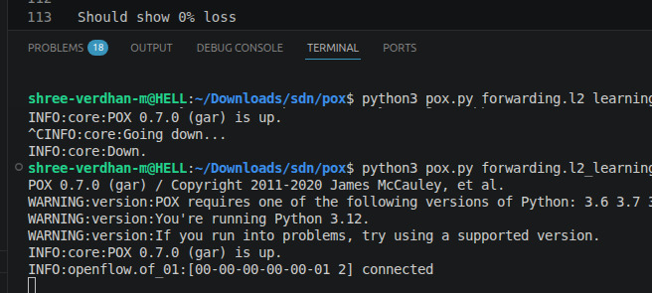
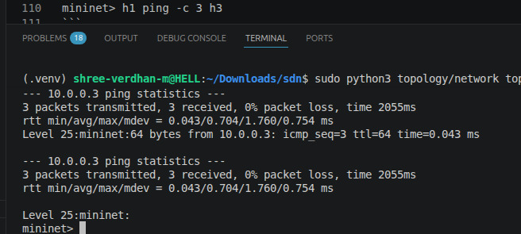

5. Scenario 1: Normal Communication
In this scenario, no firewall rules are applied. All hosts are allowed to communicate.
Test 1: h1 → h2
- Packets transmitted: 3
- Packets received: 3
- Packet loss: 0%

Test 2: h2 → h3
- Communication successful
- Packet loss: 0%
- 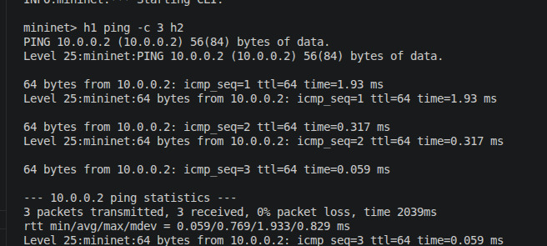

Test 3: h1 → h3
- Communication successful
- Packet loss: 0%
- 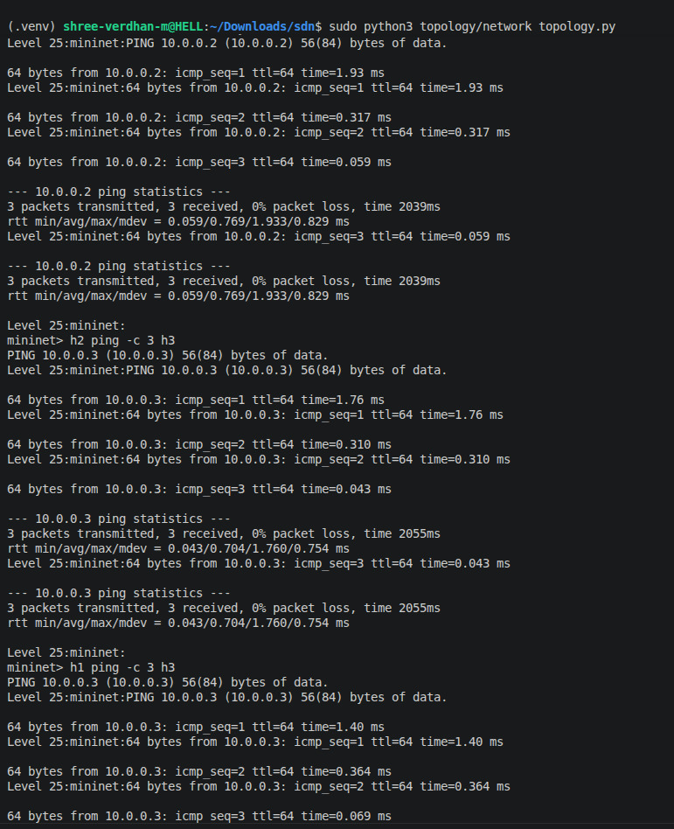

6. Wireshark Analysis (Normal Case)
From the captured packets:
Observed Packets
- ARP Request → Broadcast
  - Example: Who has 10.0.0.3? Tell 10.0.0.2
- ARP Reply → Unicast
- ICMP Echo Request (Ping)
- ICMP Echo Reply
Key Observations
- ARP occurs before ICMP communication
- MAC address resolution is necessary for packet delivery
- After ARP, ICMP packets flow normally
- 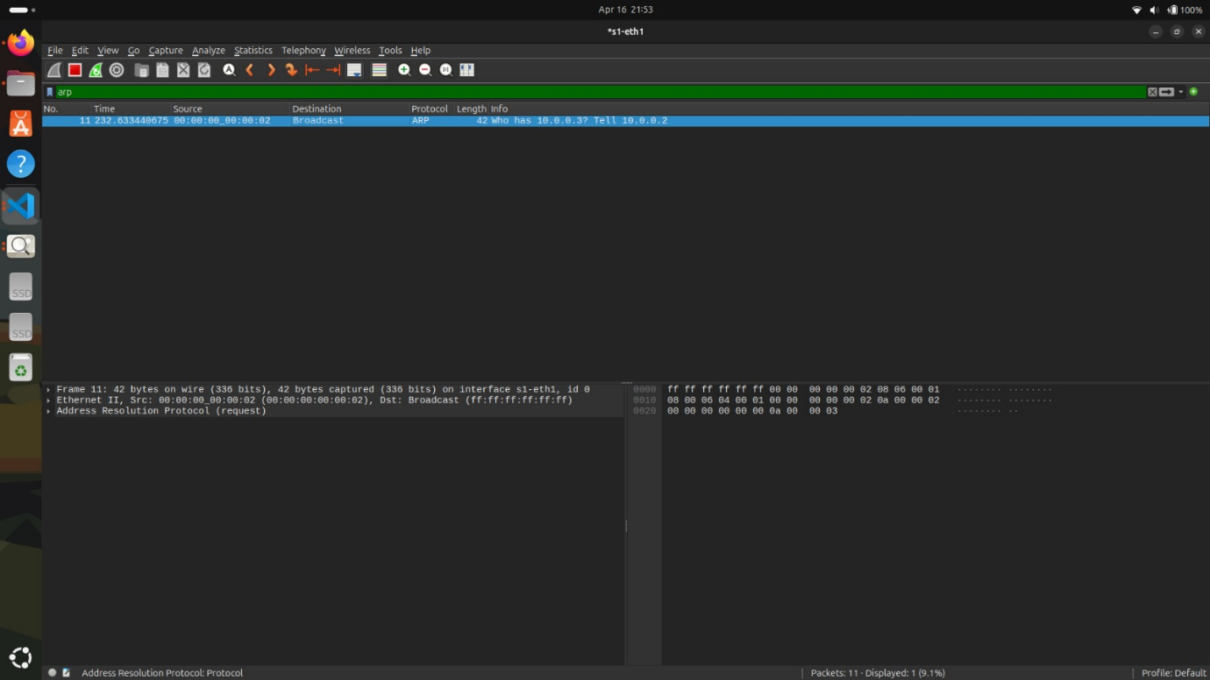
- 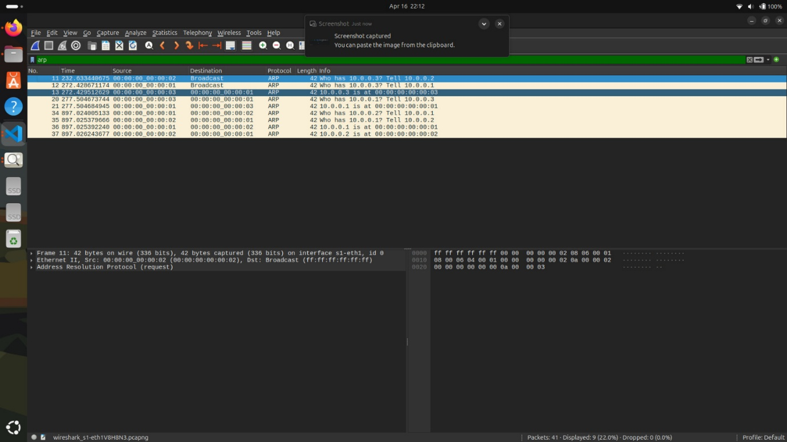

Test 4: h1 → h2 (Blocked)
- Packets transmitted: 3
- Packets received: 0
- Packet loss: 100%
- 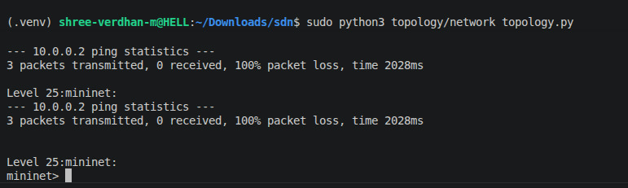

Test 6: h1 → h3 (Allowed)
- Communication successful
- Demonstrates selective filtering

8. Flow Table Analysis
The OpenFlow switch maintains flow entries:
Types of Rules
- Normal forwarding rules → Allow packets
- Firewall rule (high priority) → Drop packets
Important Observation
- Firewall rule has higher priority
- Matching packets are dropped at switch level
- 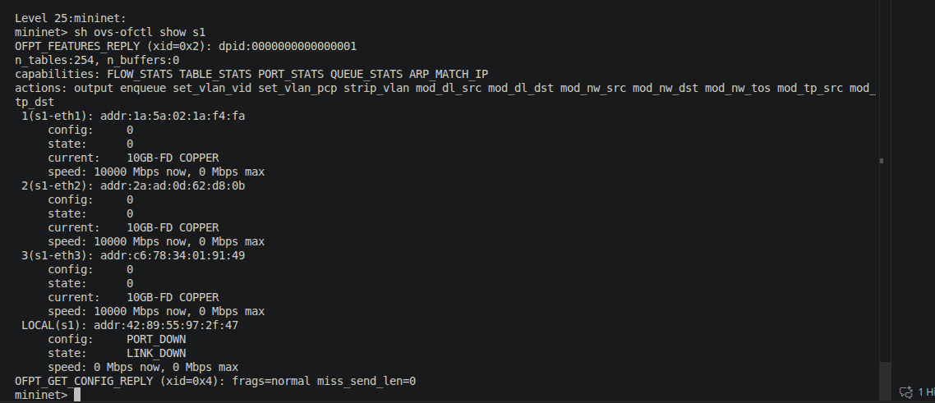

9. Wireshark Analysis (Firewall Case)
Observations
- ARP packets are still visible
- ICMP packets from h1 → h2 are absent
Conclusion
- ARP is not blocked
- ICMP packets are dropped by the firewall rule

10. Result Analysis
Scenario | Communication | Packet Loss
Normal | All hosts reachable | 0%
Firewall | h1 → h2 blocked | 100%
Firewall | Other communications OK | 0%
Key Insights
- ARP always occurs before communication
- SDN controller dynamically installs flow rules
- Firewall rules override normal forwarding behavior

11. Conclusion
This experiment successfully demonstrates:
- The working of ARP in a network
- The role of an SDN controller (POX)
- Implementation of a firewall using OpenFlow rules
- Real-time packet inspection using Wireshark
The project highlights how SDN provides centralized control, flexibility, and programmability in managing network traffic.

