AIR QUALITY MONITORING

**PHASE -3**

DEVELOPMENT PART-1

Introduction:

In a world where we're increasingly aware of environmental issues, monitoring air quality has become a top priority. Poor air quality has wide-ranging impacts on both the environment and our health. To address this, our project has taken a big leap forward.

We're excited to introduce a significant upgrade to our project - a set of advanced sensors carefully chosen to make our air quality assessments more detailed and precise. Alongside our trusty gas sensors, which have been doing a great job, we've added some new sensors to provide a more comprehensive view of air quality.

Circuit Diagram

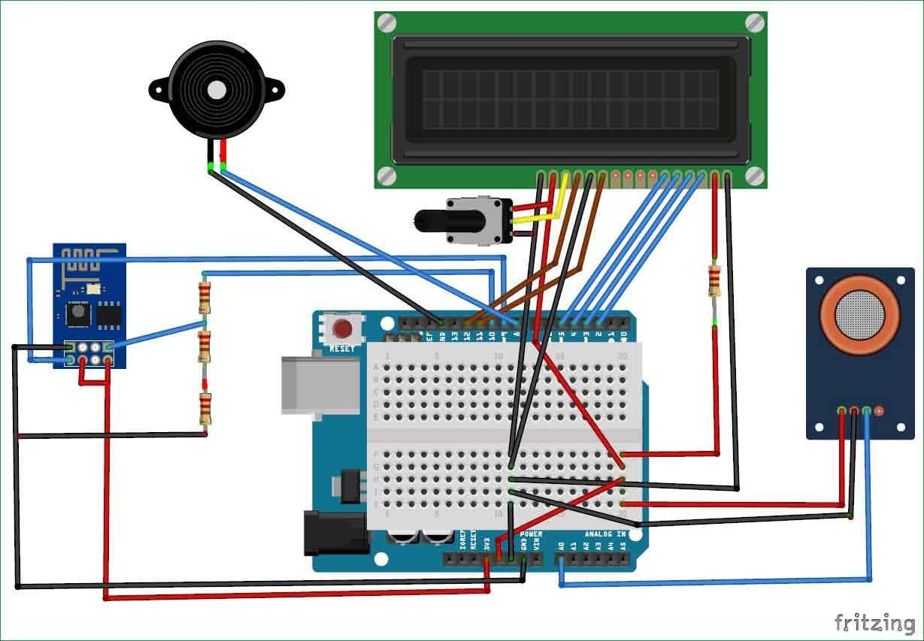

Components we are going to added:

* DHT11 or DHT22
* MQ-135
* Flame Sensor
* MQ-2

DHT11 or DHT22

These little guys are pros at measuring temperature and humidity with real accuracy. It might sound basic, but they help us understand how the air behaves and how stuff in it, like pollutants, moves around.

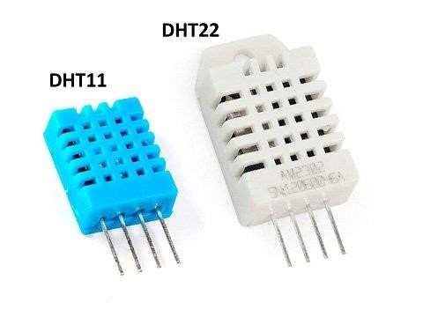

MQ-135

This one's like our superstar in gas detection. It can spot all sorts of nasty gases, from smelly ammonia to carbon dioxide and those tricky volatile organic compounds. So, we're on the ball in protecting people and the environment.

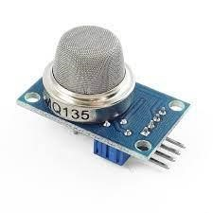

Flame Sensor

Fires can be a real headache for air quality. That's where this special sensor comes in. It's like a watchful guardian always keeping an eye out for fires. But it's not just about safety; it helps protect air quality too by giving us a heads-up and stopping nasty stuff from getting out.

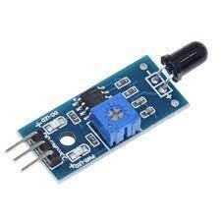

MQ-2

Think of this one as our backup for bad gases. It's really good at sniffing out things like gas leaks, smoke, and all sorts of weird-smelling stuff. With this sensor, we're double-prepared.

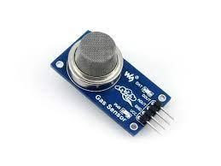

Code:

#include "MQ135.h"

#include <SoftwareSerial.h>

#define DEBUG true

SoftwareSerial esp8266(9,10); // This makes pin 9 of Arduino as RX pin and pin 10 of Arduino as the TX pin

const int sensorPin= 0;

int air_quality;

#include <LiquidCrystal.h>

LiquidCrystal lcd(12,11, 5, 4, 3, 2);

void setup() {

pinMode(8, OUTPUT);

lcd.begin(16,2);

lcd.setCursor (0,0);

lcd.print ("circuitdigest ");

lcd.setCursor (0,1);

lcd.print ("Sensor Warming ");

delay(1000);

Serial.begin(115200);

esp8266.begin(115200); // your esp's baud rate might be different

sendData("AT+RST\r\n",2000,DEBUG); // reset module

sendData("AT+CWMODE=2\r\n",1000,DEBUG); // configure as access point sendData("AT+CIFSR\r\n",1000,DEBUG); // get ip address

sendData("AT+CIPMUair_quality=1\r\n",1000,DEBUG); // configure for multiple connections

sendData("AT+CIPSERVER=1,80\r\n",1000,DEBUG); // turn on server on port 80

pinMode(sensorPin, INPUT); //Gas sensor will be an input to the arduino

lcd.clear();

}

void loop() {

MQ135 gasSensor = MQ135(A0);

float air_quality = gasSensor.getPPM();

if(esp8266.available()) // check if the esp is sending a message

{

if(esp8266.find("+IPD,"))

{

delay(1000);

int connectionId = esp8266.read()-48; /* We are subtracting 48 from the output because the read() function returns the ASCII decimal value and the first decimal number which is 0 starts at 48*/

String webpage = "<h1>IOT Air Pollution Monitoring System</h1>";

webpage += "<p><h2>";

webpage+= " Air Quality is ";

webpage+= air_quality;

webpage+=" PPM";

webpage += "<p>";

if (air_quality<=1000)

{

webpage+= "Fresh Air";

}

else if(air_quality<=2000 && air_quality>=1000)

{

webpage+= "Poor Air";

}

else if (air_quality>=2000 )

{

webpage+= "Danger! Move to Fresh Air";

}

webpage += "</h2></p></body>";

String cipSend = "AT+CIPSEND=";

cipSend += connectionId;

cipSend += ",";

cipSend +=webpage.length();

cipSend +="\r\n";

sendData(cipSend,1000,DEBUG);

sendData(webpage,1000,DEBUG);

cipSend = "AT+CIPSEND=";

cipSend += connectionId;

cipSend += ",";

cipSend +=webpage.length();

cipSend +="\r\n";

String closeCommand = "AT+CIPCLOSE=";

closeCommand+=connectionId; // append connection id

closeCommand+="\r\n";

sendData(closeCommand,3000,DEBUG);

}

}

lcd.setCursor (0, 0);

lcd.print ("Air Quality is ");

lcd.print (air_quality);

lcd.print (" PPM ");

lcd.setCursor (0,1);

if (air_quality<=1000)

{

lcd.print("Fresh Air");

digitalWrite(8, LOW);

}

else if( air_quality>=1000 && air_quality<=2000 )

{

lcd.print("Poor Air, Open Windows");

digitalWrite(8, HIGH );

}

else if (air_quality>=2000 )

{

lcd.print("Danger! Move to Fresh Air");

digitalWrite(8, HIGH); // turn the LED on

}

lcd.scrollDisplayLeft();

delay(1000);

}

String sendData(String command, const int timeout, boolean debug)

{

String response = "";

esp8266.print(command); // send the read character to the esp8266

long int time = millis();

while( (time+timeout) > millis())

{

while(esp8266.available())

{

// The esp has data so display its output to the serial window

char c = esp8266.read(); // read the next character.

response+=c;

}

}

if(debug)

{

Serial.print(response);

}

return response;

}