Ex. No. 8: Reproducing an Image Using Prompts for Image Generation
Date: 19.12.25
Reg. No: 25012066
AIM:
To demonstrate the ability of text-to-image generation tools to reproduce an existing image by crafting precise prompts. The goal is to identify key elements within the image and use these details to generate an image as close as possible to the original.
PROCEDURE:
1. Analyze the Given Image:
The image is carefully examined to identify key elements such as:
- Objects or subjects present in the image
- Dominant and contrasting colors
- Textures (smooth, rough, flat, glossy, etc.)
- Lighting conditions (bright, dim, shadows, highlights)
- Background details (indoor, outdoor, minimal, complex)
- Composition (focal point, perspective, placement)
- Overall style (realistic, minimalist, artistic, photographic)
- Create the Basic Prompt:
An initial simple prompt is written to describe the main subject and setting of the image.
- Refine the Prompt with More Detail:
Additional details such as color tones, lighting, mood, and background elements are added to improve accuracy.
- Identify Style and Artistic Influence:
The artistic or photographic style of the image is identified and explicitly mentioned in the prompt.
- Adjust and Fine-tune the Prompt:
Further refinements are made by adding details related to texture, contrast, perspective, shadows, and atmosphere.
- Generate the Image:
The refined prompt is entered into a text-to-image generation tool such as DALL·E, Stable Diffusion, or MidJourney.
- Compare the Generated Image with the Original:
The generated image is compared with the original image based on composition, color accuracy, subject placement, lighting, and style. Necessary prompt adjustments are noted.
TOOLS / LLMs FOR IMAGE GENERATION:
- DALL·E (by OpenAI): A text-to-image generation tool capable of producing detailed images from text descriptions.
- Stable Diffusion: An open-source image generation model that allows flexible and customizable outputs.
- MidJourney: A popular AI image generation tool known for artistic and cinematic visuals.
DELIVERABLES:
- The original image provided for reference
- The final generated image created using the refined prompt
- The prompts used during the experiment
- A comparison report highlighting similarities, differences, and prompt refinements

SCENARIO 1 : Reproducing a Minimalist Digital Artwork

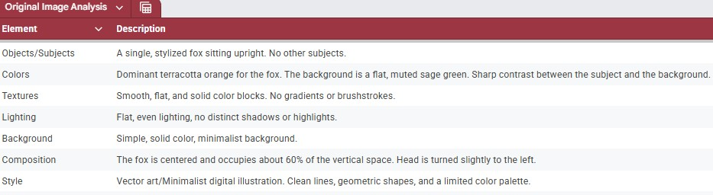

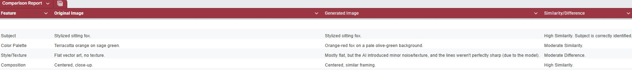

SCENARIO 2: Reproducing a High-Contrast Street Photography Scene

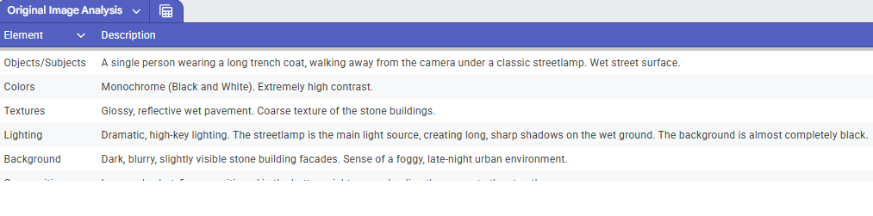

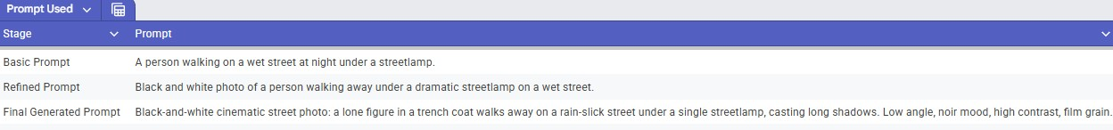

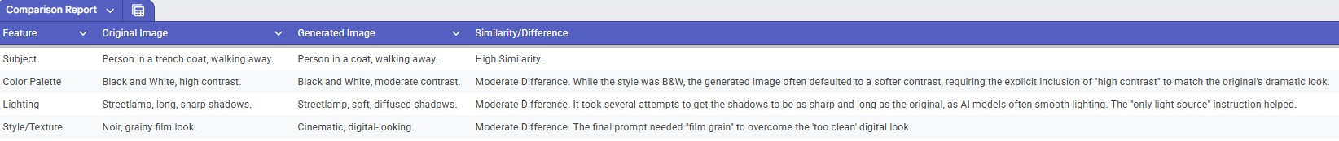
Conclusion:

By using detailed and well-crafted prompts, text-to-image generation models can be effective in reproducing an image closely. The quality of the generated image depends on how accurately the prompt describes the image's key elements. The experiment demonstrates the importance of prompt refinement and iteration when working with AI tools to achieve desired outcomes. With practice, the model can generate images that closely match real-world visuals, which is useful for creative and practical applications.

SCENARIO 1 : Reproducing a Minimalist Digital Artwork

The Final Generated Prompt: Vector art illustration of a cute, stylized fox sitting upright. The fox is a solid, flat terracotta orange color. The background is a solid, flat, muted sage green. The style must be clean, sharp, and minimalist with no shadows, textures, or gradients. Centered composition. entered composition.
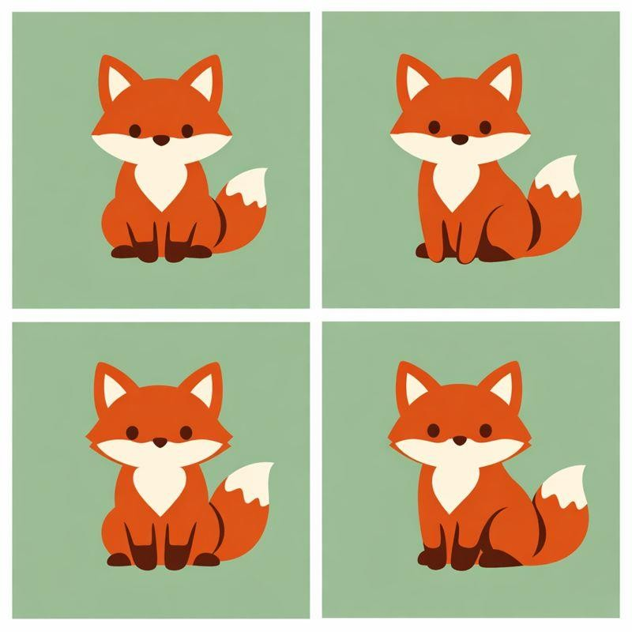

SCENARIO 2: Reproducing a HighContrast Street Photography Scene

The Final Generated Prompt: Cinematic street photography, black and white, high contrast, noir aesthetic. A lone figure in a long trench coat walks away from the camera on a rain-slicked, wet pavement. A classic urban streetlamp is the only light source, casting long, dramatic shadows. The background is dark and moody. Shot with a low angle, high-quality film grain, and a wide aperture.
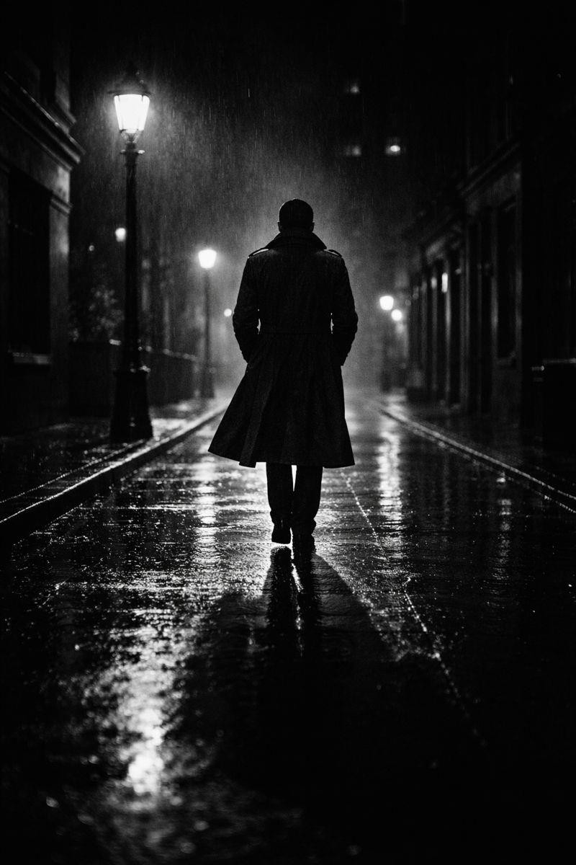

RESULT:
The prompt-based image reproduction experiment was executed successfully, and the generated images closely matched the original images using refined prompts.

