# WEEK 4: Spring REST using Spring Boot 3

## Exercise 1: Create a Spring Web Project using Maven

This exercise demonstrates how to set up a basic Spring Boot application using Maven. The main class initializes the Spring application and logs when the app starts.

### Coding:

**SpringLearnApplication.java:**

package com.cognizant.spring_learn;  
  
import org.springframework.boot.SpringApplication;  
import org.springframework.boot.autoconfigure.SpringBootApplication;  
  
@SpringBootApplication  
public class SpringLearnApplication {  
 public static void main(String[] args) {  
 System.out.println("Application starting...");  
 SpringApplication.run(SpringLearnApplication.class, args);  
 System.out.println("Application started.");  
 }  
}

### Output:

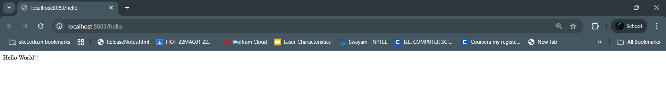

## Exercise 2: Spring Core – Load Country from Spring Configuration XML

This solution loads a Country bean from XML configuration using Spring's ApplicationContext. The loaded bean is printed in the console.

### Coding:

**Country.java:**

public class Country {  
 private String code;  
 private String name;  
 // getters and setters  
}

**SpringLearnApplication.java:**

ApplicationContext context = new ClassPathXmlApplicationContext("country.xml");  
Country country = context.getBean("country", Country.class);  
System.out.println(country);

**country.xml:**

<bean id="country" class="com.cognizant.spring_learn.Country">  
 <property name="code" value="IN"/>  
 <property name="name" value="India"/>  
</bean>

### Output:

