# WEEK 4: Spring REST using Spring Boot 3

## Exercise 3: Hello World RESTful Web Service

This exercise implements a simple REST controller that returns a 'Hello World!!' message when accessed via a GET request to `/hello`.

### Coding:

**HelloController.java:**

@RestController  
public class HelloController {  
 @GetMapping("/hello")  
 public String sayHello() {  
 return "Hello World!!";  
 }  
}

### Output:

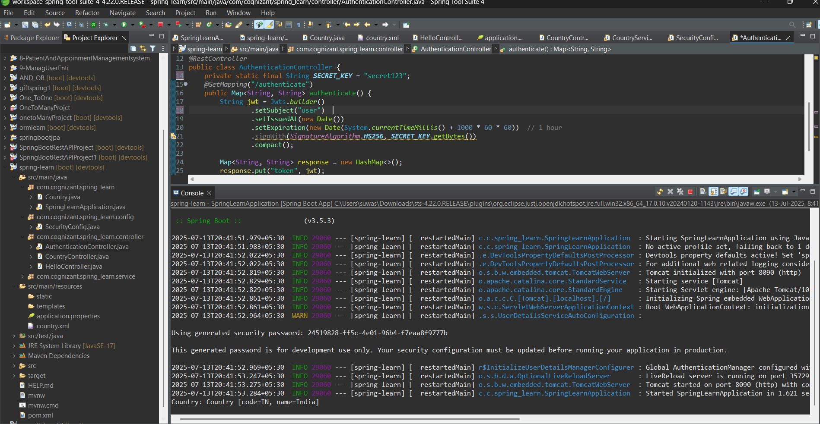

## Exercise 4: REST - Country Web Service

This solution creates a REST controller that loads a Country bean from XML and exposes it through the `/country` endpoint.

### Coding:

**CountryController.java:**

@RestController  
public class CountryController {  
 @RequestMapping("/country")  
 public Country getCountryIndia() {  
 ApplicationContext context = new ClassPathXmlApplicationContext("country.xml");  
 return context.getBean("country", Country.class);  
 }  
}

### Output:

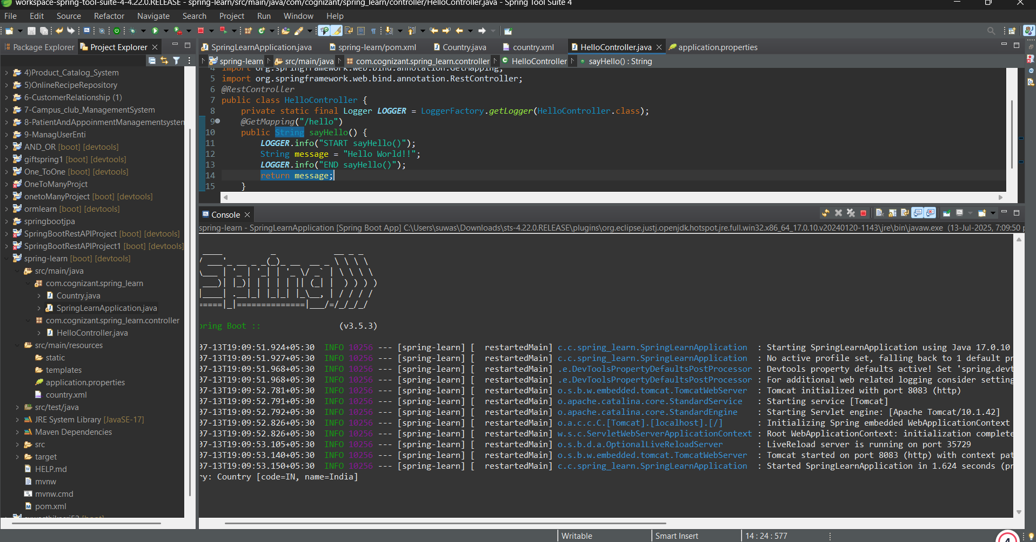

## Exercise 5: REST - Get country based on country code

This solution creates a dynamic REST endpoint that retrieves a country object by its code from a list of countries loaded from XML.

### Coding:

**CountryService.java:**

public class CountryService {  
 public Country getCountry(String code) {  
 // find country by code from list  
 }  
}

**CountryController.java:**

@GetMapping("/countries/{code}")  
public Country getCountry(@PathVariable String code) {  
 return countryService.getCountry(code);  
}

### Output:

