

University of Bahrain

College of Information Technology

Department of Computer Science

ITCS 389: Software Engineering I

Online Shopping System

**Phase Number:** 1

**Phase Title:** Project Management

**Due Date:** 15/10/2024

**Team Members:**

Project Manager:

Name 20xxXXXX

Members:

Name 20xxXXXX

Name 20xxXXXX

Name 20xxXXXX

# Table of Contents

Table of Contents 2

Chapter 1 | Project Management 3

1.1 Introduction 3

Project Overview 3

Client/Organization 3

Stakeholders 3

1.2 Background 4

Client's Business 4

Existing System 4

Business Goals 4

1.3 Problem Definition 5

Specific Issues 5

Impact analysis 5

Desired outcomes 5

1.4 Project Objectives 6

1.5 DevOps Model 7

References 7

Team Worksheet 7

# Chapter 1 | Project Management

## 1.1 Introduction

### Project Overview

The Online Shopping System is a comprehensive software designed to make it easier to purchase and sell products and services over the internet. The primary purpose of this project is to provide customers with a user-friendly, safe, seamless, and efficient online purchasing experience, as well as a strong platform for businesses to manage their online sales operations. The project's scope includes creating software that allows customers to register, explore products in the catalogue, make secure payments, track orders, and to provide customer service assistant. The main objectives are to enhance user engagement, simplify purchasing processes, and ensure data security, ultimately leading to increased sales and customer satisfaction.

### Client/Organization

The system is being developed to serve all e-commerce businesses, who are medium-sized retail businesses seeking to increase their market reach via an online platform. They aim to improve their digital presence and give customers an efficient online shopping experience in order to attract a larger audience and boost overall sales performance.

### Stakeholders

The main stakeholders in the Online Shopping System project are:

* Project Sponsors: leadership team who fund and manage the project.
* End-users: Online shoppers.
* Technical team members: developers, designers, and IT support staff members who create, test, and maintain the system.
* Marketing Team: employees who promote the online commerce platform and drives visitors to the site.
* Customer Support Team: Assists people with enquiries and difficulties relating to online purchases.

Collaboration among stakeholders will guarantee the Online buying System satisfies the demands of both the organization and its consumers, leading to a successful digital buying experience.

## 1.2 Background

### Client's Business

The client operates within the e-commerce industry, specifically targeting medium-sized retail businesses. Their operations focus on providing a wide array of products and services through an online platform, allowing customers to shop conveniently from any location. The target market includes tech-savvy consumers who value the accessibility and efficiency of online shopping, ranging from busy professionals to families seeking convenience. By utilizing digital platforms, the client aims to enhance customer engagement and foster long-term relationships with their audience.

### Existing System

Currently, the client employs a mix of manual processes and outdated software to manage their online sales. This includes basic website functionalities that do not integrate well with inventory management, payment processing, or customer service tools. Key limitations of the existing system include:

* User Experience: The current interface is not user-friendly, which can lead to customer frustration. Navigation is often cumbersome, potentially deterring purchases.
* Payment Security: Existing payment methods lack robust security features, raising concerns about data protection and customer trust.
* Order Tracking: Customers face challenges in effectively tracking their orders, resulting in increased inquiries to customer support.
* Inventory Management: Manual inventory tracking processes can lead to discrepancies, negatively impacting sales and customer satisfaction.

These inefficiencies hinder the client's ability to compete effectively in a rapidly evolving digital marketplace.

### Business Goals

The new Online Shopping System is designed to align closely with the client's overarching business goals, which include:

* Enhancing Digital Presence: By implementing a modern, user-friendly platform, the client aims to attract a broader audience and improve brand visibility.
* Increasing Sales: Streamlined purchasing processes and enhanced customer engagement are expected to drive higher conversion rates and boost overall sales performance.
* Improving Customer Satisfaction: The system will provide secure payment options, efficient order tracking, and responsive customer support, leading to a more satisfying shopping experience.
* Data Security: With a focus on security, the new system will ensure that customer data is protected, fostering trust and loyalty.

## 1.3 Problem Definition

### Specific Issues

* Complicated user interface design that does not take into account usability fundamentals
* Listed stock is not consistently updated, leading to inaccurate information about available products
* Quality of items may be inaccurately presented and (for edible products) the expiry date may be incorrect
* Delivery time is not clearly specified and/or may be incorrect
* Inefficient service quality, especially with regards to customer support, which is not always available
* Payment gateways are not always secured and/or may have bugs

### Impact analysis

* The above issues have the following negative consequences:
* Complex system interfaces are also difficult to traverse for most users; wasting their time with actions that should ideally be quick and effortless
* Mistakenly labeling unavailable products as available may cause issues with orders and therefore lead to unsatisfied customers
* Inaccurate information about the quality of products may lead to unsatisfied customers
* Incorrect delivery information may cause issues when it comes to urgent orders
* Unsecured payment gateways often lead users to fall into phishing attacks and fraudulent transactions

### Desired outcomes

* To design an easy-to-use system that helps users find their desired products with minimal time and effort
* To develop an easy to maintain system that can be easily updated with up-to-date stock and order information
* To provide users with accurate information about the system, its products, and the user’s order
* To equip the system with a satisfactory customer support service that speedily responds to users’ problems and queries
* To implement secure payment gateways that allow users to safely complete their transactions

## 1.4 Project Objectives

The project aims to achieve the following objectives by the deadline specified in the contract:

1. Integrate all business operations, such as selling products, payment, delivery, return policy, customer support, etc., into the online system to be available at any time and any place.
2. Minimize the cost and time needed by all business operations.
3. Reduce chances of mistakes by humans (customers, staff, administrators) by implementing safety measures and checks into the system.
4. Provide accurate real-time statistics for the business operations and generate readable, presentable reports.
5. Increase security of operations such as payment.
6. Faster response times to customer requests.

These project objectives are well aligned with the goals of online shopping businesses, which aim to increase the ROI and customer sales. These objectives prioritize creating an efficient system that’s easy to use and stable in the long run. The system is made to be attractive to the customer, simple to do processes through, and provides all the processes needed with minimal need for customer support. This should increase the returns of investing in this system and the sales.

## 1.5 DevOps Model

The DevOps iterative model was chosen to meet business objectives in an efficient and rapid manner. Modern tools and solutions are key for a modern system to be developed, deployed, and maintained. Since the system is intended for a quickly changing market and industry, and the fact that the business itself is fundamentally a large-scale online business; a modern and quick lifecycle such as DevOps is needed to fulfill the project objectives.[1]

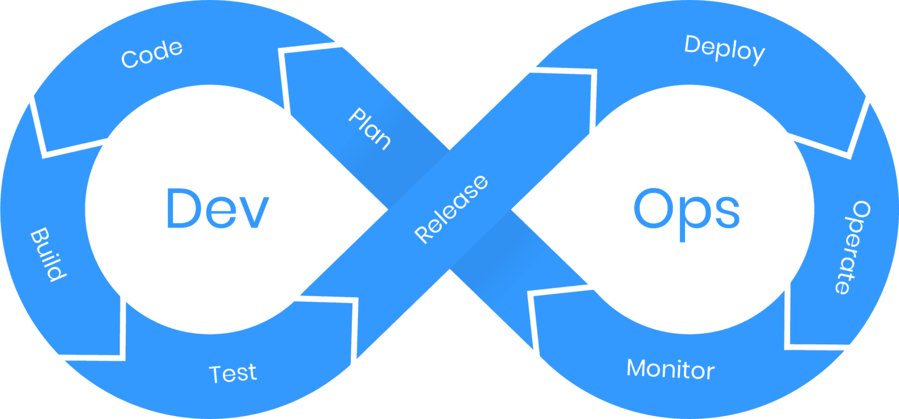

The iterative phases of the DevOps model are as follow:

1. Plan
2. Code
3. Build
4. Test
5. Release
6. Deploy
7. Operate

# References

# Team Worksheet

1. https://www.betsol.com/blog/what-is-devops/