

University of Bahrain  
College of Information Technology  
Department of Computer Science  
ITCS 389: Software Engineering I

**Online Shopping System**

**Phase Number:** 3

**Phase Title:** Object-Oriented Analysis

**Due Date:** 5/12/2024

**Team Members:**

**Project Manager:**

Shahad Yaser Abdulrahman Nassar 202210309

**Members:**

Maimoona Abdulrahman Alawadhi 202208599

Amal Abdulhameed Ahmed 202204700

Maryam Ali Jama 202107498

Table of Contents

3.1 Use Case Diagram 3

3.2 State Transition Diagram (STD) 7

3.2.1 STD for customers 7

3.2.2 STD for admins 8

3.2.3 STD for vendors 8

3.3 Class Diagram 9

3.4 Sequence Diagram 10

3.5 Activity Diagram 14

**Table of Figures**

Figure 1: UML use case diagram 3

Figure 2: **View Item** Use Case 4

Figure 3: **Checkout** Use Case 5

Figure 4: **Contact** Use Case 6

Figure 5: State transition diagram for customers 7

Figure 6: State transition diagram for admins 8

Figure 7: State transition diagram for vendors 8

Figure 8: Class diagram of the system 9

Figure 9: Sequence diagram for customer 11

Figure 10: Sequence diagram for admin 12

[Figure 11: Sequence diagram for vendor 13](https://stuuobedu-my.sharepoint.com/personal/202208599_stu_uob_edu_bh/Documents/ITCS389-ProjectPhase3.docx#_Toc184334578)

[Figure 12: **User Registration** activity diagram 14](https://stuuobedu-my.sharepoint.com/personal/202208599_stu_uob_edu_bh/Documents/ITCS389-ProjectPhase3.docx#_Toc184334579)

[Figure 13: **Ordering** activity diagram 15](https://stuuobedu-my.sharepoint.com/personal/202208599_stu_uob_edu_bh/Documents/ITCS389-ProjectPhase3.docx#_Toc184334580)

# 3.1 Use Case Diagram

A UML (Unified Modeling Language) use case diagram visually represents the interactions between users (actors) and a system, illustrating the system's functionalities (use cases) and how users engage with them. It helps identify the requirements and scope of the system.

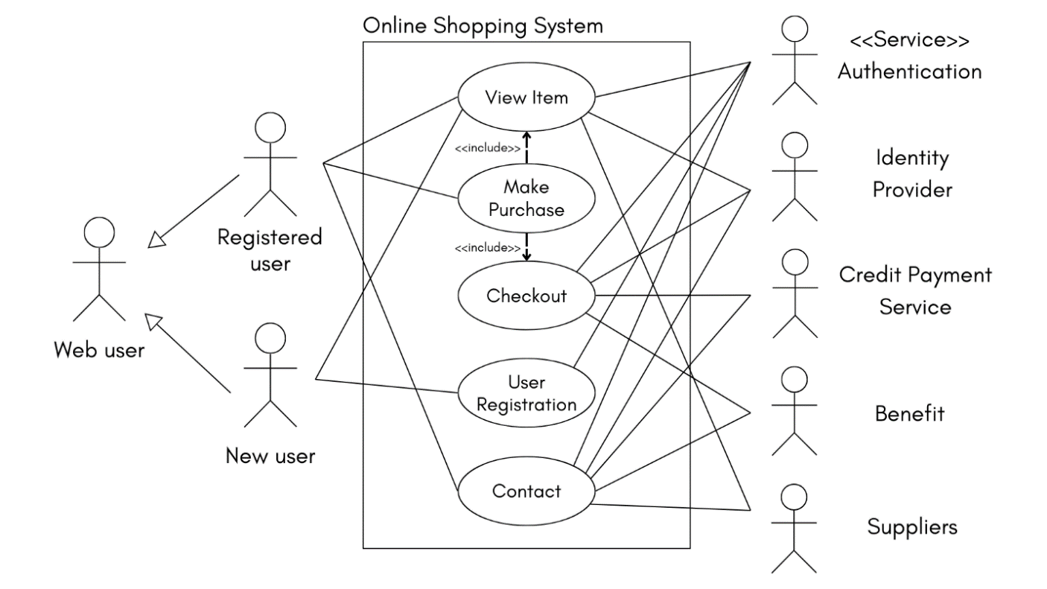

Figure 1: UML use case diagram

It represents the use case diagram of an online shopping system. It represents one of the main actors, the customer. A new customer can view items but if he wants to buy, he must register. A previously registered customer can browse items, add to cart, proceed to checkout and payment, and contact the concerned parties in case query or error.

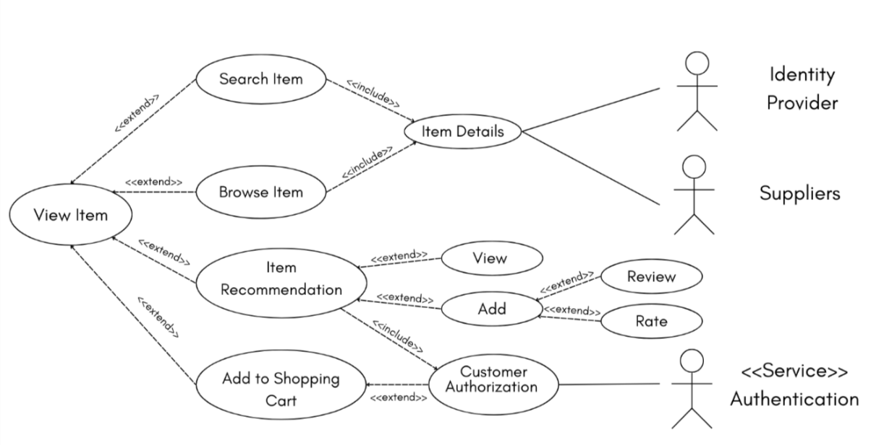

Figure 2: **View Item** Use Case

The figure shows that the customer can search or browse for an item, add a recommendation, view a previous recommendation, and add an item to the shopping cart.

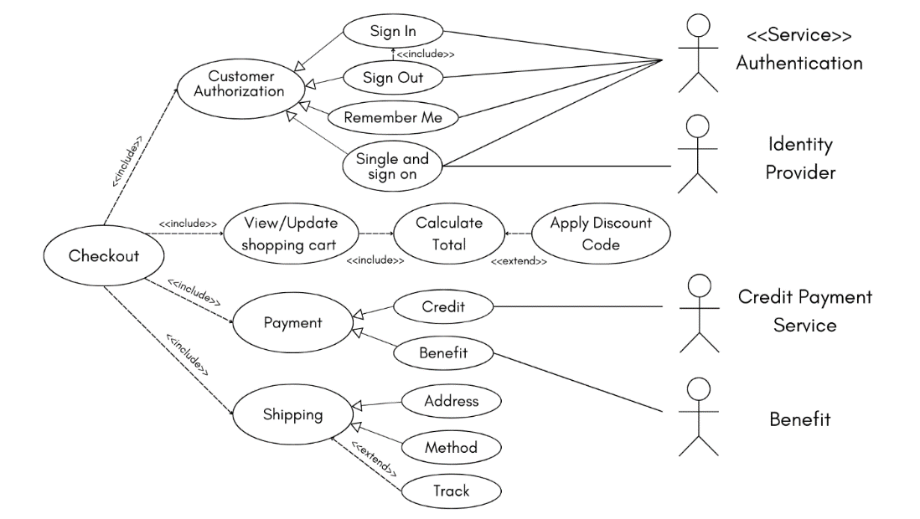

Figure 3: **Checkout** Use Case

The Figure shows that the customer should be registered to update the shopping cart and apply a discount code to calculate the total amount. Also, the customer can choose the payment and shipping method, and he can track his order.

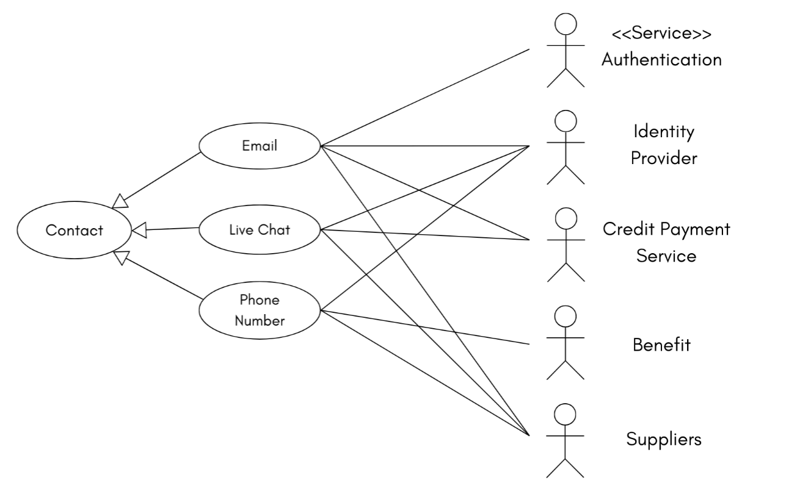

Figure 4: **Contact** Use Case

The figure shows that the customer can contact any of the parties concerned to get the necessary assistance and answers to inquiries.

# 3.2 State Transition Diagram (STD)

The diagram of the state machine is a behavior diagram that illustrates discrete behavior by finite state transformations of a portion of designed system.

## 3.2.1 STD for customers

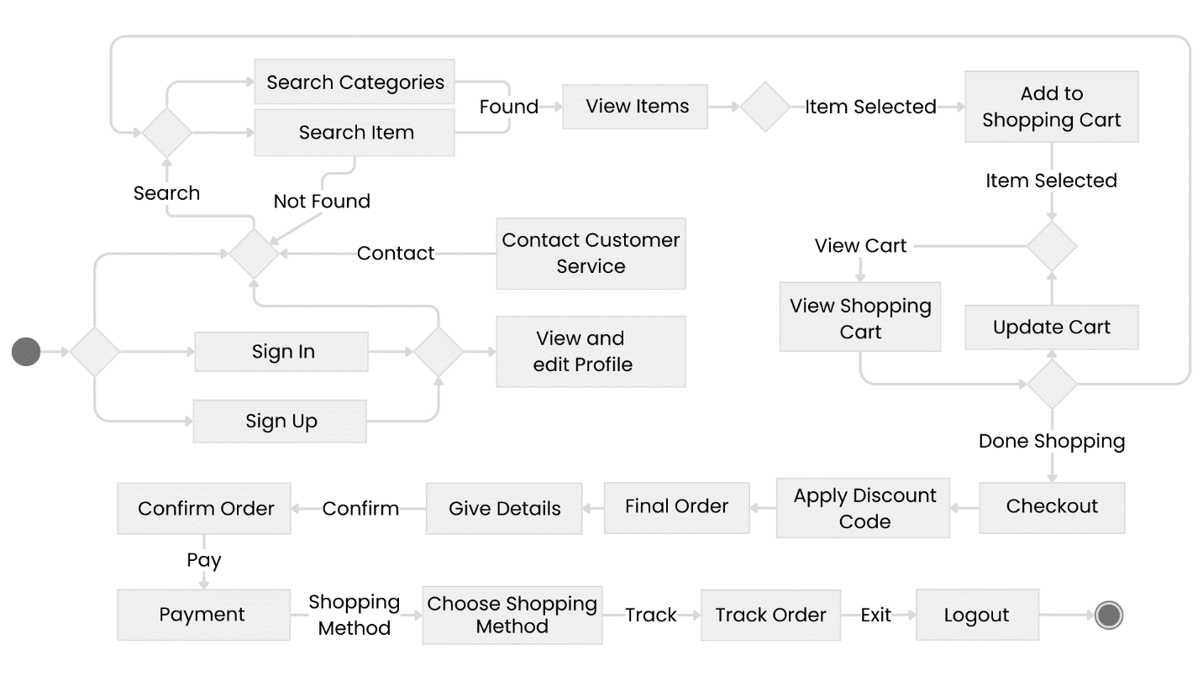

Figure 5: State transition diagram for customers

## 3.2.2 STD for admins

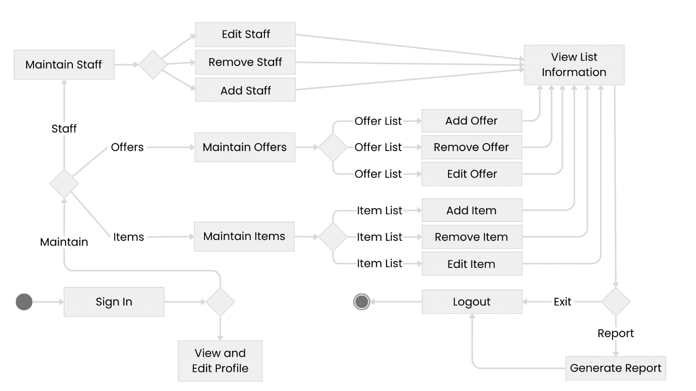

Figure 6: State transition diagram for admins

## 3.2.3 STD for vendors

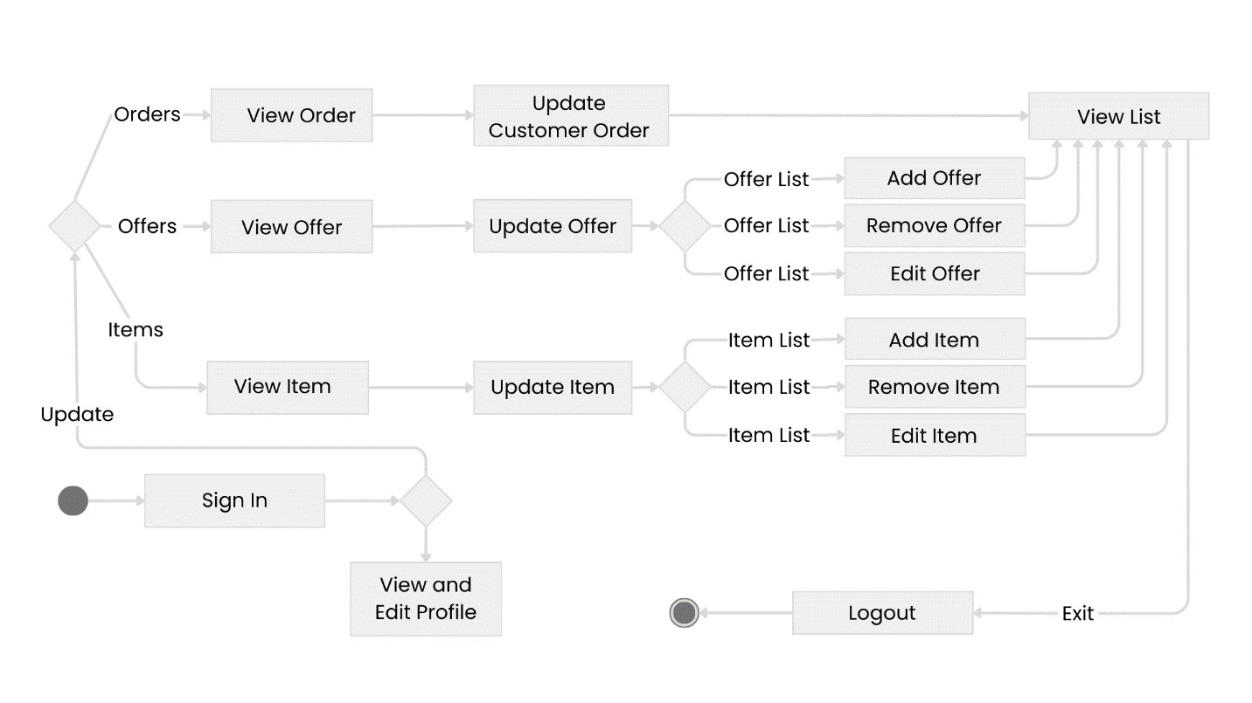

Figure 7: State transition diagram for vendors

# 3.3 Class Diagram

The system will follow an object-oriented design, this means that the primary drivers of the system functionalities will be objects constructed from classes.

The following class diagram (Figure 8) illustrates the structure of this system.

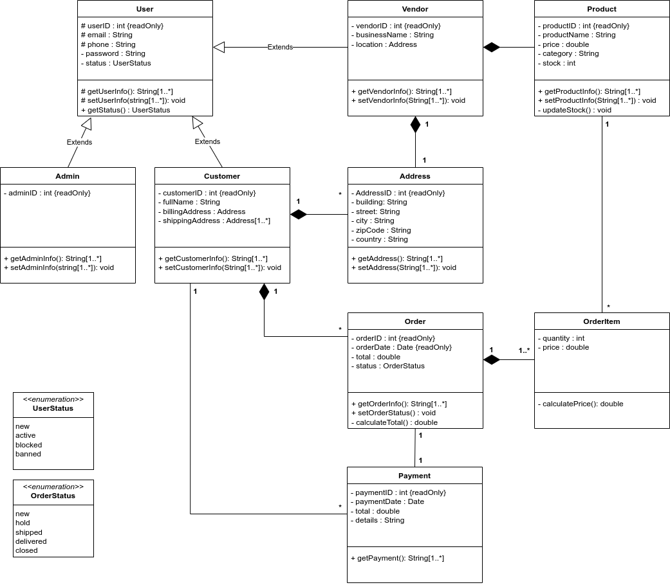

Figure 8: Class diagram of the system

# 3.4 Sequence Diagram

The sequence diagram is an interaction diagram that illustrates the sequence of messages between objects. It consists of a group of objects that are represented by lifelines, and the messages that they exchange over time during the interaction.

**3.4.1 Customers Sequence Diagram**

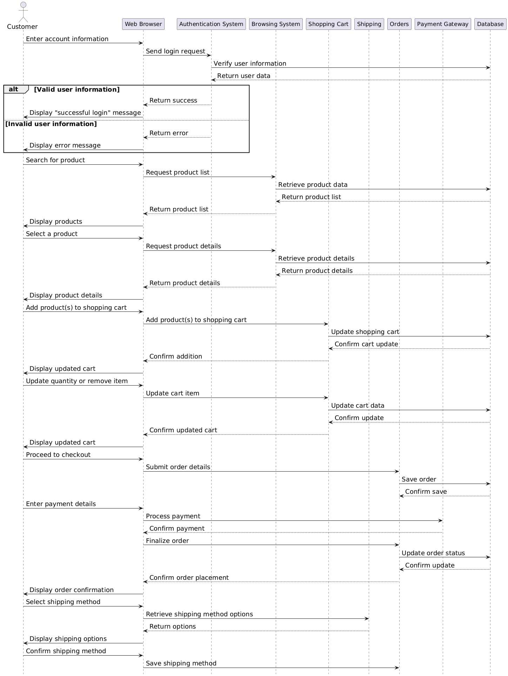

Figure : Sequence diagram for customer

**3.4.2 Admins Sequence Diagram**

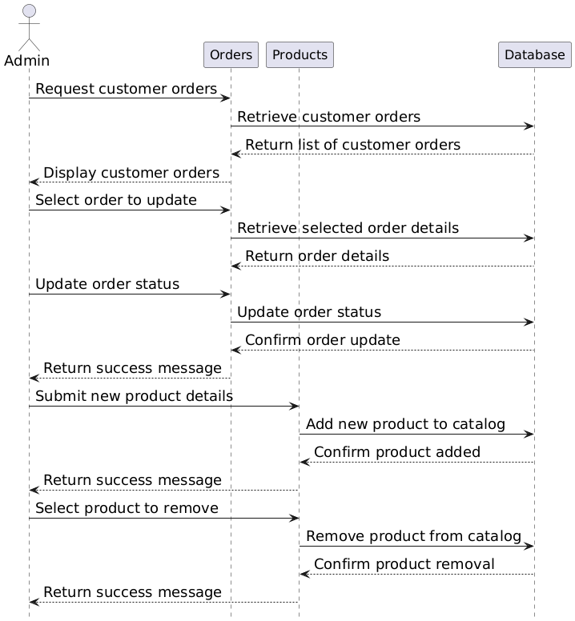

Figure : Sequence diagram for admin

**3.4.1 Vendors Sequence Diagram**

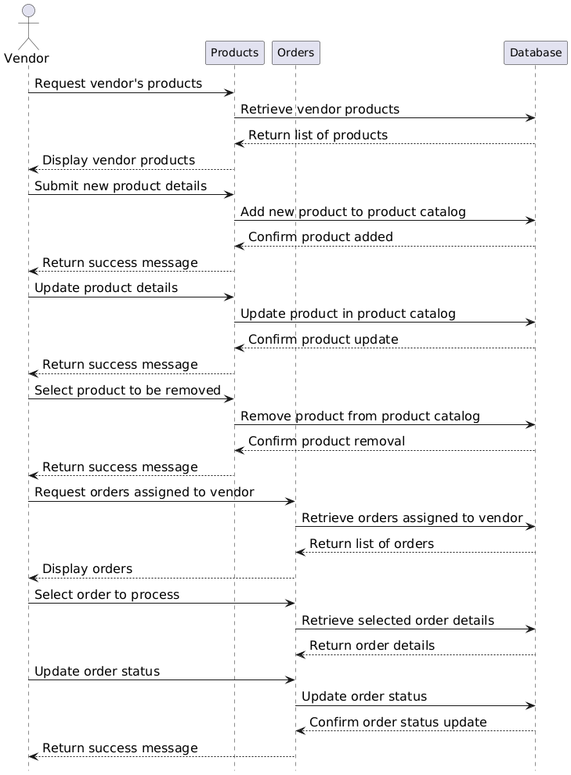

Figure : Sequence diagram for vendor

# 3.5 Activity Diagram

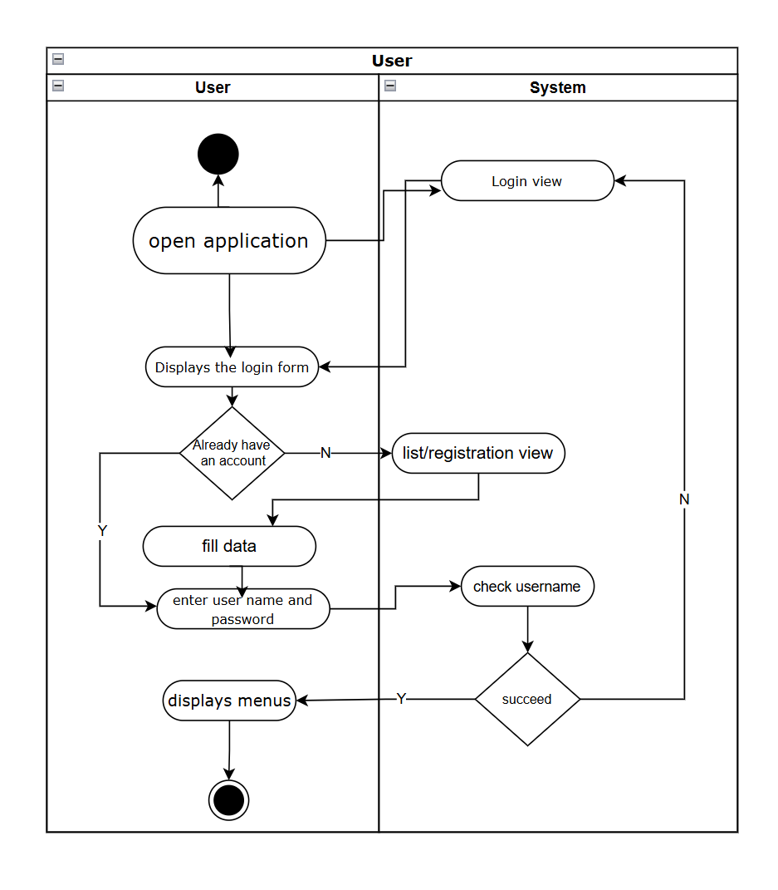

Figure : **User Registration** activity diagram

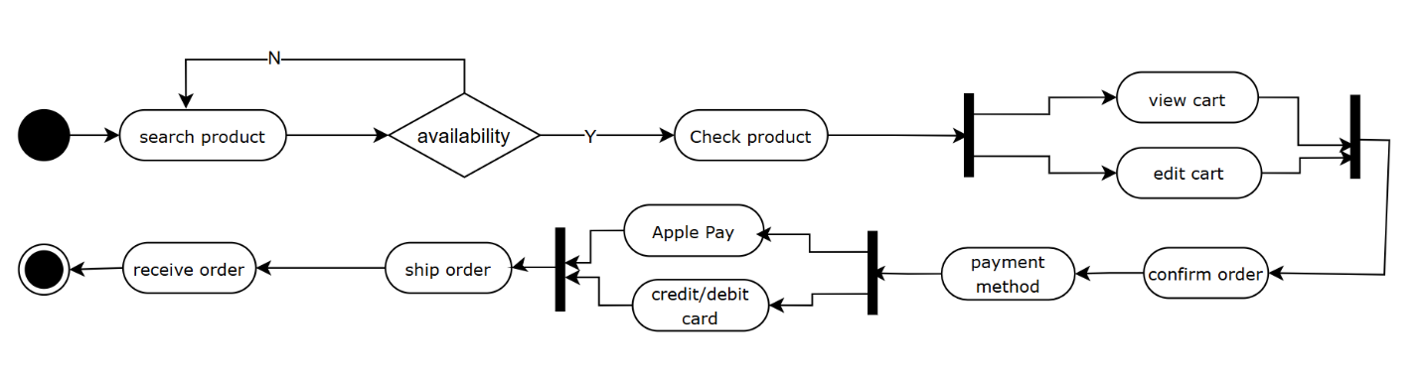

Figure : **Ordering** activity diagram