Design and Analysis of Algorithm
Saikrishna N
CH.SC.U4CSE24244
- BFS
Code:
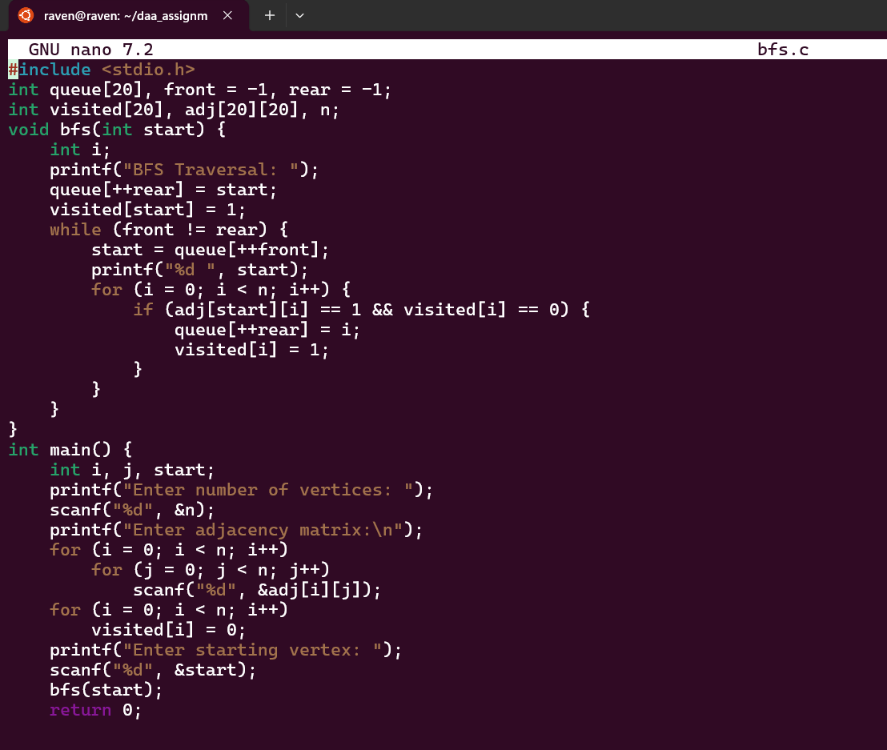

Output:
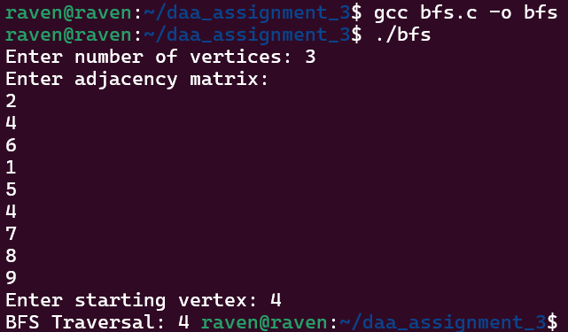

Time Complexity: O(n^2)
My interpretation:
To solve the problem of traversing a graph level by level, I decided to use the Breadth First Search (BFS) algorithm. Since BFS processes vertices in the order they are discovered, a queue data structure is suitable to maintain this order. The graph is represented using an adjacency matrix, which makes it easy to check whether an edge exists between two vertices. I also used a visited array to ensure that each vertex is processed only once and to avoid infinite loops in cyclic graphs. The algorithm begins by inserting the starting vertex into the queue and marking it as visited. Then, while the queue is not empty, each vertex is dequeued, printed, and all its unvisited adjacent vertices are added to the queue. This approach ensures that nodes are explored level by level, which is the key idea behind BFS traversal.

- DFS
Code:
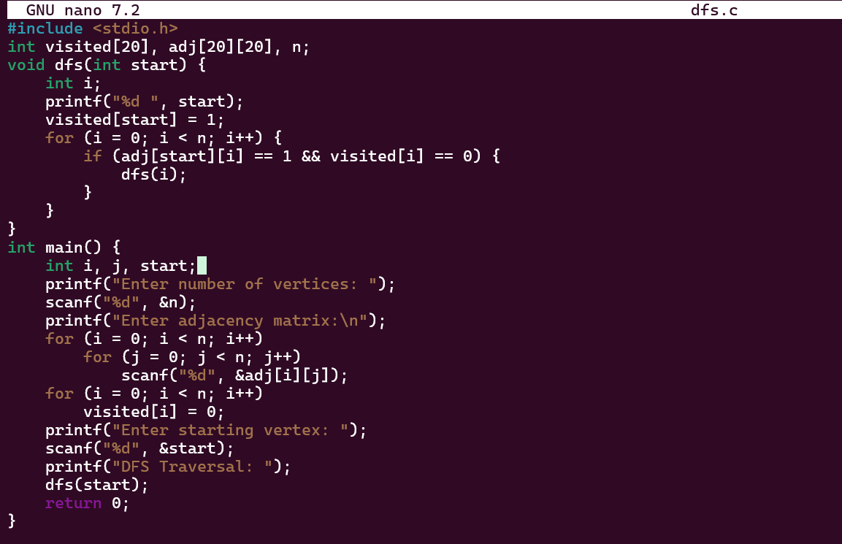

Output:
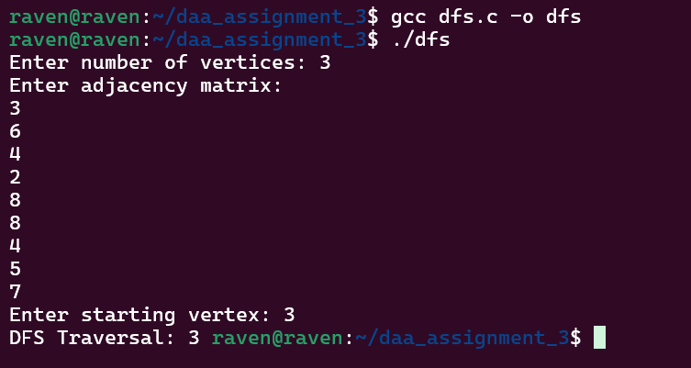

Time Complexity: O(n^2)
My interpretation:
To traverse the graph deeply before exploring other branches, I chose the Depth First Search (DFS) algorithm. The idea was to start from a given vertex and continue visiting its adjacent vertices as far as possible before backtracking. Since DFS naturally follows a recursive pattern, recursion was used to simplify the implementation. The graph is represented using an adjacency matrix, which allows easy checking of whether two vertices are connected. A visited array is maintained to keep track of the vertices that have already been explored and to prevent revisiting the same node. The algorithm prints the current vertex, marks it as visited, and then recursively calls DFS for each unvisited adjacent vertex. This process continues until all reachable vertices from the starting node are explored, effectively performing a depth-wise traversal of the graph.

