Design and Analysis of Algorithms
Saikrishna N
CH.SC.U4CSE24244
- RedBlack Tree
Code:
#include <stdio.h>
#include <stdlib.h>

enum Color {RED, BLACK};

struct Node {
int data;
int color;
struct Node *left, *right, *parent;
};

struct Node* root = NULL;

void leftRotate(struct Node *x) {
struct Node *y = x->right;
x->right = y->left;
if (y->left != NULL) y->left->parent = x;
y->parent = x->parent;
if (x->parent == NULL) root = y;
else if (x == x->parent->left) x->parent->left = y;
else x->parent->right = y;
y->left = x;
x->parent = y;
}

void rightRotate(struct Node *x) {
struct Node *y = x->left;
x->left = y->right;
if (y->right != NULL) y->right->parent = x;
y->parent = x->parent;
if (x->parent == NULL) root = y;
else if (x == x->parent->right) x->parent->right = y;
else x->parent->left = y;
y->right = x;
x->parent = y;
}

void fixViolation(struct Node *pt) {
struct Node *parent_pt = NULL;
struct Node *grand_parent_pt = NULL;

while ((pt != root) && (pt->color != BLACK) && (pt->parent->color == RED)) {
parent_pt = pt->parent;
grand_parent_pt = pt->parent->parent;

if (parent_pt == grand_parent_pt->left) {
struct Node *uncle_pt = grand_parent_pt->right;
if (uncle_pt != NULL && uncle_pt->color == RED) {
grand_parent_pt->color = RED;
parent_pt->color = BLACK;
uncle_pt->color = BLACK;
pt = grand_parent_pt;
} else {
if (pt == parent_pt->right) {
leftRotate(parent_pt);
pt = parent_pt;
parent_pt = pt->parent;
}
rightRotate(grand_parent_pt);
int t = parent_pt->color;
parent_pt->color = grand_parent_pt->color;
grand_parent_pt->color = t;
pt = parent_pt;
}
} else {
struct Node *uncle_pt = grand_parent_pt->left;
if ((uncle_pt != NULL) && (uncle_pt->color == RED)) {
grand_parent_pt->color = RED;
parent_pt->color = BLACK;
uncle_pt->color = BLACK;
pt = grand_parent_pt;
} else {
if (pt == parent_pt->left) {
rightRotate(parent_pt);
pt = parent_pt;
parent_pt = pt->parent;
}
leftRotate(grand_parent_pt);
int t = parent_pt->color;
parent_pt->color = grand_parent_pt->color;
grand_parent_pt->color = t;
pt = parent_pt;
}
}
}
root->color = BLACK;
}

void insert(const int data) {
struct Node *pt = (struct Node*)malloc(sizeof(struct Node));
pt->data = data;
pt->color = RED;
pt->left = pt->right = pt->parent = NULL;

if (root == NULL) {
pt->color = BLACK;
root = pt;
return;
}

struct Node *curr = root, *parent = NULL;
while (curr != NULL) {
parent = curr;
if (pt->data < curr->data) curr = curr->left;
else curr = curr->right;
}
pt->parent = parent;
if (pt->data < parent->data) parent->left = pt;
else parent->right = pt;

fixViolation(pt);
}

void inorder(struct Node *n) {
if (n == NULL) return;
inorder(n->left);
printf("%d(%s) ", n->data, n->color == RED ? "R" : "B");
inorder(n->right);
}

int main() {
int n, val;
printf("Enter number of elements to insert in RB Tree: ");
scanf("%d", &n);
printf("Enter elements:\n");
for(int i = 0; i < n; i++) {
scanf("%d", &val);
insert(val);
}
printf("Inorder Traversal (Sorted with Colors): \n");
inorder(root);
printf("\n");
return 0;
}

Output:
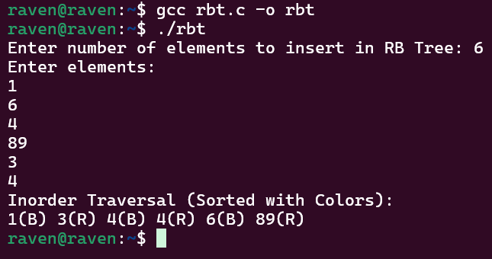

Time complexity: O(n)
My interpretation:
To maintain a balanced binary search tree while inserting elements, I implemented a Red-Black Tree, which is a self-balancing BST. The idea is to insert elements similar to a normal BST, where smaller values go to the left and larger values go to the right. Each node is assigned a color (Red or Black), which helps maintain balance in the tree. After inserting a new node, it is initially colored red, and the tree may temporarily violate Red-Black properties. To fix this, the fixViolation() function checks the relationship between the node, its parent, and its uncle. Depending on the situation, the algorithm performs recoloring or tree rotations (leftRotate and rightRotate) to restore the Red-Black rules. These operations ensure that the tree remains approximately balanced, keeping its height small. Finally, an inorder traversal is used to display the elements in sorted order along with their colors.

- QuickSelect
Code:
#include <stdio.h>

void swap(int* a, int* b) {
int t = *a; *a = *b; *b = t;
}

int partition(int arr[], int l, int r) {
int x = arr[r], i = l;
for (int j = l; j <= r - 1; j++) {
if (arr[j] <= x) {
swap(&arr[i], &arr[j]);
i++;
}
}
swap(&arr[i], &arr[r]);
return i;
}

int quickSelect(int arr[], int l, int r, int k) {
if (k > 0 && k <= r - l + 1) {
int index = partition(arr, l, r);

if (index - l == k - 1)
return arr[index];
if (index - l > k - 1)
return quickSelect(arr, l, index - 1, k);

return quickSelect(arr, index + 1, r, k - index + l - 1);
}
return -1;
}

int main() {
int arr[] = {10, 4, 5, 8, 6, 11, 26};
int n = sizeof(arr) / sizeof(arr[0]);
int k = 3;
printf("Array: 10 4 5 8 6 11 26\n");
printf("The %d-th smallest element is %d\n", k, quickSelect(arr, 0, n - 1, k));
return 0;
}

Output:
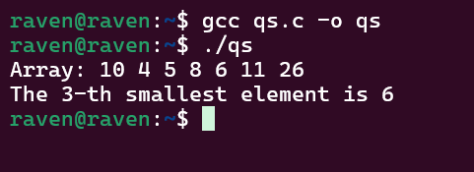

Time Complexity: O(n^2)

My interpretation:
To find the k-th smallest element efficiently without fully sorting the array, I used the QuickSelect algorithm, which is based on the partitioning idea of Quick Sort. The approach begins by selecting a pivot element (in this case, the last element of the array) and rearranging the array using the partition() function so that elements smaller than the pivot are placed on its left and larger elements on its right. After partitioning, the pivot reaches its correct sorted position in the array. If this position matches the required k-th index, the pivot itself is the answer. Otherwise, the algorithm recursively continues the search only in the relevant subarray (left or right side of the pivot). This reduces unnecessary work because only part of the array is processed instead of sorting the entire array. Thus, the method efficiently identifies the required element using a divide-and-conquer strategy.

3)Quick sort with different Pivot choices
Code:
#include <stdio.h>

void swap(int* a, int* b) {
int t = *a; *a = *b; *b = t;
}

// Standard partition using the LAST element as pivot
int partition(int arr[], int low, int high) {
int pivot = arr[high];
int i = (low - 1);
for (int j = low; j <= high - 1; j++) {
if (arr[j] < pivot) {
i++;
swap(&arr[i], &arr[j]);
}
}
swap(&arr[i + 1], &arr[high]);
return (i + 1);
}

// 1. Pivot = Last Element
void quickSortLast(int arr[], int low, int high) {
if (low < high) {
int pi = partition(arr, low, high);
quickSortLast(arr, low, pi - 1);
quickSortLast(arr, pi + 1, high);
}
}

// 2. Pivot = First Element
void quickSortFirst(int arr[], int low, int high) {
if (low < high) {
swap(&arr[low], &arr[high]); // Move first to last, then partition
int pi = partition(arr, low, high);
quickSortFirst(arr, low, pi - 1);
quickSortFirst(arr, pi + 1, high);
}
}

// 3. Pivot = Middle Element
void quickSortMid(int arr[], int low, int high) {
if (low < high) {
int mid = low + (high - low) / 2;
swap(&arr[mid], &arr[high]); // Move mid to last, then partition
int pi = partition(arr, low, high);
quickSortMid(arr, low, pi - 1);
quickSortMid(arr, pi + 1, high);
}
}

void printArray(int arr[], int size) {
for (int i = 0; i < size; i++) printf("%d ", arr[i]);
printf("\n");
}

int main() {
int arr1[] = {10, 7, 8, 9, 1, 5};
int arr2[] = {10, 7, 8, 9, 1, 5};
int arr3[] = {10, 7, 8, 9, 1, 5};
int n = 6;

quickSortLast(arr1, 0, n - 1);
printf("Sorted using LAST element as pivot: ");
printArray(arr1, n);

quickSortFirst(arr2, 0, n - 1);
printf("Sorted using FIRST element as pivot: ");
printArray(arr2, n);

quickSortMid(arr3, 0, n - 1);
printf("Sorted using MIDDLE element as pivot: ");
printArray(arr3, n);

return 0;
}

Output:
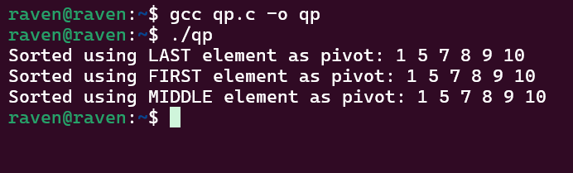

Time Complexity: O(n^2)

My interpretation:
To study how pivot selection affects Quick Sort, I implemented three variations where the pivot is chosen as the last element, first element, and middle element. The core idea remains the same: use the partitioning technique to place the pivot in its correct sorted position while arranging smaller elements to its left and larger elements to its right. For the first and middle pivot cases, the selected pivot is temporarily swapped with the last element so that the same partition() function can be reused. After partitioning, the array is divided into two smaller subarrays, and the Quick Sort algorithm is applied recursively to both halves. This process continues until all subarrays are sorted. By comparing these three approaches, we can observe how pivot choice can influence the performance and efficiency of Quick Sort.

