Design and Analysis of Algorithm
Assignment-1
Saikrishna N
CH.SC.U4CSE24244
- Write a program to find the sum of n natural using a user defined function
CODE:
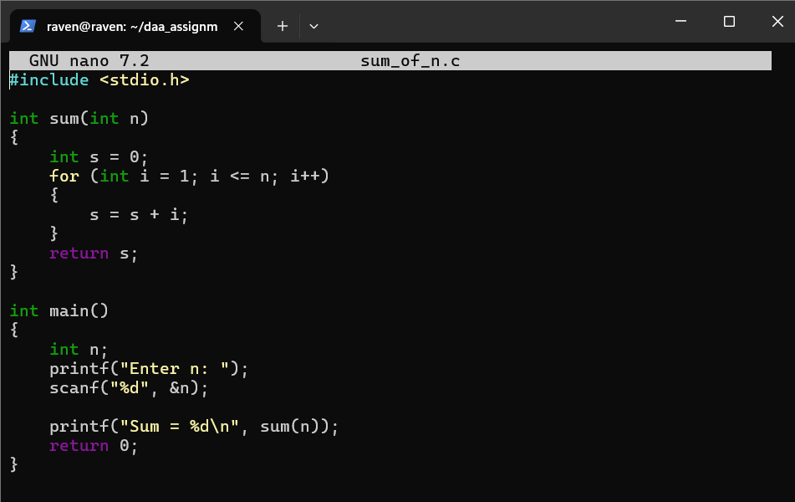

OUTPUT:
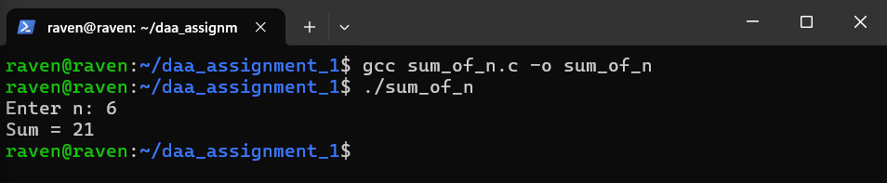
TIME COMPLEXITY: O(n)
MY INTERPRETATION:
The problem asks to add all numbers from 1 up to n.
A loop is the easiest way because it lets you go through each number one by one.
A variable is used to store the running total while the loop keeps adding new values.
A user-defined function helps keep the logic separate and neat.
The loop starts at 1, ends at n, and keeps increasing by 1 each time.
Each value gets added to the total inside the function.
When the loop finishes, the total is returned back to the main program.

- Write a program to find the sum of squares of first n natural numbers using user-defined function.
CODE: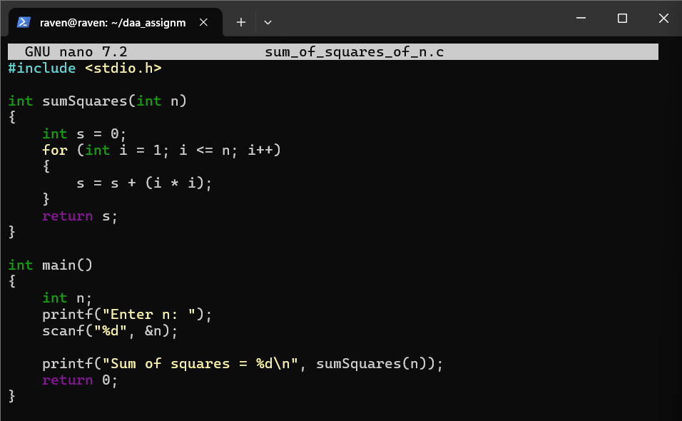

OUTPUT:
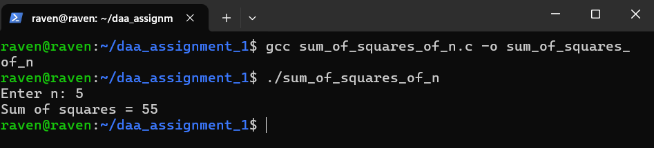
TIME COMPLEXITY: O(n)
MY INTERPRETATION:
This is similar to the first problem, but instead of adding the number, we add its square.
A loop from 1 to n allows easy calculation of i * i for each number.
A variable stores the total sum of all squares.
A user-defined function organizes the calculation nicely.
Each loop step calculates the square and adds it to the sum.
The function finishes when the loop reaches n.
Finally, the function returns the total square-sum.

- Write a program to find the sum of cubes of first n natural numbers using user-defined function.
CODE:
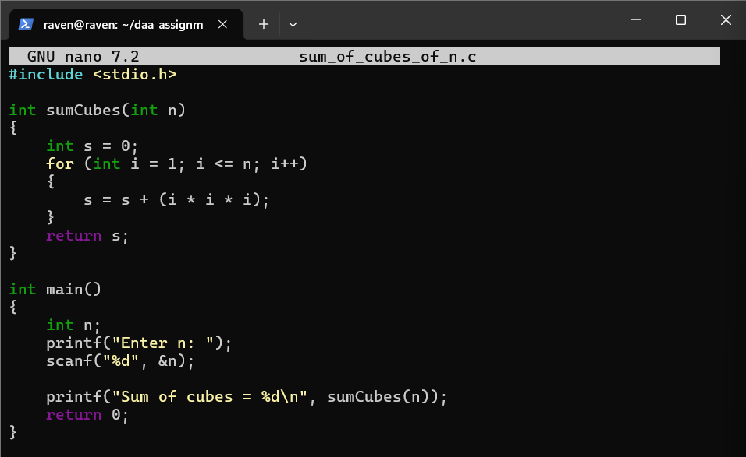

OUTPUT:
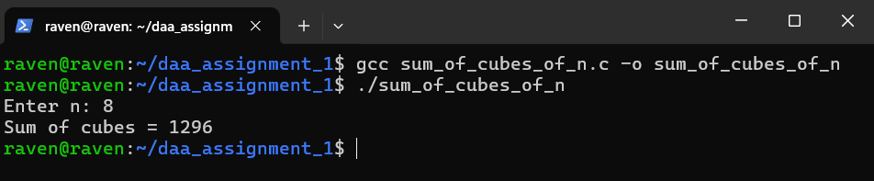

TIME COMPLEXITY: O(n)

MY INTERPRETATION:
Again, the structure matches the previous two problems.
A loop is used to go from 1 to n in order.
Inside the loop, the cube of each number is calculated using i * i * i.
A running sum variable keeps track of all cubes added together.
A user-defined function makes the logic clean.
The loop gradually builds the answer by adding each cube.
The resulting total is returned after all cubes are processed.

- Write a program to find factorial of a natural number using recursive function.
CODE:
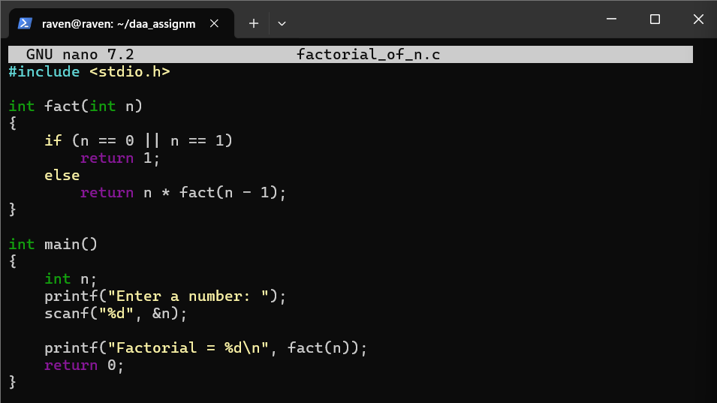

OUTPUT:
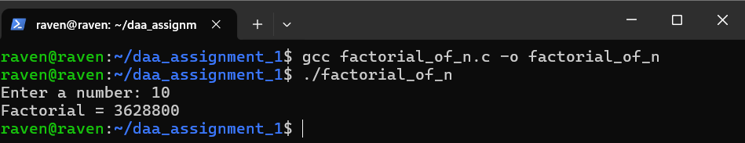

TIME COMPLEXITY: O(n)
MY INTERPRETATION:
Factorial is based on the mathematical rule: n! = n * (n-1)!.
Recursion fits this rule naturally because a function can call itself.
A base case is important to stop the recursion when n becomes 0 or 1.
Each recursive call reduces the value of n by 1.
The function keeps multiplying numbers as it returns back through the calls.
Recursive thinking helps understand how the result is built step by step.
The final result comes after all recursive calls complete.

- Write a program to transpose a 3×3 matrix.
CODE:
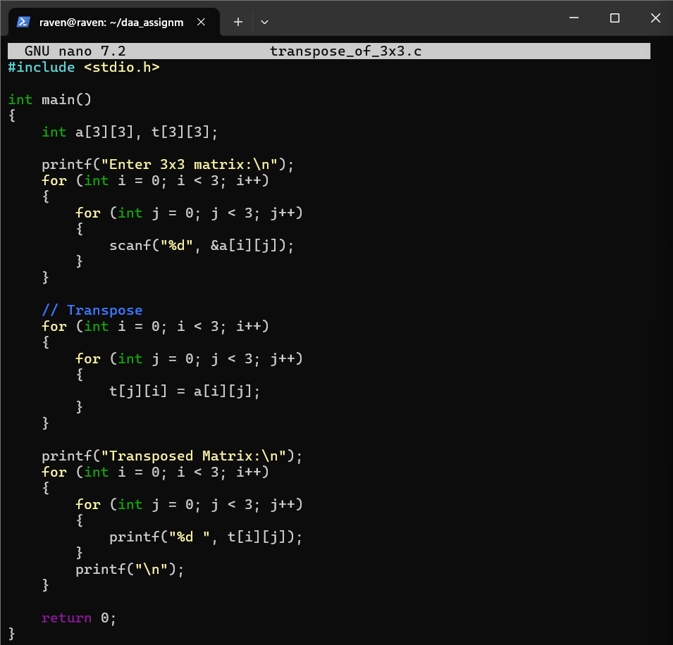

OUTPUT:
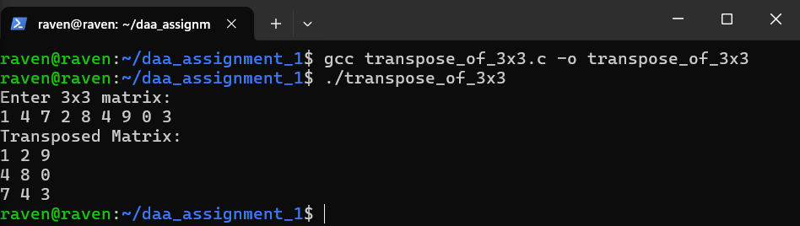

TIME COMPLEXITY: O(1)
MY INTERPRETATION:
A 3×3 matrix has rows and columns that need to be swapped for the transpose.
Nested loops are the simplest way to access every element in the matrix.
The element at position (i, j) becomes (j, i) in the transpose.
Storing the result in a second matrix keeps the process simple.
This swapping of row and column positions is repeated for all 9 elements.
A small fixed-size matrix makes the logic straightforward.
Finally, the transposed matrix is printed row by row.

- Write a program to print the Fibonacci series up to a given number using user-defined function (for first n natural numbers).
CODE:
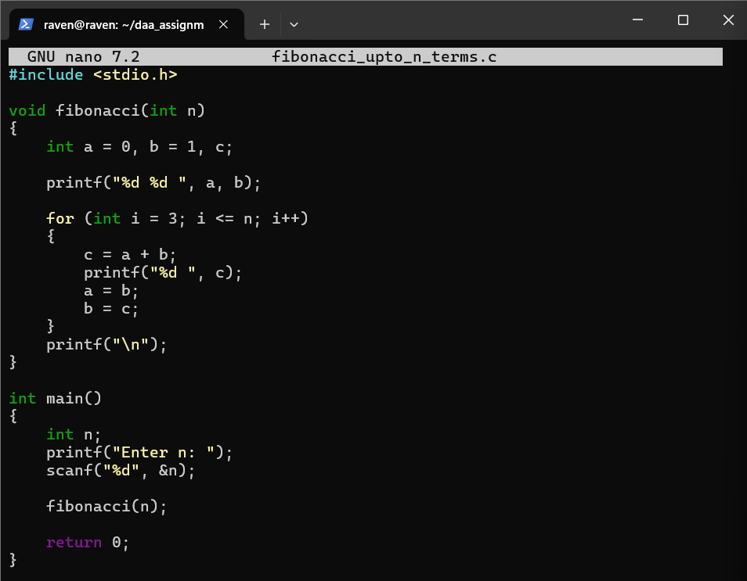

OUTPUT:
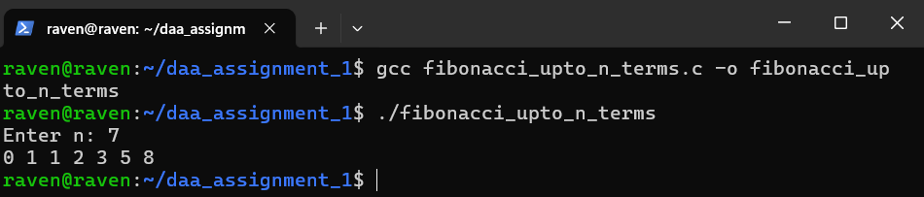

TIME COMPLEXITY: O(n)
MY INTERPRETATION:
The first two Fibonacci numbers are always 0 and 1.
Each new number is found by adding the two previous numbers together.
Two variables keep track of the last two values in the sequence.
A loop starts generating new terms one by one.
Each iteration updates the variables to move forward in the sequence.
The newly generated number is printed immediately.
This continues until all n terms are produced.

Design and Analysis of Algorithm
Assignment-2
Saikrishna N
CH.SC.U4CSE24244
- BUBBLE SORT
CODE:
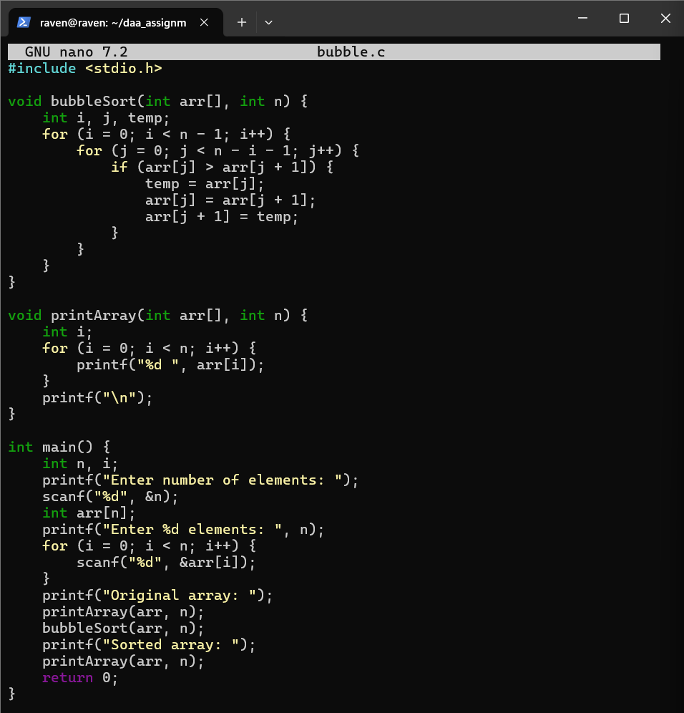
OUTPUT:
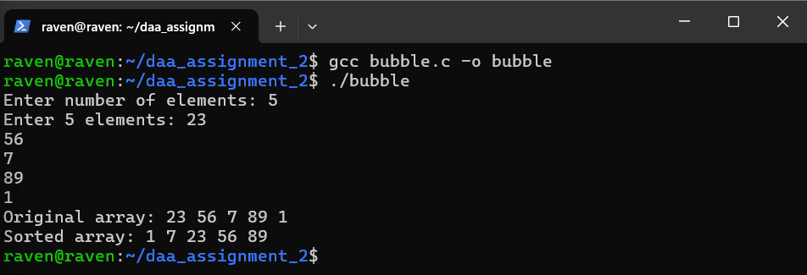

TIME COMPLEXITY: O(n²)

MY INTERPRETATION:
Bubble sort works by comparing two adjacent elements at a time and swapping them if they are in the wrong order. This process repeats for every pair of adjacent elements in the array, moving the largest element to the end after each complete pass. The algorithm keeps making these passes through the array until no more swaps are needed, which means the array is sorted. The name comes from how larger values "bubble up" to the end of the array.

- INSERTION SORT
CODE:
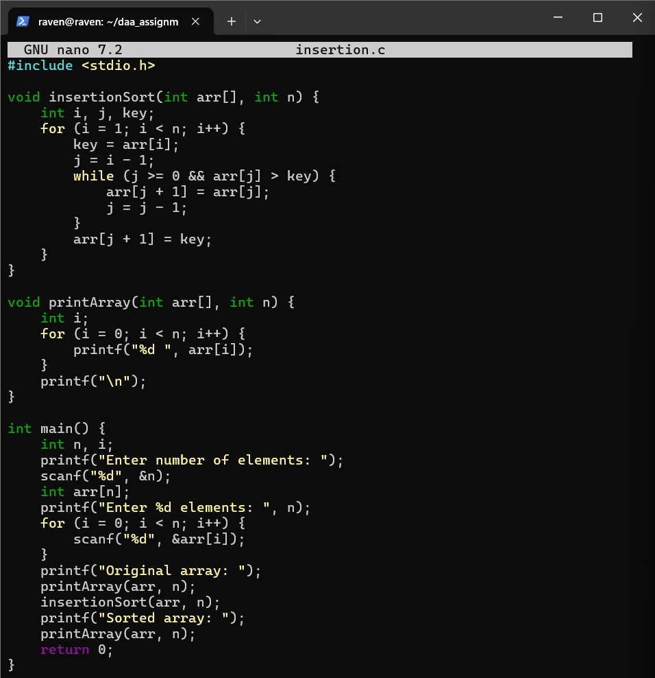

OUTPUT:
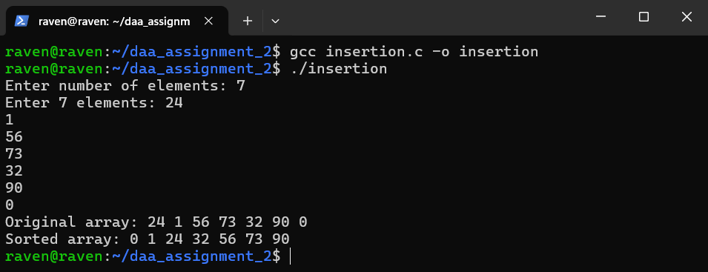

TIME COMPLEXITY: O(n²)

MY INTERPRETATION:
Insertion sort builds the sorted array one element at a time by taking each element and finding its correct position in the already sorted portion. It starts with the second element and compares it with elements before it, shifting them to the right until the correct spot is found. This is similar to how we sort playing cards in our hands - we pick a card and insert it into its proper place among the cards we've already arranged.

- BUCKET SORT
CODE:
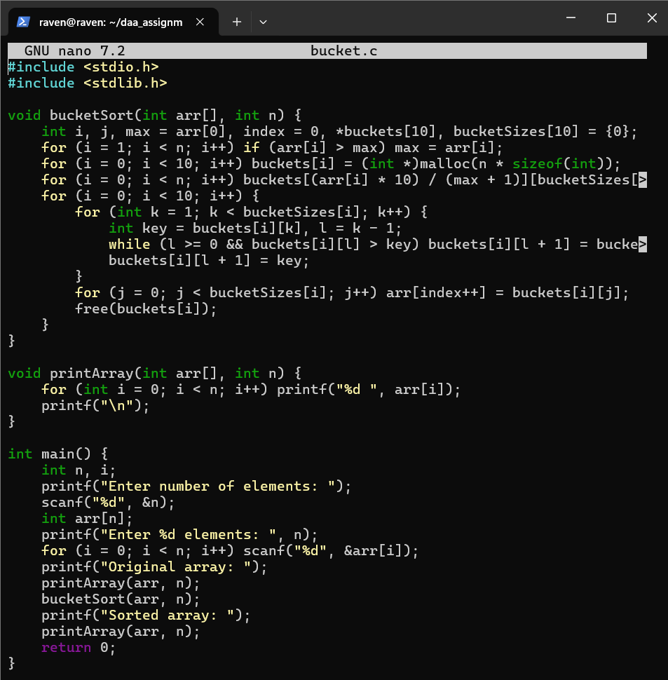

OUTPUT:
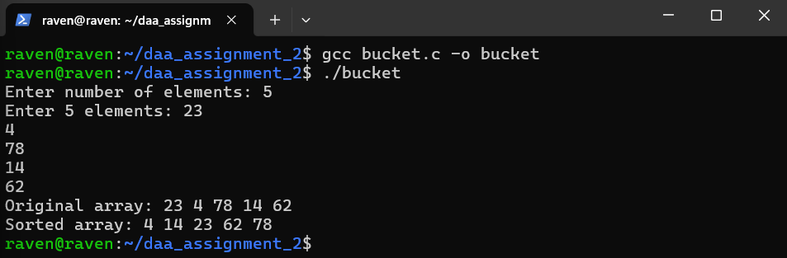

TIME COMPLEXITY: O(n²)

MY INTERPRETATION:
Bucket sort distributes all elements into several buckets based on their values, where each bucket holds elements within a specific range. After distributing, each bucket is sorted individually using a simple sorting method. Finally, all the sorted buckets are combined back together in order to get the fully sorted array. This approach works well when the input values are spread fairly evenly across the range.

- HEAP SORT
CODE:
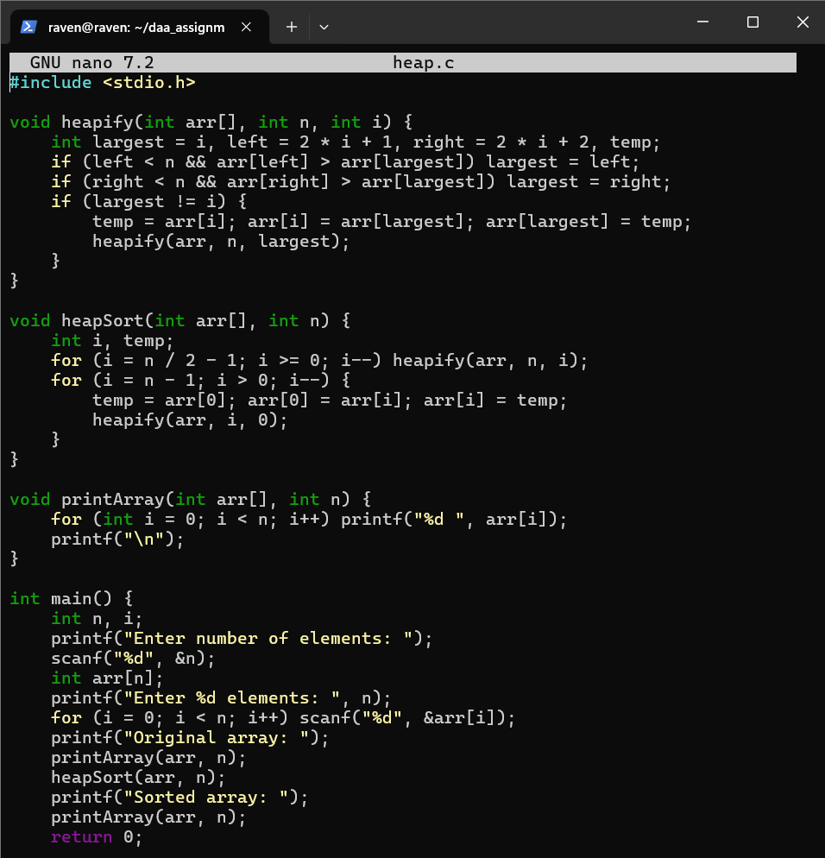

OUTPUT:
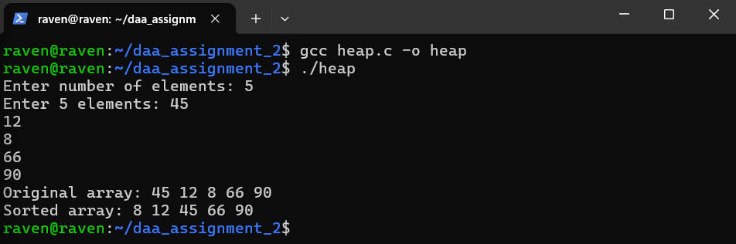

TIME COMPLEXITY: O(nlog(n))

MY INTERPRETATION:
Heap sort organizes the array into a special tree structure called a max heap where each parent node is larger than its children. Once the heap is built, the largest element sits at the root. The algorithm repeatedly removes this largest element and places it at the end, then rebuilds the heap with the remaining elements. This process continues until all elements are removed from the heap and placed in sorted order in the array.

- SELECTION SORT
CODE:
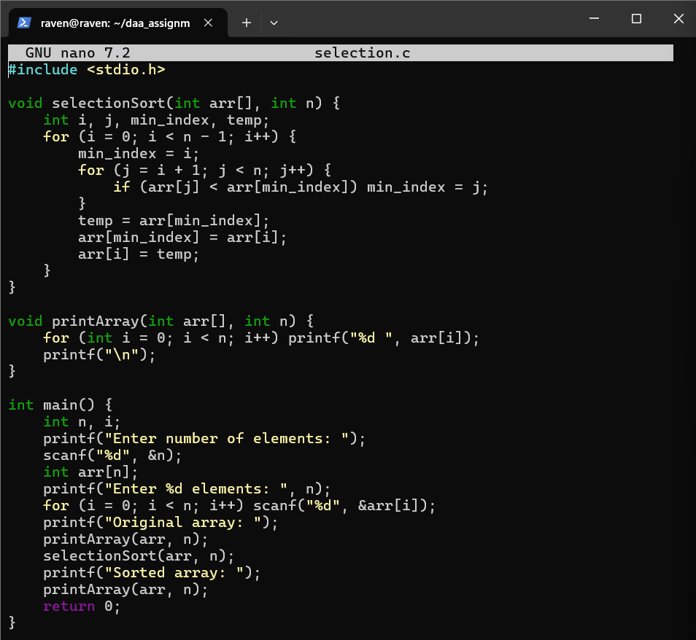

OUTPUT:
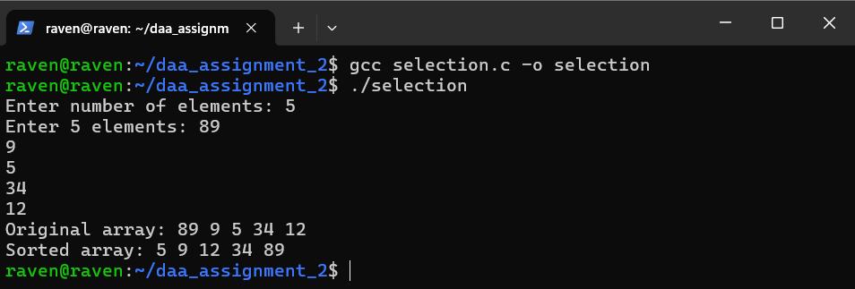
TIME COMPLEXITY: O(n²)

MY INTERPRETATION:
Selection sort divides the array into two parts - a sorted part and an unsorted part. It repeatedly finds the smallest element from the unsorted part and swaps it with the first element of the unsorted part, effectively moving it to the end of the sorted part. After each pass, the sorted portion grows by one element while the unsorted portion shrinks. This continues until the entire array is sorted from smallest to largest.

