Design and Analysis of Algorithm
Saikrishna N
CH.SC.U4CSE24244
- AVL
code:
#include <stdio.h>
#include <stdlib.h>

typedef struct Node {
int key;
struct Node *left;
struct Node *right;
int height;
} Node;

int getHeight(Node *n) {
return (n == NULL) ? 0 : n->height;
}

int max(int a, int b) {
return (a > b) ? a : b;
}

Node* newNode(int key) {
Node* node = (Node*)malloc(sizeof(Node));
node->key = key;
node->left = node->right = NULL;
node->height = 1;
return node;
}

Node* rightRotate(Node *y) {
Node *x = y->left;
Node *T2 = x->right;

x->right = y;
y->left = T2;

y->height = max(getHeight(y->left), getHeight(y->right)) + 1;
x->height = max(getHeight(x->left), getHeight(x->right)) + 1;

return x;
}

Node* leftRotate(Node *x) {
Node *y = x->right;
Node *T2 = y->left;

y->left = x;
x->right = T2;

x->height = max(getHeight(x->left), getHeight(x->right)) + 1;
y->height = max(getHeight(y->left), getHeight(y->right)) + 1;

return y;
}

int getBalance(Node *N) {
return (N == NULL) ? 0 : getHeight(N->left) - getHeight(N->right);
}

Node* insert(Node* node, int key) {
if (node == NULL) return newNode(key);

if (key < node->key)
node->left = insert(node->left, key);
else if (key > node->key)
node->right = insert(node->right, key);
else
return node;

node->height = 1 + max(getHeight(node->left), getHeight(node->right));

int balance = getBalance(node);

if (balance > 1 && key < node->left->key)
return rightRotate(node);

if (balance < -1 && key > node->right->key)
return leftRotate(node);

if (balance > 1 && key > node->left->key) {
node->left = leftRotate(node->left);
return rightRotate(node);
}

if (balance < -1 && key < node->right->key) {
node->right = rightRotate(node->right);
return leftRotate(node);
}

return node;
}

void inOrder(Node *root) {
if (root != NULL) {
inOrder(root->left);
printf("%d ", root->key);
inOrder(root->right);
}
}

int main() {
Node *root = NULL;

root = insert(root, 10);
root = insert(root, 20);
root = insert(root, 30);
root = insert(root, 40);
root = insert(root, 50);
root = insert(root, 25);

printf("In-order traversal of the constructed AVL tree is: \n");
inOrder(root);
printf("\n");

return 0;
}

Output:
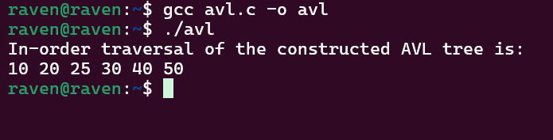

Time Complexity: O(n)
To maintain efficient search and insertion operations, I implemented an AVL Tree, which is a self-balancing Binary Search Tree. The idea is similar to a normal BST where elements smaller than a node go to the left and larger elements go to the right. However, after each insertion, the height of each node is updated and the balance factor (difference between left and right subtree heights) is checked. If the tree becomes unbalanced, rotations are performed to restore balance. The program handles all four imbalance cases: Left-Left, Right-Right, Left-Right, and Right-Left using appropriate rotations (leftRotate and rightRotate). This ensures that the height of the tree remains balanced after every insertion. Finally, an in-order traversal is used to print the elements, which outputs them in sorted order.

