Design and Analysis of Algorithms
Saikrishna N
CH.SC.U4CSE24244
1)BST
Code:
#include <stdio.h>
#include <stdlib.h>

struct Node {
int key;
struct Node *left, *right;
};

struct Node* newNode(int item) {
struct Node* temp = (struct Node*)malloc(sizeof(struct Node));
temp->key = item;
temp->left = temp->right = NULL;
return temp;
}

struct Node* insert(struct Node* node, int key) {
if (node == NULL) return newNode(key);

if (key < node->key)
node->left = insert(node->left, key);
else if (key > node->key)
node->right = insert(node->right, key);

return node;
}

void inorder(struct Node* root) {
if (root != NULL) {
inorder(root->left);
printf("%d ", root->key);
inorder(root->right);
}
}

struct Node* search(struct Node* root, int key) {
if (root == NULL || root->key == key)
return root;

if (root->key < key)
return search(root->right, key);

return search(root->left, key);
}

int main() {
struct Node* root = NULL;
int n, i, val, key;

printf("Enter number of elements to insert: ");
scanf("%d", &n);
printf("Enter elements:\n");
for(i=0; i<n; i++) {
scanf("%d", &val);
root = insert(root, val);
}

printf("Inorder Traversal (Sorted): ");
inorder(root);
printf("\n");

printf("Enter element to search: ");
scanf("%d", &key);
if(search(root, key) != NULL)
printf("Element Found\n");
else
printf("Element Not Found\n");

return 0;
}
Output:
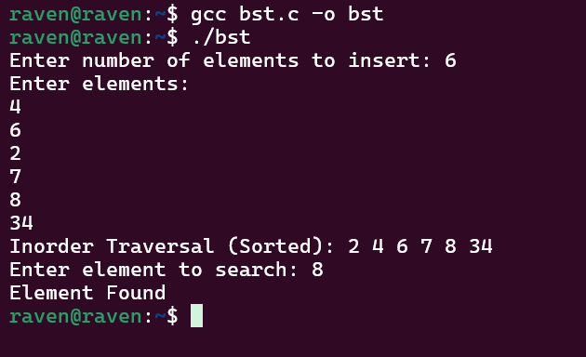
Time Complexity: O(logn)
My interpretation:
To efficiently store and search elements, I used a Binary Search Tree (BST). The idea behind a BST is that for every node, all elements in the left subtree are smaller and all elements in the right subtree are larger than the node’s key. I first created a structure for the tree node containing the key and pointers to the left and right children. Elements are inserted using the insert() function, which recursively finds the correct position in the tree based on the BST property. After constructing the tree, an inorder traversal is performed, which naturally prints the elements in sorted order. To find a specific element, the search() function compares the key with the current node and moves either left or right accordingly. This approach reduces unnecessary comparisons and makes searching more efficient than linear methods.

2)Merge
code:
#include <stdio.h>

void merge(int arr[], int l, int m, int r) {
int i, j, k;
int n1 = m - l + 1;
int n2 = r - m;

int L[50], R[50];

for (i = 0; i < n1; i++)
L[i] = arr[l + i];
for (j = 0; j < n2; j++)
R[j] = arr[m + 1 + j];

i = 0; j = 0; k = l;
while (i < n1 && j < n2) {
if (L[i] <= R[j]) {
arr[k] = L[i];
i++;
} else {
arr[k] = R[j];
j++;
}
k++;
}

while (i < n1) {
arr[k] = L[i];
i++; k++;
}

while (j < n2) {
arr[k] = R[j];
j++; k++;
}
}

void mergeSort(int arr[], int l, int r) {
if (l < r) {
int m = l + (r - l) / 2;

mergeSort(arr, l, m);
mergeSort(arr, m + 1, r);

merge(arr, l, m, r);
}
}

int main() {
int arr[100], n, i
printf("Enter number of elements: ");
scanf("%d", &n);
printf("Enter %d elements:\n", n);
for(i = 0; i < n; i++) {
scanf("%d", &arr[i]);
}

mergeSort(arr, 0, n - 1);

printf("\nSorted array:\n");
for(i = 0; i < n; i++) {
printf("%d ", arr[i]);
}
return 0;
}

Output:
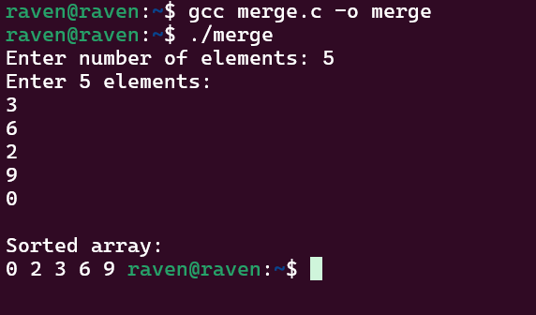

Time Complexity : O(nlogn)
My interpretation:
To sort the elements efficiently, I chose Merge Sort, which uses the divide and conquer technique. The idea is to repeatedly divide the array into two smaller halves until each subarray contains only a single element. The mergeSort() function handles this recursive division by finding the middle index and calling itself for the left and right halves. Once the subarrays become small enough, the merge() function combines them back together in sorted order. During merging, two temporary arrays store the left and right parts so their elements can be compared easily. The smallest element from the two arrays is placed back into the original array one by one. By continuously dividing and merging, the algorithm gradually builds a completely sorted array from smaller sorted subarrays.

3)Quick
Code:
#include <stdio.h>

void swap(int* a, int* b) {
int t = *a;
*a = *b;
*b = t;
}

int partition(int arr[], int low, int high) {
int pivot = arr[high];
int i = (low - 1);

for (int j = low; j <= high - 1; j++) {
if (arr[j] < pivot) {
i++;
swap(&arr[i], &arr[j]);
}
}
swap(&arr[i + 1], &arr[high]);
return (i + 1);
}

void quickSort(int arr[], int low, int high) {
if (low < high) {
int pi = partition(arr, low, high);

quickSort(arr, low, pi - 1);
quickSort(arr, pi + 1, high);
}
}

int main() {
int arr[100], n, i;
printf("Name: M M VASANTH\n");
printf("Roll No: CH.SC.U4CSE24227\n\n");
printf("Enter number of elements: ");
scanf("%d", &n);
printf("Enter %d elements:\n", n);
for(i = 0; i < n; i++) {
scanf("%d", &arr[i]);
}

quickSort(arr, 0, n - 1);

printf("\nSorted array:\n");
for(i = 0; i < n; i++) {
printf("%d ", arr[i]);
}
return 0;
}

Output:
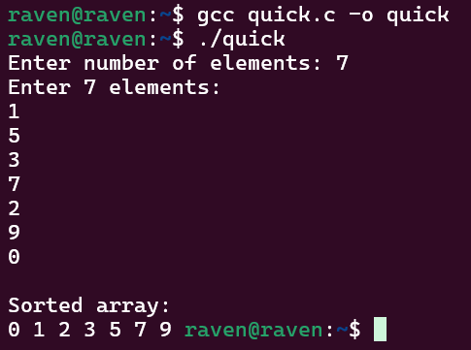
Time Complexity: O(n^2)
My Interpretation:
To efficiently sort the given list of elements, I used the Quick Sort algorithm, which also follows the divide and conquer strategy. The idea is to choose a pivot element and rearrange the array so that all elements smaller than the pivot are placed on its left and larger elements on its right. In this implementation, the last element is chosen as the pivot in the partition() function. During partitioning, elements are compared with the pivot and swapped to maintain the correct order. After the pivot reaches its correct sorted position, the array is divided into two smaller subarrays. The quickSort() function then recursively sorts the left and right subarrays. By repeatedly partitioning the array and sorting smaller sections, the algorithm eventually produces a fully sorted array.

