Design and Analysis of Algorithms
Saikrishna N
CH.SC.U4CSE24244
1)Job Sequencing with Deadlines
Code:
#include <stdio.h>
#include <stdlib.h>
#include <stdbool.h>

struct Job {
char id;
int dead;
int profit;
};

int compare(const void* a, const void* b) {
struct Job* temp1 = (struct Job*)a;
struct Job* temp2 = (struct Job*)b;
return (temp2->profit - temp1->profit); // Sort descending by profit
}

int min(int num1, int num2) {
return (num1 > num2) ? num2 : num1;
}

void printJobScheduling(struct Job arr[], int n) {
qsort(arr, n, sizeof(struct Job), compare);

int result[n];
bool slot[n];

for (int i = 0; i < n; i++) slot[i] = false;

for (int i = 0; i < n; i++) {
for (int j = min(n, arr[i].dead) - 1; j >= 0; j--) {
if (slot[j] == false) {
result[j] = i;
slot[j] = true;
break;
}
}
}

printf("Following is maximum profit sequence of jobs: \n");
int totalProfit = 0;
for (int i = 0; i < n; i++) {
if (slot[i]) {
printf("%c ", arr[result[i]].id);
totalProfit += arr[result[i]].profit;
}
}
printf("\nTotal Profit: %d\n", totalProfit);
}

int main() {
struct Job arr[] = { {'a', 2, 100}, {'b', 1, 19}, {'c', 2, 27},
{'d', 1, 25}, {'e', 3, 15} };
int n = sizeof(arr) / sizeof(arr[0]);
printJobScheduling(arr, n);
return 0;
}

Output:
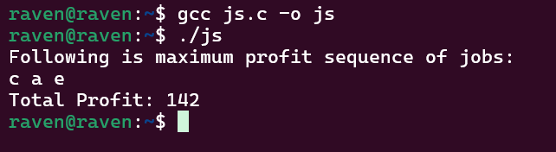
Time Complexity: O(n^2)
My Interpretation:
To maximize the total profit while scheduling jobs with deadlines, I used a greedy approach called the Job Sequencing with Deadlines algorithm. Each job has an ID, deadline, and profit, and the goal is to schedule jobs within their deadlines to obtain the highest possible profit. First, the jobs are sorted in descending order of profit using qsort() so that the most profitable jobs are considered first. Then an array of time slots is maintained to track which slots are already occupied. For each job, the algorithm checks for the latest available slot before its deadline and assigns the job if a slot is free. If the slot is already filled, it moves backward to check earlier slots. This greedy strategy ensures that high-profit jobs are prioritized while still respecting deadline constraints. Finally, the selected jobs and the total profit are printed.

2)Huffman Coding
Code:
#include <stdio.h>
#include <stdlib.h>

#define MAX_TREE_HT 100

struct MinHeapNode {
char data;
unsigned freq;
struct MinHeapNode *left, *right;
};

struct MinHeap {
unsigned size;
unsigned capacity;
struct MinHeapNode** array;
};

struct MinHeapNode* newNode(char data, unsigned freq) {
struct MinHeapNode* temp = (struct MinHeapNode*)malloc(sizeof(struct MinHeapNode));
temp->left = temp->right = NULL;
temp->data = data;
temp->freq = freq;
return temp;
}

struct MinHeap* createMinHeap(unsigned capacity) {
struct MinHeap* minHeap = (struct MinHeap*)malloc(sizeof(struct MinHeap));
minHeap->size = 0;
minHeap->capacity = capacity;
minHeap->array = (struct MinHeapNode**)malloc(minHeap->capacity * sizeof(struct MinHeapNode*));
return minHeap;
}

void swapMinHeapNode(struct MinHeapNode** a, struct MinHeapNode** b) {
struct MinHeapNode* t = *a;
*a = *b;
*b = t;
}

void minHeapify(struct MinHeap* minHeap, int idx) {
int smallest = idx;
int left = 2 * idx + 1;
int right = 2 * idx + 2;

if (left < minHeap->size && minHeap->array[left]->freq < minHeap->array[smallest]->freq)
smallest = left;
if (right < minHeap->size && minHeap->array[right]->freq < minHeap->array[smallest]->freq)
smallest = right;

if (smallest != idx) {
swapMinHeapNode(&minHeap->array[smallest], &minHeap->array[idx]);
minHeapify(minHeap, smallest);
}
}

int isSizeOne(struct MinHeap* minHeap) {
return (minHeap->size == 1);
}

struct MinHeapNode* extractMin(struct MinHeap* minHeap) {
struct MinHeapNode* temp = minHeap->array[0];
minHeap->array[0] = minHeap->array[minHeap->size - 1];
--minHeap->size;
minHeapify(minHeap, 0);
return temp;
}

void insertMinHeap(struct MinHeap* minHeap, struct MinHeapNode* minHeapNode) {
++minHeap->size;
int i = minHeap->size - 1;
while (i && minHeapNode->freq < minHeap->array[(i - 1) / 2]->freq) {
minHeap->array[i] = minHeap->array[(i - 1) / 2];
i = (i - 1) / 2;
}
minHeap->array[i] = minHeapNode;
}

void buildMinHeap(struct MinHeap* minHeap) {
int n = minHeap->size - 1;
for (int i = (n - 1) / 2; i >= 0; --i)
minHeapify(minHeap, i);
}

void printArr(int arr[], int n) {
for (int i = 0; i < n; ++i)
printf("%d", arr[i]);
printf("\n");
}

int isLeaf(struct MinHeapNode* root) {
return !(root->left) && !(root->right);
}

struct MinHeap* createAndBuildMinHeap(char data[], int freq[], int size) {
struct MinHeap* minHeap = createMinHeap(size);
for (int i = 0; i < size; ++i)
minHeap->array[i] = newNode(data[i], freq[i]);
minHeap->size = size;
buildMinHeap(minHeap);
return minHeap;
}

struct MinHeapNode* buildHuffmanTree(char data[], int freq[], int size) {
struct MinHeapNode *left, *right, *top;
struct MinHeap* minHeap = createAndBuildMinHeap(data, freq, size);

while (!isSizeOne(minHeap)) {
left = extractMin(minHeap);
right = extractMin(minHeap);
top = newNode('$', left->freq + right->freq);
top->left = left;
top->right = right;
insertMinHeap(minHeap, top);
}
return extractMin(minHeap);
}

void printCodes(struct MinHeapNode* root, int arr[], int top) {
if (root->left) {
arr[top] = 0;
printCodes(root->left, arr, top + 1);
}
if (root->right) {
arr[top] = 1;
printCodes(root->right, arr, top + 1);
}
if (isLeaf(root)) {
printf("%c: ", root->data);
printArr(arr, top);
}
}

void HuffmanCodes(char data[], int freq[], int size) {
struct MinHeapNode* root = buildHuffmanTree(data, freq, size);
int arr[MAX_TREE_HT], top = 0;
printCodes(root, arr, top);
}

int main() {
char arr[] = { 'a', 'b', 'c', 'd', 'e', 'f' };
int freq[] = { 5, 9, 12, 13, 16, 45 };
int size = sizeof(arr) / sizeof(arr[0]);
printf("Huffman Codes generated:\n");
HuffmanCodes(arr, freq, size);
return 0;
}

Output:
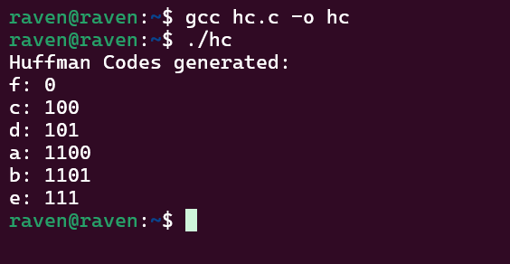

Time Complexity: O(nlogn)
My Interpretation:
To generate efficient prefix codes for characters based on their frequencies, I implemented the Huffman Coding algorithm, which follows a greedy strategy. The idea is to repeatedly combine the two characters with the smallest frequencies to build a binary tree that minimizes the total encoding cost. First, all characters and their frequencies are inserted into a Min Heap, which allows quick access to the nodes with the smallest frequency. Then, the two minimum nodes are extracted, combined into a new internal node with their total frequency, and inserted back into the heap. This process continues until only one node remains, which becomes the root of the Huffman Tree. Finally, the tree is traversed to generate binary codes, assigning 0 for left edges and 1 for right edges. This ensures that frequently occurring characters receive shorter codes, making the encoding more efficient.

