Design and Analysis of Algorithms
Saikrishna N
CH.SC.U4CSE24244
- Kruskals
Code:
#include <stdio.h>
#include <stdlib.h>

struct Edge {
int src, dest, weight;
};

struct Edge edges[100];
int parent[20];
int n, e_cnt = 0;

int find(int i) {
if (parent[i] == -1)
return i;
return find(parent[i]);
}

void Union(int x, int y) {
int xset = find(x);
int yset = find(y);
if(xset != yset)
parent[xset] = yset;
}

int compare(const void* a, const void* b) {
struct Edge* a1 = (struct Edge*)a;
struct Edge* b1 = (struct Edge*)b;
return a1->weight - b1->weight;
}

void kruskalMST() {
int mst_weight = 0;
qsort(edges, e_cnt, sizeof(edges[0]), compare);

for (int i = 0; i < n; i++)
parent[i] = -1;

printf("Edge \tWeight\n");
for (int i = 0; i < e_cnt; i++) {
int x = find(edges[i].src);
int y = find(edges[i].dest);

if (x != y) {
printf("%d - %d \t%d \n", edges[i].src, edges[i].dest, edges[i].weight);
mst_weight += edges[i].weight;
Union(x, y);
}
}
printf("Total Cost: %d\n", mst_weight);
}

int main() {
int weight;
printf("Enter number of vertices: ");
scanf("%d", &n);
printf("Enter number of edges: ");
scanf("%d", &e_cnt);

for(int i = 0; i < e_cnt; i++) {
printf("Enter src, dest, weight for edge %d: ", i+1);
scanf("%d %d %d", &edges[i].src, &edges[i].dest, &edges[i].weight);
}

kruskalMST();
return 0;
}

Output:
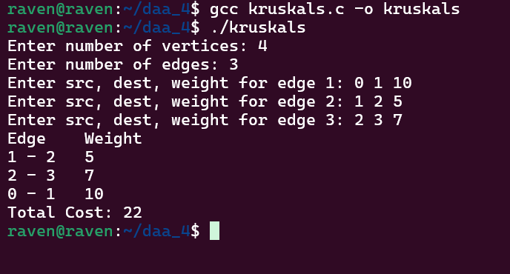

Time Complexity: O(nlogn)
My interpretation:
To find the Minimum Spanning Tree (MST) of a weighted graph, I decided to use Kruskal’s algorithm, which follows a greedy approach. The idea is to always select the edge with the smallest weight that does not form a cycle in the graph. First, all edges of the graph are stored in a structure containing source, destination, and weight. Then the edges are sorted in increasing order of weight using qsort(). To efficiently detect cycles while adding edges, a Disjoint Set (Union–Find) data structure is used with find() and Union() functions. Each edge is checked in sorted order, and it is added to the MST only if the vertices belong to different sets, ensuring no cycle is formed. This process continues until the required edges for the MST are selected, and the total weight of the spanning tree is calculated.

- Prims
Code:
#include <stdio.h>
#include <limits.h>

#define INF 9999
int n;

int minKey(int key[], int mstSet[]) {
int min = INF, min_index, v;
for (v = 0; v < n; v++)
if (mstSet[v] == 0 && key[v] < min)
min = key[v], min_index = v;
return min_index;
}

void printMST(int parent[], int graph[20][20]) {
printf("Edge \tWeight\n");
for (int i = 1; i < n; i++)
printf("%d - %d \t%d \n", parent[i], i, graph[i][parent[i]]);
}

void primMST(int graph[20][20]) {
int parent[20];
int key[20];
int mstSet[20];

for (int i = 0; i < n; i++)
key[i] = INF, mstSet[i] = 0;

key[0] = 0;
parent[0] = -1;

for (int count = 0; count < n - 1; count++) {
int u = minKey(key, mstSet);
mstSet[u] = 1;

for (int v = 0; v < n; v++)
if (graph[u][v] && mstSet[v] == 0 && graph[u][v] < key[v])
parent[v] = u, key[v] = graph[u][v];
}
printMST(parent, graph);
}

int main() {
int graph[20][20];
printf("Enter number of vertices: ");
scanf("%d", &n);
printf("Enter adjacency matrix:\n");
for(int i = 0; i < n; i++)
for(int j = 0; j < n; j++)
scanf("%d", &graph[i][j]);

primMST(graph);
return 0;
}
Output:
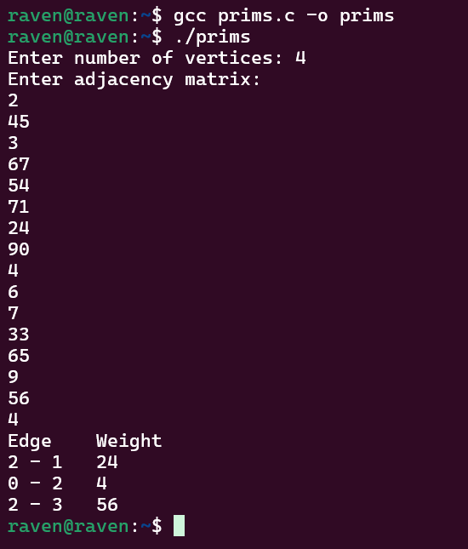

Time Complexity: O(n^2)
My interpretation:
To construct the Minimum Spanning Tree (MST) of a weighted graph, I used Prim’s algorithm, which follows a greedy strategy. The idea is to start from an initial vertex and repeatedly add the minimum weight edge that connects a vertex in the MST to a vertex outside it. The graph is represented using an adjacency matrix to easily access edge weights between vertices. An array key[] is used to store the minimum weight required to connect each vertex to the MST, while mstSet[] keeps track of vertices already included in the MST. In each iteration, the minKey() function selects the vertex with the smallest key value that is not yet included in the MST. After selecting a vertex, the algorithm updates the key values of its adjacent vertices if a smaller edge weight is found. This process continues until all vertices are included, after which the edges of the MST are printed.

