1.Create a database named Employee. Create a collection named empDetails

You can use any of the fields Name, Age ,e_mail, phone,salary

1 .Insert 5 documents in it using the different insert() methods and

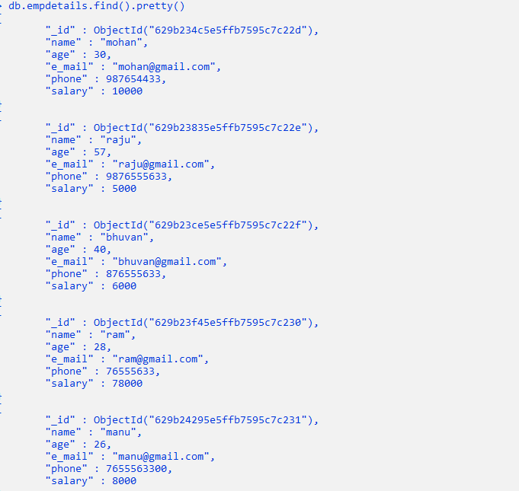

1. Find the details of employee whose name is mohan

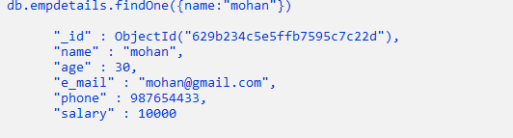

1. Fetch the documents of employees whose salary >=5000
2. Find the documents of employees whose name starts with letter r

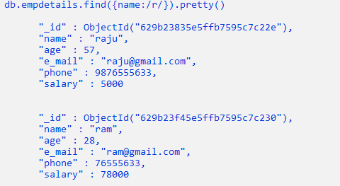

1. Find the documents of employees whose name is not in mohan , raju, bhuvan

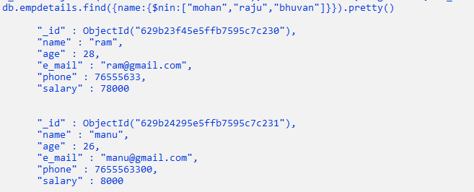

1. Find the documents of employees whose names are mohan , raju, bhuvan

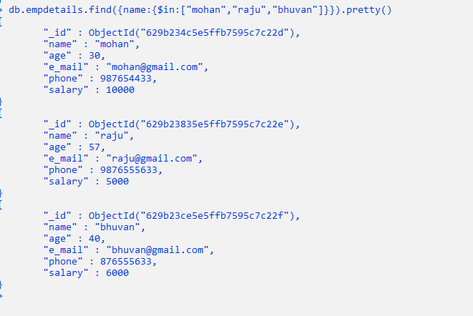

1. Retrieve the details of employees whose age is less than 30. Display only the fields name, salary
2. Find the details of employees whose salary is >5000 and age is < 30

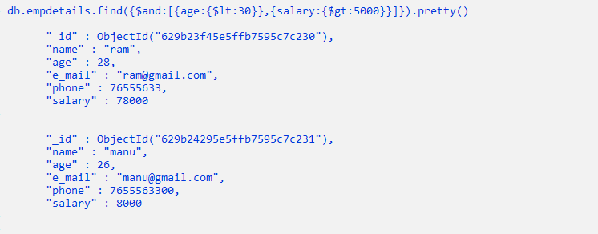

1. Update the e-mail of employee whose name is mohan  // findOneAndUpdate()
2. Delete all the documents of employees whose age>56