**Co5 programs**

**1.write a program to read a file line by line and store it into a list.**

**f1=open("firstfile.txt","w")**

**f1.write("This is my first file in python.\nWant to work with files.\nThis is my third.")**

**f1.close()**

**f1=open("firstfile.txt","r")**

**f1.seek(0,0)**

**ff=f1.readlines()**

**for x in range(0,len(ff)):**

**print(ff[x])**

**print()**

**print(ff)**

**f1.close()**

**output:**

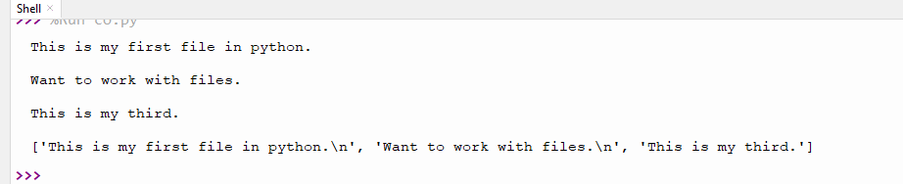

**2.Python program to copy odd lines of one file to other.**

**f1=open("secfile.txt","r")**

**ff=f1.readlines()**

**with open("odd.txt","w") as f2:**

**for x in range(0,len(ff)):**

**if(x%2!=0):**

**f2.write(ff[x])**

**output:**

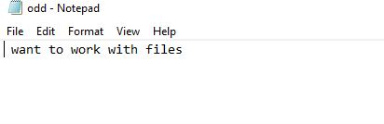

**3. Write a Python program to read each row from a given csv file and print a list of strings..**

import csv

filename = "username.csv"

rows = []

cf=open(filename, 'r')

csvreader = csv.reader(cf)

for r in csvreader:

rows.append(r)

print(rows)

cf.close()

**username.cvs**

|  |  |  |  |
| --- | --- | --- | --- |
| Username; Identifier;Firstname;Lastname | | | |
| booker12;9012;Rachel;Booker | | |  |
| grey07;2070;Laura;Grey | | |  |
| johnson81;4081;Craig;Johnson | | |  |
| jenkins46;9346;Mary;Jenkins | | |  |
| smith79;5079;Jamie;Smith | | |  |
|  |  |  |  |

**output:**

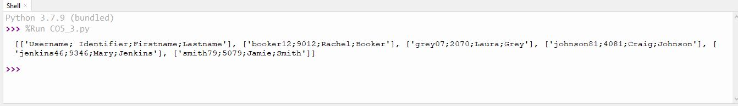

**4. Write a Python program to read specific columns of a given CSV file and print the content of the columns.**

import csv

filename = "emp.txt"

fields = []

rows = []

cf=open(filename, 'r')

csvreader = csv.DictReader(cf)

for r in csvreader:

print(dict(r))

**emp.txt**

name,department,birthday month

John Smith,Accounting,November

Erica Meyers,IT,March

**output:**

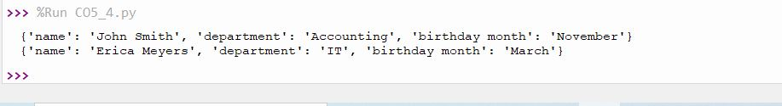

**5. Write a Python program to write a Python dictionary to a csv file. After writing the CSV file read the CSV file and display the content**.

import csv

field_names = ['No', 'Company', 'Car Model']

cars = [

{'No': 1, 'Company': 'Ferrari', 'Car Model': '488 GTB'},

{'No': 2, 'Company': 'Porsche', 'Car Model': '918 Spyder'},

{'No': 3, 'Company': 'Bugatti', 'Car Model': 'La Voiture Noire'},

{'No': 4, 'Company': 'Rolls Royce', 'Car Model': 'Phantom'},

{'No': 5, 'Company': 'BMW', 'Car Model': 'BMW X7'},

]

with open('Names1.csv', 'w') as csvfile:

writer = csv.DictWriter(csvfile, fieldnames = field_names)

writer.writeheader()

writer.writerows(cars)

#print(".................")

filename = "names1.csv"

cf=open(filename, 'r')

rows=[]

csvreader = csv.reader(cf)

for r in csvreader:

rows.append(r)

for r in rows[:3]:

print(*r)

**output:**

